

**warehouse for restaurant**

**Software Requirement Specification**

**Report 2 - Overall Description**

– HoChiMinh, August 2022 –

**Table of Contents**

Record of Changes 3

II. Overall Description 4

1. Product Overview 4

2. Business Process 5

# Record of Changes

|  |  |  |  |
| --- | --- | --- | --- |
| Date | A* M, D | In charge | Change Description |
|  |  |  |  |
|  |  |  |  |
|  |  |  |  |
|  |  |  |  |
|  |  |  |  |
|  |  |  |  |
|  |  |  |  |
|  |  |  |  |
|  |  |  |  |
|  |  |  |  |
|  |  |  |  |
|  |  |  |  |
|  |  |  |  |

*A - Added M - Modified D - Deleted

# II. Overall Description

## 1. Product Overview

The warehouse for restaurant system is an irreplaceable software system for the chain restaurants that can reduce the human resources, avoid wasted materials or leftovers. The system is expected to evolve over several releases, ultimately connecting to the Internet warehouse management services for all chain restaurants and easier to control the import or export of materials*.*

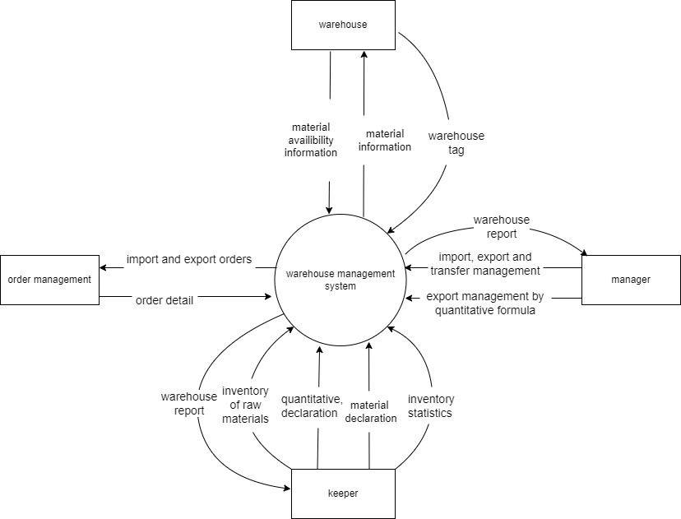

## 2. Business Process

Shows a partial swimlane diagram for the CTS. The swimlanes in this example are roles or departments, showing which group executes each step in the business process to manage the warehouse.

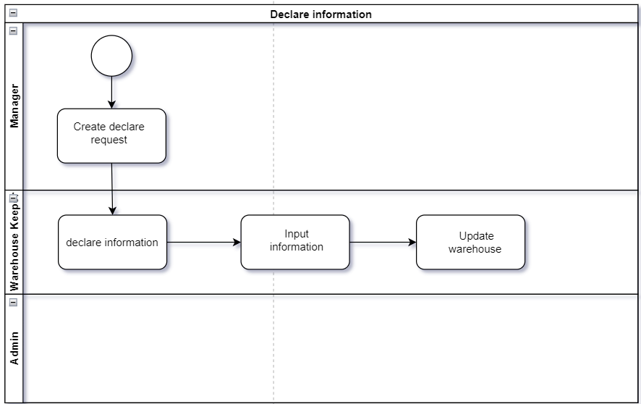

|  |  |  |
| --- | --- | --- |
| **#** | **Process Step** | **Description** |
| 1 | Create a declare request | Manager create a warehouse declare request for the keeper |
| 2 | Declare information | Checking import information |
| 3 | Input information | Input information to the system |
| 4 | Update warehouse | Update information |

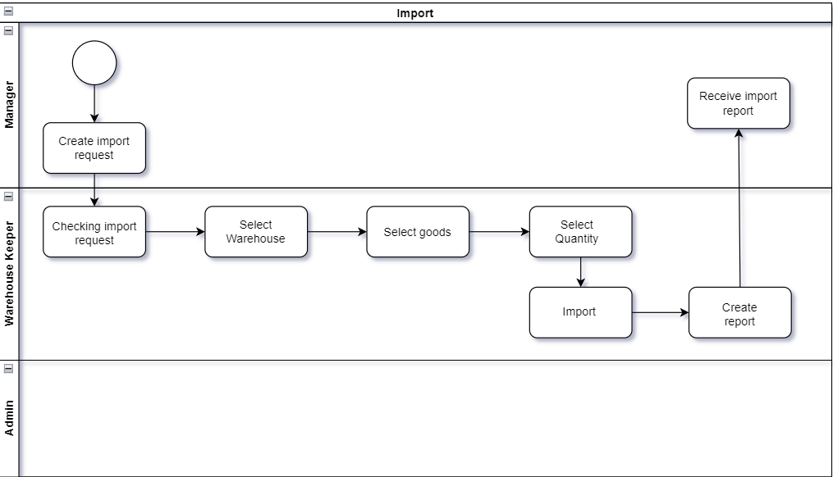

|  |  |  |
| --- | --- | --- |
| **#** | **Process Step** | **Description** |
| 1 | Create a import request | Manager create a warehouse import request for the keeper |
| 2 | Checking import request | Checking import information |
| 3 | Select warehouse | The keeper select which warehouse will be import |
| 4 | Select goods | The keeper select which goods will be import |
| 5 | Select quantity | The keeper select quantity of goods |
| 6 | Import | Import to warehouse |
| 7 | Create report | Create report for manager |
| 8 | Receive report | Receive report from Keeper |

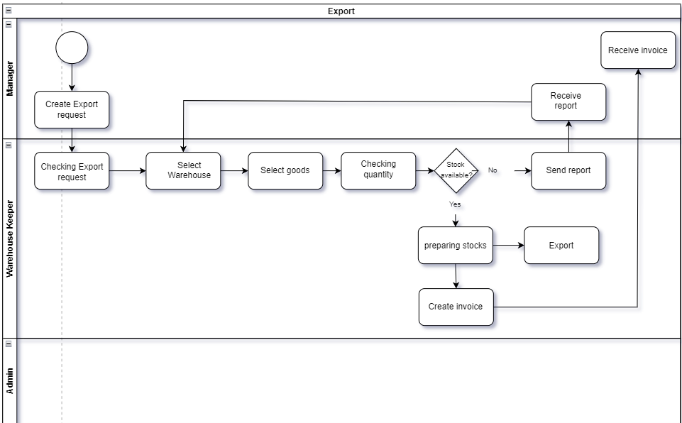

|  |  |  |
| --- | --- | --- |
| **#** | **Process Step** | **Description** |
| 1 | Create a export request | Manager create a warehouse export request for the keeper |
| 2 | Checking export request | Warehouse keeper checking for export information |
| 3 | Select warehouse | The keeper select which warehouse will be export |
| 4 | Select goods | The keeper select which goods will be export |
| 5 | Checking quantity | The Keeper checking for quantity of goods is available or not |
| 6 | Stock available | Checking |
| 7 | Preparing stocks | If stocks available then preparing to export |
| 8 | Export | Export stocks |
| 9 | Send report | Create report for manager |
| 10 | Receive Report | Receive report from Keeper |
| 11 | Create invoice | Create invoice for manager |
| 12 | Receive invoice | Receive invoice from Keeper |

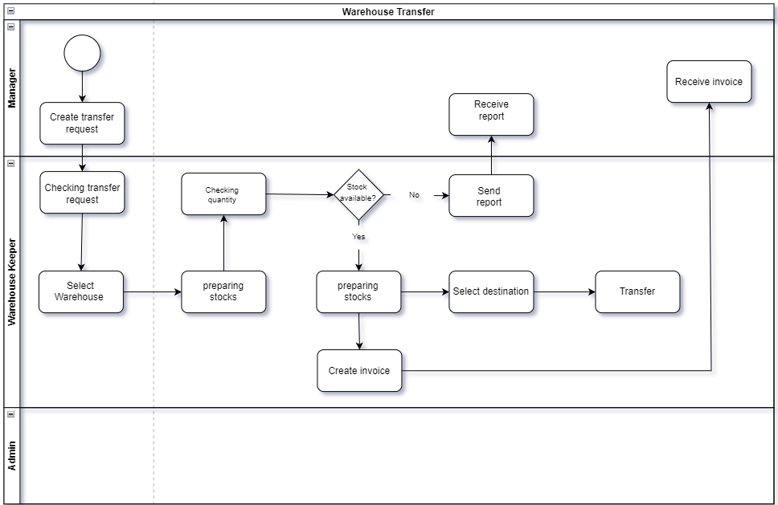

|  |  |  |
| --- | --- | --- |
| **#** | **Process Step** | **Description** |
| 1 | Create transfer request | Manager create a warehouse transfer request for the keeper |
| 2 | Checking transfer request | Warehouse keeper checking for transfer information |
| 3 | Select warehouse | The keeper select which warehouse will transfer |
| 4 | Checking quantity | The Keeper checking for quantity of goods is available or not |
| 5 | Stock available |  |
| 6 | Send report | Create report for manager |
| 7 | Receive report | Receive report from Keeper |
| 8 | Preparing stock | If stocks available then preparing to transfer |
| 9 | Select destination | Select warehouse to receive stocks |
| 10 | Transfer | Transfer stock to destination |
| 11 | Create invoice | Create invoice for manager |
| 12 | Receive invoice | Receive invoice from Keeper |