**Group Assignment**

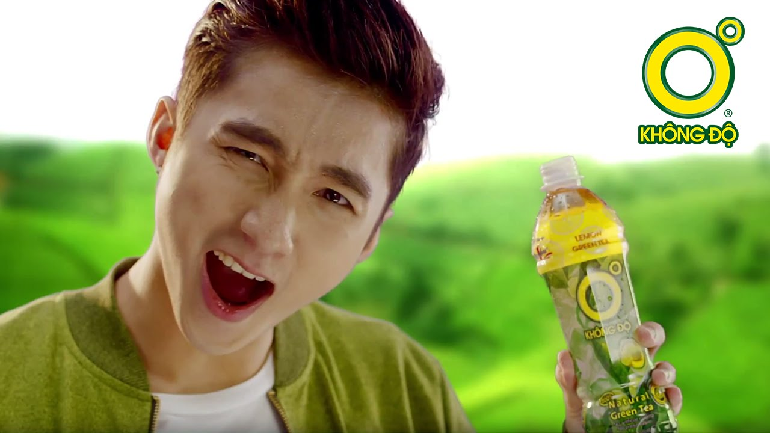**Trà Xanh Không Độ**

Group Members :

Trịnh Bá Bình

Lưu Hoàng Thiện

Khúc Xuân Hào

Phạm Văn Toàn

1. **EXECUTIVE SUMMARY**

Tra Xanh Khong Do is a product of the Tan Hiep Phat Group's product line, which is well-known in Vietnam's beverage business. Tan Hiep Phat was founded in 1994 with the precursor Ben Thanh Brewery, and after more than two decades of growth and development, the company is now a household name in the Vietnamese FMCG market. Tan Hiep Phat's products have consistently won the title of "Vietnamese High-Quality Goods" as voted by people, as well as the National Brand and numerous other prestigious prizes. Tan Hiep Phat's products are widely trusted due to the guarantee. Each of its products incorporates quality management, environmental protection, and rigorous ISO requirements.

Green tea, more than any other product produced by the corporation, does not have a minor place in comparison to other beverage brands. Tan Hiep Phat produced a product in 2006 based on the criterion "Customer is God," which captures the criteria of Vietnamese people's tea preferences. Zero-grade green tea immediately acquired popularity among consumers, and the firm promoted it as a healthy product. Green tea has an easy time dominating the market. In 2007, the consumption rate was in the hundreds of thousands, and the growth rate was sometimes as high as 190 percent. These amazing figures make us wonder if Tan Hiep Phat's marketing strategy is aimed towards youngsters.

1. **SITUATION ANALYSIS**
2. **Industry Analysis**

* The following are the primary beverage product categories now available in Vietnam: carbonated and non-carbonated mineral water, filtered water, soft drinks, energy drinks, instant tea, and various fruit juices.
* According to alcohol and beverage groups, soft drinks, quick teas, fruit juices of all kinds, and rose water account for 85 percent of yearly beverage production and consumption in Vietnam. The remaining 15% is attributable to mineral water, which makes up the rest.
* According to the association's plans, Vietnam's soft drink output will increase from 8.3 to 9.2 billion liters per year by 2020. In addition, ViettinBank (an industrial and commercial banking securities joint stock company) declared in September 2015 that , the non-alcoholic beverage sector in Vietnam generated a total revenue of 80 billion VND. copper.
* The first reason is that, due to Vietnam's hot and humid climate, the beverage industry is rapidly expanding. The demand for beverage production increased by roughly 18% in 2014 due to the diverse culinary culture.
* On hot summer days, the non-alcoholic beverage service business, particularly carbonated beverages with ice for drinking in hot weather, assists users in staying hydrated. Vietnam has a young population, with the 15-to-50-year-old age group accounting for 63 percent of soft drink demand.
* The number of per capita in Vietnam in 2016 was reported in the press. Vietnam consumes 7.2 liters of soft drinks per year, which is much more than the previous year.
* One of the leading businesses that cannot help but talk about the success of the beverage industry is:
* SUNTORY PEPSICO Vietnam Beverage Co., Ltd
* Tan Hiep Phat Group + Red Bull Co., Ltd
* Lavie Co., Ltd
* Vinamilk Company
* Vinh Hao mineral water joint stock company
* Unilever company
* Coca-Cola Vietnam
* Non-alcoholic beverages' market value increased by 7% in 2018 compared to the previous year, owing to increased consumption. Also contributing to the FMCG industry is beer, which accounts for 20% of all sales. The beverage business has provided billions of dong in state taxes each year to the country's economic development.
* Non-alcoholic beverages' market value increased by 7% in 2018 compared to the previous year, owing to increased consumption. Also contributing to the FMCG industry is beer, which accounts for 20% of all sales. The beverage business has provided billions of dong in state taxes each year to the country's economic development.
* The number of 20 had risen to 50 trillion VND by 2017. According to a spokesman from the beer and wine business association
* The beverage business in Vietnam is currently drawing a large number of investors. The reason for this is because domestic growth has consistently remained at a remarkable 7% each year, compared to 2% in France and Japan.
* The number of 20 had risen to 50 trillion VND by 2017. According to a spokesman from the beer and wine business association
* The beverage business in Vietnam is currently drawing a large number of investors. The reason for this is because domestic growth has consistently remained at a remarkable 7% each year, compared to 2% in France and Japan.

1. **Company Description**
   1. **Company History**

Tra Xanh Khong Do is a product made from 100 percent pure green tea leaves, packaged in PET bottles and resistant to high temperatures, allowing nutrients to be preserved. The compact and convenient bottle design, in a fresh green color, evokes a sense of being connected to nature. Tan Hiep Phat Group launched Tra Xanh Khong Do in early 2006.

Tan Hiep Phat Trading - Service Company Limited is Tan Hiep Phat's full name. Ben Thanh Beverage Factory was the forerunner, specializing in soft drinks, carbonated soft drinks, and beer flavors. The company's headquarters are in Thuan An district, Binh Duong province, and the factory has a larger scale of 110,000m2.

Tan Hiep Phat's company was founded in 1994, according to records.

The company expanded in 1995, producing a 220ml bottle of soy milk (Soya soy milk).

* In 1996, the company expanded its production line and entered the market with Flash draft beer.
* In 1999, Ben Thanh Beverage Factory changed its name to Ben Thanh Beverage Factory, producing soy milk, bottled beer, draft beer, and Flash draft beer.
* 2000: Ben Thanh Beer was the first beer industry in Vietnam to obtain ISO 9001-2000 certification, certified by the international quality management agency Det Norske Veritas (Netherlands) on March 23, 2000.
* In 2001, the company built a factory and office in Vinh Phu commune, Thuan An district, Binh Duong province.

In the following years, the company launched the products Number 1 Energy Drink, Laser Bottled Beer, Number 1 Soy Milk, Number 1 Pure Water, Ben Thanh Gold Beer… The founder of Tan Hiep Phat is Mr. Tran Qui Thanh, currently Chairman of the Board of Directors and General Director of this business.

Mr. Thanh was born in 1953. In 1978, he graduated from the University of Technology, majoring in mechanical engineering in machine building in 1978. Mr. Thanh received his Doctor of Business Administration degree from Southern California University.

* In September 2015, Tan Hiep Phat changed its name to Number 1.

Number 1 Group or Number 1 Company Limited (formerly Tan Hiep Phat Trading and Service Company Limited), English trading name: Number 1 Corp - is an enterprise specializing in manufacturing and trading beverage products and bottled drinks in Vietnam.

* 1. **Misson Statement**

With the ambition of "Becoming a leading corporation in Asia in the field of beverages and food", Tan Hiep Phat has constantly invested in developing production line systems, modernizing technology, and Proud to be one of the domestic units possessing many of the world's most modern production technologies and lines such as Aseptic cold extraction lines, European and Japanese technology lines...

Tan Hiep Phat's products continuously won the title of "Vietnamese High-Quality Goods" voted by consumers, honored the National Brand, and many other valuable awards, widely trusted thanks to the guarantee, quality management, environmental protection and ISO standards

* Aspiration: "Contributing to the prosperity of society and being the pride of Vietnamese people by building a Group with a strong and international brand name".
* Vision: To become a leading corporation in Asia in the field of beverage and food.
* Mission: Producing and trading healthy products for Asian consumers with appropriate taste and product quality according to international standards, while satisfying the existing and potential needs of customers to become a more preferred partner in business.
  1. **Product and services**

**Number 1 Active**

Number 1 Active is the ideal choice for consumers looking to maintain a balanced body when exercising. The sweet taste combines a special lemon salt, 3 further mineral salts and essential minerals including sodium and potassium. Number 1 Active will give you the energy you need to get through endurance sport or your daily activities.

**Number 1 Juicie Fruit – Orange, Passion Fruit and Wintermelon**

Number 1 juice Juicie is produced from pure natural fruit flavours direct from the fruit. We have preserved a piece of nature and combined it with pure water to create a cooling drink, rich in vitamin C. The natural ingredients in Number 1 Juicie Fruit aid the digestion of fibre and help fight infection.

**Number 1 Purified Water**

Number 1 juice Juicie is produced from pure natural fruit flavours direct from the fruit. We have preserved a piece of nature and combined it with pure water to create a cooling drink, rich in vitamin C. The natural ingredients in Number 1 Juicie Fruit aid the digestion of fibre and help fight infection.

**Number 1 Purified Water**

Number 1 Purified Water is bottled pure water extracted from natural underground sources. To ensure the purest water reaches our consumer, Number 1 Purified Water is processed through our advanced reverse osmosis system before going through a strong sterilization process.

**Number 1 Soya Milk – Original and Green Bean**

By using modern shelling technology from Japan we ensure we retain 100% of the nutrients found in soy. This drink is especially rich in vegetable protein and contains no cholesterol. Number 1 Soya Milk brings you maximum nutrition whilst also tasting delicious.

**Zero Degree Oolong Tea**

Zero Degree Oolong Tea is made with natural extracts that prevent the absorption of fat and reduce cholesterol in the body.Ganoderma extract enhances the body’s immune system and detoxifies the liver. Ganoderma has also been proven to reduce cholesterol and toxins, stabilise the nervous system, reduce fatigue, promote relaxation and reduce the effects of caffeine. Zero Degrees Oolong Tea also contains reishi which is used to treat migraines, insomnia, nervous depression and stress.

**Zero Degree Wintermelon Green Tea with Collagen**

Zero Degree Wintemelon Green Tea with Collagen is produced on by THP using state of the art aseptic technology and contains no preservatives or artificial colors which helps retain the maximum nutritional content and flavour if the wintermelon. Furthermore, wintermelon is cooling and helps avoid the side effects of heat and a hot climate such as heat stroke or heat rashes.Collagen helps maintain youthful skin as it is a protein founds in 70% of skin’s structure; it has also been found to increase metabolism. THP imports specially selected collagen from Germany for its products.

* 1. **Key** partnerships

**Media group Yeah1**

Both sides will focus on developing apps for the technological and digital ecosystem of Yeah 1. Besides investors with financial capability, Yeah1 is seeking partners with management expertise to speed up its media commerce strategy, Yeah1’s Chairman Nguyen Anh Nhuong Tong noted on Thanh Nien Online website. Tran Quy Thanh, general director of Tan Hiep Phat Group, stated that Yeah1 will help the group approach young consumers and deploy marketing programs. The target is to reduce marketing costs, raise revenue and improve consumer benefits.

1. **Market Analysis**
   1. **Market segmentation & Target Market Selection**

**Segment size**

Market segment for unsweetened green tea products: This group of customers is increasing in number because people are more inclined and conscious to protect their health.

Market segmentation for lemon flavored green tea, honey green tea and honey lemon green tea: was born early in the lemon tea product line and created a great buzz, so the market share of this product is quite large, unique Maintaining and sustaining such results is a success. Moreover, the current competition of the product line is quite strong.

**Anticipate changes**

Expected changes in target customer needs: The needs of target customers often change. In order to meet the needs of customers that are constantly changing, the company regularly surveys customers to know what their needs are in order to find the right solutions and new products to continue to meet the desired needs. of target customers. Expected changes in shopping behavior: Today's strong economic development and improved living standards have changed the consumption trend in Vietnam (shopping at supermarkets, commercial centers, specialized stores, etc.) % (2005) increased to 14% in 2007. As people become busier, consumption behaviors also change from daily shopping in traditional markets, to buying in bulk for the whole week in supermarkets, shopping centers and through the Internet. Their buying behavior is determined from many factors, and studying these influencing factors helps businesses promptly have effective and appropriate 4ps strategies.

Expected changes in customer perceptions and attitudes. Customers often consider and compare the company's products with those of competitors. Customers are often concerned about the safety of products, and they often have access to information about the quality and harmful substances in products in the press and media. Therefore, they choose products that, according to them, are clean, highly reliable products. For a product that is not of good quality, even if it is only suspected, consumers will have an attitude of boycotting that product.

**Target Market Selection**

Tan Hiep Phat selects the target market by Product specialization, providing 0 degree green tea products with different characteristics to meet different segments in the entire market.

- Market segment for unsweetened green tea products: Groups of customers who do not drink sugar, want to reduce the risk of diabetes, can replace purified water with outstanding cooling properties. This group of customers is increasing in number because people are more and more inclined to protect their health.

- Market segment for lemon flavored green tea, honey green tea: the group of customers who prefer to drink sugary and natural beverages. Born early, in this market segment, 0 degree green tea still holds the pioneer position

**Customer Behavior**

The market that green tea is not aimed at is dynamic, modern young people, busy with a bustling and fast-paced life. This object requires convenient products that still ensure health, and at the same time meet the needs of refreshment. Therefore, Green Tea does not need to have reasonable changes to satisfy customer requirements.

**Competitor analysis**

Industry competitors

Level of industry competition and number of competitors in the industry

The level of competition in the bottled green tea industry is extremely fierce today. In recent years, the level of competition has increased gradually with the development of many competitors with enormous potential

Some brands of bottled green tea

- Green tea C2

- Lipton Pure Green Green Tea

- Green tea 100 Tribeco

- Vedan tea heaven

- Jcha mint green tea

- Real Leaf Green Tea

In which, the main competitors of Green Tea without degrees are C2 and Lipton Pure Green. C2 green tea product of URC Vietnam limited liability company was born later, chose to approach customers by similar methods and has grown extremely fast, threatening the market share of zero degree Green Tea.

There was a time when C2 grew hot, growing up to 97%/year. Worth mentioning, C2 is also the number 1 bottled green tea brand in the Philippines market. Before the big competitor, Green Tea without degrees, C2 found a niche market to attack. They found that Tan Hiep Phat uses a half-liter bottle, which is quite large and not all consumers drink it all. Therefore, C2 chose a smaller capacity, bottled 360ml and strongly communicated the quality "made from 100% Thai Nguyen green tea", a famous tea growing site in Vietnam. Later, C2 also received strong support from communication campaigns and distribution system (over 3 million retail points and present in 63 provinces and cities), helping products to be everywhere, reach customers. products on a large scale. In addition, C2 also diversify products with many flavors to meet different needs of consumers

Lipton Pure Green Green Tea

Entering the market later, in 2008, Lipton Pure Green is a name that makes competitors wary because it is under the control of a "giant" in the beverage industry: Pepsi Lipton Pure Green is positioned as premium beverage line and attract attention with difference. Lipton Pure Green asserts: “The product is made from 100% young tea leaves to create a strong fresh tea flavor. The tea plants are grown and controlled according to the strict regulations of Lipton worldwide. With great resources, a methodical marketing strategy and inheriting Pepsi's good distribution system, many people predict that it is not difficult for Lipton Pure Green to make a big deal of redrawing the map of bottled green tea market share.

Potential opponents

According to the Vietnam Beer and Beverage Association, Vietnam's non-alcoholic beverage market is attracting a lot of investors. The market growth rate in the past 5 years has reached over 20%/year – a high level compared to the world. Especially when Vietnam joins the Trans-Pacific Partnership (TPP), Although the benefits are many in the export of clothes, shoes...but the import tax for beverage products is 0%, because the protectionist measures are removed. This will cause beer businesses to trade. , soft drinks have difficulty gaining market share with foreign companies when the market "opens up" like that. Tan Hiep Phat's green tea is no exception. The market share of this product is greatly threatened by strong competitors who are products from abroad landing in Vietnam.

The threat of substitute products

There are about 3000 beverage products on the market today. Therefore, the possibility of a substitute for zero degree green tea is very large. In addition to directly competitive products, there are typical substitutes:

- Pure water, typical bottled mineral water such as Lavie, Aquafina ... The advantage of these products is that they are cheap and convenient to use instead of boiled water.

- Types of carbonated water: most of the big, long-standing brands such as Coca cola, Pepsi ... Having the advantage of entering the Vietnamese market early, it has become a habit of many people.

- Other beverages such as cooling teas, tea bags...

Negotiating power of suppliers

- Tan Hiep Phat has 23 strategic suppliers (according to the homepage www.thp.com) and each type of material has different suppliers and are all reputable suppliers. Tan Hiep Phat is a regular and long-term customer of suppliers, so it is convenient in the buying and selling process, ensuring the price and quality of input materials, ensuring stability for the production process.

- To get good tea, the ingredients are also carefully selected by Tan Hiep Phat which is tea from Thai Nguyen land, it is said that this place is the cradle of Vietnamese tea, the place where the best and most special tea is grown. . In addition to the raw materials of domestic companies, Tan Hiep Phat also uses raw materials from foreign companies, causing high transportation costs, increasing product costs and reducing the competitiveness of products. Products.