**ROLAP(Relational online analytical processing)**

* **ROLAP** stands for Relational Online Analytical Processing. In this case, the OLAP system

is built on top of a relational database

* In the ROLAP model, data is stored as rows and columns as in a relational data model
* This model presents data to the users in the form of business dimensions
* In order to hide the storage structure to the user and present data multidimensionally, a semantic layer of metadata is created. The metadata layer supports the mapping of dimensions to the relational tables

**What is Metadata ?**

* Metadata is simply data about data. It means it is a description of the data. It helps to organize, find and understand data.

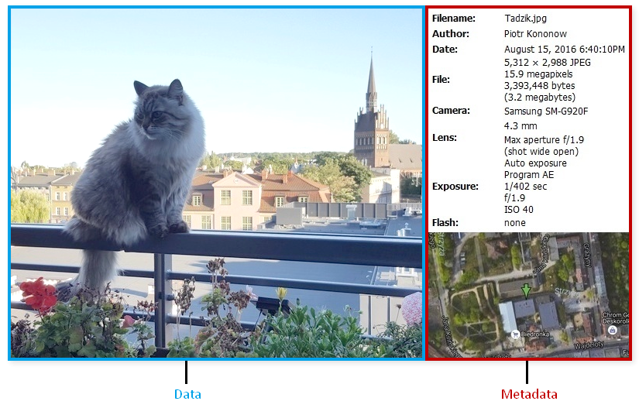

* You may store the meta-data in relational databases.

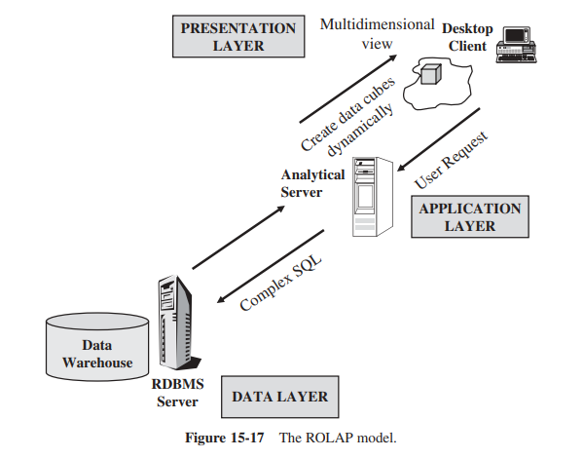

**Three distinct characteristics of ROLAP**

Unlike the MOLAP model, static multidimensional structures are not created and stored.

True ROLAP has three distinct characteristics:

† Supports all the basic OLAP features and functions discussed earlier

† Stores data in a relational form

† Supports some form of aggregation

**Local hypercubing is a variation of ROLAP provided by vendors**

This is how it works:

1 The user issues a query.

2 The results of the query get stored in a small, local, multidimensional database.

3 The user performs analysis against this local database.

4 If additional data is required to continue the analysis, the user issues another query and

the analysis continues.

**Advantages**

* + handle the large amount of data.
  + **Hiệu quả dữ liệu cao.**Nó mang lại hiệu quả dữ liệu cao vì hiệu suất truy vấn và ngôn ngữ truy cập được tối ưu hóa đặc biệt cho phân tích dữ liệu đa chiều
  + Full security and administration is provided through RDBMS
  + Data can be stored efficiently
  + can leverage functionalities inherent in the relational database

**Disadvantages**

* Performance can be slow
* Limited by SQL functionality.
* Hard to maintain aggregate tables in the data warehouse.

