**USER GUIDE FOR FILLING QUESTIONS AND ANSWERS TO SOLVE AN EXAM**

1. Filling Subject

You fill your subject you want to solve in mouse click like the picture below :



Example:



1. Filling Number Of Question

Fill in your **Number of questions** in your exam test like the picture below:



1. Filling Your First Question

The first question format should be like the picture following:

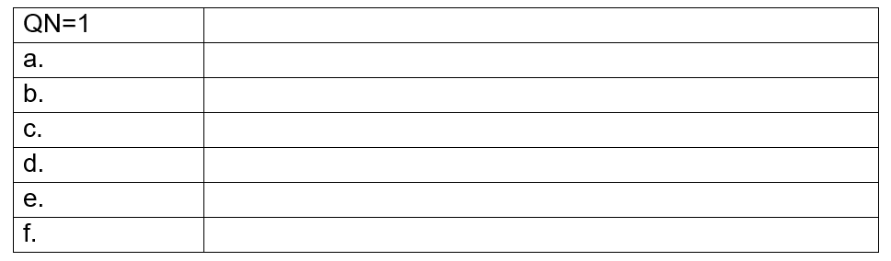

**Step 1**: Fill Question Content

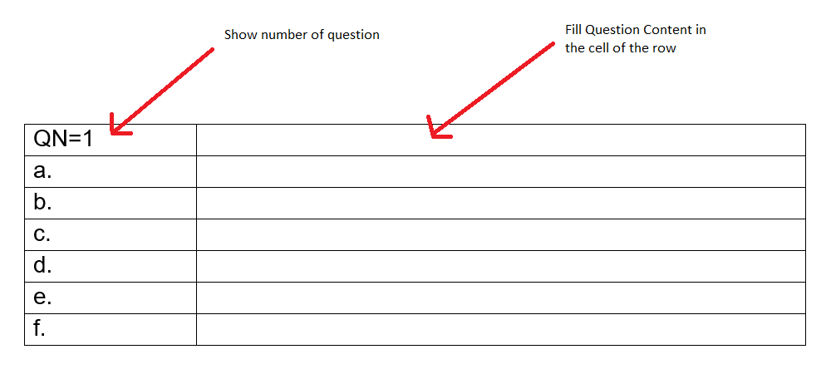

Example:

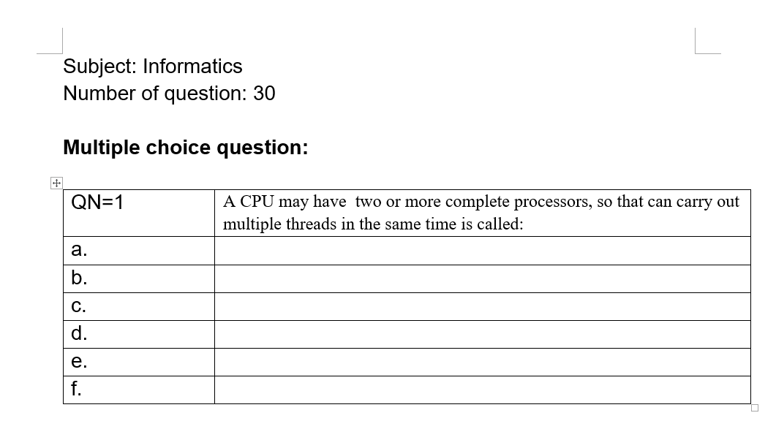

Step 2: Fill your Answer Content

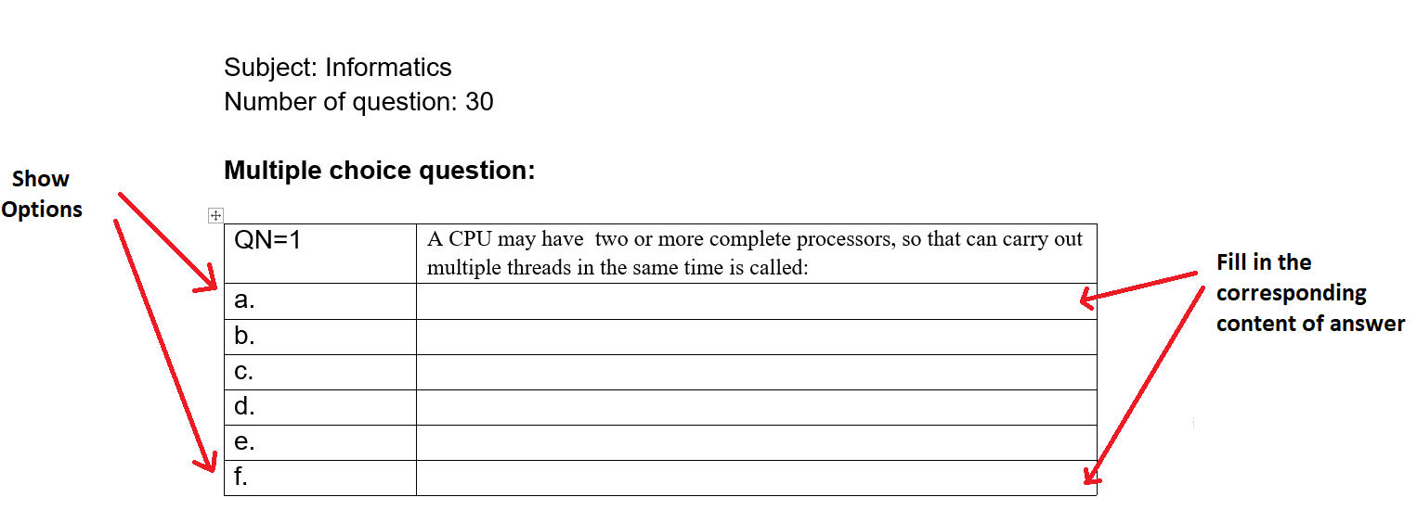

Example:  
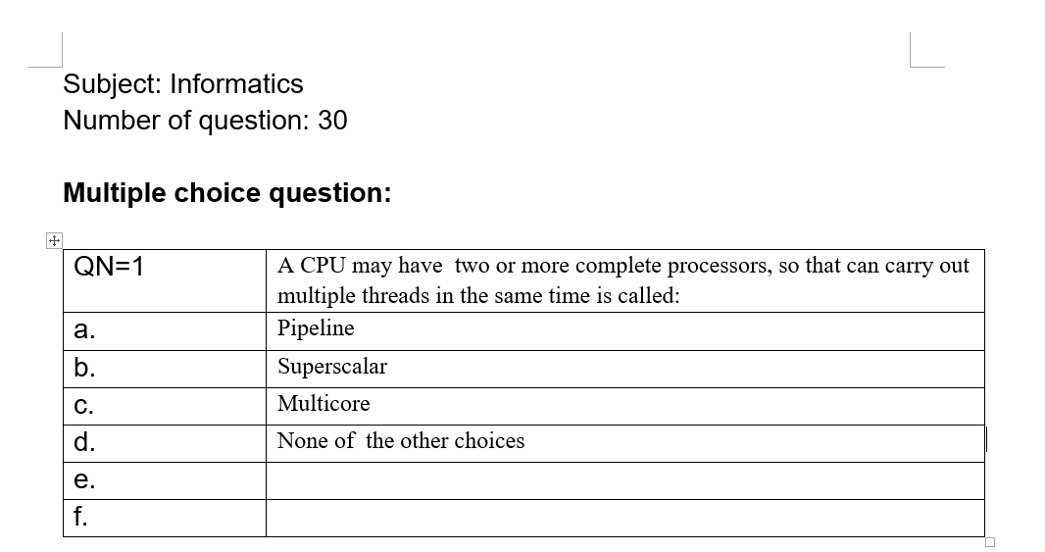

**NOTE:**  If you **don’t have** option **e.** or **f.** you let it empty, or **you have more options,** you insert more rows and push option letter and content like this :

Right mouse click in the table:

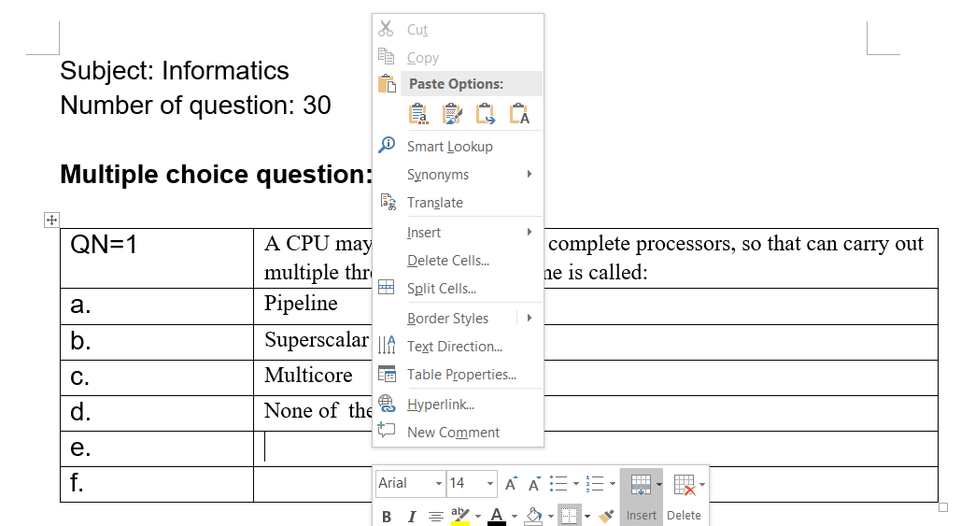

Click insert has already bold

Click Insert Below:

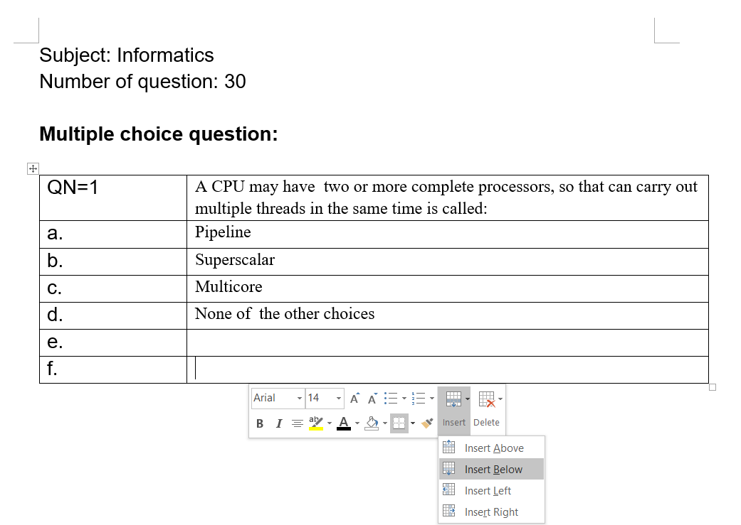

And push more options and content of your question:

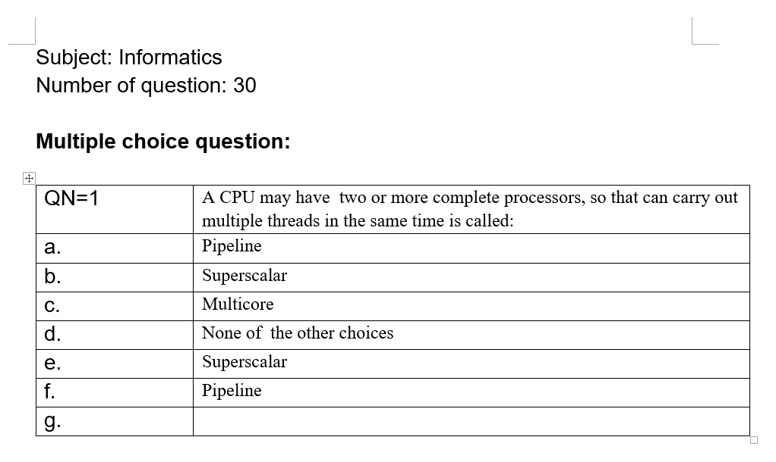

**FOR MORE QUESTIONS, YOU CAN DO AS FOLLOWING:**

1. Blackout the board with the mouse and right-click in the table:

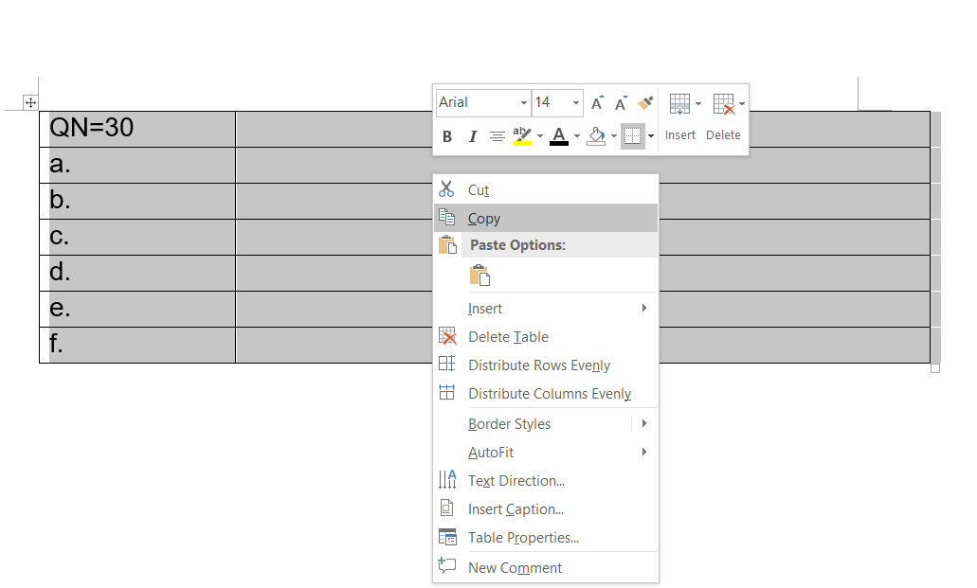

1. Choose Copy -> Click Below to enter a new line, and press Ctrl + V. You will have a new table like below:

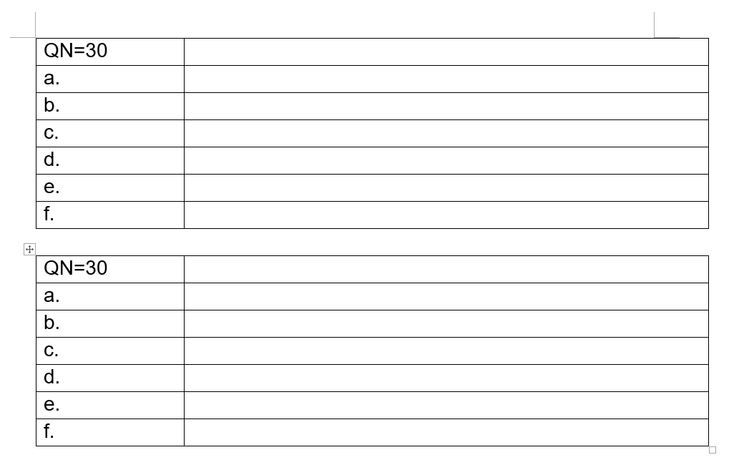

1. Change your Number of questions:

