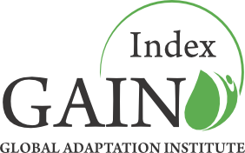

2012 consultation process:

Summary of changes and Feedback

*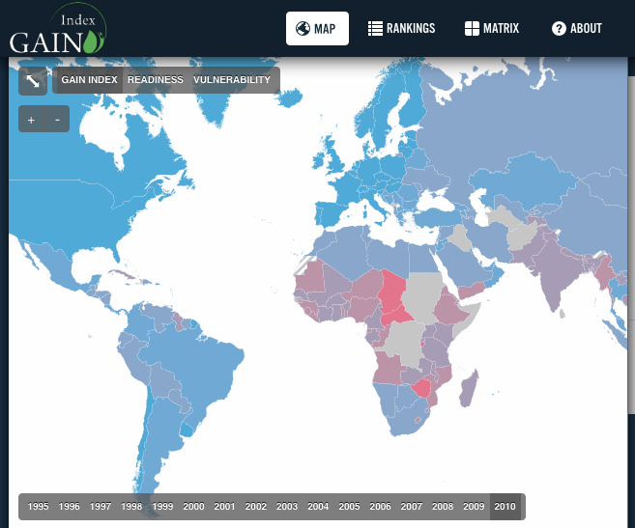*

*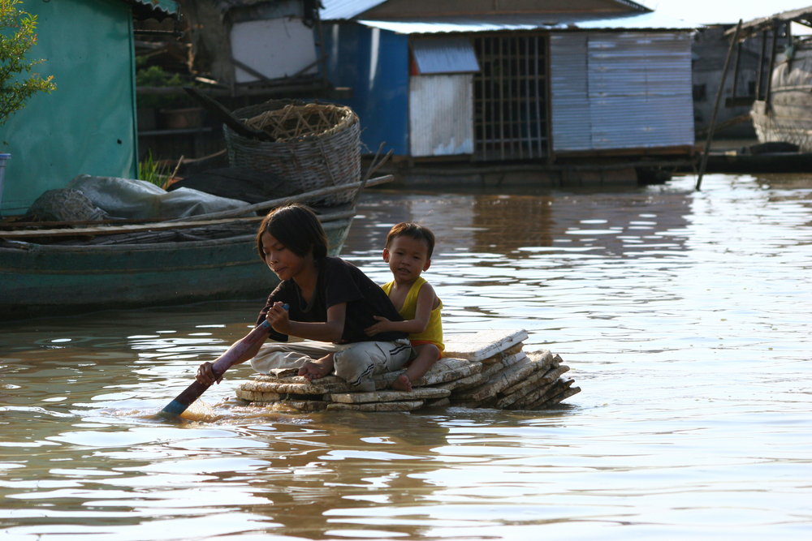*

Building resilience to climate change and other global forces.

Table of Contents

GAIN Advisory Council 3

Council of Scientific Advisors 4

GAIN Staff 5

Mission for the Index 6

What Makes The GAIN Index Unique? 6

The consultation process 7

Summary of 2012 Changes 8

Feedback: Year 1 8

GAIN Index Website Analytics 8

Presentations 11

Email and Personal Feedback 12

GAIN Index 2012 12

Changes in the code 13

Re-sourced data 13

Tolerance for Missing Numbers 13

Preliminary Ranking 14

Differences in the Score for 2010 15

GAIN 2012 Additional Measures 16

Specific Open Issues 16

Website update-upgrade 16

Readiness Axis 16

Complementary Activities of the Institute 17

# 

## GAIN Advisory Council

**The Honorable José María Aznar**

Chairman of the Advisory Council,

Global Adaptation Institute

Mr. Aznar is the former President

of Spain (1996-2004)

**Anthony Morris**

Founder, The Morris Company

**Ana Palacio**

Foreign Minister of Spain (2002-2004)

**Jorge Quiroga**

President of Bolivia (2001-2002)

Vice President of Bolivia (1997-2001)

**Andreas Widmer**

Co-Founder, Seven Fund

## Council of Scientific Advisors

# 

## GAIN Staff

# **Dr. Ian Noble** Chief Scientist

# **Tim Wierzbicki** Vice President of Development

# **Jessica Siegel** Vice President of Finance & Administration

# **Dr. Bruno Sanchez-Andrade Nuño** Director of Science & Technology

# **Jamie Carson** Director of Communications

# **Carmen Tobar** Senior Advisor

# **Davis Cherry** Development & Communications Associate

# **Mission for the Index**

*The world is changing in many ways. Population growth continues to drive global change. Population shifts are driving things even more. Urbanization in an enormous factor in any country in the world at the moment, in many developing countries, it is the primary factor driving things there.*

*On top of this, we have to cope with a changing climate. This means, that for many people, the past is no longer a good guide to the future. Things are changing.*

Dr. Ian Noble

Chief Scientist, GAIN

Adaptation is an imperative. The world is changing fast. Countries are being challenged to prepare for and, if possible, minimize the effects of climate change. The challenge will only be greater as populations and economies grow. People around the world experienced a variety of sudden as well as gradual disasters in 2012. From a record-breaking draught in the United States to unprecedented flooding in Thailand, governments, businesses and communities had to grapple with massive losses stemming from the inability of the affected agricultural, energy, water and urban systems to cope with these changes.

These events forced the world to reflect on how to deal with increasing disasters. Meanshwile, the Global Adapation Institute (GAIN) has been busy consulting with government, business, academic and civil society leaders around the world on how to measure and improve all societies' ability to adapt to the global forces of climate change, population and economic growth, and urbanization.

Since its release September 14, 2011, we have presented the GAIN Index to audiences on six continents and more than two-dozen think tanks, governmental bodies and businesses.

We are now preparing the first update of the Index. This document summarized the most important changes and lessons learned since launch, as well as some open Questions.

## What Makes The GAIN Index Unique?

The GAIN Index is not the first attempt at measuring the vulnerabilities of countries to climate change and other global forces. Scientists and institutions around the world have conducted significant work throughout the last decade, many listed in the Reference section of this report. The GAIN Index seeks to build upon this previous work by creating an index that promotes pragmatic action among governments, the private sector and NGOs and uniquely combines the concepts of vulnerability with readiness to drive action. Further, the index:

* Is open and transparent¬ – All indicators and sources are readily available and easily accessible to the public.
* Brings the private sector to the table – Most indices focus solely on the vulnerabilities of countries; the GAIN Index includes indicators that guide governments and communities in how to prioritize action and harness the power of the private sector.
* Focuses on sectors crucial to human wellbeing – The GAIN Index does not cover all aspects of vulnerability, but targets those sectors most important to human health and prosperity that also can be greatly improved by innovation.
* Tracks changes in countries’ vulnerability and readiness from 1995 to present
* The GAIN Index has a simple but effective structure that allows for expansion of its coverage and the substitution of better indicators as they become available.
* Is politically neutral – A tool for both pragmatic policy makers and business people.

# The consultation process

GAIN solicits input from various stakeholder groups working on Adaptation – private sector companies, scientists, governments, international organizations, NGOs, and others. This is accomplished through various mechanisms, such as this consultation, presentations throughout the year and via web analytics and email support. You can consult our White Paper from last year in the attached document or at [index.gain.org/about](http://index.gain.org/about" \t "_blank).

The purpose of this consultation is to assist GAIN in making the Index as effective as possible. These reviews not only fulfill GAIN's institutional priority to be open, transparent and pragmatic, but also provides us with preliminary reactions from a diverse group of users and experts and, as a result, enhances the clarity, practicality, and credibility of the final Index.

We ask reviewers to consider whether, in their judgment, the arguments and decisions presented are sound and the Index is responsive to its stated goals and the Feedback received, not if reviewers concur with the findings.

The content of the comments are registered online, together with our response. This helps us build a continuous open process of improvement. To encourage reviewers to express their views freely, reviews can be confidential and won't be published. The list of names and affiliations of participants in the review will be made public when the Index is released, but comment authorship will remain confidential.

With the consultation process we aim to answer these questions:

1. Is the goal of the Index clearly described? Is the Index responsive to these goals?
2. Are the metric framework decisions and consequences adequately documented, supported and explained?
3. Are uncertainties or incompleteness recognized and addressed for future work?
4. Are the data and analyses handled competently? Are statistical methods applied appropriately?
5. Is the Index fair? Is it impartial and fact based?
6. What other significant improvements might be made in the Index?

# **Summary of 2012 Changes**

The GAIN Index methodology and framework has remained unmodified since late August 2011. For the 2012 release GAIN has concentrated on a complete internal audit, fixing “bugs” and also supporting users of the index and gathering user feedback. Communications and fundraising around the index were also important focuses of GAIN. Following the recommendations from last year, GAIN has drafted additions to the index (indicators that measure ecosystem services and urban resilience). GAIN is also considering improving the Readiness Axis, but not for the 2012 release.

## Feedback: Year 1

### GAIN Index Website Analytics

Embedded within the Index website is a Google Analytics tracking code, which provides a lower estimate[[1]](#footnote-1) for visits, and includes important information such as e.g. navigation flow, time per visit or source of the visit. Visits from inside the Institute´s IP network are not counted.

Analytics for the GAIN Index web site during the last year (from the Sept. 14, 2011 launch until July 24, 2012) include:

* 85,463 Page Views, with an average visit duration of four minutes and twenty-one seconds per visit.
* 2.90 Page Views per visit, approximately 30.000 visits, of which at least 20.000, are unique visitors.

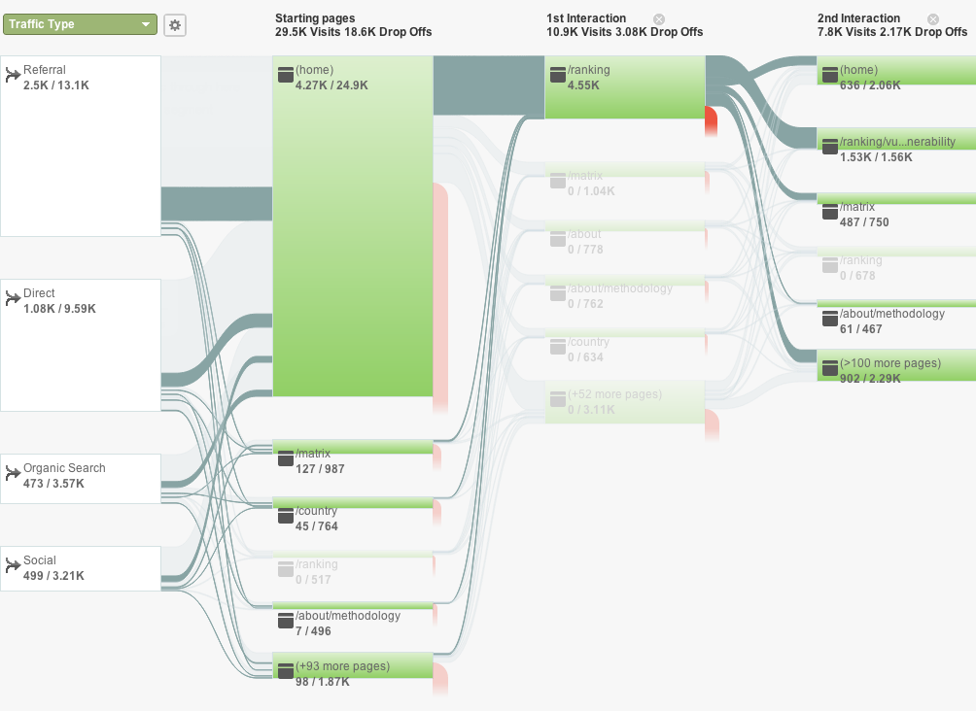

Figure . Visitor flow. From left to right, the first column is the breakdown by entry type (referral, direct, organic or from social networks), the following breaks down the pages visited. Lines between columns connect visitors to create the thread of usage. Red lines represent dropouts, or the end of the visit. The highlighted connecting path corresponds to those users who visit the Ranking page on their first interaction on the site. Numbers below each green block correspond to visits towards this highlighted path, versus total views.

From the visitor flow graph, we can read that the home page is the most visited page, and the biggest attractor is the Rankings page.

Removing the month of the launch, with a peak of 12.000 pageviews following the launch event, the baseline is roughly 1,000 pageviews/week with returning visitors representing a steady 50% of visits per week.

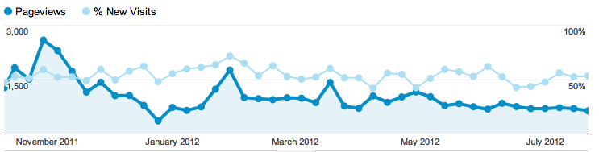

Figure . Timeline of pageviews per week from October 2011 to July 2012 in dark blue, and faint blue for the percentage of new versus returning visitor.

Figure . Breakdown of pageviews on index.gain.org from Sep 2011 to July 2012.

Most of the views are of the front page, which is also the most common landing page, as we can also see on the flow chart. The GAIN Index Rankings page is the second most visited (12%), which confirms its importance (i.e. users are twice as interested in viewing the Rankings compared to the Methodology (5%).

Figure . Top 6 traffic sources for index.gain.org from Sep 2011 to July 2012. The green section [gain.org / globalai.org] corresponds to the Institute´s page

Half of the traffic is *direct*, meaning visitors with an unkown source (typing the url address, bookmarks or some email clients). *Organic* sources (people searching related keywords in search engines like Google) are steady around 17%. Interestingly, two high-traffic websites alone have provided more inbound links than the organic search traffic.

Regarding search terms, the list includes obvious search terms such us “Global Adaptation Index”, “GAIN Index.” Other common entry keywords include terms such as “Adaptation Index” (the 9th most common entry keyword — the GAIN Index is the first page to show up in Google for that search query).

Some country specific profile pages are all in the top 100 search terms as well. These include Chad, the 10th most searched term, Mongolia, the 28th most common entry point via keywords, as well as Denmark, Australia and the USA.

Thus, most common pathway is a referral to the front page, where the user is lead to the Rankings. The Matrix page is the second most common landing page, but with far fewer visits than the home page. Interestingly the Matrix is the most interesting part in our presentations, but it seems to be not properly captured or utilized on the layout of the website.

### Presentations

Given the focus on expanding the user base for the index, GAIN staff have been active in making presentations to a wide range of companies, consultancies, think-tanks, government and non-government institutions, and technical forums. This is a short Summary of some of the presentations GAIN has made since September 2011.

* Presentation with Calvert Investments, September 16, 2011, Bethesda, Maryland
* Panel discussion, *Rethinking Resiliency*, during NYC Climate week, September 21, 2011
* European Ideas Network in Bucharest, Romania, September 22, 2011
* Inter-American Development Bank, October 7, 2011, Washington, DC
* GAIN Index presentation, Tecnológico de Monterrey webcast throughout Latin America, November 3, 2011
* Carnegie Moscow Center, Carnegie Endowment for International Peace, Moscow, November 9, 2011
* GAIN Index Presentation to Latin American Ambassadors to the U.S., November 15, 2011
* Presentation to the UNFCCC Secretariat, Bonn Germany, November 15, 2011
* Meeting of international vulnerability experts, “Workshop on Vulnerability Indices,” Paris France, November 16, 2011
* World Bank, Asian Regions Experts, November 18, 2011
* Virtual Presentation to PepsiCo, Mexico, November 22, 2011
* Presentation to Caribbean Ambassadors to the U.S., OEA, Washington, DC, November 22, 2011
* Presentation to GRULA Ambassadors, Washington, DC, November 22, 2011
* *COP 17, UNFCCC climate negotiations* GAIN Index discussion, Durban, South Africa
* American University, November 30, 2011
* Presentation at IFC, January 27, 2012, Washington, DC
* *Is Latin America Ready to Cope with Climate Change? A Discussion of the Global Adaptation Index*, Inter-American Dialogue, Washington, DC, March 20, 2012
* *Engineers Without Borders-USA, Annual Meeting*, Henderson, Nevada, March 22, 2012
* *A Conversation on the Future of Central America*, Brookings Institution, Washington, DC, March 29, 2012
* *World Economic Forum on Latin America*, Puerto Vallarta, Mexico, April 16-18,
* *GAIN Annual Meeting & Scientific Convening*, Washington, DC, May 9 & 10
* *RIO + 20, UN Global Sustainability Conference*, Rio de Janeiro, June 20, 2012
* *USAID, July, 2012*
* *State Department,* Office of Global Change, August, 2012

The Index also featured in a number of technical presentations dealing more broadly with the application of indices in adaptation planning, including meetings in Bonn, Tucson and Melbourne. A partial list of events can also be found here: <http://news.gain.org/tagged/events>

The Index website source files and instructions for local deployment are available here:

<https://github.com/globalai/Index-site/tags>

### Email and Personal Feedback

We have compiled a list of ~40 Issues; i.e. questions from users at our presentations or via email regarding definitions, data sources, problems, data gaps, criteria and others. The list is available online at: <https://github.com/globalai/GaIn-Index/issues>. We are also listing how GAIN has resolved or intends to address the Issue (14 of those Issues are already fixed/closed).

## GAIN Index 2012

The Gain Index 2012 draws most of its structure on the GAIN Index last year ( i.e. the one currently available at <index.gain.org>). The code, files and data that create the Index are available here:

<https://github.com/globalai/GaIn-Index/>

The proposed Gain Index 2012 reflects these main improvements:

* Data is updated from its sources to include new information arising in the past year.
* The index code has been internally audited to ensure consistent results.
* More countries are included in the index.
* Re-sourcing of the data from its sources has transformed some static measures into dynamic data. (i.e. we have new temporal data)

### Changes in the code

The code has been completely reworked through an internal audit process. The conceptual framework of the index remains the same, but a new computational approach was developed separate from the original code. All identified bugs in the code have been fixed, as reflected in the online issue tracker (<https://github.com/globalai/GaIn-Index/issues> ) . The parameters for the framework (such as thresholds for each measure) remain the same.

The code is written in Microsoft Visual Basic. It is available as a Macro under file Main.xls and also periodically copied here: <https://github.com/globalai/GaIn-Index/blob/master/GAIN-main-code.vb>



### Re-sourced data

We have run comparisons of the input data (“Raw0”) used for the GAIN Index 2011 and the re-sourced data for the GAIN Index 2012. In most cases we find none to few minor differences — no more than 5% of the numbers differ more than 10%. In three cases, however, differences were significant (we are investigating this issue):

* *Agricultural Malnutrition* - Significant difference in about 50% of the data points were noted and traced to the use of data from an earlier attempt to derive information on malnutrition rather than from the WDI data as stated in the documentation.  This has now been corrected.
* *World Development Indicators* - There are differences scattered according to countries and year. Up to 40% of numbers differ 10% or more. Up to 10% differ more than 50%.
* *Agricultural Capacity* - these numbers are also off. Re-sourced data has scattered differences.

### Tolerance for Missing Numbers

Whenever a measure is not available for a particular year GAIN uses a standard algorithm to interpolate linearly and/or extrapolate with constant value. If no data are available for a country, the measure is dropped for that country.

While developing the 2011 index, our analysis showed[[2]](#footnote-2) that a country could have up to a third of its measures missing and still reflect a reasonable estimate of its vulnerability and readiness in the GAIN Index. In the 2012 index a quarter to a third of a country's measures are allowed to be missing for any component of the Index before dropping its score from the Ranking. In such cases the normalization process only considers the available number of measures. This leads to the following tolerance table:

|  |  |  |
| --- | --- | --- |
|  | Components | **at least** |
| Water | 6 | 4 |
| Food | 6 | 4 |
| Health | 6 | 4 |
| Infrastructure | 6 | 4 |
| Exposure | 9 | 7 |
| Sensitivity | 9 | 7 |
| Capacity | 6 | 4 |
| Economic | 7 | 5 |
| Governance | 3 | 2 |
| Social | 4 | 3 |
| Vulnerability | 24 | 18 |
| Readiness | 14 | 10 |
| **GAIN Index** | 38 | 28 |

Table . Tolerance for missing Indicators for each partial Score. The middle column reflect the number of measures that integrate each Sector, and the thrid column the number of measures that can be missing before dropping its score.

### Preliminary Ranking

The list below shows the rankings of the top 20 countries according to the:

1) GAIN Index 2011;

2) the new Ranking with the new code[[3]](#footnote-3), for 2010; and

3) the new Ranking with the new code for 2011.

(see file *gain2012update-draft.xls* with all countries and scores)

|  |  |  |  |  |  |  |
| --- | --- | --- | --- | --- | --- | --- |
|  | “GAIN 2011” | | “Gain 2012” | | | |
| RANK | Country | 2010 | Country | 2010 | Country | 2011 |
| 1 | Denmark | 85.36 | Denmark | 84.84 | Denmark | 84.76 |
| 2 | Switzerland | 83.59 | Australia | 83.91 | Australia | 84.39 |
| 3 | Ireland | 82.24 | Norway | 81.97 | Norway | 82.18 |
| 4 | Australia | 82.03 | Switzerland | 81.01 | Switzerland | 81.56 |
| 5 | N. Zealand | 81.70 | Finland | 80.49 | Finland | 80.92 |
| 6 | Finland | 81.65 | N. Zealand | 79.99 | Ireland | 80.25 |
| 7 | Norway | 81.41 | Ireland | 79.79 | N. Zealand | 80.26 |
| 8 | USA | 80.01 | Austria | 79.26 | Austria | 79.70 |
| 9 | Germany | 79.98 | UK | 78.85 | UK | 78.92 |
| 10 | UK | 79.96 | Sweden | 77.65 | Sweden | 78.05 |
| 11 | Sweden | 79.75 | Singapore | 77.51 | Singapore | 77.74 |
| 12 | Czech R. | 79.70 | USA | 77.30 | Germany | 77.58 |
| 13 | Austria | 79.54 | Germany | 77.15 | USA | 77.63 |
| 14 | Netherlands | 79.21 | Chile | 76.74 | Romania | 77.20 |
| 15 | Iceland | 78.72 | Czech R. | 76.73 | Czech R. | 77.36 |
| 16 | France | 78.71 | Slovakia | 76.46 | Slovakia | 77.26 |
| 17 | Luxembourg | 78.53 | France | 76.31 | Chile | 76.53 |
| 18 | Poland | 78.23 | Iceland | 76.10 | Slovenia | 76.18 |
| 19 | Canada | 78.15 | Canada | 75.91 | France | 76.16 |
| 20 | Chile | 77.74 | Romania | 75.89 | Uruguay | 77.37 |

### Differences in the Score for 2010

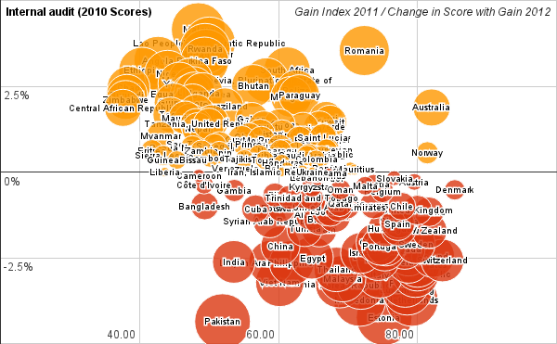

Figure Differences in Score between “Gain 2011” and “Gain 2012” without the additional measures for better comparison. Horizontal axis is the “Gain 2011 Legacy” Score. Vertical Axis, and bubble size is the percentage change in Scores compared to “Gain 2012 Update”. Negative numbers (and red color) indicate less Score in the updated version.

The median change in scores is 0.10% (min -4.36%, max 4.15%). Several sources of these differences have been identified:

* Agricultural Capacity composite measure; we are investigating the issue.
* Re-sourcing of some of the measures includes updated or revised numbers and sometimes more data points, which means more countries can be included and less interpolation for existing countries.
* Fixing bugs such as an error that allocated 0 vulnerability in Water Capacity to some countries.
* A slightly different, more consistent approach dealing with missing numbers.

We are still tracing the sources of the biggest differences to make sure the origin of these changes is known referenced, and understood.

### GAIN 2012 Additional Measures

Following the Feedback received throughout the year, we are adding 2 additional measures for the Vulnerability Axis (Ecosystems and Urban). Please see the Technical Description of the new Measures for Ecosystem Services and Urban Infrastructure.

## Specific Open Issues

### Website update-upgrade

There are significant improvements suggested by the users for the website. Some are feasible as additions to the current website framework, some are more suitable as an Excel file.

Some proposed website changes:

* Consistent use of matrix quadrant colors in maps.
* Improve the selection of similar countries for that tab by considering not only the overall score, but also neighboring countries, income group, etc.
* Add an ability to compare countries/sectors.
* Disaggregate dots in Matrix according to sectors. This means the ability to place in the matrix the different components of each Axis (Exposure, Food, Economic, …)
* Filter countries by range of scores in selected sectors.
* Present histogram of values for Measures, to have an idea of the global spread of values.
* Resolve Rank ties within the chosen uncertainty in scores. In the current Ranking we only count one decimal point. New Zealand (5th in the ranking) and Finland (6th ) both have Score 81.7. Finland would then be tied in 5th position, and Norway will keep it´s Rank (7th).

*Excel Version*: We are considering preparing a version of the Index in Excel format with more comparators and tools for advanced users.

### Readiness Axis

We also recognize the importance of revisiting the Readiness Axis. Feedback received in this regard suggests several directions to investigate. For example, a Readiness Structure separating *Policies* and *Outcomes*. In combination with the 3 current sectors (Economic, Government and Social) this would create a conceptual matrix similar to the Vulnerability Axis. There is also an Issue on how to treat and distinguish Adaptation Capacity (currently part of the Vulnerability Score) and some components of Readiness.

We need to explore all these possibilities, but we have decided to focus on the priorities listed in this document for the GAIN Index 2012.

## Complementary Activities of the Institute

[Davis, this is a section tu summarize our work in Mexico, Proposals, Prizes, … nothing too long]

1. Google Analytics uses JavaScript, which is not present, or blocked, in some computers. E.g. the estimation for these non-tracked cases in the US is around 3% of all Internet users. More information at: en.wikipedia.org/wiki/Google\_Analytics [↑](#footnote-ref-1)
2. See Figure 4 on Technical Document on Vulnerability Variables from last year. [↑](#footnote-ref-2)
3. Note, the “GAIN 2012 Update” does not include new Ecosystem Services and Urban indicators, described later in this document. We were also able to include more countries in the “GAIN Index 2012 Update”. [↑](#footnote-ref-3)