CS3343 Project Report: Online Second-hand Trade System
1. INTRODUCTION
1.1. PURPOSE
The primary purpose of this project report is to document the complete software development lifecycle of the Online Second-hand Trade System. This system is designed to provide a centralized, secure, and user-friendly platform for university students to trade idle items.
Specifically, this report aims to:
1. Outline the development process: From initial requirement analysis to final system testing, adhering to the MVC (Model-View-Controller) architectural pattern.
2. Detail technical implementation: Describe the use of Java 23 and SQLite to build a robust desktop application that operates without complex server infrastructure.
3. Demonstrate system reliability: Present the functional capabilities (e.g., secure transactions, real-time messaging) and non-functional attributes (e.g., compatibility across Windows, Mac, and Linux).
4. Serve as a user manual and maintenance guide: Providing future developers and stakeholders with a clear understanding of the system's internal logic and database structure.
1.2. PROJECT BACKGROUND
In the modern university environment, students often face a common dilemma: the accumulation of idle items (such as textbooks, electronics, and furniture) that are still in good condition but no longer needed. Conversely, many students operate on a tight budget and are constantly looking for affordable alternatives to new products.
The Problem:
- Inefficiency: Traditional methods of trading (e.g., bulletin boards, scattered social media posts) are disorganized and time-consuming.
- Safety Concerns: Informal trading lacks a structured verification process, leading to potential scams or unreliable transactions.
- Waste: Without an easy channel for resale, many usable items end up being discarded, contributing to environmental waste.
The Solution: To address these issues, our team (Group 11) developed the Online Second-hand Trade System.
- Resource Optimization: By facilitating the circulation of second-hand goods, the system helps students save money and promotes an eco-friendly lifestyle by reducing waste.
- Structured Trading: Unlike chaotic social media threads, our system offers a dedicated "Order Lifecycle" (Pending -> Paid -> Shipped -> Completed), ensuring that every step of the transaction is tracked and secure.
- Community Trust: With features like "User Reviews" and "Identity Verification" (via login roles), the system builds a trusted community environment specifically tailored for campus needs.
This project not only solves a practical logistical problem for students but also serves as a comprehensive practice of software engineering principles, integrating database management, UI/UX design, and object-oriented programming.

2. PROJECT PLAN
2.1. PROJECT OBJECTIVES
The primary objective of this project is to develop a desktop-based "Online Second-hand Trade System" that facilitates the buying and selling of idle items among university students.
The key objectives are summarized as follows:
- Functionality: To provide a complete trading lifecycle, including item posting, searching, ordering, and reviewing.
- Reliability: To ensure data consistency and secure transactions using a local database (SQLite).
- Usability: To create a user-friendly interface that allows users to complete a transaction within minutes.
- Maintainability: To implement a clean MVC architecture that allows for future feature expansion.
2.2. CONSTRAINTS & BOUNDARIES
The project is developed under the following constraints:
- Time Constraint: The project must be completed within the semester timeframe (approx. 13 weeks).
- Technical Constraint: The system must be developed using Java 23 and JavaFX for the GUI.
- Platform Constraint: The application must be cross-platform compatible (Windows, macOS, Linux).
- Data Storage: Due to the absence of a dedicated cloud server, all data must be stored locally using SQLite, which limits real-time synchronization across different devices but simplifies deployment.
2.3. PROJECT ORGANIZATION
Our team consists of four members, each with a specialized role to ensure efficient development.
- (建议在此处插入 PDF 第 3 页的 "OUR TEAM MEMBERS" 截图)
- FU Qianli (Project Manager & System Architect): Responsible for overall system architecture design and project management.
- LI Yuan (Frontend Engineer & UI Designer): Responsible for designing responsive UIs and implementing modern visual interactions.
- LI Yuyang (Backend Engineer & Database Operator): Responsible for database schema design, API development, and system architecture implementation.
- LIU Yuchuan (QA Tester & Documentation): Responsible for testing, debugging, and maintaining project documentation.
2.4. PROJECT STAKEHOLDERS
- End Users (Students): The primary users who will buy and sell items on the platform.
- Administrators: Users with special privileges to manage user accounts (e.g., banning users) and oversee system health.
- Development Team (Group 11): Responsible for the design, implementation, and maintenance of the system.
- Course Instructors: The evaluators of the project deliverables.
2.5. WORK BREAKDOWN STRUCTURE (WBS)
The project is divided into four main phases:
1. Requirement Analysis: Defining functional and non-functional requirements.
2. System Design: Designing the database schema (ER Diagram) and UI wireframes.
3. Implementation:
- Backend: Implementing Service and DAO layers (User, Item, Order modules).
- Frontend: Developing FXML views and Controller logic.
4. Testing & Deployment: Conducting Unit Tests and Integration Tests, followed by final packaging.
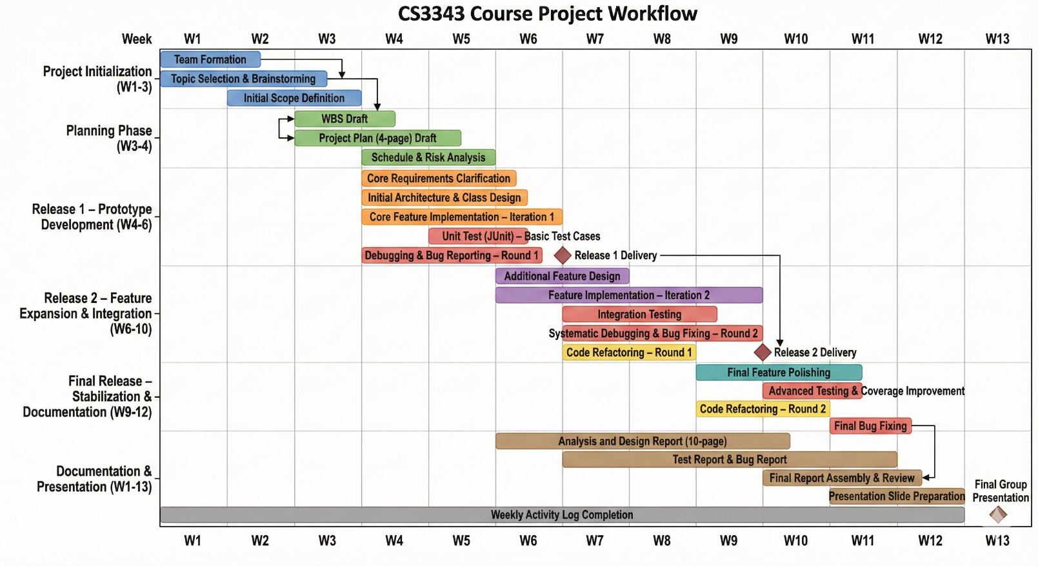
2.6. GANTT CHART

2.8. SCHEDULE
- Week 1-3: Requirement gathering and feasibility study.
- Week 4-6: Database design and UI prototyping.
- Week 7-10: Core development (Authentication, Item Listing, Order Processing).
- Week 11-12: Testing (Unit Test & System Test) and Bug fixing.
- Week 13: Final report writing and presentation preparation.
2.9. SOFTWARE DEVELOPMENT METHODOLOGY
We adopted an Agile-like methodology combined with the Waterfall model's structure.
- Iterative Development: We developed the system module by module (e.g., finishing the User module before moving to the Order module).
- Regular Meetings: The team held weekly meetings to synchronize progress and resolve blockers.
- Version Control: We used Git for collaborative coding and version management.
2.10. SOFTWARE CONFIGURATION
- Operating System: Windows 10/11, macOS, Linux.
- Development Kit: JDK 23.
- Database: SQLite (Version 3.x).
- Build Tool: Maven (for dependency management).
- IDE: IntelliJ IDEA / Eclipse.
2.11. USE OF TECHNOLOGIES AND PLATFORMS
The system is built upon a robust technology stack designed for maintainability and performance.
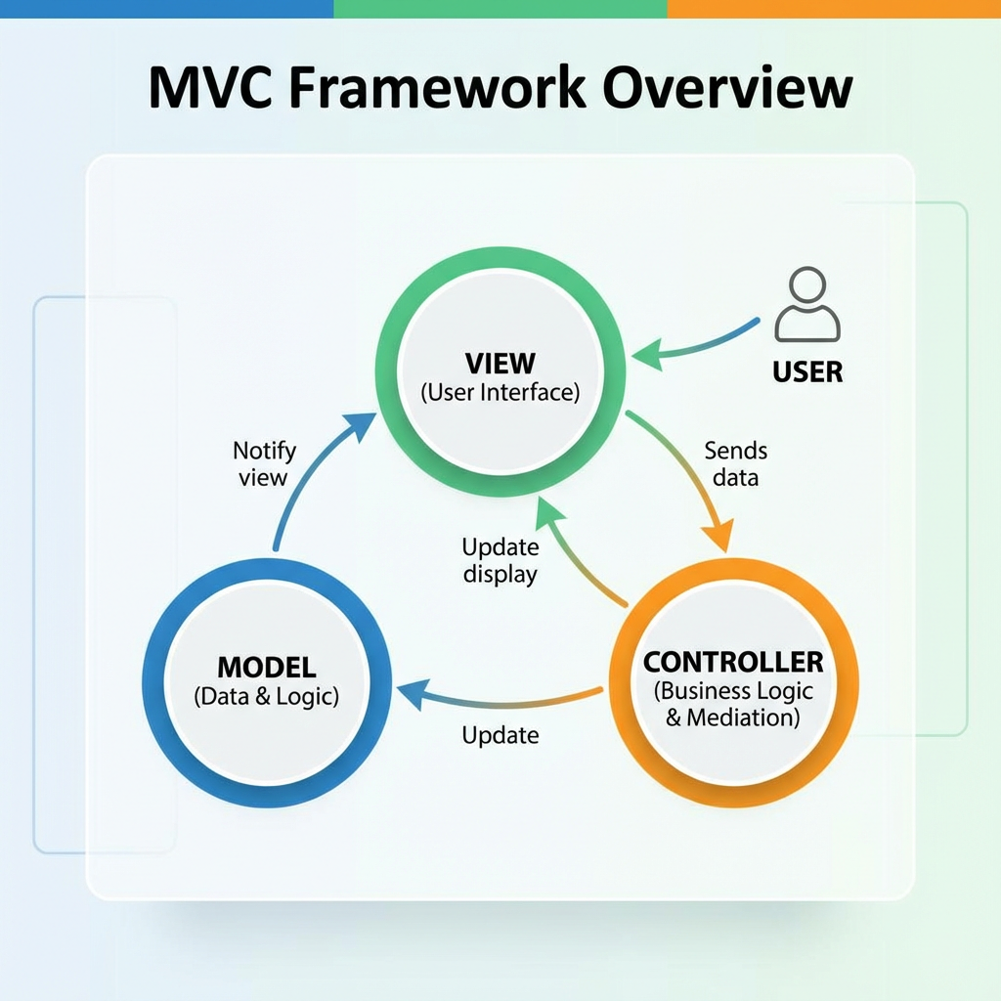

- Programming Language: Java 23. We chose the latest Java version to leverage its strong Object-Oriented Programming (OOP) features and modern syntax improvements.
- GUI Framework: JavaFX. Used for building rich client applications with separation of presentation (FXML) and logic (Controller).
- Database: SQLite. A self-contained, serverless SQL database engine. It was chosen for its simplicity and zero-configuration requirement, making it ideal for a desktop application.
- Architecture Pattern: MVC (Model-View-Controller).
- Model: Represents data and business logic (e.g., User.java, UserService.java).
- View: Represents the UI components (.fxml files).
- Controller: Handles user input and updates the model (LoginController.java).
3. ANALYSIS (系统分析与设计)
3.1. DESIGN CONSTRAINTS
- 系统必须支持 MVC 分层架构，确保代码的解耦和灵活性 (Flexible)。
3.2. CLASS DIAGRAM
Given the substantial size and complexity of the class diagram, first presents an overview of the overall project architecture below.
Fig.4 project architecture overview

Subsequently, the class diagrams for each layout within the overall project are presented below: the module layout, the service layout, and the view-controller layout.

Fig.5 module layout
Fig.6 service layout
Fig.7 view-controller layout
3.3. SEQUENCE DIAGRAM (时序图)
- (选取一个核心功能，如 "User Buying an Item" 或 "Login"，绘制时序图)。
3.4. DESIGN PATTERN (设计模式)
- MVC (Model-View-Controller) - 核心模式：
- Model: 处理数据逻辑 (User info, Item info)，与 Database/DAO 交互。
- View: 处理 UI 显示 (FXML/CSS)，用户看到的界面。
- Controller: 连接 Model 和 View，处理用户点击和输入逻辑。
- (PDF Page 4 详细描述了你们的 MVC 实现机制)。

4. TEST PLAN (测试计划)
4.1. TESTING MODULE HIERARCHY
- Authentication Module (Login/Signup)
- Transaction Module (Buy/Sell)
- Social Module (Chat/Review)
4.2. TEST PLAN DESCRIPTION
- 由 QA Tester (LIU Yuchuan) 执行，确保功能符合 Non-Functional Requirements (Fast, Safe, Easy)。
4.3. UNIT TEST
- 测试独立的 Model 类（如测试 User 类的数据存取是否正常）。
4.4. INTEGRATION TEST
- 测试 Controller 与 View 的交互（如点击按钮后是否正确跳转页面）。
4.5. SYSTEM TEST
- 完整流程测试（从注册账号到完成一笔交易的全过程）。
5. BUG REPORT (Bug 报告)
- (记录开发过程中遇到的主要 Bug 及其解决方案)
- 例如：SQLite 连接锁死问题、JavaFX 界面刷新延迟问题等。

6. BUG REPORT (Bug 报告)

Second-hand online trading system
Progress Report

Group 11
LI Yuyang(58521324), LI Yuan(58521312),FU Qianli(57126013)
Date: 6/12/2025

Table of Contents
1. INTRODUCTION
1.1 Project background
1.2 Purpose
2. PROJECT PLAN
2.1 Project Objectives
2.2 Constraints & Boundaries
2.3 Work Breakdown Structure (WBS)
2.4 Gantt Chart
2.5 Schedule
2.6 Software Development Methodology
2.7 Software Configuration
2.8 Use of Technologies and Platforms
3. ANALYSIS & DESIGN
3.1 Use Case Diagram
3.2 Class Diagram
3.3 Sequence Diagram
3.4 Design Pattern
3.5 Functional Requirements
3.5.1 User Account Management
3.5.2 Item Lifecycle Management
3.5.3 Order Processing & State Machine
3.5.4 Social Interactions
3.6 Key Implementation Highlights
A. Transaction Integrity Logic
B. Strict Order Status State Machine
C. Password Encryption Standard
D. Integrity in Review System
4. TEST PLAN
4.1 Testing Module Hierarchy
4.2 Test Plan Description
4.3 Unit Test
4.4 Integration Test
4.5 System Test
5. BUG REPORT
- Major bugs encountered during development
- Fixes and solutions
- (e.g., SQLite lock issue, JavaFX UI refresh delays)

1. Introduction

1.1 Project background
In the modern university environment, students often face a common dilemma: the accumulation of idle items such as textbooks, electronics, and furniture that are still in good condition but no longer needed. Conversely, many students operate on a tight budget and constantly look for affordable alternatives to new products.
The problem lies in several areas. Traditional trading methods—such as bulletin boards or scattered social media posts—are often inefficient, disorganized, and time-consuming. Informal transactions also raise safety concerns, as they lack a structured verification process and may lead to scams or unreliable exchanges. Additionally, the absence of an easy resale channel results in many usable items being discarded, contributing to unnecessary environmental waste.
To address these issues, our team (Group 11) developed the Online Second-hand Trade System. The system promotes resource optimization by facilitating the circulation of second-hand goods, helping students save money while encouraging an eco-friendly lifestyle. It introduces structured trading through a dedicated order lifecycle (Pending → Paid → Shipped → Completed), ensuring that every step of the transaction is clearly tracked and secure. Furthermore, features such as user reviews and identity verification (implemented through different login roles) help build a trusted community environment tailored to campus needs.
This project not only solves a practical logistical problem for students but also serves as a comprehensive application of software engineering principles, integrating database management, UI/UX design, and object-oriented programming.

1.2 Purpose
The primary purpose of this project report is to document the complete software development lifecycle of the Online Second-hand Trade System. This system is designed to provide a centralized, secure, and user-friendly platform for university students to trade idle items.
Specifically, this report aims to:
- Outline the development process: From initial requirement analysis to final system testing, adhering to the MVC (Model-View-Controller) architectural pattern.
- Detail technical implementation: Describe the use of Java and SQLite to build a robust desktop application that operates without complex server infrastructure.
- Demonstrate system reliability: Present the functional capabilities (e.g., secure transactions, real-time messaging) and non-functional attributes (e.g., compatibility across Windows, Mac, and Linux).
- Serve as a user manual and maintenance guide: Providing future developers and stakeholders with a clear understanding of the system's internal logic and database structure.

2. Project Plan

2.1 Project Objectives
The primary objective of this project is to develop a desktop-based "Online Second-hand Trade System" that facilitates the buying and selling of idle items among university students.
The key objectives are summarized as follows:
- Functionality: To provide a complete trading lifecycle, including item posting, searching, ordering, and reviewing.
- Reliability: To ensure data consistency and secure transactions using a local database (SQLite).
- Usability: To create a user-friendly interface that allows users to complete a transaction within minutes.
- Maintainability: To implement a clean MVC architecture that allows for future feature expansion.

2.2 Constraints & Boundaries
The project is developed under several key constraints. First, there is a time constraint: the entire development process must be completed within the semester’s duration of approximately 13 weeks. Technically, the system is required to use Java 23 along with JavaFX to construct the graphical user interface. In terms of platform compatibility, the application must function properly across Windows, macOS, and Linux. Finally, due to the absence of a cloud server, all data must be stored locally using SQLite, which simplifies deployment but limits real-time synchronization between different devices.

2.3. Work breakdown structure
The project is divided into four main phases:
1. Requirement Analysis: Defining functional and non-functional requirements.
2. System Design: Designing the database schema (ER Diagram) and UI wireframes.
3. Implementation:
- Backend: Implementing Service and DAO layers (User, Item, Order modules).
- Frontend: Developing FXML views and Controller logic.
4. Testing & Deployment: Conducting Unit Tests and Integration Tests, followed by final packaging.

2.4 Gantt Chart

2.5 Schedule
Week 1 Group recruitment
Week 2-3: Requirement gathering and feasibility study.
Week 4-6: Database design and UI prototyping.
Week 7-10: Core development (Authentication, Item Listing, Order Processing).
Week 11-12: Testing (Unit Test & Integration Test & System Test) and Bug fixing.
Week 13: Final report writing and presentation preparation.

2.6 Software Development Methodology
We adopted an Agile-like methodology combined with the structured approach of the Waterfall model. The system was developed iteratively, module by module, completing components such as the User module before moving on to the Order module. Our team held weekly meetings to synchronize progress and address any blockers, ensuring smooth coordination throughout the development process. Additionally, Git was employed for version control, facilitating collaborative coding and efficient management of the project’s source code.

2.7 Software Configuration
Operating System: Windows 10/11, macOS, Linux.
Development Kit: JDK 23.
Database: SQLite (Version 3.x).
Build Tool: Gradle (for dependency management).
IDE: IntelliJ IDEA, Eclipse, VS code.

2.8 Use of Technologies and Platforms
The system is built upon a robust technology stack designed for maintainability and performance.
- Programming Language: Java 23. We chose the latest Java version to leverage its strong Object-Oriented Programming (OOP) features and modern syntax improvements.
- GUI Framework: JavaFX. Used for building rich client applications with separation of presentation (FXML) and logic (Controller).
- Database: SQLite. A self-contained, serverless SQL database engine. It was chosen for its simplicity and zero-configuration requirement, making it ideal for a desktop application.
- Architecture Pattern: MVC (Model-View-Controller).
  - Model: Represents data and business logic (e.g., User.java, UserService.java).
  - View: Represents the UI components (.fxml files).
  - Controller: Handles user input and updates the model (LoginController.java).

3. ANALYSIS & DESIGN

3.1 Design Constraints

3.2 Use Case Diagram
The following is the overview of the whole Use Case Diagram, which shows the basic structure and functions of our project.
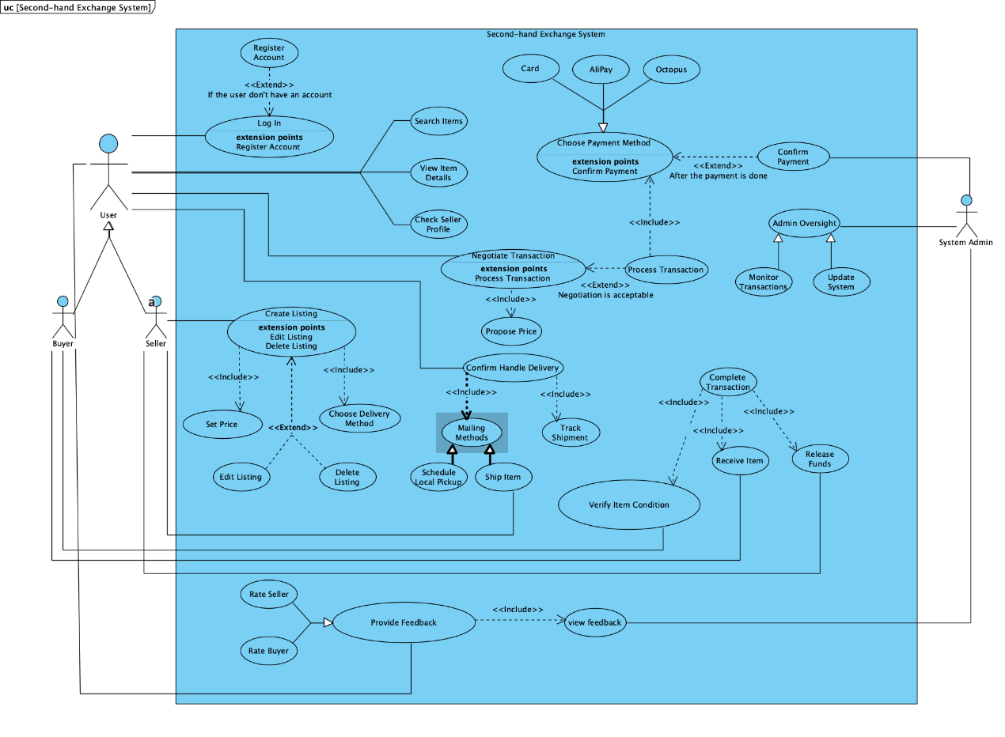
Fig.1 Use Case Diagram Overview

Users can register an account using a verified email and phone number, enabling them to log in. To enhance credibility and unlock buying/selling functions, users can upload a government-issued ID.
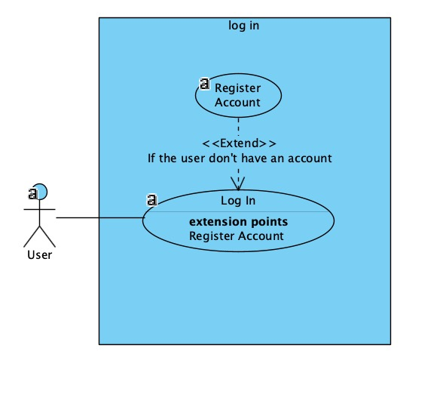
Fig.2 Identity Verification

This feature allows buyers and sellers to negotiate prices via a negotiation system. Once an agreement is reached, the buyer can place an order. If the buyer disagrees with the seller’s price, they can cancel the transaction.
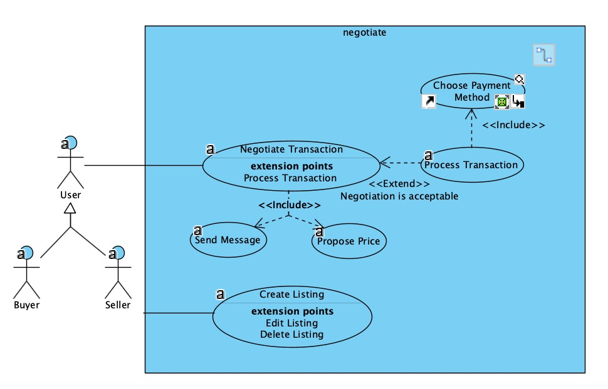
Fig.3 Real-time Price Negotiation

After each transaction, both users and sellers are prompted to rate each other from 1 to 5 stars. A user’s rating is updated in real-time based on an algorithm. Low ratings may lead to transaction restrictions or temporary bans.
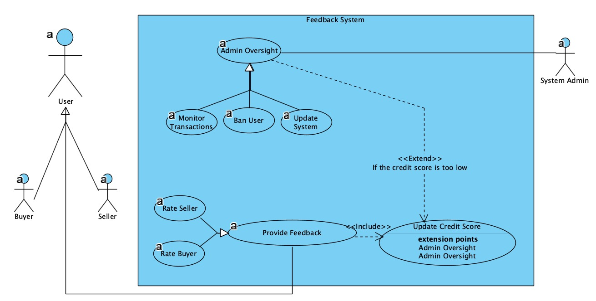
Fig.4 Feedback Sys
3.3 Class Diagram
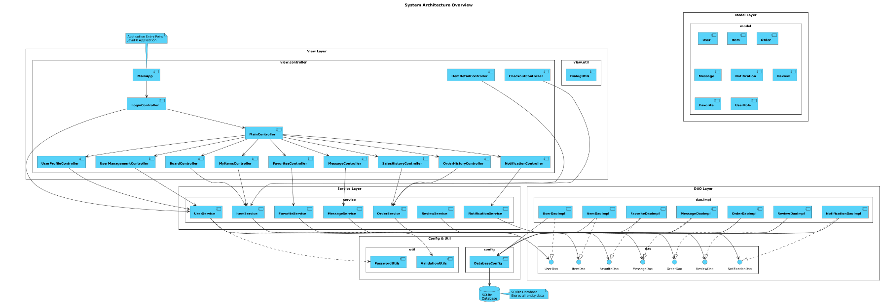
Given the substantial size and complexity of the class diagram, first presents an overview of the overall project architecture below.
Fig.5 project architecture overview
Subsequently, the class diagrams for each layout within the overall project are presented below: the dao layout,the module layout, the service layout, and the view-controller layout.
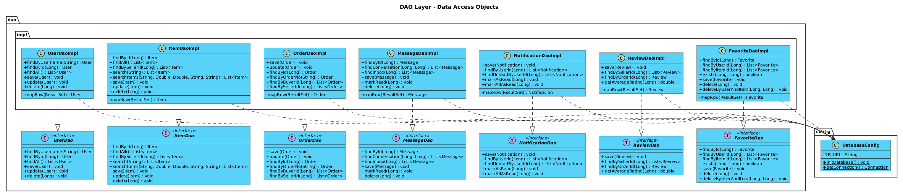
Fig .6 DAO layou

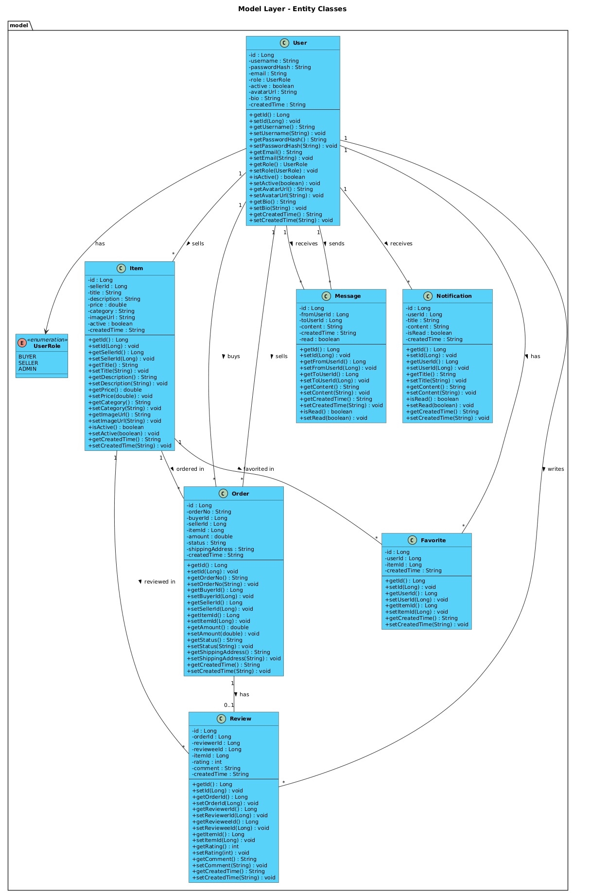

Fig.7 module layout

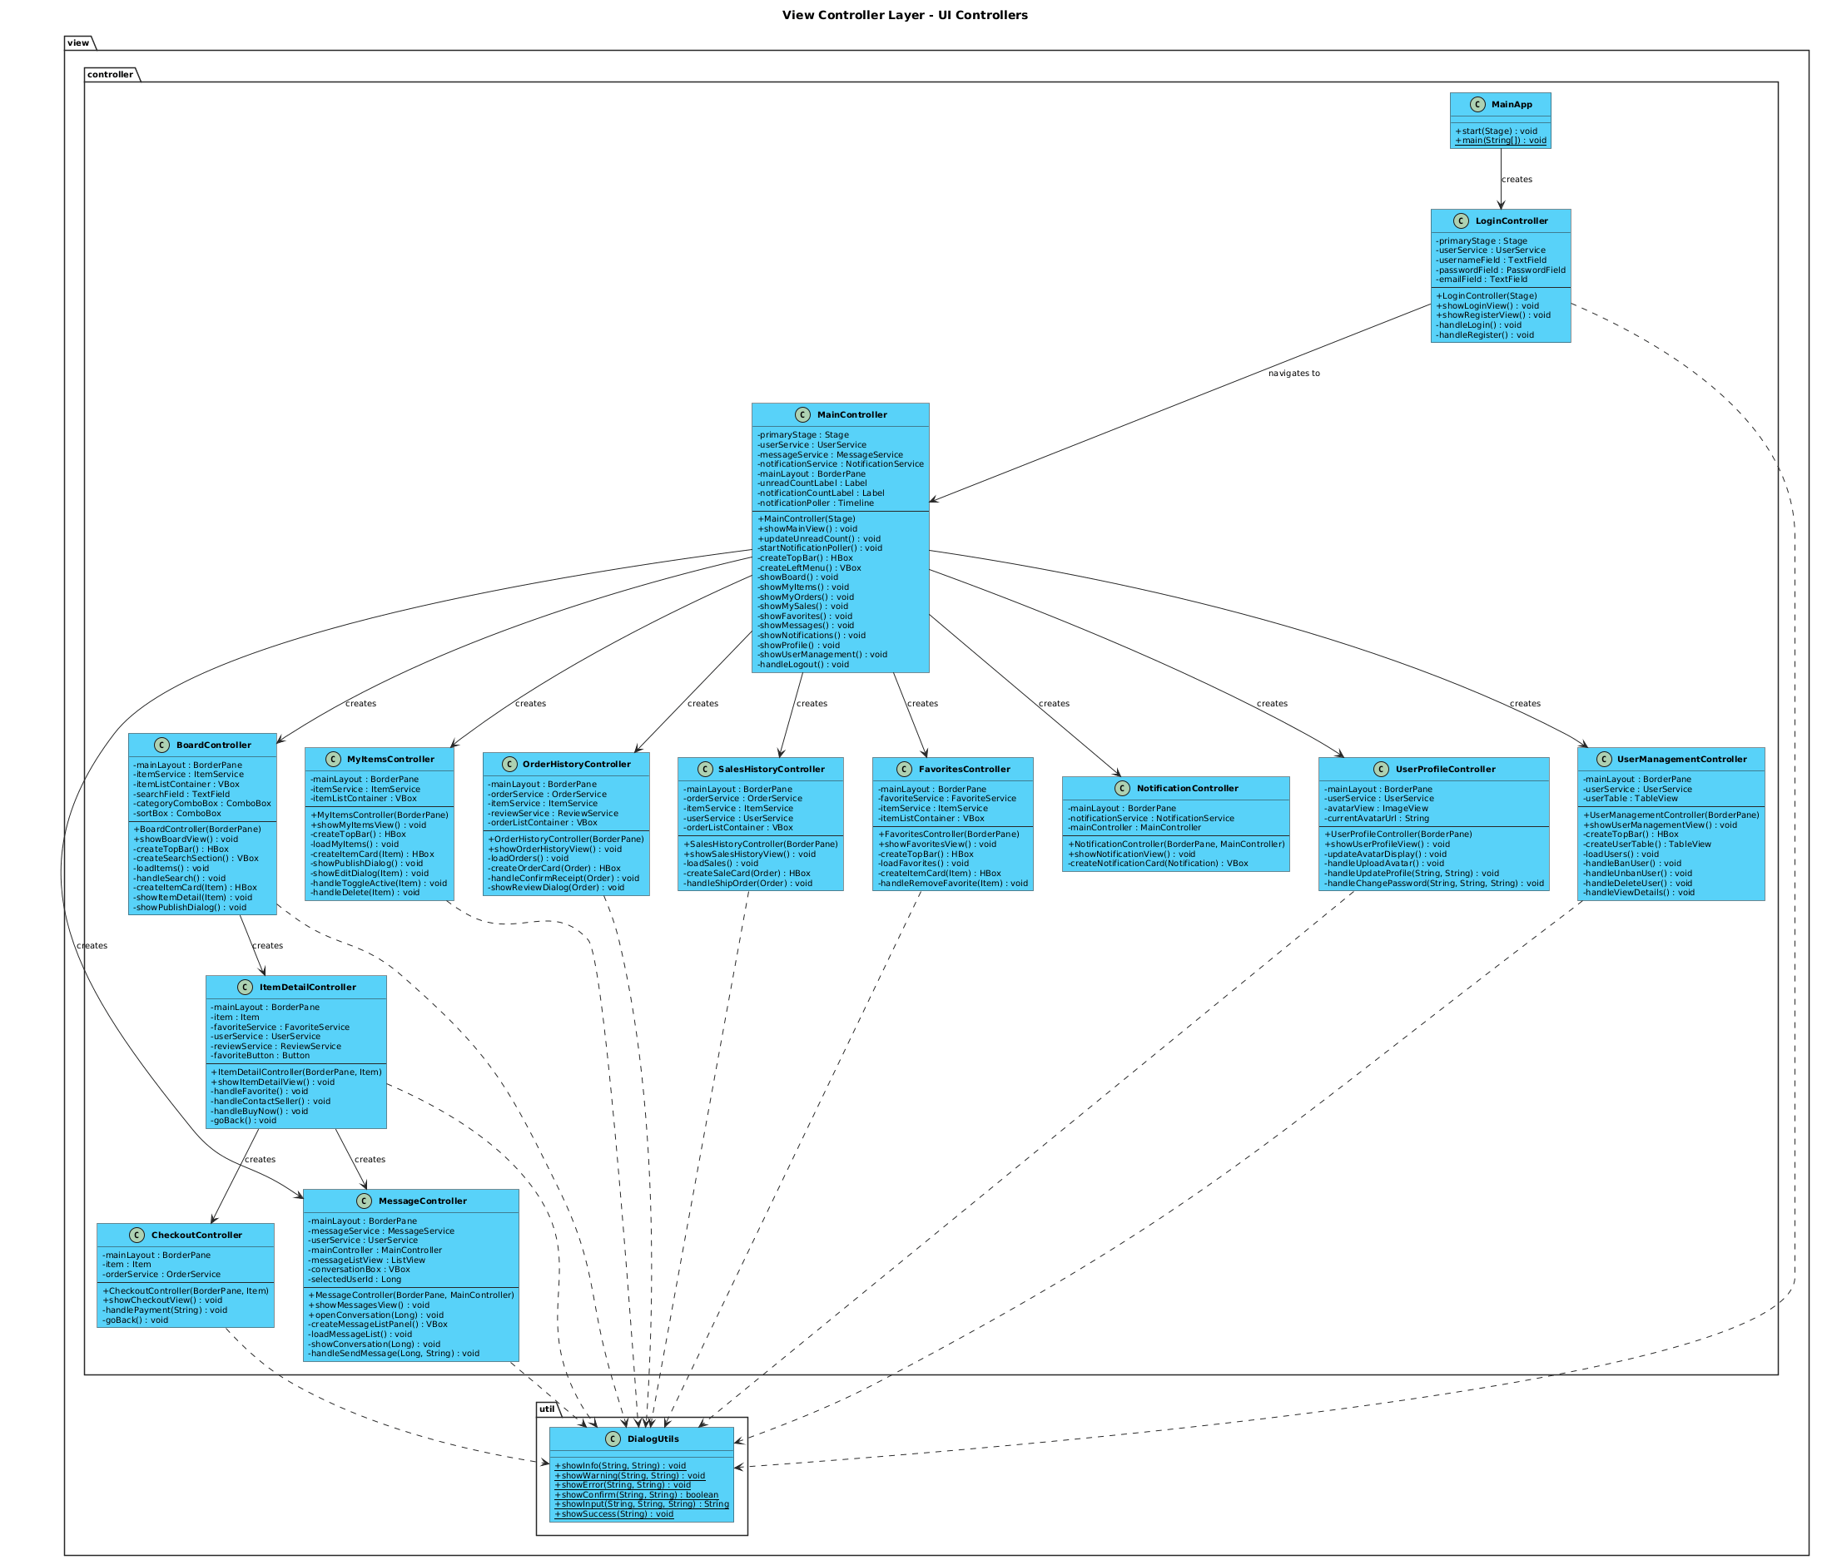
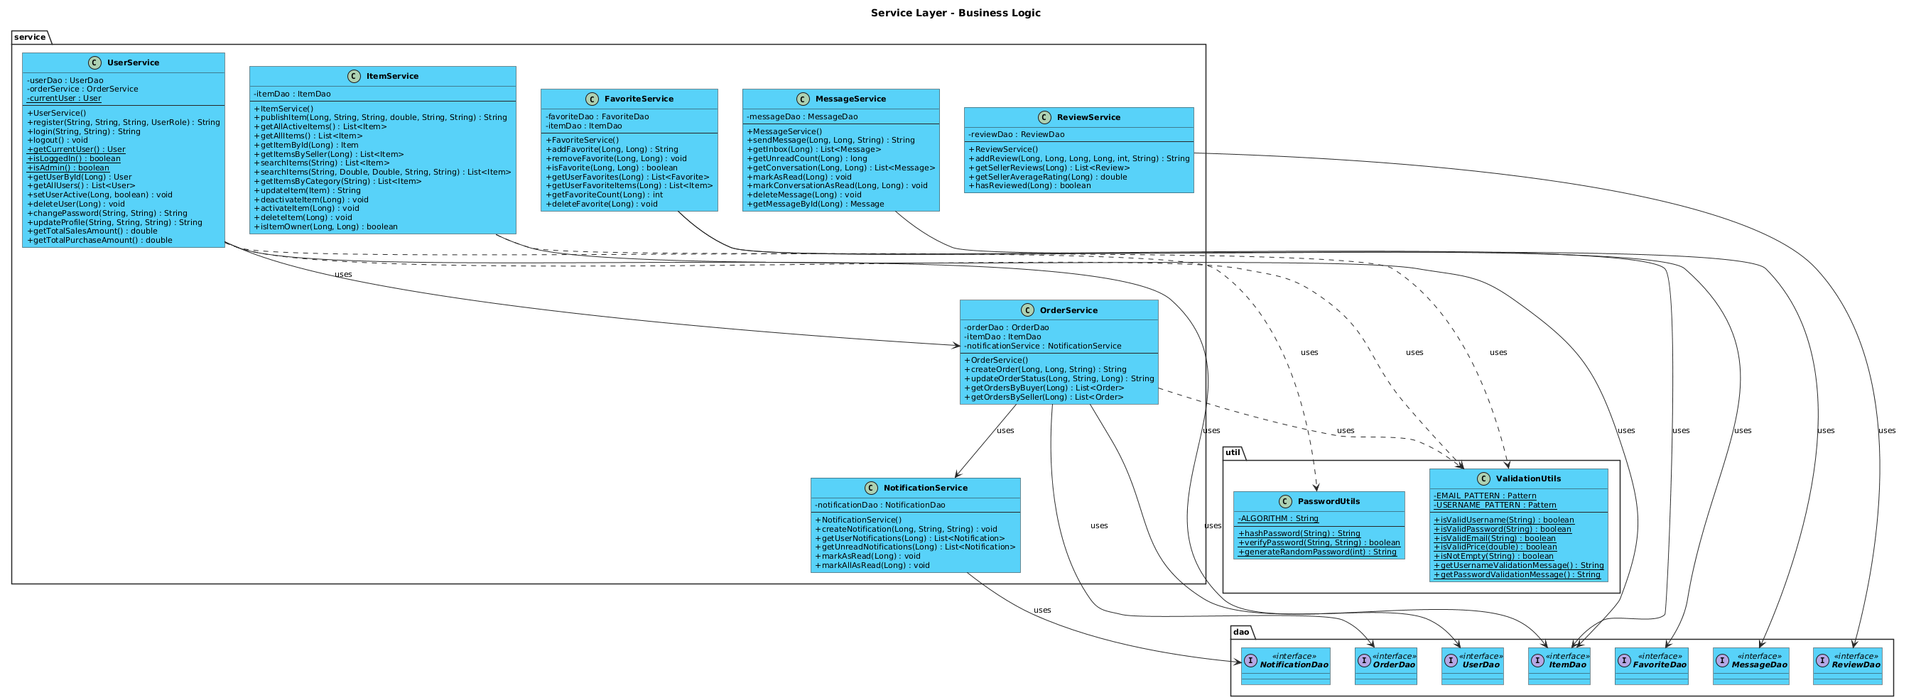
Fig.8 service layout
Fig.9 view-controller layout

3.4 Sequence Diagrams
The following sequence diagrams illustrate the core user interactions and system behaviors of the Second-hand Trading Platform. Each diagram corresponds to a specific user story and demonstrates the flow of control between system components.
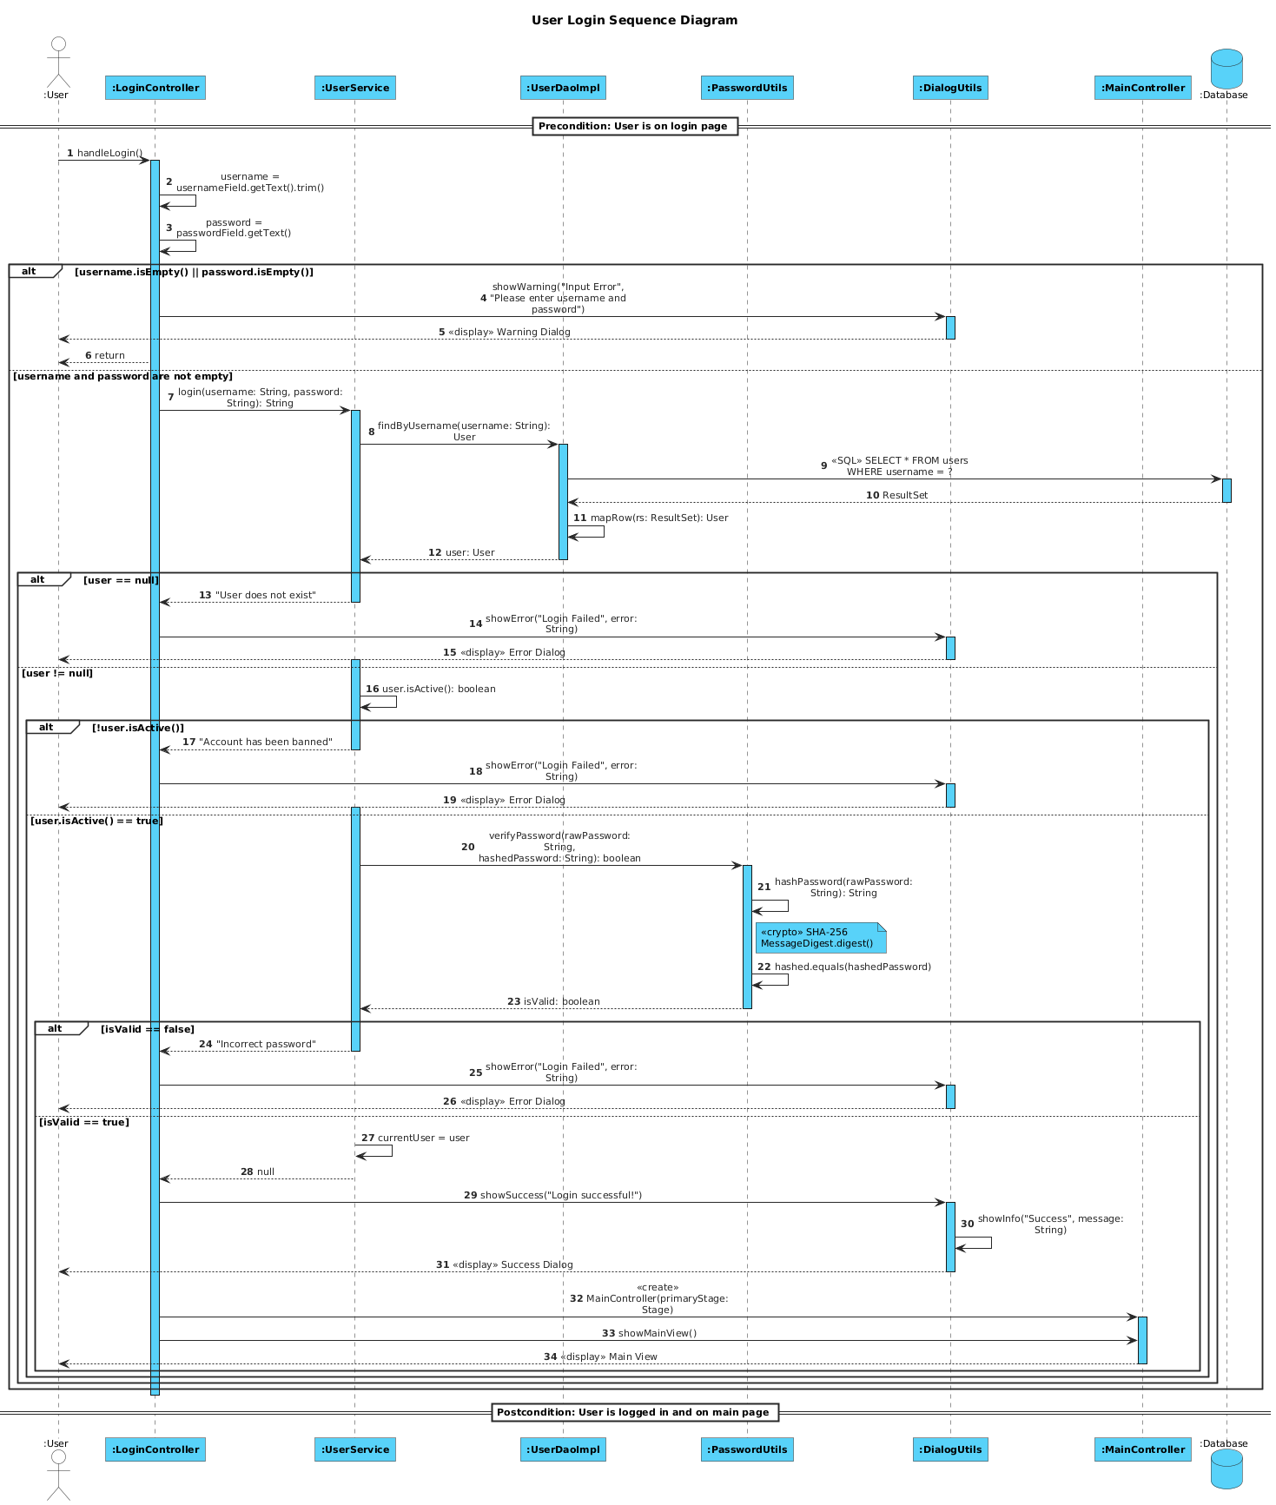
Fig.10 user login
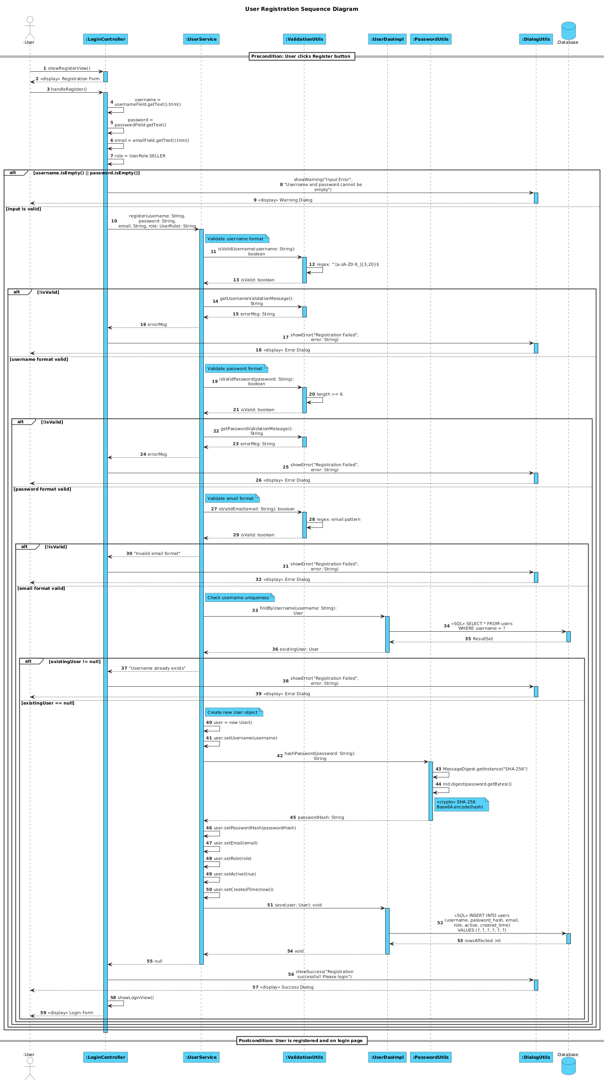
Fig.11 user registration
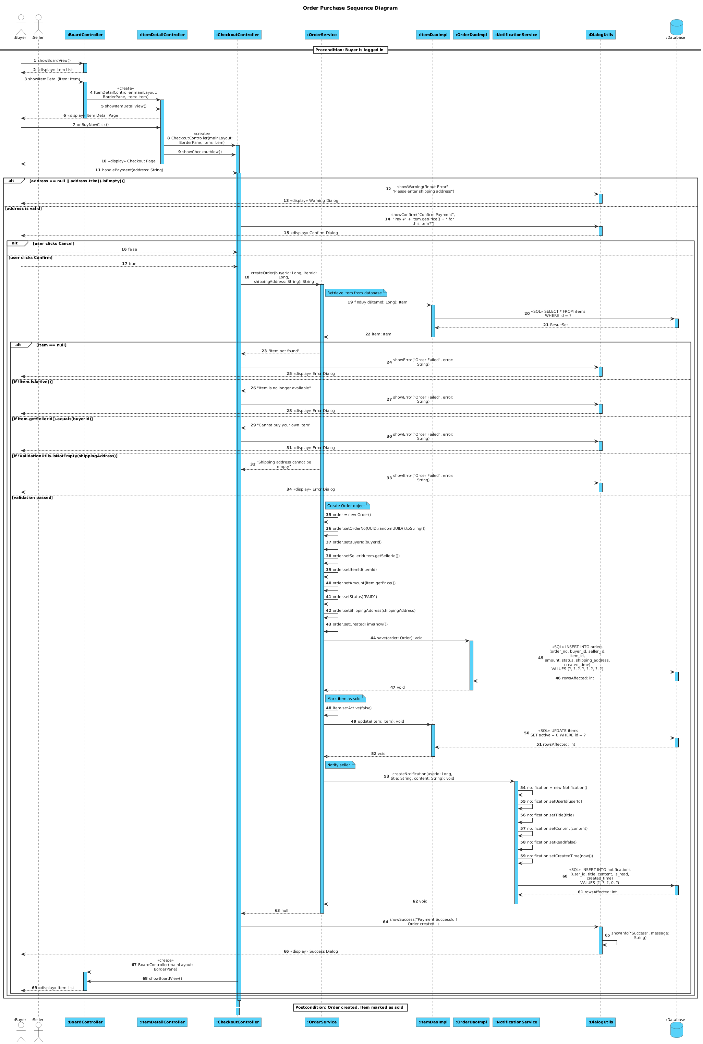
Fig.12 buyer purchase item
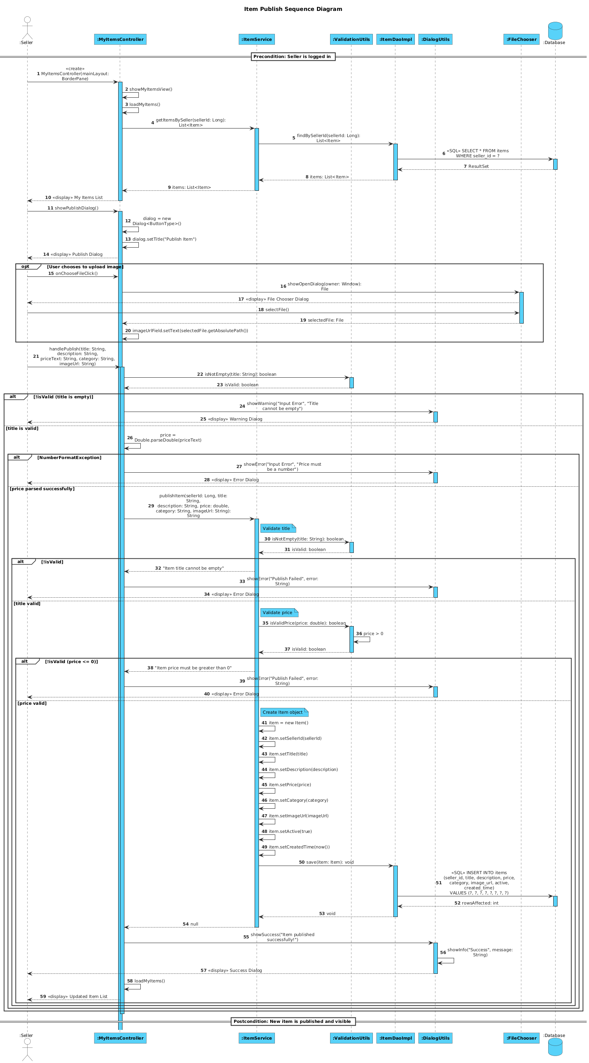
Fig.13 seller publishes item
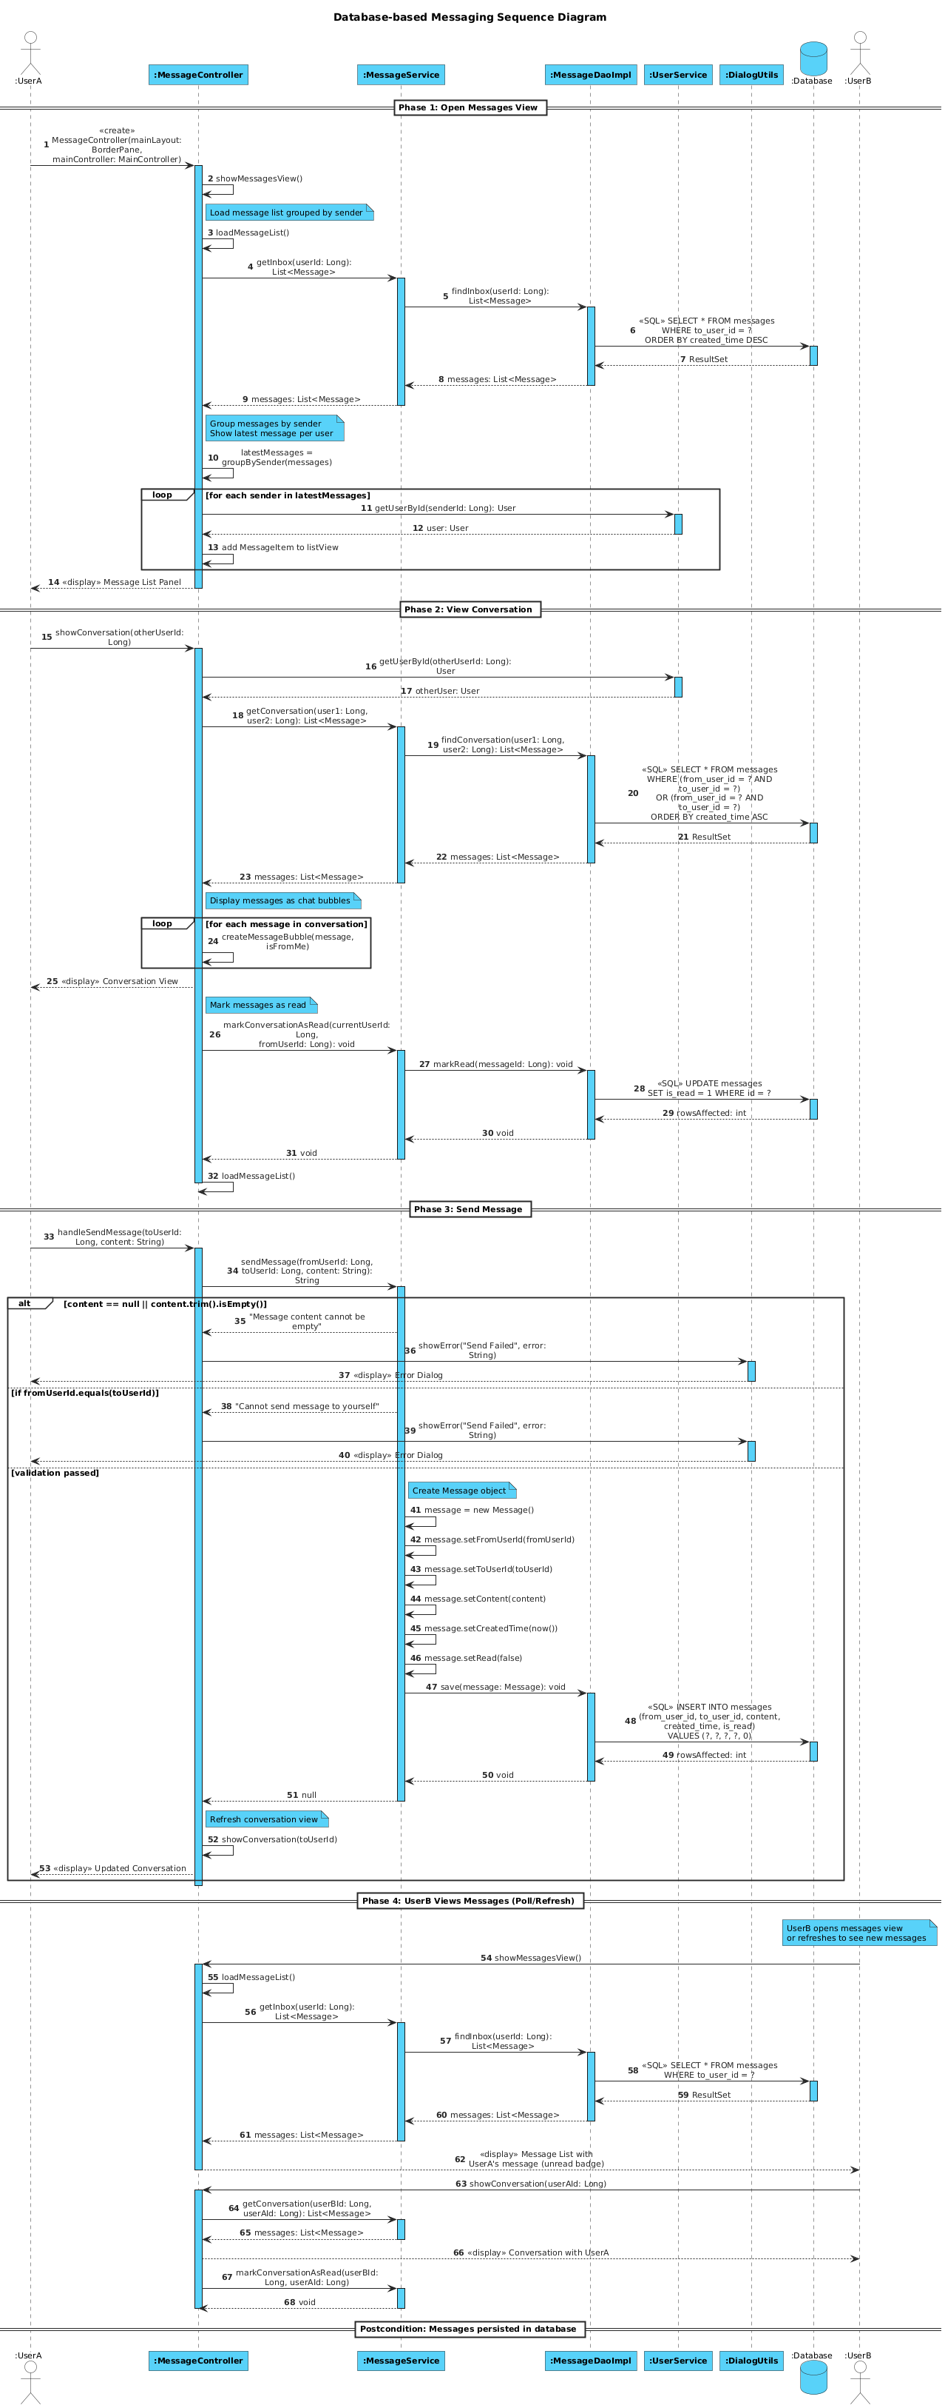
Fig.14 user sends and receives message
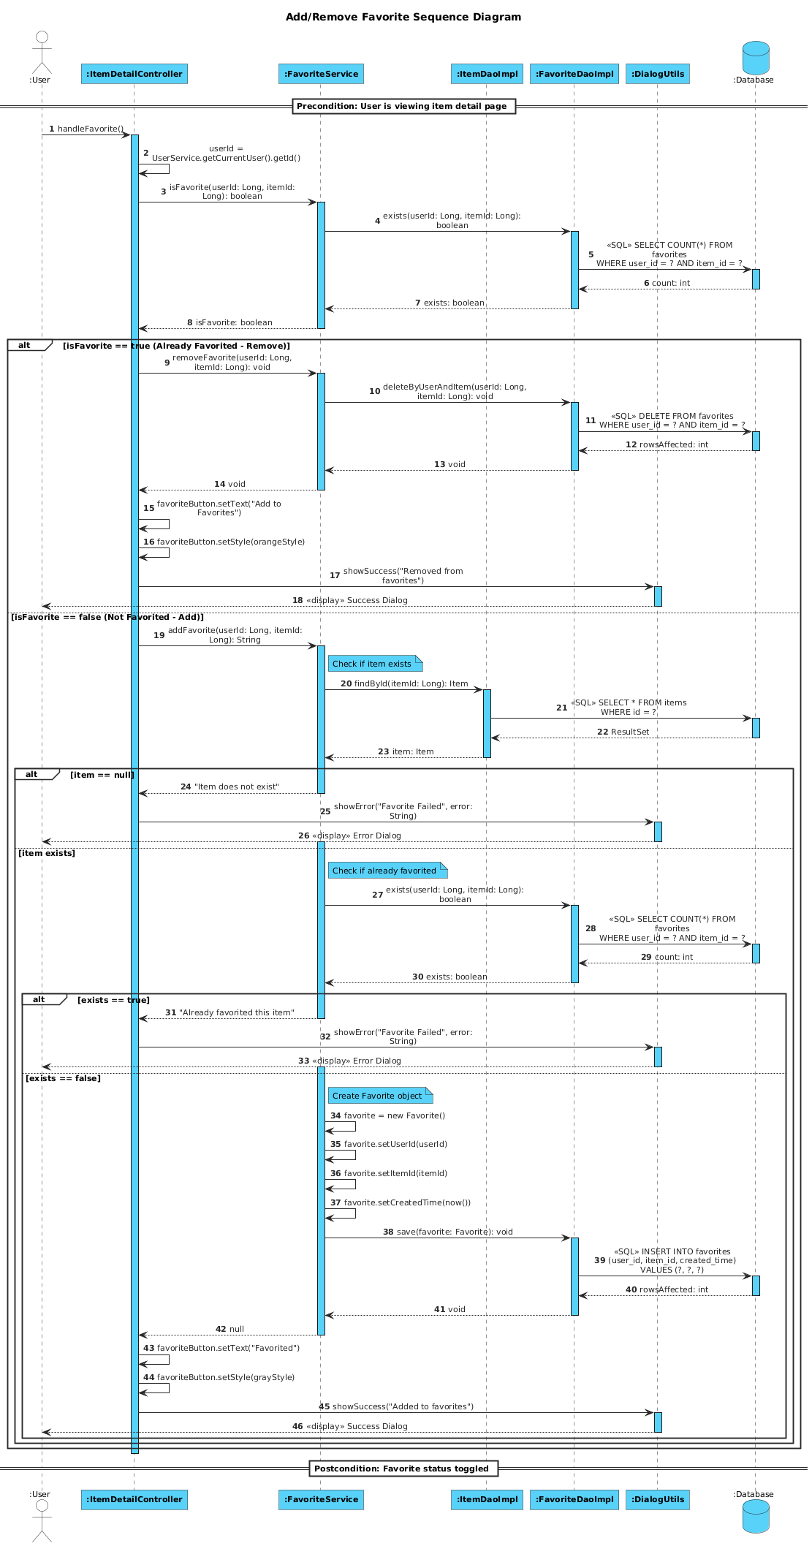
Fig.15 seller updates order status
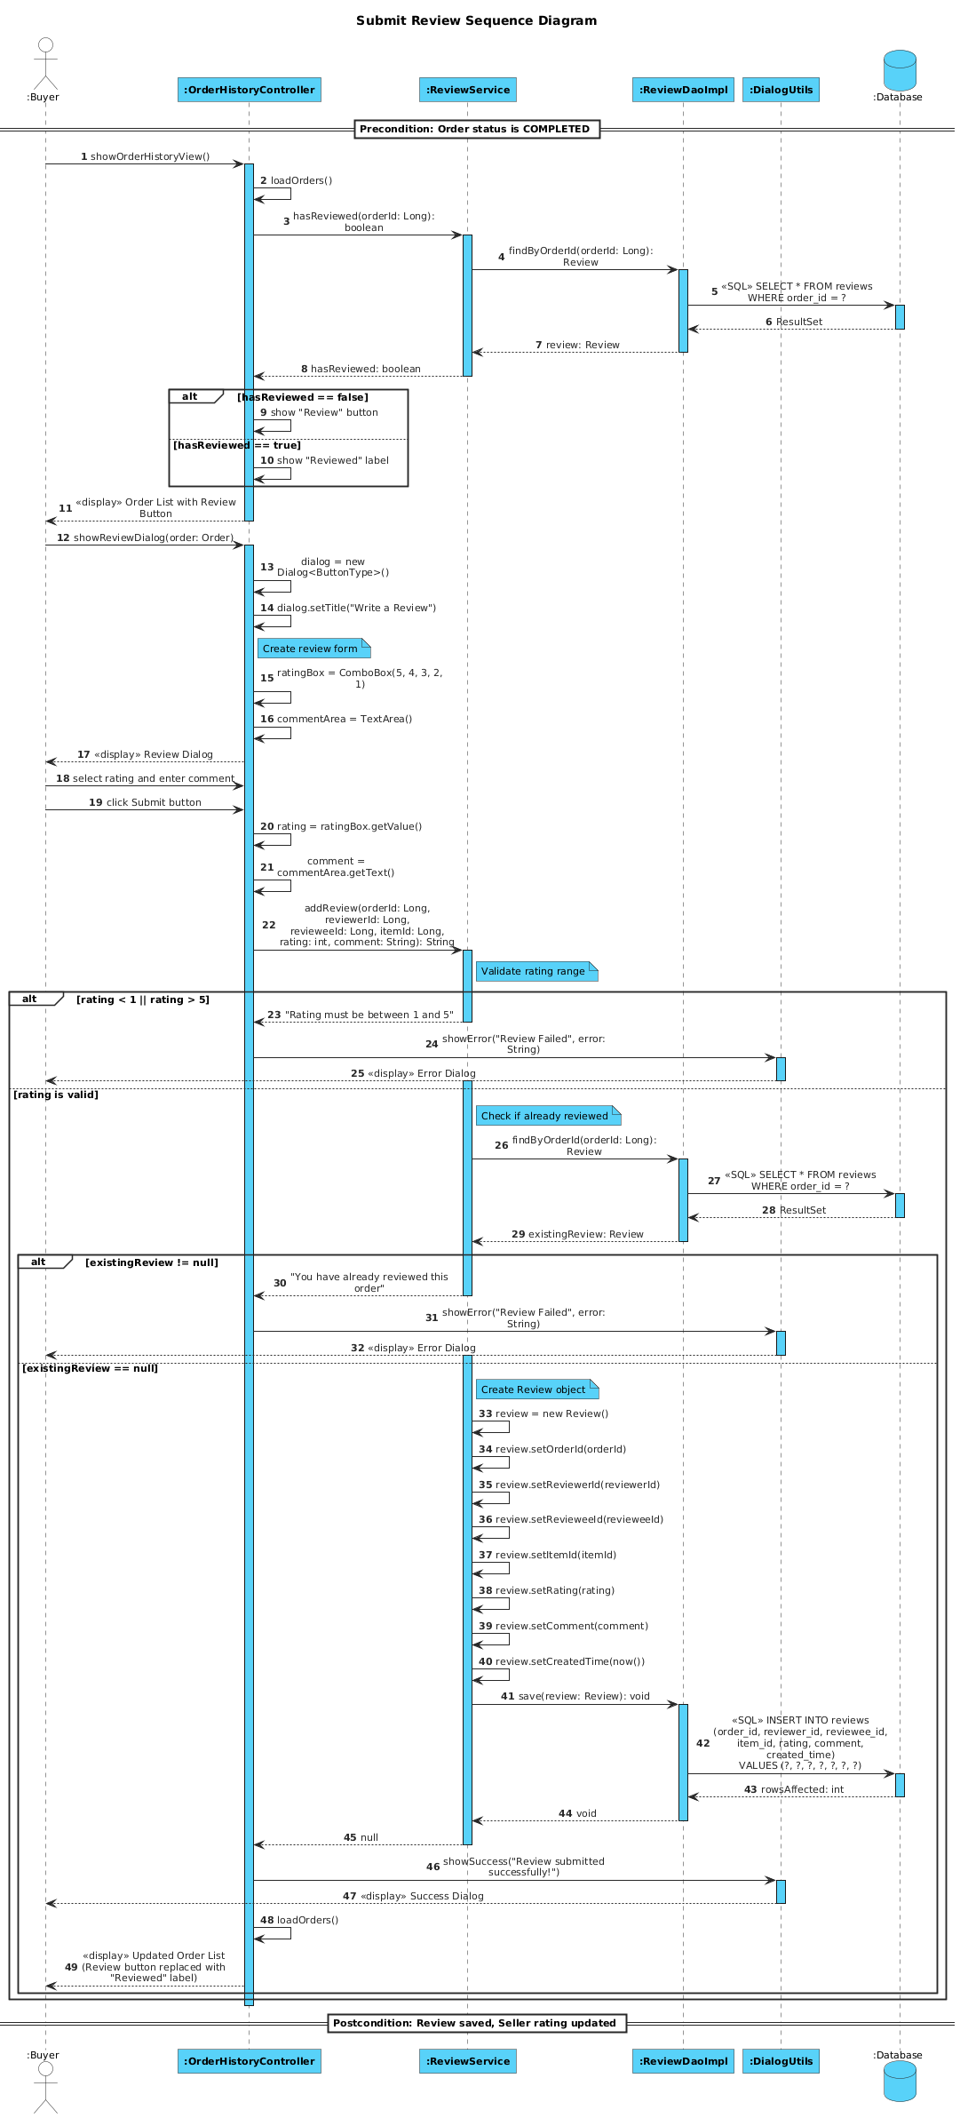
Fig.16 buyer submits review
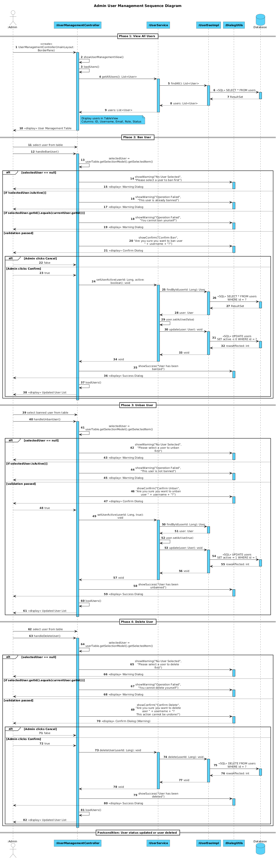
Fig.17 administrator management

3.5 Design Pattern

3.6 FUNCTIONAL REQUIREMENTS
The system functionalities are categorized based on the service-layer implementation, ensuring a distinct separation of concerns (SoC).

3.6.1. User Account Management
- Registration Validation: The system enforces strict validation rules during the register() process. Usernames must match specific regex patterns (alphanumeric, 3-20 chars), and passwords must meet minimum length requirements defined in ValidationUtils.
- Security: Passwords are never stored in plain text. The system uses SHA-256 hashing (via PasswordUtils.hashPassword) to encrypt credentials before persistence, ensuring data security.
- Financial Statistics: Users can view their financial performance. The system calculates TotalSalesAmount and TotalPurchaseAmount in real-time by aggregating completed orders using Java Stream API.

3.6.2. Item Lifecycle Management
- Publication: Sellers can publish items with details including title, price, and category. The publishItem() function validates that prices are positive and titles are non-empty.
- Status Control: The system supports both manual and automatic status changes. Items can be manually deactivated (deactivateItem) or automatically marked as inactive when an order is created to prevent double-spending.
- Ownership Verification: The system implements an isItemOwner() check to ensure only the original creator can edit or delete an item.

3.6.3. Order Processing & State Machine
- Order Creation: The createOrder() function implements critical business rules:
- Availability Check: Verifies the item is currently active.
- Self-Dealing Prevention: Prevents users from purchasing their own items.
- ID Generation: Generates a unique UUID for the order number.
- Status Workflo2w: The system enforces a strict state transition model in updateOrderStatus(). For example, an order cannot move to "SHIPPED" unless it is currently "PAID", and only the Seller has the permission to trigger this action.

3.6.4. Social Interactions
- Messaging: Users can exchange private messages. The system tracks the "read status" of messages, allowing for an unread message count feature via getUnreadCount().
- Reviews: To ensure authentic feedback, the addReview() function allows only one review per valid order ID, preventing spam or duplicate ratings.
- Favorites: Users can maintain a wishlist. The system prevents duplicate entries for the same item in the favorites list.

3.7. KEY IMPLEMENTATION HIGHLIGHTS
This section demonstrates the robustness of the system by highlighting core functions that handle complex business logic and security.
A. Transaction Integrity Logic
- File: service/OrderService.java
- Function: createOrder(Long buyerId, Long itemId, String shippingAddress)
- Description: This function acts as a transactional gatekeeper. It performs three critical checks before generating an order to ensure data integrity:
- Availability Check: It checks !item.isActive() to ensure the item hasn't been sold.
- Conflict of Interest Check: It verifies item.getSellerId().equals(buyerId) to prevent sellers from purchasing their own stock (self-dealing).
- Concurrency Control: It sets the item to inactive immediately upon order creation to prevent other users from buying it simultaneously.
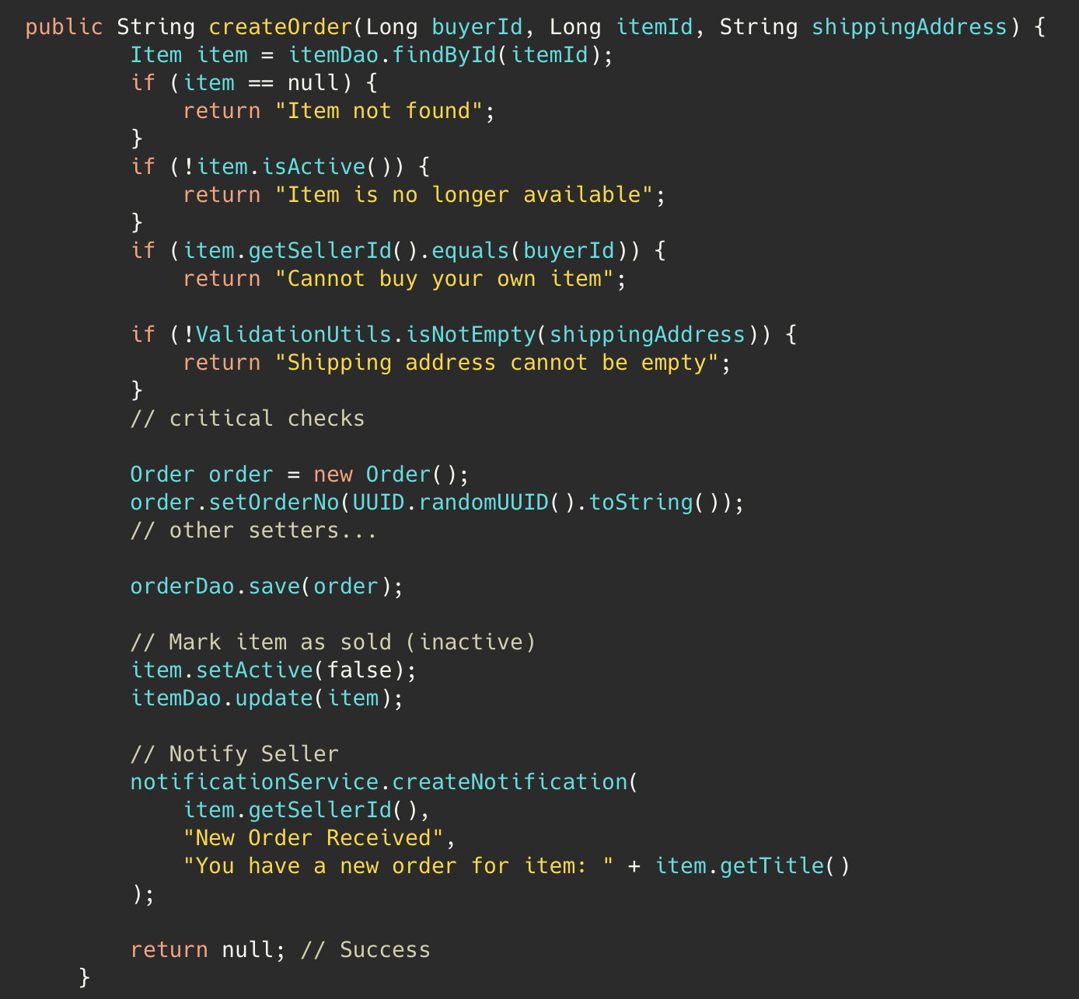
B. Strict Order Status State Machine
- File: service/OrderService.java
- Function: updateOrderStatus(Long orderId, Long operatorId, String newStatus)
- Description: This function implements a finite state machine to enforce the business process. It uses conditional logic to validate transitions and permissions:
- Permission Check: Verifies if the operator is the Buyer or Seller.
- Pre-condition Check: E.g., if ("SHIPPED".equals(newStatus) && !"PAID".equals(oldStatus)) ensures goods are not shipped before payment is confirmed.
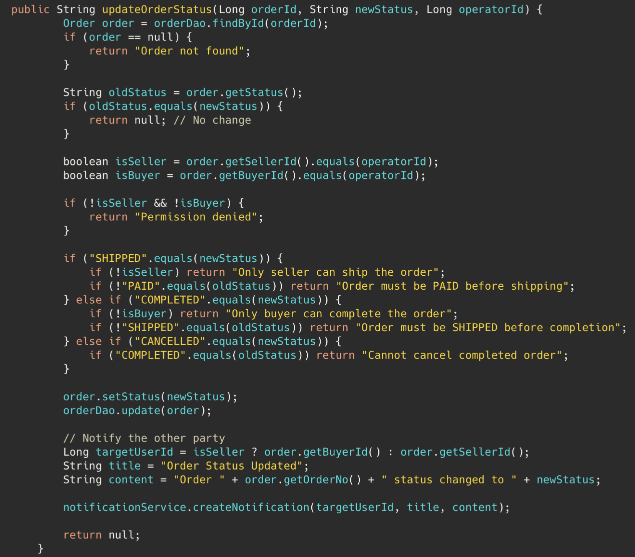
C. Password Encryption Standard
- File: util/PasswordUtils.java
- Function: hashPassword(String password)
- Description: To ensure user data security and compliance with security best practices, the system utilizes the SHA-256 algorithm.
- The system uses MessageDigest to compute the hash.
- It converts the byte array into a Base64 string for safe storage in the database.
- This ensures that even if the database file is compromised, raw passwords remain protected.
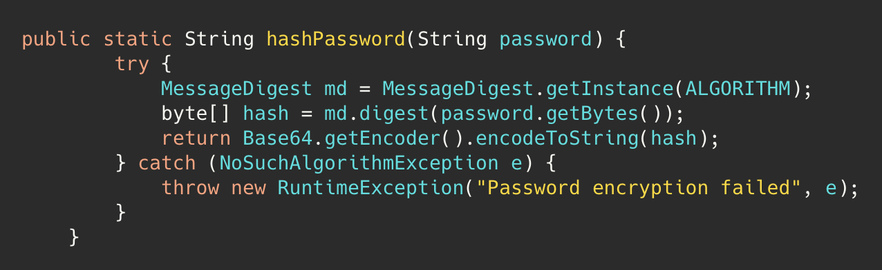
D. Integrity in Review System
- File: service/ReviewService.java
- Function: addReview(...)
- Description: This function enforces data integrity for the reputation system.
- Range Check: Validates that the rating is strictly between 1 and 5.
- Uniqueness Check: Uses reviewDao.findByOrderId(orderId) to ensure a specific transaction can only be reviewed once, preventing rating manipulation.
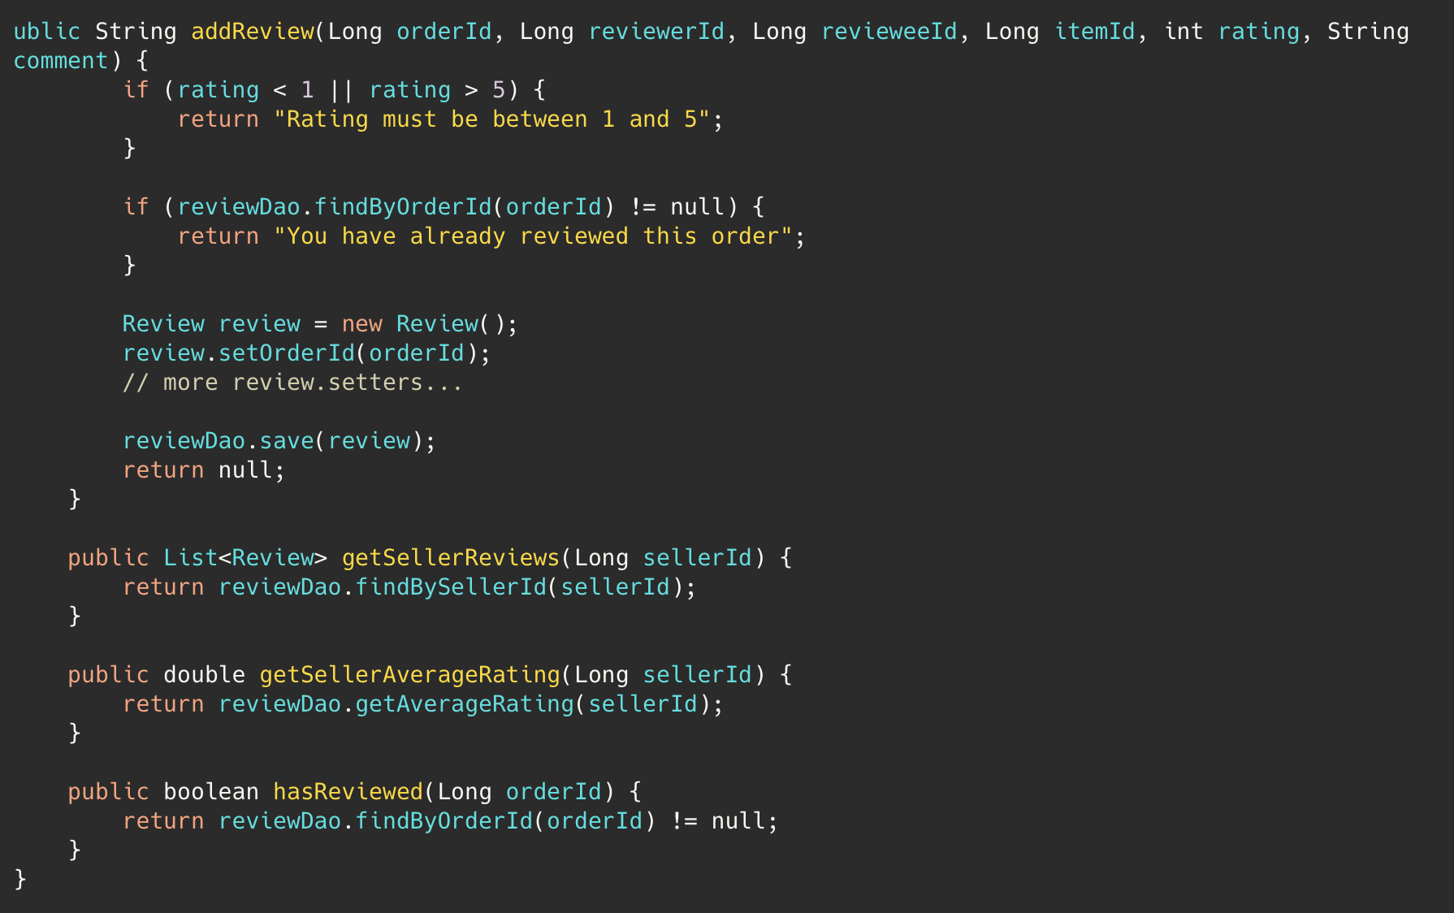

5. Bug Reports
Bug Report #1
Github Issue Number | #9
Title | [Bug] Favorites Table Schema Mismatch - Missing id Column Causes Favorites Feature to Fail
Assignee | FU Qianli (PM)
Found in/ Located in | Database Table and DAO layout
Type | Bug - Module Mismatch
Platform | Windows
Importance | Medium
Description | There is a critical schema mismatch between the database table definition and the DAO implementation for the favorites feature. The favorites table in DatabaseConfig.java uses a composite primary key (user_id, item_id) without a standalone id column. However, the FavoriteDaoImpl.java and Favorite.java model assume the existence of an id column, causing all favorite retrieval operations to fail silently.
Steps to reproduce | - Log in to the application as any user  - Navigate to "Item Market" and click on any item to view details  - Click "Add to Favorites" to favorite an item (this may succeed)  - Go to "My Favorites" from the left sidebar menu  - Observe: The favorites list appears empty, even though the favorite was supposedly added
Expected behavior | The "My Favorites" view should display all items that the user has previously favorited, showing the item title, description, price, and status with options to view details or remove from favorites.
Actual behavior | The "My Favorites" view shows "You haven't favorited any items yet" message, even though favorites have been added.
Analyst of root cause | When FavoriteDaoImpl.findByUserId() or findByItemId() is called, the mapRow() method attempts to execute rs.getLong("id") on a column that doesn't exist in the database  This throws a SQLException which is caught and causes the method to return an empty list  All favorite queries silently fail, making the entire favorites feature non-functional
Change after fix | - Remove id field from Favorite model class  - Remove findById() and delete(Long id) methods from FavoriteDao interface  - Update FavoriteDaoImpl to not reference non-existent id column  - Remove unused deleteFavorite(Long id) method from FavoriteService
Github Commit of fixing this bug | Commit a8b564d
Status | Fixed/Issue closed

