FQM 0.2.5
User Guide Beta
https://fqms.github.io
freequem@gmail.com

FQM was crated with the intention of it been fully customize-able and befitted of any environment with disregard to the scale or hardware. Therefore the process of stetting up the system and the options to be chosen might vary from use-case to another. With that been said, this document will guide you through setting-up the system and highlight the different available options for different setups. And brief you of some of the missing features , which we intend to add in the coming releases.

Notice: This is a temporary BETA user guide, that avoids to go into much details on purpose. And disregard explaining major features which are available but less likely to be used in a simple setup. A more fully detailed documentation will be released with the next version, hopefully.

Index
- Basic set-up : 2
- User Management: 10
- Connecting: 11
- Printers : 13

- Basic set-up :

Will start the set-up by changing the Admin account password to anything other than the default password, So that the reminder message in the login page disappears.

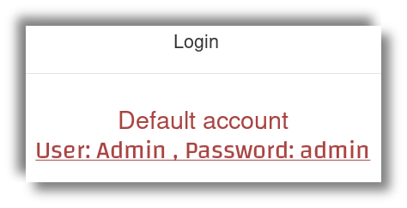Illustration 1: Default password reminder message

- First login with the Admin account.
- Go to the top right corner, to drop-down menu Admin.
- Select update Admin.
- Enter the new password and press Update.
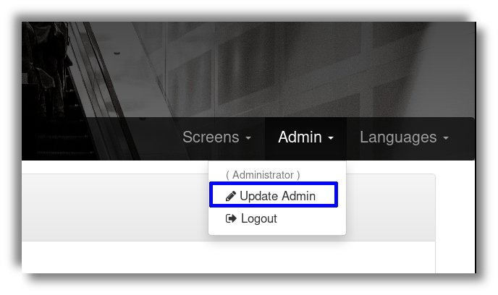Illustration 2: Updating Admin password
Now that’s done. Lets setup the offices. Depending on how many offices or counters, to-which the customer will submit his ticket to receive a service. And wither the offices employee will participate in operating the office with a his special account. Well lets go through it step by step and highlight the detailed above differences. First we want to add new office :

1. Click on Manage, on the top left corner.
2. Click on Add new office, the third option on the side-bar.

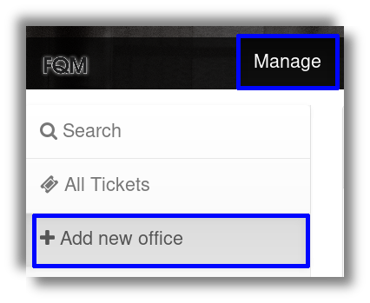Illustration 3: Manage - adding new office

Now we will have one empty field to fill and two fields to select from. The first one will take any number with the condition of it been unique so you can give two different offices the same number. The second field is for selecting an operator, till now we have not add any users, the only existing account is the Admin account so this field will be “Without an operator” by default. We will get on the subject of users with more details in User Management. For now lets stick to the default. Lastly the third field which will select a unique prefix of a single English letter, that will allow us to further differentiate between different offices tickets. So after entering a unique number and selecting a prefix, press Add.
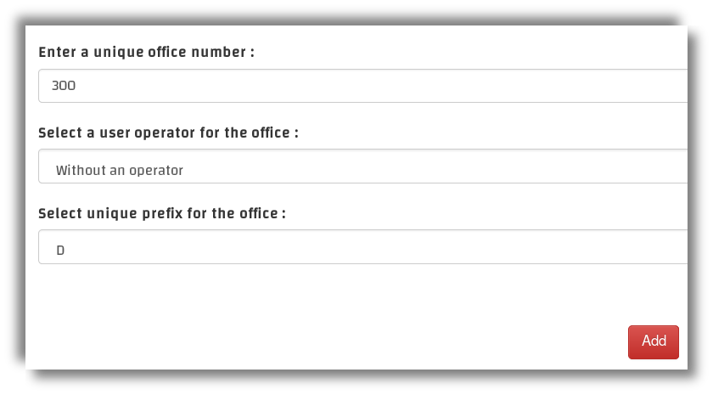Illustration 4: New office filled form
Now if all went well a new office should appear on the left side-bar, with a drop-down menu that contains three options, lets go option by option with full details :

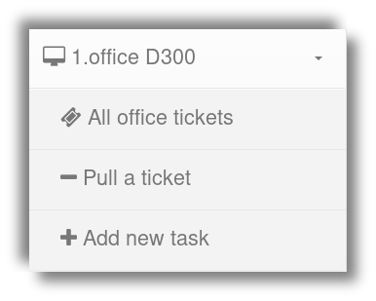Illustration 5: new office D300

- All office tickets: it will display all the tickets generated to this specific office. And gives also the options of : - update : to update or change the office number, prefix or operator. - Reset: to remove all the registered tickets and restore the current ticket number of the office to zero. - Delete: to delete the office, it is required that you reset the office before you will be able to delete it.
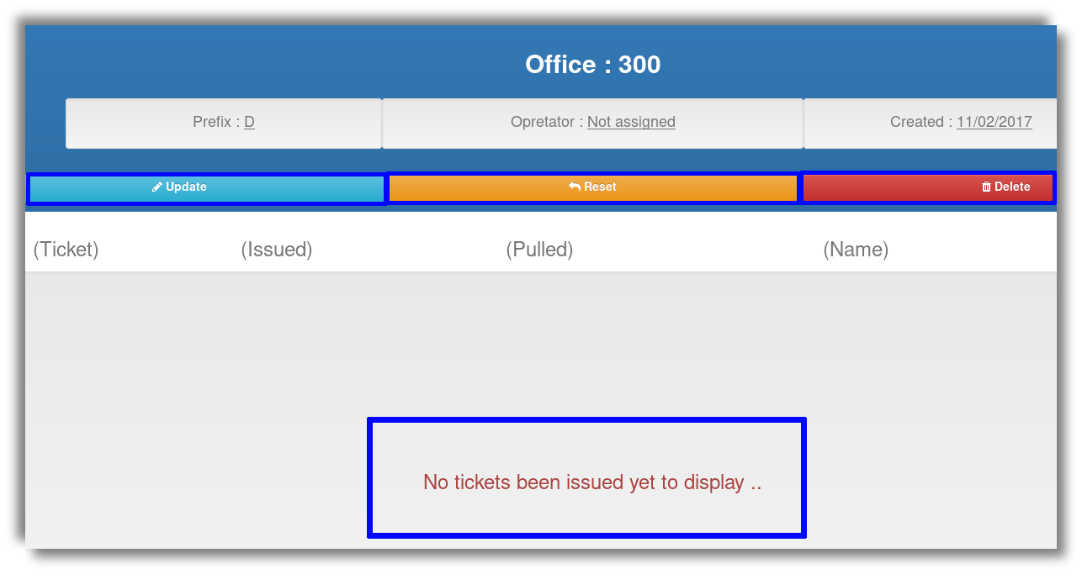Illustration 6: All office tickets
- Pull a ticket: this options allows you to pull the first ticket in the office’s waiting list into the processed tickets list. Currently we have no tickets been generated yet, so pulling a ticket now won’t be possible. Lets skip pulling a ticket for now.
- Add new task: Tasks are the options or services that will appear to the customers to chose from and have a waiting ticket specific for that task and office generated. Creating a new task only requires you to input the task unique title, which will appear to the customer as an option to choose from.

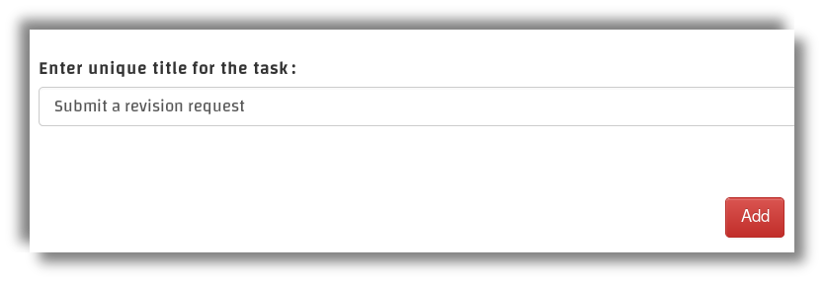Illustration 7: Adding a new task
Now if you notice the side-bar a new task has been added under the office selected, lets click on it. You will find a similar layout to that of All office tickets. Except the tickets that will be displayed here are the specific task tickets, So All office tickets will contain the tickets if any task you’ve created and generated tickets for, but each specific task will only display its own tickets. The new task layouts contains three similar options: -Update: to update the task title. -Reset: to remove all the tickets generated under this specific task. -Delete : to delete the task, which requires you to reset the task first before you delete it.

Everything’s setup perfectly for us. To start generating new tickets. So lets do that, first we have to explain the different types of tickets that FQM generates and the different type of display screens that it supports.

- Registered ticket: it requires the customer to input a value that will be registered with the ticket. The Value can be either Name or Number the system can use to reference the ticket and use it to announce the ticket correctly. In FQM version 0.2 the only allowed registered value is Name, but from version 0.2.5 you can set the value to Name or Number.
- Printed ticket: it requires the existence of a properly installed POS USB printer. Printed ticket contains the ticket number with the office, task, date-time and other parameters, which help guiding the customer. As of 0.2 version the only supported printers are USB ones, in future releases, support for Bluetooth and Network printers will be added. For more info on how to setup USB printers properly go to Printers.
- Smart ticket: (This option is not available currently) a virtual ticket, that requires the customer to have a smart phone or any smart devices has capabilities of scanning a QR code and browsing the internet. To explain it simply, it generates a special interactive ticket that the customer cant interact with from his smart phone or smart device, And notify him whenever the ticket is due. So to simplify it more, imagine instead of having one big display TV screen that displays everyone tickets. Everyone will have a small display on his phone.

Lets get into the different types of display screens, that FQM supports, but lets explain what does screen mean in this context. it means the web pages on-which the tickets or tasks will be displayed. The screens are meant to be displayed on other devices, that allows the customer to interact with the system like a touchscreen tablet and a TV screen for example. For more details on how to connect other devices to the system go to Connecting. Types of screens :

- Touch Screen: Screen used to display tasks titles and generate the tickets.
- Display Screen: Screen used to display a live feed of the generated tickets and announcements.
- Smart screen: (This option is not available currently) Interactive screen to control and display single unique ticket form a smart device.

Enough explaining for now, lets setup our tickets and start generating them :
- On the top left corner, Click on customize.
- On the side-bar on the left, select the last option Tickets

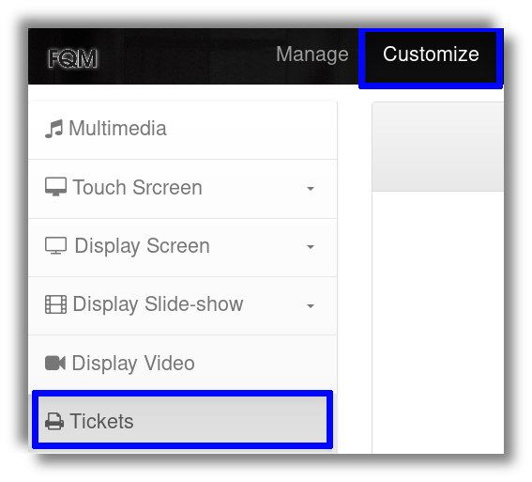Illustration 8: Customizing - Tickets
For now will setup tickets to be registered, if you want to see how to setup a printer and the setup for printed ticket, go to Printers. So lets set the ticket:
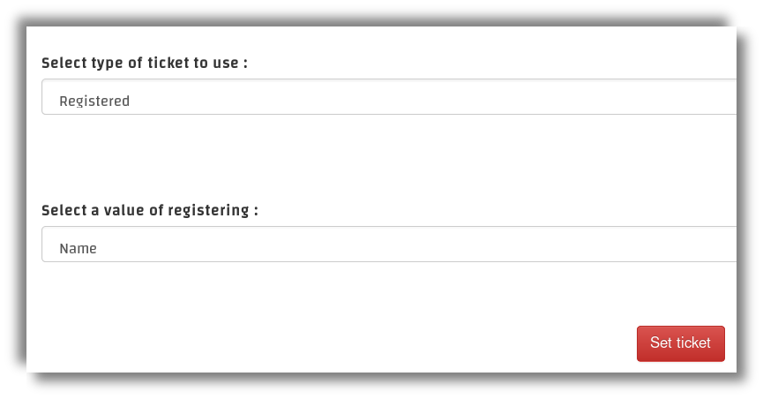Illustration 9: Seting up - Tickets
Now lets see the task we’ve created and generate a ticket for it :
- On the top left corner, click on Screens.
- On the drop-down menu under (new tab) , click on Touch Screen.

In the Touch Screen, you will find all the tasks, that you’ve added on any office. So far we’ve added a single task. So whenever it’s pressed it will either print the ticket, printed tickets was selected. Or be redirected to a form to enter a name or number. If all went well you should be redirect with a message telling you that the message has been generated successfully. And to see the tickets that we have generated we should head back to the task we have created. There you will find the tickets categorized is Waiting.
Alright, lets go to the Display Screen to see our waiting tickets that we’ve created :
- On the top left corner, click on Screens.
- On the drop-menu (new tab), click on Display Screen.

Now try pulling a ticket from the task we created earlier, and see the system in action.

Give Customize a try, you can almost customize everything on the Touch or Display screens. Unfortunately we will not get into explaining it in this guide. It’s yours to discover.
Since this is meant to be a brief setup guide, A lot of features and details has been avoided. Another more complete form of documentation is still under the making so behold the next version of FQM. And wish you a good time using the current one.

- User Management:

A basic management interface still under development, but functional enough so far. The whole purpose of it is to allow multiple employees and users to interact with system. There are three different classes which users can be categorized under :

- Admin : has the permissions to access and monitor everything.
- Monitor : has permissions to monitor and access everything except Administrate.
- Operator : has limited permissions only to access and monitor the office assigned to.
So lets create a new operator and assign it on-to an office:
- On the top left corner, click on Administrate.
- On the drop-down menu, click on Add user.
Lets fill the name, password and give it the role of an operator as well. Then will go to the office we’ve created on Manage and update it :

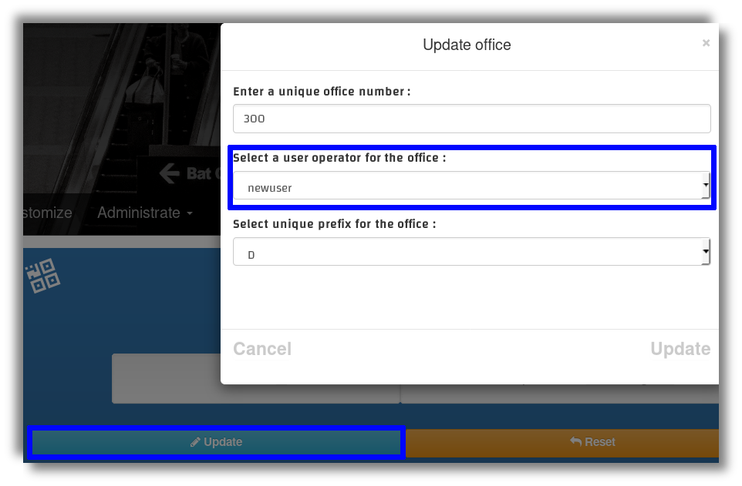Illustration 10: Updating the office with operator

- Connecting:

Connecting different devices into the FQM system, is made super easy due to the nature of serving the system as a web service on the local network. Also scale-ability was taken in consideration upon FQM design, The user interface will auto adjust itself to whatever size, the system will be displayed on. So lets demonstrate three different ways we can connect the system Screens onto various devices.

- Connecting smart devices: simply by connecting to the same network that the system is been streamed on, and connecting to the server, by copying the address and port. Smart devices includes all smart TVs, smart phones … Smart devices with a camera has an easier way to connect to the system with using QR code support, which can be found and used on the main available routes :

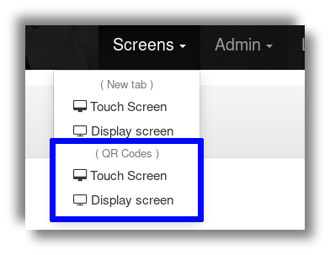
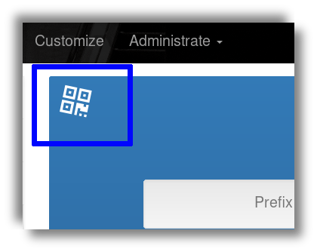
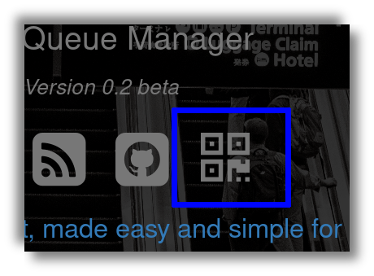

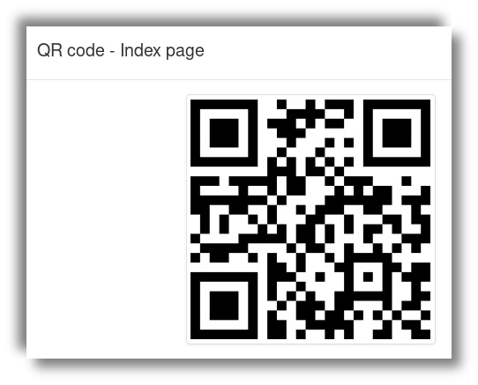Illustration 11: QR Code - to connect with
- Connecting via display ports: HDMI for example, it can be used to display the screens onto other display devices like TVs or HDMI touch screens.
- Connecting via streaming devices: Chromecast for example, a device that allows you to stream screen capture from your computer to the streaming device, which will display the stream on any display device its connected to via HDMI.

There are many other different ways and scenarios to how to connect different type of devices to a web server on a local network. But these are the ones which we’ve tried and used personally. If you’ve found or used it in other ways, please let us know, would love to add your way to our list of ways.

- Printers :

Supporting POS USB printers will vary in difficulties and details from operating system to another. However MacOS systems has a full support for the printers by default without any additions needed. So lets start by setting up printers on Windows systems :

- Installing the drivers: make sure to install the official drivers that came bundled with the printer or any other reliable alternative.
- Go to control panel, select View devices and printers under Hardware and Sound.
- From the list of devices select your printer and copy its current name.
- Right click on the printer and select printer properties.
- From the top tabs on the window select Sharing and check the checkbox Sharing this printer.
- Now paste the default printer name you copied previously the Share name field.
- Apply and OK.

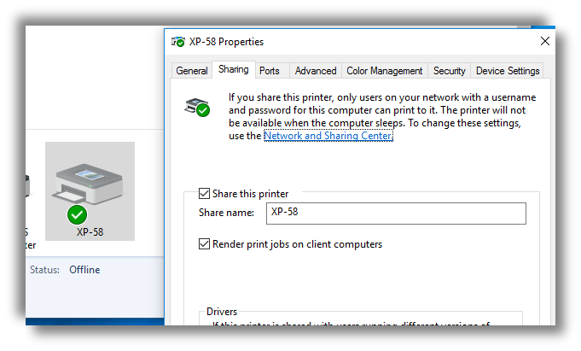Illustration 12: Sharing printer on Windows

By that the printer is perfectly setup and ready for printing on Windows. lets go through how to setup the printer for GNU/Linux systems, All you need to get it running there is for the current operating system user to be a member of the lp group which stands for LAN Printers, so you can easily use the following command to add your current user into the mentioned group, `sudo usermod -a -G lp $(whoami)`. After that you will have to reboot the system for the modifications to be applied.

Alright now finally that our printers are setup, lets get back to FQM to Customize Tickets and update its settings :

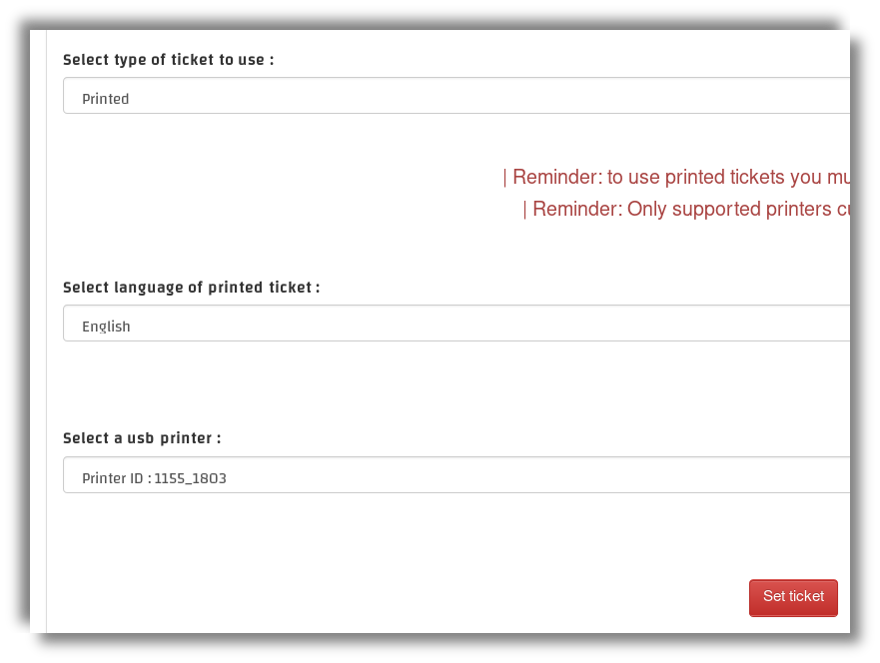

The End

