TEST CERTIFICATE

TC NO: AFPL/2026-27/101 DATE: 2026-07-14
CLIENT NAME: Nawaz Engineering Services

CLIENT PO NO: - 9876543210 PO DATE: 2026-07-14
FILTER SERIAL NUMBER: Test TESTING DATE: 2026-07-14
EQUIPMENT USED FOR TESTING: 2026-07-14
MANUFACTURER: - AIRFIL FILTECH PVT. LTD.
TYPE OF FILTER:

PRODUCT DETAILS

FILTER MEDIA | FILTER CAPACITY | FILTER DIMEMSION |  | MOC
HDPE + NON-WOVEN SYNTHETIC MEDIA + HDPE | Test | Test |  | ALUMINIUM
AIR FLOW RATE | INITIAL PRESSURE DROP | FINAL PRESSURE DROP |  | TEMPERATURE
Test | Test | Test |  | Test
TEST DATA

TEST AIRFLOW | AIR VELOCITY |  | AIR TEMPERATURE
Test | Test |  | Test
TEST RESULT

INITIAL PRESSURE DROP (Pa) | EFFCIENCY |  | FILTER CLASS
Test | Test |  | BS EN 1822
TEST TYPE: Test
INSPECTED BY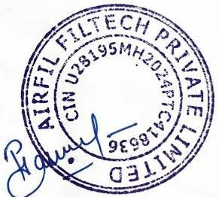

For Queries Related To TC Please Contact – quality@airfil.in Authorised Signatory

