TEST CERTIFICATE

TC NO: AFPL/2026-27/4283 DATE: 2026-09-30
CLIENT NAME: MACLEODS PHARMACEUTICALS LIMITED - PALGHAR PLANT
CLIENT PO NO: - PO-4500020105 PO DATE: 2026-08-18
FILTER SERIAL NUMBER: AFPL/202627/EU04/11666 TO 11677 TESTING DATE: 2026-09-28
EQUIPMENT USED FOR TESTING: 2026-09-28
MANUFACTURER: - AIRFIL FILTECH PVT. LTD.
TYPE OF FILTER: PRE FILTER - 20 MICRON (BOX TYPE)

PRODUCT DETAILS

FILTER MEDIA | FILTER CAPACITY | FILTER DIMEMSION |  | MOC
HDPE + Non-Woven Synthetic Media + HDPE Supported By Al Rod | 201 CFM | 400 X 170 X 25MM |  | ALUMINIUM
AIR FLOW RATE | INITIAL PRESSURE DROP | FINAL PRESSURE DROP |  | TEMPERATURE
201 CFM | 20 - 30 Pa | 150 Pa |  | AMBIENT
TEST DATA

TEST AIRFLOW | AIR VELOCITY |  | AIR TEMPERATURE
250 FPM | 25 °C |  | 25 °C
TEST RESULT

INITIAL PRESSURE DROP (Pa) | EFFCIENCY |  | FILTER CLASS
20 ± 5 % | 85% DOWN TO 20 MICRON |  | EU 04
TEST TYPE: BS EN 779
INSPECTED BY
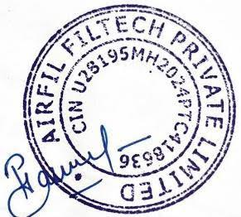



For Queries Related To TC Please Contact – quality@airfil.in Authorised Signatory

