TEST CERTIFICATE

TC NO: DATE:
CLIENT NAME:

CLIENT PO NO: - 12345 PO DATE: 2026-07-14
FILTER SERIAL NUMBER: SER/001 TESTING DATE: 2026-07-14
EQUIPMENT USED FOR TESTING: 2026-07-14
MANUFACTURER: - AIRFIL FILTECH PVT. LTD.
TYPE OF FILTER: FINE FILTER -- 3 MICRON (FLANGE TYPE)

PRODUCT DETAILS

FILTER MEDIA | FILTER CAPACITY | FILTER DIMEMSION |  | MOC
HDPE + NON-WOVEN SYNTHETIC MEDIA + HDPE | 2000 CFM | 610 X 610 X 305 MM |  | ALUMINIUM
AIR FLOW RATE | INITIAL PRESSURE DROP | FINAL PRESSURE DROP |  | TEMPERATURE
2000 CFM | 70 - 80 Pa | 450 Pa |  | AMBIENT
TEST DATA

TEST AIRFLOW | AIR VELOCITY |  | AIR TEMPERATURE
500 FPM | 25 °C |  | 25 °C
TEST RESULT

INITIAL PRESSURE DROP (Pa) | EFFCIENCY |  | FILTER CLASS
70 ± 5 % | 99% DOWN TO 3 MICRON |  | EU 07
TEST TYPE: BS EN 779
INSPECTED BY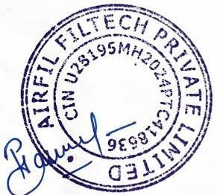

For Queries Related To TC Please Contact – quality@airfil.in Authorised Signatory

