TEST CERTIFICATE

TC NO: DATE:
CLIENT NAME:

CLIENT PO NO: - PO DATE:
FILTER SERIAL NUMBER: TESTING DATE:
EQUIPMENT USED FOR TESTING:
MANUFACTURER: - AIRFIL FILTECH PVT. LTD.
TYPE OF FILTER:

PRODUCT DETAILS

FILTER MEDIA | FILTER CAPACITY | FILTER DIMEMSION |  | MOC
AIR FLOW RATE | INITIAL PRESSURE DROP | FINAL PRESSURE DROP |  | TEMPERATURE
TEST DATA

TEST AIRFLOW | AIR VELOCITY |  | AIR TEMPERATURE
TEST RESULT

INITIAL PRESSURE DROP (Pa) | EFFCIENCY |  | FILTER CLASS
TEST TYPE:
INSPECTED BY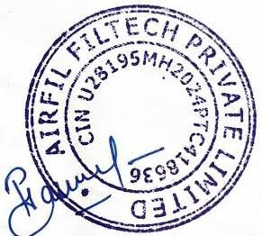

For Queries Related To TC Please Contact – quality@airfil.in Authorised Signatory

