|  |
| --- |
|  |
|  |
|  |

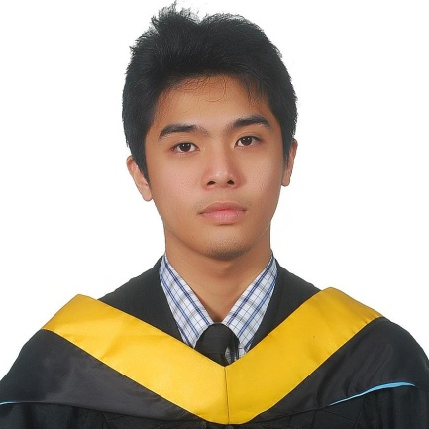

|  |  |
| --- | --- |
| Kenichi Shibata  +81 070-2195-0831  Saitama Prefecture Kuki City (346-0013)  kenichi.shibata3123@gmail.com  Japanese National |  |

Summary

A university graduated and IT Professional versed in Web Development, Front-end Engineer, Back-end Developer, and Computer Operations. Skilled in all aspects of office management, interpersonal communication and customer service. Accomplished competition programmer, leader and team manager. Values being on time and teamwork.

A dynamic, energetic, youthful person who can easily learn new things adapt company policies and work in a fast paced working environment using new technologies and frameworks. Thrives in working with new languages, implementation, software, technologies and organizational structure. Loves brainstorming with people and communicating consistently, gives out new ideas and has very flexible work expectations.

Skills

Core Skills

* Web Developer (HTML5,CSS3,PHP)
* Desktop and Mobile Developer(JAVA)
* Computer Operations and Functions (MS Office)
* Strong Analyst and Algorist (C,C++)
* Strong Relational Database Background(MySql)
* Knowledge in MVC Frameworks(Express, Sails, Ext.js)
* Knowledge of OOP Concepts and Practice(JAVA, PHP)

Hardware OS

* Windows (XP, 7, 8, Vista, 8.1)
* Linux (Ubuntu)

Software

Languages: SQL, C, C++, Excel Syntax, Windows CLI, Linux CLI, Java, Node/NPM

Databases: MS Access, MySQL

Applications: MS Excel, MS Word, MS Power point, Recuva, Sublime Editor, Netbeans, Eclipse, DevC++, Apache, XAMPP, Dreamweaver, Photoshop, Filezilla, CoreFTP, GitHub

Networking

Protocol: TCP/IP v4,

Device: Bridge, Router, UTP

Website Coding language

HTML5, CSS3, Bootstrap, Javascript, C/C++, PHP MySQL, MEANS Stack(basic), Phonegap, Jquery, JSON, XML, DOM, SpaceJS, NodeJS, PhaserJS

Sample Website Completed

http://mcvillstudios.com/ - A website made for wedding cinematography for McVill Studios

http://kenichishibata31.github.io/Kamatix-Final/ - A website made by Kenichi Shibata as a timer application.

Experience

2013 - 2014 | Customer Service Staff

The New Sanno Hotel | Minato-Ku Tokyo Japan

* Overall Customer Service
* Demonstrated and explained food products to the customers
* Set up various dining presentations for the customers

**2012 – 2013 |** College Student Council President (Student)

Bicol University College of Science

* Appointed Councilors for the Academic Year through rigorous selection processes
* Proposed, managed, procured and implemented projects throughout the year (Student Offices, Various Students Activities)
* Prepared the yearly budget plan, procurement plan, activities plan and scheduled/delegated all the departmental functions
* Prepared the yearly accomplishment report and approved the financial reports

2011 | Ateneo Programming Challenge (Student)

Ateneo De Naga

* Won as the champion of the Ateneo Programming Challenge 2011 using C++/C language
* Competed with 10+ teams throughout the region

Education

Bicol University College of Science 2015 | B.S. in Computer Science

* College Student Council President 2012-2013

Languages

English: Fluent

Japanese: Daily Conversational

Filipino (Tagalog): Fluent

Reference

Dr. Lucy P. Estioko (Available 9:00 – 18:00 JST)

Dean, Bicol University

College of Science, Albay Philippines

+639185053021 / (052) 481-2159 (Philippine Phones)