

Session: May, 2016
Supervisor’s Name: Mark Johnson

Group 3 Course
IB Subject of Essay: Economics
Word Count: 3897

Research Question: To what extent does the Palandöken Ski Center actively practice price discrimination?
Contents
INTRODUCTION 4
METHODOLOGY 5
BACKGROUND INFORMATION 6
What is Price Discrimination? 6
Types of Price Discrimination 8
1. First-degree price discrimination 8
2. Second-degree price discrimination 8
3. Third-degree price discrimination 9
INVESTIGATION 10
How Can Palandöken Resort Hotels Use Price Discrimination? 10
Primary Research Findings 11
CONCLUSION 14
IMPROVEMENTS 18
APPENDIX 19
1. Questionnaire 19
2. Interview 20
BIBLIOGRAPHY 21

INTRODUCTION

Erzurum Palandöken Ski Center is an important tourist attraction of Turkey in which there are 22 ski tracks, 5 hotels and about 5000 visitors every day. It is the best ski center in Turkey for skilled skiers because of the steepness of slopes, quality of snow, length of trail etc. This makes Palandöken Ski Center a popular destination for tourists and the resort welcomes visitors from all over the world, including Turkey.
There are 5 hotels which sell tickets to the ski lifts, rent ski equipment to visitors as well as hotel rooms to the visiting tourists and local people. For my essay, I will focus on whether the resort hotels use price discrimination as a method of maximizing their sales revenues. To investigate this price discrimination, I will compare the prices paid by three different groups of customer – Turkish residents of Erzurum, Turkish people living in other cities of Turkey and foreigners. It is my opinion that the hotels will actively pursue price discrimination, charging lower prices to locally based customers. This is based on my own experience having spoken to foreign tourists and asking them how much they paid for those items.
My essay will be based firstly on secondary research where I will outline the theory behind price discrimination and secondly, I will conduct a series of short interviews and surveys to collect my data. I intend to test my thesis and answer the question:
“To what extent does the Palandöken Ski Center actively practice price discrimination?”
The reason why I have chosen this topic is because I have been a keen skier since I was 8 years old and I have been skiing for 9 years. I also enjoy speaking to foreigners and sharing experiences with them. I will enjoy working on this essay.

METHODOLOGY

In writing this essay, I intend to complete the following:
Firstly, I will complete my secondary research where I will summarize ‘Price Discrimination’. After completing my secondary research I will start my primary research which will be based on surveys of customers at the ski center as well as interviews with hotel owners and the salesmen who rent ski equipment. I will start by going to Palandöken Ski Center to check the price of accommodation, ski equipment and ski lifts.
I will record this data and then choose 10 people from Erzurum, 10 from other cities of Turkey (who are here as tourists) and 10 foreigners. Then I will ask this sample to fill in a short questionnaire where they will detail the price that each paid for their accommodation, ski lifts and ski equipment.
Finally, I will make a table to record all the data. This data table will help me to compare the results and decide whether my results support my hypothesis or not. I intend to use the data as the basis for my in depth questionnaires, which will also help me to form my conclusions.
Lastly, having collected all of my data I will attempt to reach a conclusion as to the question: “To what extent does the Palandöken Ski Center actively practice price discrimination?”

BACKGROUND INFORMATION

What is Price Discrimination?
Price discrimination is the way of selling in which the producer charges different prices to different consumers for the exact same product or service. For example a cinema may charge a lower price for students but a higher price for the adults. In this case there is a price discrimination caused by the age of the two consumers. For a producer there should be three conditions which are listed below so that the producer can be able to price discriminate:
- To be able to price discriminate easily, the producer should have the price-setting ability. The more price-setting ability the producer has, the easier to price discriminate. Price discrimination generally occurs in imperfect markets rather than the perfect competition. That is why price discrimination mostly occurs in monopoly and oligopoly. This is because the more competitive the market and the more firms in the industry, the less ability each firm has to control prices – i.e. they become price takers, not price makers.
- A product with inelastic demand would generally be easier to price discriminate. This is because the more important a product is to a consumer, then the easier it to charge them higher prices. So another condition for price discrimination is that the consumers should have different price elasticities of demand for the product.
- The third condition is that the producer must be able to separate the consumers so that the segment(s) that pays a lower price for a product must not be able to resell the product on to a customer paying a higher price for the same product.
In order for producers to price discriminate, they must be able to separate the different markets by using the ways listed below:
- Time: Some consumers may be ready to pay higher prices at some certain times. For example a hotel may have more visitors at weekend rather than weekdays so the producer, in this case the hotel room, may charge lower prices at weekdays but higher prices at weekend. If the hotel can set the price correctly and discriminate the price well, they can maximize their profit.

- Age: Different ages may pay different prices for the exact same product or service. For example an airline company may charge less to a child than an adult for the flight ticket. The reason is that children has lower income so that their demand for the flight ticket is more price elastic.

- Income: Some firms may change prices according to the income level of the customer. Under this method, people with higher incomes (e.g foreign tourists) would pay more than people with lower incomes (Erzurum residents). Another example might be a university charging lower tuition fees for a student with lower income and higher tuition fees for a student with higher income.

- Types of the consumer: A firm that sells their product to the different consumers charges different prices to these consumers. Firms determine different rates for the different types of the consumer and these rates are determined with respect to the elasticities of demand of the consumer. For example ski resorts may charge different prices to foreign tourists than local consumers, because the hotel believes that foreign tourists and local residents have different PEDs, i.e. tourists are simply more willing and able to purchase the hotel at a higher price than the local resident.

In order to discriminate the price, at least three of the above conditions above should exist; if not price discrimination will not be possible. Generally people think that sales promotion is also a type of price discrimination but actually it is the shrewd attitude of the seller in order to attract the customers. For example nightclubs’ idea of taking the girls in with a lower price is actually a way for them to attract more boys to come in their nightclubs. In this sense sales promotion is not included to price discrimination.

Types of Price Discrimination
There are three levels of price discrimination to be considered;
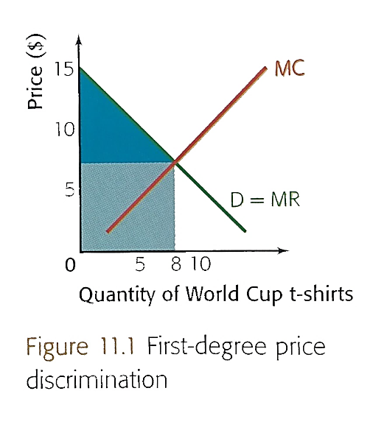
- First-degree price discrimination: This means charging each consumer the maximum price consumers are willing to pay.
Figure 1.1: First Degree Price Discrimination
For the Figure 1.1 the trader sells the product to different consumers at different prices. If that trader sells his product with the price where MC=MR, he would receive a revenue which is only the pale blue area but if the trader sells his products by discriminating the price, selling with higher prices to tourists, he will also get the dark blue triangle as a revenue. In this case the hotel will charge higher prices during the peak season when demand is higher and less during the off peak season. This method effectively charges different prices for the same hotel room, depending on the time of the season that they want it.
- Second-degree price discrimination: This is basically charging different prices depending on the quantity consumed.
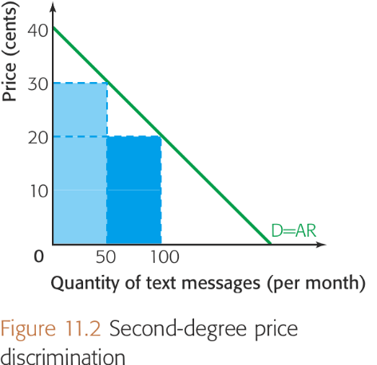
Figure 1.2: Second Degree Price Discrimination
For the Figure 1.2 the GSM company decreases the price if the user sends more than 50 messages per month. Normally if the price stays the same GSM Company should get only the pale blue rectangle as a revenue but by discriminating the price they could also earn the dark blue rectangle as a profit. Relating this method of discrimination to my essay, the hotel would charge a lower daily rate to visitors staying longer periods. As the consumers are willing and able to stay more, then the hotel will charge these consumers less per night which will help hotel to maximize their profits. In my research the quantity stands for the number of nights that consumers will stay.

- Third-degree price discrimination: This means charging different prices depending on a particular market segment, e.g. age profile, income group, time of use.
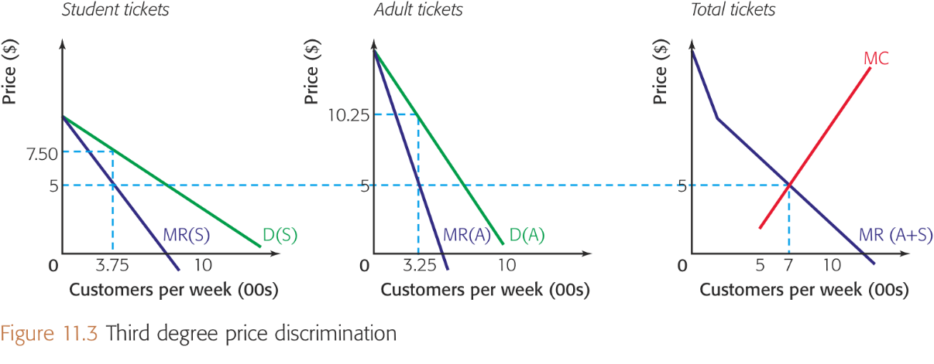
Figure 1.3: Third Degree Price Discrimination

Here in figure 1.3 the cinema knows that students have more price elastic demand for going to the cinema because they have lower income. I.e. they are more sensitive to price than people in fulltime employment. In this sense they charge lower prices to students, by contrast they charge higher to adults since they have higher income. In this example the student price would be 7.5 TL and the adult price 10.25. Both prices are higher than the marginal cost of the ticket at 5TL. If the cinema did not price discriminate they would have to charge either 7.5 TL and miss out on additional revenue from adults or charge 10.25 and have lower demand from students. In this way consumer surplus is reduced and profits are raised as the cinema is filled with discounted tickets, rather than having this segment ignore the cinema.

INVESTIGATION

How Can Palandöken Resort Hotels Use Price Discrimination?
It is my belief that Palandöken hotels are able to use first, second and third degree price discrimination because they are able to separate the market. For my essay I will presume that there are three different types of customer – local residents (people living in Erzurum), Turkish tourists from Istanbul, Izmir and other wealthy Turkish cities as well as foreign (i.e. non-Turkish speaking) tourists.
The reason why foreigners cannot simply get Turkish people to purchase their hotel rooms is that the identity card of the customers are needed during the check in process. This is really important for hotels since they separate their market in this process. The identity card gives enough information about the nationality of the customer so that hotels are getting information in order to practice third degree price discrimination. This process enables hotels to separate the Erzurum residents from İstanbul and other wealthy Turkish cities’ residents. Distinguishing them from foreigners is very easy. They are looking at the hometown of the customer and trying to offer the best price, based on what they believe customers are willing and able to pay.

Primary Research Findings
The survey that I have done in Palandöken Ski Center shows the price discrimination clearly. Data tables are created and shown below:

Table 1: Price paid by local people
Subjects | Price paid for one night in Dedeman Hotel (TL)
Erzurum | 230
Erzurum | 230
Erzurum | 230
Erzurum | 230
Erzurum | 235
Erzurum | 240
Erzurum * | 210
Erzurum * | 210
Erzurum * | 210
Erzurum * | 225
Table 2: Price paid by people from different cities of Turkey
Subjects | Price paid for one night in Dedeman Hotel (TL)
Ankara | 235
Ankara | 235
Ankara | 235
Kocaeli | 230
Kocaeli | 230
Eskişehir | 230
Adana | 230
İstanbul | 235
İstanbul* | 215
İstanbul* | 215

Table 3: Price paid by foreigners
Subjects | Price paid for one night in Dedeman Hotel (TL)
England  (Native Foreigner) | 245
USA | 300
Bulgaria | 280
Finland | 280
Austria | 280
Russia | 265
USA* | 245
New Zealand* | 230
Georgia* | 220
Iran* | 230

Note: Subjects with (*) near them are taken towards the end of the season. (March 15, 2015)
Graphical representations of the above data are as follows:

Average percentage change of the above data is as follows calculated by the formula:
$\frac{(Average Price 2(People from Turkey or Foreigners)-Average Price of Local Residents)}{Average Price of Local Residents}×100$
Table 4: Average Prices and the Percentage Change of Prices
 | Local Residents | People from Turkey (Others) | Foreigners
Average Prices in the Season | 232,5 | 232,5 | 275
Average Prices towards the end of the season | 213,75 | 215 | 231,25
Percentage Change in the Season | - | 0% | 18.2796%
Percentage Change Towards the end of the season | - | 0.939% | 8.4507%

CONCLUSION
In this investigation, there had been 10 sample prices for each of the 3 types of costumers: Local residents, people from different cities and foreigners. All the data are from two different weeks in which one of them is taken during the ski season and the other one is taken towards the end of the ski season. (Marked with “*” sign.)
According to the results, in the ski season, people from other cities of Turkey pay approximately same price (0%) with the local residents. On the other hand, foreigners pay approximately 18.2796% more than the local residents. Towards the end of the season this percentage falls to 8.4507%.
Data tables above have shown that customers have paid different prices for the same product or service at a given time. This shows that hotels are practicing the price discrimination depending on the criteria listed in the introduction part. According to the tables above there are two factors that the hotels use to separate the markets: Income, based on the nationality of the customers and the time, based on the ski season when more or less customers are willing and able to pay for their goods and services.
Starting from the income of the customers, results show that local people pay the least price compared to the people from other cities and the foreigners. This result depends on the fact that local people earn less than the rest of the country and foreigners because of the cheaper living standards as a result of the geographical position of Erzurum which is the east part of the Turkey.
People from the other cities of Turkey pay slightly more than the local residents. This result depends on the fact that as you go from east to west part of the Turkey, the living standards rise and causes an increase in the wages. As a result of a difference in wages, hotel management sets different prices for the customers coming from different parts of the Turkey. Within the results of the people from other cities of Turkey, the hypothesis of “the prices rise as you go from east to west” is supported. In fact, not the geographical position of the city but the importance of the city and living standards determine the price of the hotels. According to the results taken from the questionnaire, people in İstanbul which is the most well-known and expensive city of Turkey pay more than anyone in the Turkey as a result of the highest wages in the country. Ankara is the second city that pays more than other cities of Turkey. This is because Ankara is the capital city of Turkey and like İstanbul, Ankara is also an expensive city which is a result of higher wages. Rest of the results for the other cities of Turkey, the prices are approximately same with the local residents which might seem a little bit strange. According to the price discrimination logic, people from different cities of Turkey other than Erzurum are supposed to pay more than the local residents. Probably; since the skiing is a luxury activity, hotel management thinks that local people who prefer to lodge in the hotel although they have their house in the city are willing and able to pay more for the goods and services of the hotel; so the hotel management considers these customers as customers who came from the other cities of Turkey and charge the same as the other people pay.
Foreigners are the customers who pay the highest prices for the hotels. This can be explained by the price elasticity of demand theory. The theory says that quantity demanded for a product or service responses to the change in price. In this investigation, it is known that tourists have lower price elasticity than the people from other cities of Turkey and the local people. This means tourists’ demand for the hotels will have a slight change for the increase in prices of the hotels. A lower PED is caused by the same theory of the people who live in the big and expensive cities of Turkey and the local people: Foreign people earn more money compared to the people in Turkey and also the difference in the currency provides them a chance to have a more valuable money in Turkey. When the foreigners are compared within themselves, it can be seen that American people pay more money than any other foreigners which shows that American people have the least price elasticity. Most of the customers from the European countries pay the same prices because of a similar price elasticities. Only Russian customer pays less than the other European countries probably because of the wide range of skiing opportunities in Russia. Hotel management sets a different and a cheaper price for the Russian people in order to attract them for their hotels instead of the hotels in Russia. The customer from the England is an exceptional sample in which he is capable of talking in Turkish. Normally, a British customer is supposed to pay a price similar to the American; however the hotel management set a lower price closer to the local people in order to appeal the customer.
The other factor that hotels use to price discriminate is the time of the year. The data in the tables show that towards the end of the skiing season the prices are lower than the normal skiing season. Price elasticity of demand theory can be used to explain the discrimination applied according to the time. In a normal season, there is a very high demand for the hotels so that although prices are very high, customers are willing and able to pay for the higher prices. Excess demand for the hotel rooms provides a chance for the hotel management to raise the price for their hotels by a logic that customers are ready to pay more. However, towards the end of the season, demand for the hotel room falls and this causes an excess supply. As a result of an excess supply, hotels lower the prices in order to attract more customers even if it is the end of the skiing season.
Having identified what I believe is evidence of price discrimination I wanted to test my theory by interviewing the manager of one of the most popular hotels, which I arranged on.
The manager of the Dedeman Hotel stated that they have 4 types of booking which are the ways of communicating with customers in order to practice price discrimination:
- Online booking
- Booking by telephone
- Booking in the hotel (Face to face)
- Regular Customers
He stated that it is very important for them to be able to practice price discrimination. A closer look at the booking types shows that the hotel charges different prices to different customers. For the online booking they reserve a limited number of rooms and the price for the rooms are determined transiently by the online receptionist according to the number of remaining rooms. For example a price of a room in the online booking can be 200 Turkish Liras when there are 10 rooms left and the price can go up to 250 when there is only 1 room left. This would be similar to first degree price discrimination, as the airlines do. Mr. Akca, the manager of the hotel, said that the prices for online booking are determined in a meeting of the board of directors and then applied in the booking websites such as “www.booking.com“ , “www.trivago.com” etc.
However the same process does not work for the booking by telephone. While people are booking for their rooms by telephone, the receptionist firstly asks where they are calling from in order to separate the customers. Mr. Akca says that after they have learned the hometown of the consumer, they are considering whether the hometown is wealthy or not and only then do they inform the consumers about the price. He outlined that there is not much difference in price between customers from Erzurum or customers from other Anatolian cities however they do apply a small difference if they are calling from Ankara, İstanbul and İzmir. These customers pay more and this difference comes from the income level of these cities, which are generally higher than the income of people from Erzurum or other Anatolian cities. In this sense the hotel believes that they are more willing and able to pay higher prices than the Anatolian cities’ customers.
While people are booking the hotel face to face, the prices go a little bit up. Mr. Akca explains this situation with these words: “When people come here for booking, we consider that they have only a few alternatives that is why they have to pay whatever the price we charge them is. As hotel administration we charge higher prices than normal but as always the price is negotiable. If they bargain with us, we may decrease the prices about 10-20 Turkish lira less.”
He also says that if the customer is a foreigner, they are charged more than the Turkish customers. According to Mr. Akca the reason for this is because foreigners have a lower price elasticity than Turkish customers which means they are willing and able to pay higher prices. The higher wages in foreign countries means that they are spending more money than Turkish customers and because of this reason they are ready to pay more for their rooms. Mr. Akca also says that they are charging different prices to different customers from different countries, meaning that Americans or people from the Middle East would pay more than Europeans who are more difficult to overcharge.
This can be explained by differing price elasticities. He uses these words to explain this situation: “We all know that Americans earn more than everyone else including Europeans and this means they can pay more than everyone else.” According to what Mr. Akca says the board of management determines some prices for the foreigners by considering the national income of these consumers. They give a decision-making-authority to the receptionists so that they can increase the prices about 10 to 20 Turkish liras.
The last type of customer is the regular customer such as pharmaceutical representatives. Mr. Akca says that for the regular customers they are generally charging the exact same price for the rooms and they do not practice the price discrimination for them.
According to the overall results of this investigation and the answers taken from the interview, it can be seen that hotels have different methods to maximize their profits. In order to use the advantages of price discrimination, they are separating their consumers and practicing the price discrimination. In other words, they charge consumers the highest price that they are willing and able to pay so that they get the maximum profit that they can get.

IMPROVEMENTS
The investigation has shown that ski resorts in the Palandöken Mountain practice price discrimination to get the maximum profit. Data taken from the consumers in the resorts have proven that price discrimination occurs. However for this investigation, only 10 data for each type of consumers are used which is the weakness of this investigation. Small sample may cause the danger of one or two rogue results and falsely skewing the figures. If there could be more than 10 data, there might be more accurate results that show whether price discrimination occurs or not; but the investigation has supported the limited data by the interview made by the hotel manager so that the manager has also mentioned the price discrimination. All the data used in this investigation are taken from only 1 of the ski resorts in Palandöken so that all the price are similar; however if there could be the data of the other hotels, the price discrimination within hotels can also be observed.
Since the investigation is limited to 4000 words, it might be normal to have 10 data for each, however the investigation is opened to the improvements in order to see the price discrimination logic and the way that producers/hotels use to maximize their profits.

APPENDIX

Questionnaire
This is the script of the questions that I have asked to the consumers of the hotels in the Palandöken Ski Center to learn about the way hotels use to practice price discrimination:


Bilkent Erzurum Laboratory School
Economics Extended Essay Questionnaire

1: Where are you from?

2: How much do you pay for the hotel per night? (Including the ski lifts and ski equipments)

3: Do you think the hotel practice price discrimination?

Thank you.
Student

Interview
This is the interview that I have made with the hotel manager to learn about the way hotels use to practice price discrimination. This is translated from the original and oral conversation.
Me: Hello Mr. Akca! I am here to learn about price discrimination that is practiced by the hotels. Firstly, let me ask you whether you practice price discrimination or not? If yes, can you tell me about the way you follow for practicing the price discrimination?
Mr. Akca: Of course we do. Price discrimination is something that is legal in the economy. As a hotel that has a wide range of tourist attraction from all around the world, we do practice price discrimination to make as much profit as we can. The most important thing about the price discrimination is that you should be able to practice price discrimination. We, as the Board of Directors of the hotel, have a meeting at the beginning of every week to talk about the profits and the prices. In these meetings, we are trying to find appropriate prices for the hotels in order to maximize our profits. During these meetings, we consider the price discrimination and we try to set the prices according to the price discrimination concepts. Let me explain these concepts from the booking ways of our hotels. We have 4 types of booking in our hotel: Online booking, booking by telephone, booking in the reception desk, regular bookings. Let me start with the online booking: In the meetings, we set a certain number of rooms that are reserved for the online booking. While people try to book from the websites like trivago.com etc., the online receptionist set different prices according to the number of rooms left for the online booking. As the number of rooms reserved for the online booking falls, the prices go a little bit up. If the consumers are booking on the telephone, the receptionists have the price-setting ability. They firstly ask where the consumers are calling from and then they set a price for these consumers according to their cities’ or countries’ average wealth level. When it comes to face to face booking where it take place in the reception desk, it becomes easier for us to take the prices up. When people come here for booking, we consider that they have only a few alternatives that is why they have to pay whatever the price we charge them is. As hotel administration we charge higher prices than normal but as always the price is negotiable. If they bargain with us, we may decrease the prices about 10-20 Turkish lira less. The regular consumers like pharmaceutical representatives we always have the same prices so that we do not practice price discrimination for these consumers. In general, I can say that tourists pay more than any other consumers and this is very normal. We all know that Americans earn more than everyone else including Europeans and this means they can pay more than everyone else. We set the price by looking at the wages so that it’s normal for these people to pay more. By considering that you know about the price elasticities, I can say that it is all about the price elasticity of these consumers. That’s all I can say about the hotels, do you have any other question?
Me: No, thank you Mr. Akca.

BIBLIOGRAPHY

Blink, J., & Dorton, I. (2011). IB Economics. Oxford: Oxford University Press.
Glass, M. (n.d.). Houston Chronicle. Retrieved from Chron: http://smallbusiness.chron.com/3-types-price-discrimination-25634.html
Phlips, L. (1999). The Economics of Price Discrimination. New York: Cambridge University Press.
Wikipedia. (2011). Retrieved from Wikipedia, the free encyclopedia: https://en.wikipedia.org/wiki/2011_Winter_Universiade

(2011 Winter Universiade, 2011)
(Glass, n.d.)
(Blink & Dorton, 2011)
(Blink & Dorton, 2011)
(Blink & Dorton, 2011)
(Blink & Dorton, 2011)
(Blink & Dorton, 2011)
(Phlips, 1999)
(Phlips, 1999)
(Phlips, 1999)
(Blink & Dorton, 2011)

