Generic plugin framework for independent AndrOBD extensions
This document describes the concept of a generic extension plugin framework for AndrOBD application.
In order to keep the AndrOBD app rather small and easy, any functional extension to AndrOBD shall be realized as independent plugin to the AndrOBD main app.

Content
Requirements: 2
Architecture 3
Overview 3
Plugin support package 3
Host application 3
Extension plugins 3
Design 4
Extension plugins 4
Identification of plugins 4
Actions: 4
IDENTIFY: 4
Features of plugins 5
PLUGIN_CONFIG 6
Actions: 6
CONFIGURE 6
MANUAL_ACTION 7
Actions: 7
ACTION 7
DATA_UPDATE 7
Actions 8
DATALIST 8
DATA 8
DATA_PROVISION 10
Actions 10
DATALIST 10
DATA 10
Host application (AndrOBD) 11
Plugin handler 11

Requirements:
- Extension plugins shall be installable as a separate apk package.
- Extension plugins shall NOT be executable as stand alone application.
- Extension plugin packages shall be invoked and utilized by the AndrOBD application.
- The operation of AndrOBD shall NOT be dependent on the existence of extension plugin packages.
- All configuration activity concerning the extended functionality shall be handled by extension plugins package.
- All storage of configuration settings concerning the extended functionality shall be handled by extension plugins package.
- Communication between AndrOBD and the installed plugins shall use the common Android system mechanisms.
- AndrOBD shall identify all existing extensions at application startup.
- AndrOBD shall allow to enable / disable identified extension plugins.
- AndrOBD shall allow to initiate a configuration method / dialog for each extension plugin. (if applicable)
- AndrOBD shall allow to manually initiate the execution of the extension plugin's intended action. (if applicable)
- AndrOBD shall allow processing and display of additional data items received by the extension plugin. (if applicable)

Architecture

Overview
@startuml
skinparam componentStyle uml2
set namespaceSeparator ::

package com.fr3ts0n.androbd.plugin {
abstract class Plugin {
}
class PluginHandler {
}
}

package HostApplication <<cloud>> {
package AndrOBD {
class MainActivity {
}
class SettingsActivity {
}
}
}

PluginHandler *- MainActivity
SettingsActivity -o MainActivity

package Plugins <<cloud>> {
package "xx.yy.csvlogger" as cvslogger {
class CsvLoggerPlugin {
}
Plugin <|-- CsvLoggerPlugin
}
package "aa.bb.cc.mqttpublisher" as mqttpublisher {
class MqttPublisherPlugin {
}
Plugin <|-- MqttPublisherPlugin
}
}

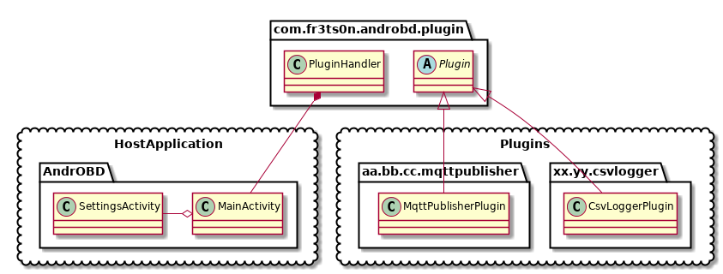
@enduml

Plugin support package
All classes and interfaces of the plugin framework shall be located in the package:
- com.fr3ts0n.androbd.plugin
The package shall contain:
- Generic plugin interfaces
- Plugin abstract implementation classes
- Host application (AndrOBD) plugin handler classes

Host application
The host application (AndrOBD) shall use- and adapt to the plugin handler class:
- com.fr3ts0n.androbd.plugin.PluginHandler

Extension plugins
AndrOBD extension plugin implementations shall be located it their corresponding target packages.
In order to implement above requirements, AndrOBD extension plugins shall extend the abstract class:
- com.fr3ts0n.androbd.plugin.Plugin.

Design

Extension plugins

Identification of plugins
Every extension plugin shall identify itself with a response to a system broadcast intent of:
- com.fr3ts0n.androbd.plugin.Plugin.IDENTIFY

Actions:

IDENTIFY:
This request shall contain following information of the host application:
- NAME: Name
- VERSION: Version
- CLASS: Fully qualified class name
- FEATURES: Supported features (Bitmask)
- DESCR: Brief description of the extension plugin
- COPYRIGHT: Information about Author/Copyright
- LICENSE: Information about license
The response to this intent shall contain the identical information of the responding extension plugin.
@startuml

actor User
control AndrOBD

box “Plugins“ #lightgreen
control Extension1
control ExtensionN
end box

User -> AndrOBD : Start
AndrOBD --x Extension1 : Broadcast IDENTIFY (Name, Class, Features, Description … )
AndrOBD <- Extension1 : IDENTIFY (Name, Class, Features, Description … )
AndrOBD <- ExtensionN : IDENTIFY (Name, Class, Features, Description … )
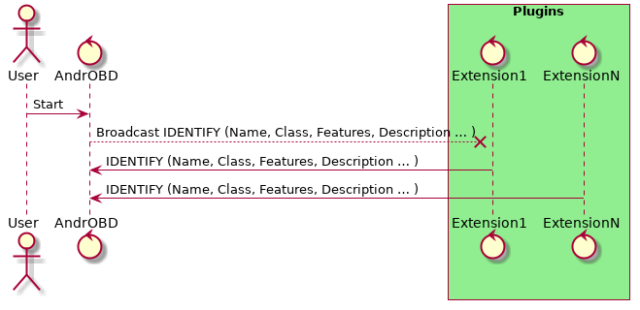
@enduml

Features of plugins
The very central part of the plugin framework is the Identification of plugins and the corresponding features which are supported by each extension.
Therefore the identification method includes the exchange of a value FEATURES, which is a bit-masked integer value.
Each supported feature is indicated by a bit value of 1 within the reported feature bitmask. All combinations of supported features shall be possible.
Following features are currently defined:
BIT | Feature | Description | Intent Action(s) supported
0 | PLUGIN_CONFIG | Configuration of extension supported | CONFIGURE
1 | MANUAL_ACTION | Manual trigger of intended action supported | ACTION
2 | DATA_UPDATE | Host application shall send data updates to extension | DATALIST  DATA
3 | DATA_PROVISION | Extension will provide data updates to host application | DATALIST  DATA

PLUGIN_CONFIG
This feature bit bit indicates that the plugin supports a configuration (dialog) to adjust all necessary parameters
This feature contains handling of following intended action notifications:
- com.fr3ts0n.androbd.plugin.Plugin.CONFIGURE

Actions:

CONFIGURE
On user request AndrOBD shall send an intent for action CONFIGURE to Extension plugins in order to trigger the configuration methods of Extension plugins .
On action request CONFIGURE Extension plugins plugin shall invoke it‘s configuration dialog / methods to allow configuration of all necessary parameters for it‘s operation.
@startuml

actor User
control AndrOBD
entity Vehicle

box “Plugins“ #lightgreen
control Extension1
control ExtensionN
end box

alt Extension enabled?
alt Feature supported?
User -> AndrOBD : Configure Extension1
AndrOBD -> Extension1 : CONFIGURE
Extension1 -> Extension1 : Invoke configuration
end
end
…
alt Extension enabled?
alt Feature supported?
User -> AndrOBD : Configure ExtensionN
AndrOBD -> ExtensionN : CONFIGURE
ExtensionN -> ExtensionN : Invoke configuration
end
end
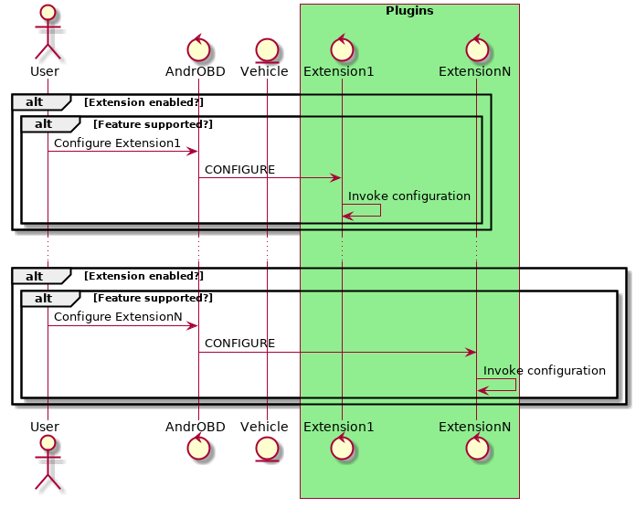
@enduml

MANUAL_ACTION
The extension plugin supports a manual trigger of it's intended action (in example: publishing received measurements to a server, logging a CSV line of received data, etc.)
This feature contains handling of following intended action notifications:
- com.fr3ts0n.androbd.plugin.Plugin.ACTION
Manual trigger the intended action of the extension plugin

Actions:

ACTION
On user request AndrOBD shall send an intent for action ACTION to extension plugins in order to manually trigger the intended action of extension plugins.
On action request ACTION extension plugins shall invoke it‘s intended action methods to allow the action to be performed on manual trigger.
@startuml

actor User
control AndrOBD
entity Vehicle

box “Plugins“ #lightgreen
control Extension1
control ExtensionN
end box

alt Extension enabled?
alt Feature supported?
User -> AndrOBD : Select Extension1 ACTION
AndrOBD -> Extension1 : ACTION
Extension1 -> Extension1 : perform intended action
end
end
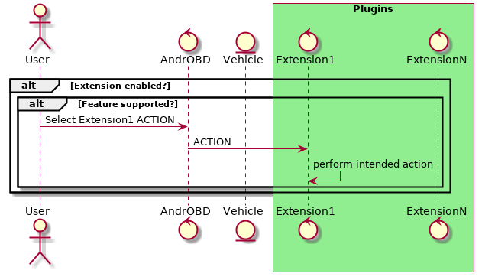
@enduml

DATA_UPDATE
The plugin supports handling of data item list and data value updates.
This feature contains handling of following intended action notifications:
- com.fr3ts0n.androbd.plugin.Plugin.DATALIST
Notification of available data items in current service
- com.fr3ts0n.androbd.plugin.Plugin.DATA
Notification of data value updates

Actions

DATALIST
Data item list notification shall contain following information for each data item:
- Name: Textual unique mnemonic name of data item
- SVC: OBD service identification
- PID: OBD PID identification of data item
- Description: Textual description of data item
- Units: Physical units of measurement value

DATA
Data item updates shall contain following information:
- Name: Textual unique mnemonic name of data item
- Value: Textual representation of data item value
AndrOBD notifies each (activated) extension of data item updates if this feature is supported
All data item updates shall be reported un-filtered.
If any data filtering, aggregation, statistics or any other post-processing of the data is necessary for the function of Extension plugins , it shall be handled by Extension plugins plugin itself.
@startuml

actor User
control AndrOBD
entity Vehicle

box “Plugins“ #lightgreen
control Extension1
control ExtensionN
end box

User -> AndrOBD : OBD Data display

AndrOBD -> Vehicle : OBD PID request
AndrOBD <-- Vehicle : supported OBD PIDs
AndrOBD -> AndrOBD : process list of PIDs

loop Extensions
alt Extension enabled?
alt Feature supported?
AndrOBD -> Extension1 : DATALIST
Extension1 -> Extension1 : process DATALIST
end
end
…
alt Extension enabled?
alt Feature supported?
AndrOBD -> ExtensionN : DATALIST
ExtensionN -> ExtensionN : process DATALIST
end
end
end

loop
AndrOBD -> Vehicle : OBD data request
AndrOBD <-- Vehicle : OBD data response
AndrOBD -> AndrOBD : process OBD

loop Extensions
alt Extension enabled?
alt Feature supported?
AndrOBD -> Extension1 : DATA
Extension1 -> Extension1 : process DATA
end
end
…
alt Extension enabled?
alt Feature supported?
AndrOBD -> ExtensionN : DATA
ExtensionN -> ExtensionN : process DATA
end
end
end
end
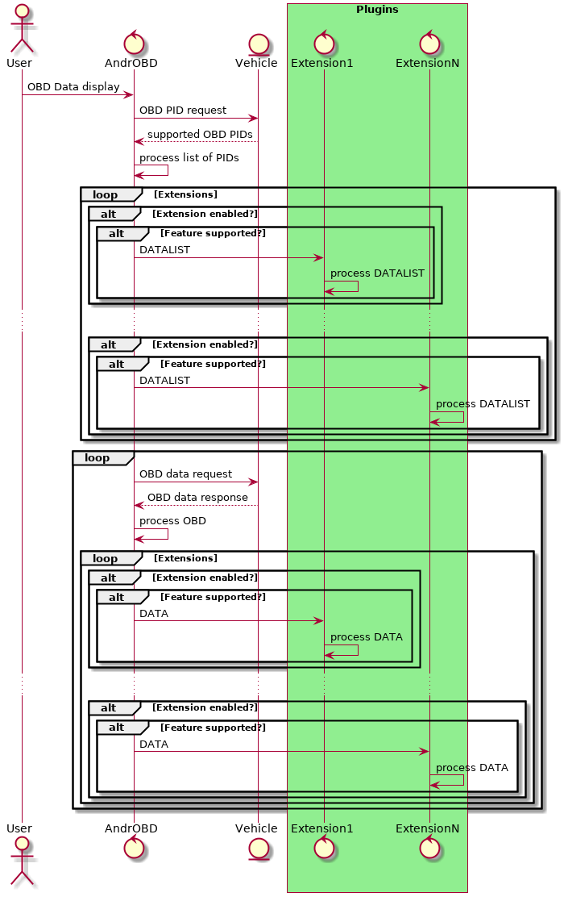
@enduml

DATA_PROVISION
This feature bit indicates that the extension plugin is capable of providing additional data to be displayed by the application.
This data provisioning works similar to the DATA_UPDATE feature, but into the opposite direction:
- Data updates are provided by the extension plugin.
indicated by DATA_PROVISION feature support of extension plugin.
- Data updates are processed by the host application.
indicated by DATA_UPDATE feature support of the host application.
This feature uses identical intent actions and data formats as the DATA_UPDATE feature, but into the opposite direction.
- com.fr3ts0n.androbd.plugin.Plugin.DATALIST
Notification of available data items
- com.fr3ts0n.androbd.plugin.Plugin.DATA
Notification of data value updates
DATA_PROVISION intents shall be sent by the extension plugin only, if the host application indicated the DATA_UPDATE feature to be supported!

Actions

DATALIST
Data item list notification shall contain following information for each data item:
- Name: Textual unique mnemonic name of data item
- SVC: OBD service identification (may be NULL)
- PID: OBD PID identification of data item (may be NULL)
- Description: Textual description of data item
- Units: Physical units of measurement value

DATA
Data item updates shall contain following information:
- Name: Textual unique mnemonic name of data item
- Value: Textual representation of data item value
@startuml

actor User
control AndrOBD
entity Vehicle

box “Plugins“ #lightgreen
control Extension1
control ExtensionN
end box

alt Extension enabled?
alt Feature supported?
ExtensionN -> AndrOBD : DATALIST (NAME, DESCR, UNITS, … )
AndrOBD -> AndrOBD : Process data list
AndrOBD --> User : Display new items
…
loop While extension running
ExtensionN -> AndrOBD : DATA (NAME, VALUE )
AndrOBD -> AndrOBD : Process data update
AndrOBD --> User : Display updated data
end
end
end
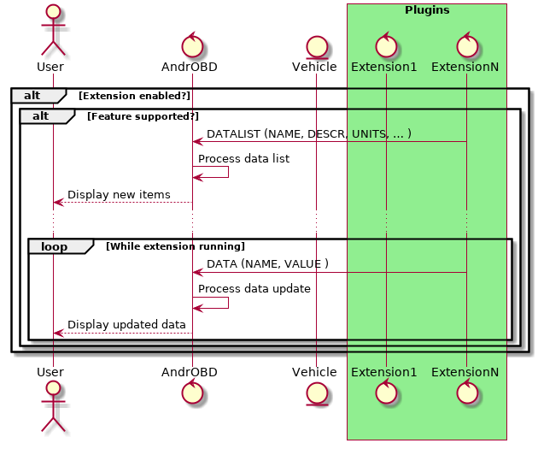
@enduml

Host application (AndrOBD)

Plugin handler
AndrOBD shall implement a handler to handle a indefinite number of extension plugins.
AndrOBD shall identify all installed extension plugins by sending a broadcast intent for action:
com.fr3ts0n.androbd.plugin.Plugin.IDENTIFY
AndrOBD shall collect the response information to this request and visualize the existence of the identified plugins.
AndrOBD shall allow to enable / disable usage of each identified plugin
AndrOBD shall analyze the reported features of each identified extension plugin to distinguish:
- Allow trigger of configuration of the extensions
- Allow trigger of manual execution of the intended action.
- What intents to be sent to the extension plugin.
- Expect reception of incoming data updates
AndrOBD shall send data updates to each extension which indicated support of this feature

