**Pew Research Cybersecurity - Pretest**

**310.111.00681.1**

III. INTRODUCTION

Base: All respondents

**DISPLAY**

Thank you for participating in this survey and we hope you enjoy it. The survey should take about 9 minutes for most people to complete.

Your responses to this survey are confidential and anonymous. You will not be individually identified and your responses will be used for research purposes only. You may skip any questions you feel uncomfortable answering.

IV. SCREENER

Base: All respondents

*Prompt*

**INTERNET**

How often did you USUALLY access the internet over the last year?

1. Every day

2. At least once a week but not every day

3. About once a week

4. About once a month

5. Less than once a month

6. Never

If INTERNET=6 (Never) or refused, mark as QFLAG=2 and skip to ACSLANG questions

V. MAIN QUESTIONNAIRE

SCRIPTER: Use default instruction text for each question type unless otherwise specified.

SCRIPTER: Do not prompt on all questions.

Base: All qualified respondents

**DISPLAY**

First, we’d like to explore some privacy and security issues. Here are a few questions of the sort you would see on a quiz show. Please answer the questions as best as you can. **(If you don’t know the answer, select “Not sure.”)**

RANDOMIZE AND RECORD ORDER OF QUESTIONS Q1-Q14

Base: All qualified respondents

*SCRIPTER: Randomize and record a-d. Always keep e last.*

**Q1 [S]**

What does the “http**s**://” at the beginning of a URL denote, as opposed to http:// (without the “s”)?

a) That the site has special high definition

b) That information entered into the site is encrypted

c) That the site is the newest version available

d) That the site is not accessible to certain computers

e) None of the above

f) Not sure

Base: All qualified respondents

*SCRIPTER: Randomize and record a-c, always keep d last.*

**Q2 [M]**

Which of the following is an example of a “phishing” attack?

a) Sending someone an email that contains a malicious link that is disguised to look like an email from someone the person knows

b) Creating a fake website that looks nearly identical to a real website, in order to trick users into entering their login information

c) Sending someone a text message that contains a malicious link that is disguised to look like a notification that the person has won a contest

d) All of the above **[S]**

e) Not sure

Base: All qualified respondents

*SCRIPTER: Randomize and record response list*

**Q3 [S]**

A group of computers that is networked together and used by hackers to steal information is called a….

a) Botnet

b) Rootkit

c) DDoS

d) Operating system

e) Not sure

Base: All qualified respondents

**Q4 [S]**

All WiFi traffic is encrypted by default on all wireless routers.

a) True

b) False

c) Not sure

Base: All qualified respondents

*SCRIPTER: Randomize and record response list order*

*Do not include notes in gray font*

**Q5 [M]**

Some websites and online services use a security process called two-step authentication. Which of the following images is an example of two-step authentication?

a) (Note: Picture of an actual two-step authentication screen)

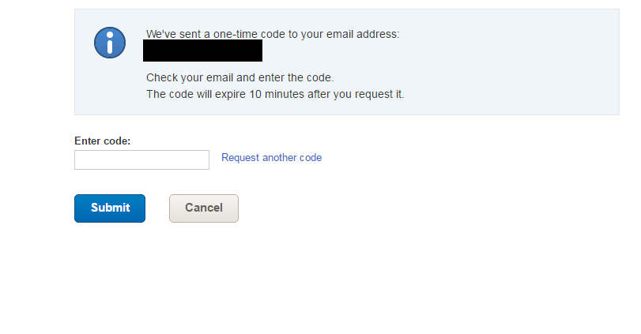b) (Note: Picture of a captcha)

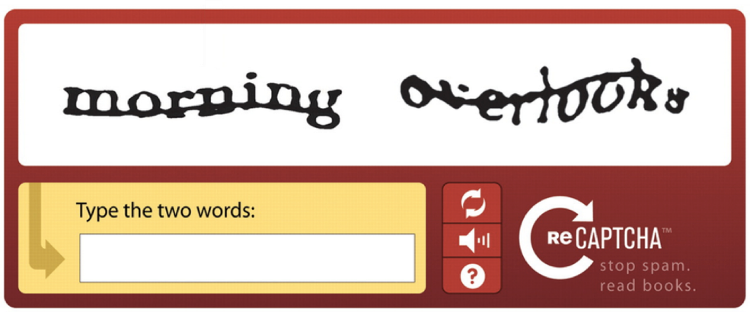

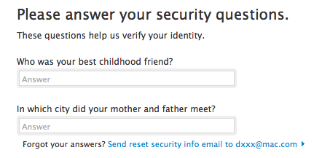c) (Note: Picture of a “What is your mother’s maiden name?” type screen)

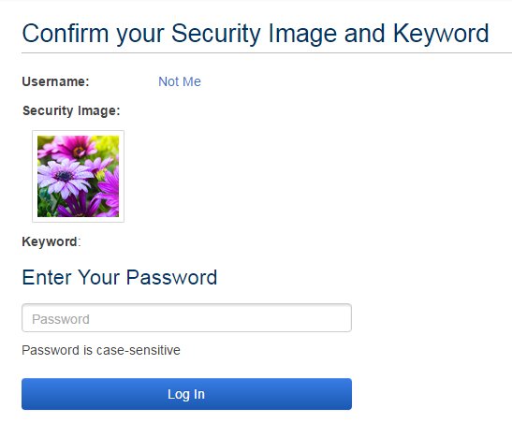d) (Note: Picture of one of those screens that shows you a graphic when you log in to let you know that you’re on the right site)

e) None of these **[S]**

f) Not sure

**[NO Q6]**

Base: All qualified respondents

*SCRIPTER: Randomize and record a-d. Always keep e last*

**Q7 [S]**

Criminals access someone’s computer and encrypt the user’s personal files and data. The user is unable to access this data unless they pay the criminals to decrypt the files. This practice is called….

a) A botnet

b) Ransomware

c) Driving

d) Spam

e) None of the above

f) Not sure

**[NO Q8]**

Base: All qualified respondents

**Q9 [S]**

“Private Browsing” is a feature in many internet browsers that lets users access web pages without any information (like browsing history) being stored by the browser. Can internet service providers see the online activities of their subscribers when those subscribers are using private browsing?

a) Yes

b) No

c) Not sure

Base: All qualified respondents

**Q10 [S]**

Turning off the GPS function of your smartphone prevents any tracking of your phone’s location.

a) True

b) False

e) Not sure

Base: All qualified respondents

**Q11 [S]**

All email is encrypted by default.

a) True

b) False

e) Not sure

Base: All qualified respondents

**Q12 [S]**

By law, how many **free** credit reports can Americans obtain in a calendar year from each of the three major credit bureaus?

a) 1

b) 3

c) 5

d) Zero

f) Not sure

Base: All qualified respondents

**Q13 [S]**

If a public WiFi network (such as in an airport or café) requires a password to access, is it generally safe to use that network for sensitive activities such as online banking?

a) Yes, it is safe

b) No, it is not safe

c) Not sure

Base: All qualified respondents

*SCRIPTER: Randomize and record order of response list*

**Q14 [S]**

What kind of cybersecurity risks can be minimized by using a Virtual Private Network (VPN)?

a) Use of insecure wifi networks

b) Key-logging

c) Tracking by website operators

d) De-anonymization by network operators

e) Phishing attacks

f) Not sure

Base: All qualified respondents

**Display**

Now we’d like to explore some of the ways you think about online activities, both by using computers and by using smartphones.

Base: All qualified respondents

**INTMOB [S]**

Do you access the internet on a cell phone, tablet or other mobile handheld device, at least occasionally?

a) Yes

b) No

Base: All qualified respondents

**INTFREQ [S]**

About how often do you use the internet?

a) Almost constantly

b) Several times a day

c) About once a day

d) Several times a week

e) Less often

Base: All qualified respondents

*Prompt*

**SMART1 [S]**

Do you own a smartphone?

a) Yes

b) No

c) Not sure

If XPEW=2 and SMART1=refused or b or c (No or Not Sure), mark as QFLAG=2 and skip to ACSLANG questions

Base: All qualified respondents

**SNSINT2 [S]**

Do you ever use social media sites like Facebook, Twitter or LinkedIn?

a) Yes

b) No

**END OF QUESTIONNAIRE**