Reentry

A spaceflight, atmospheric reentry simulator.

System requirements:
- Python3
- Following libraries:
  - Pynput
  - Numpy
  - Matplotlib

This software came as a personal challenge to combine old hobbies (physics and space) with new ones (programming, specific in Python). The goal was to keep it simple (just three libraries), fun (some easy changes allow for improved ‘gameability’) and pedagogic, so can be used by other for learning or teaching.
Three files should be in the same directory:
- reentry_(version).py (this is the main script)
- lift.py (contains some functions and a dictionary which are called in reentry...)
- Kazakhstan_map.png

Background

The Soyuz is a reliable spacecraft in use since the 60’s. Since the Space Shuttle program was canceled the Soyuz has been the only means astronauts have flown to the International Space Station until recently.
On its way back to Earth the three modules of the Soyuz detach from the ISS. Its propulsion module performs a burn to slow down the spacecraft a bit and let it fall to enter the 100Km altitude level aproximately above northern Irak.
Then the atmospheric induced drag reduces the Spacecraft speed from aprox. 7500 m/s (27000Km/h) almost horizontal to aprox 200 m/s (720Km/jh) almost vertical speed. At 10.7 Km altitude a series of parachutes are deployed to brake the capsule until the main parachute achieves a stable descending speed under 10 m/s. Finally, boosters under the capsule reduces even more the speed so the deceleration at touchdown is safe for the astronauts.
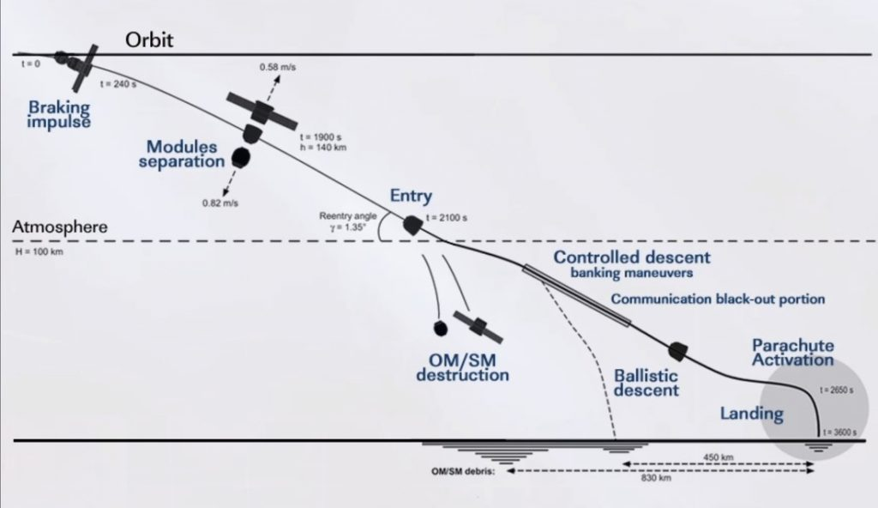

The reentry takes place during the ascending part of the orbit, heading north-east (51.6 degrees orbit inclination). This allows to predict with a certain accuracy where the reentry module will land. The weight distribution of the capsule is such that the center of mass is offset, meaning that during reentry the capsule is tilted with an inclination of aprox. 22 degrees.
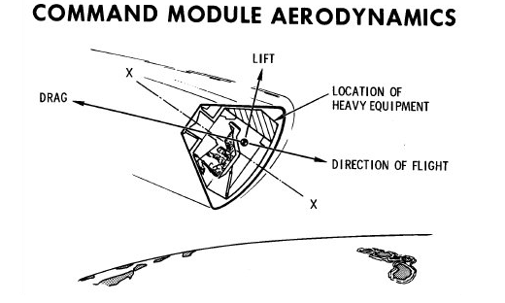

This inclination allow as well to achieve a certain degree of lift perpendicular to the drag force. By rotating the capsule, the lift vector can be oriented in any direction perpendicular to the drag vector. This allows to change a little the reentry path and ,e.g., aim better for the landing point.

This sofware

Assumptions
There are different “versions” of the Soyuz. I assumed 2.2 tons mass, aprox 2.5m diameter at the base and aprox 2.7m height.
A key equation that I used was the drag equation: Drag force = 0.5 x velocity x Cd x Area x rho, where…
rho: air density. Though there are Python libraries (e.g. Ambiance) that calculates atmospheric data, I used a set of formulas for troposphere, low stratosphere and high stratosphere (look here), at International Standard Atmosphere (this assumes aprox 25C at the surface...improbable in Kazakhstan, I think…).
Area: projected area of the object. I just took radius² * pi. At altitudes lower than 10.7Km parachutes are deployed so I just increased the area to simulate parachute opening.
Cd: drag coefficient. Normally determined in a wind tunnel. I found different values, ranging from 0.188 to 1.26. On the other side this Cd changes with the Reynolds number. For simplicity I assumed a higher Cd with lower air density. This helped to get some drag at the higher altitudes, where probably skin friction is more determinant in the overall drag (but I don’t know how to simulate it).
A drag implies a certain degree of lift, as I mentioned earlier. That’s why I assumed a fixed lift to drag ratio. Again, I couldn’t find a good explanation but it seems that 0.366 is a good aproach. It means that the lift vector has a 36.6% of the drag vector’s magnitude.
Look at this figure of the Apollo command module (source)
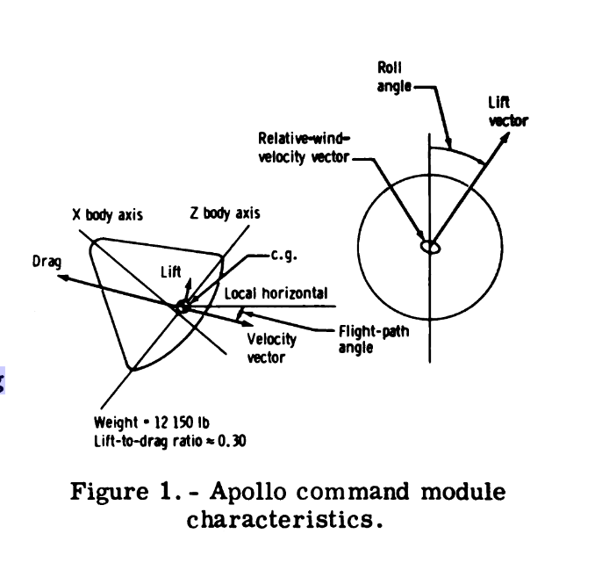

The figure above shows the ideas explained for the Apollo Command Module. In the case of the Soyuz is useful to understand that the “Flight-path angle” is about 22 degrees.

Display
First the user is asked to introduce a drag coefficient and L/D ratio (see below). Then the main window is shown.
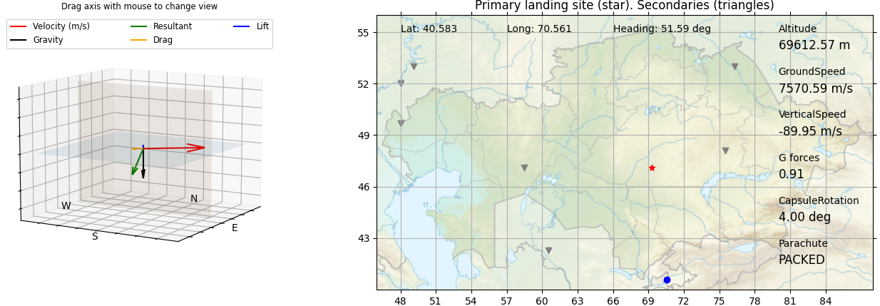
At the left a 3D graph show the velocity vector (arbitrary scale), equivalent to the direction of the flight, and other relevant force vectors (gravity, drag, lift and the vectorial sum of theese three).
To the right a map of Kazakhstan is displayed with primary and secondary landing points. Information about location, vertical and ground speed, calculated g-forces, altitude, heading and rotation of the capsule around the direction (velocity vector) is displayed, as well as the parachute’s status: ‘packed’ during most of the flight, ‘brake’ under 10.7Km altitude, ‘main’ under 9 Km.
Pressing ‘z’ will rotate the capsule anticlockwise (+) around the velocity vector. Pressing ‘x’ will rotate it clockwise (-).
Below 8.5Km altitude the simulation is stopped and a new window appears, showing a basic flight analysis: variation of altitude and g-forces vs time (‘iterations’), ground trajectory and final distance to the nearest landing point. Total flight time is presented too. Times goes slower than reality. Surely this depends on time spent on calculations, my [basic] programming skills and that I chose to do the software simple, just numpy and matplotlib. Sure other libraries had helped to make it faster.
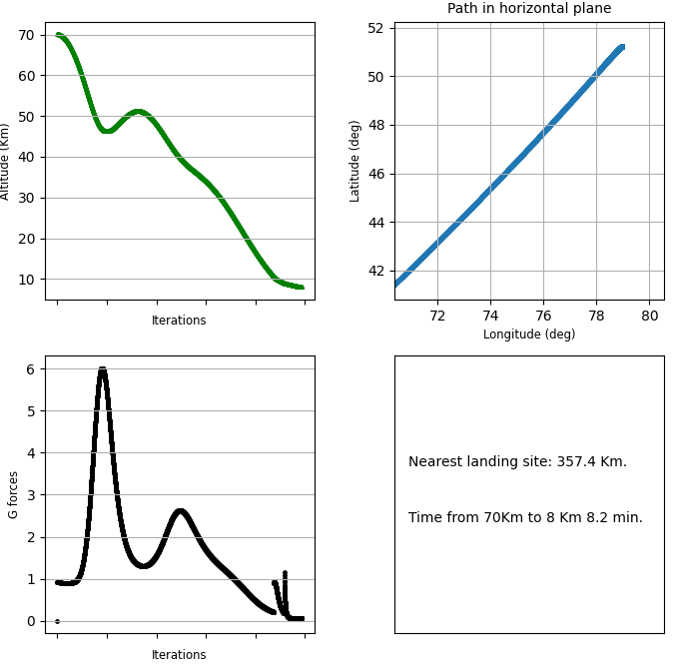

Flight analysis window.
Curious about further analysis of these data? A .csv file is saved in the same directory with these and some more parameters.

The flight
When running the script the user is asked to introduce a drag coefficient (Cd) and a lift to drag (L/D) ratio. By default these are 1.26 and 0.4. This setting gives a “realistic” experience (I mean, this are honest approaches to the real data I’ve found in the web). For “fun” I suggest 0.5 and 1.5 for longer flights and better possibilities to direct the capsule.
When the map is displayed, the capsule is shown at the bottom as a blue point. The longitude is randomly chosen each simulation. But the altitude is always 70Km. I chose this altitude because in my simulation didn’t get much drag or lift above with “realistic” Cd and L/D, probably because other factors other than my basic drag equation apply. The capsule moves with a 51.6 degrees heading (up- and rightwards, northeast), corresponding to the inclination of the ISS’s orbit.
Forces and velocity vector are displayed both in a side view (bottom right) and projected on the map. The velocity vector has its own scale. Forces have same scale.
As the capsule falls the atmosphere get more dense and the drag force increases. Because the lift to drag ratio is fixed, the lift force will be increased proportionally. If nothing is done this lift can be high enough to make the capsule go up during a while and the fall again, something well known in real spaceflight (‘skip reentry’, see figure below).

But if ‘z’ and ‘x’ are pressed, then the orientation of the lift vector will change around the velocity vector, pointing to one side and thus, changing the capsule’s heading and vertical velocity.
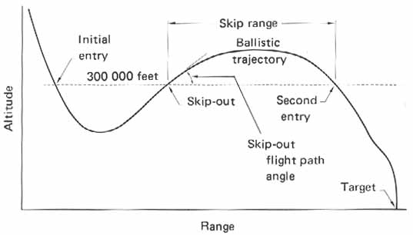

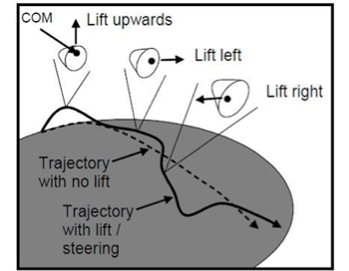

Taken from https://www.orbiterwiki.org/wiki/GPIS_6:_Reentry (left) and https://www.hq.nasa.gov/office/pao/History/SP-4209/ch3-4.htm , skip reentry (right). Looks similar to altitude graph in the flight analysis window shown before in ‘Display’.
The aim of the “game” is to adjust the ship trajectory so it lands as close as possible to the primary landing site. If not possible a secondary landing site should be chosen. The final flight analysis window shows the distance to the closest landing point. A longer distance implies a longer time waiting for the rescue team to come.
A secondary goal should be to avoid exposing the astronauts to high g-forces (i.e., intense decelerations). Though the human (trained) body can sustain higher g-forces during a short period, 9 g’s should be considered a limit to keep in mind (you can read this).
To prevent g-forces to build up and, at the same time, winning time and altitude for flying, I recommend holding the lift vector up (CapsuleRotation 0 degrees) until the resultant vector look slightly upwards. At that point the vertical speed stop decreasing (getting more negative) and changes towards positive values (vertical, upwards acceleration).
A balance in the lift rotation vector can be found to adjust both heading and vertical speed. That’s the ‘thing’ of the game.
The Apollo command module could be steered in a similar way, as far as I know. I understand that something similar happens to the Soyuz, but I didn’t found enough information in the sources I’ve found to state that.

What I’ve learned.
About spaceflight:
- I needed to understand better friction and aerodynamics in general. Glenn Research Center’s website is great.
- It’s amazing how lift can be achieved by moving the center of mass of an object and the rotating it.
- I read a lot about different form of friction, shockwaves and laminar vs turbulent flow.
- How the atmosphere is built and how it’s density varies with altitude (as well as viscosity, speed of sound...factors that I didn’t use finally in the software).
Maths:
- The mathematics of vectors and the differences between cross and dot products, for example.
- Love Rodriges formula to rotate a vector around an axis. I’ll never had finished this without it.
- Different map projections. Projecting a sphere on a plane is not an easy task. The equirectangular projection allows to have equidistant meridians and parallels, making way easier to represent changes in longitude and latitude. Thank you those who uploaded the Kazakhstan map in this projection.
Programming:
- Lots of problem solving and cleaning the code.
- The quiver command in Matplotlib for vectors visualization.
- Translating to code mechanics in the 3 dimensional axis.
- Being organized, developing test-scripts that should work before moving them to the “big” script.

