Dynamic Asset Allocation under AI-Concentration Risk
Classical Markowitz, Michaud Resampling, and an Optional Black-Litterman Extension, Evaluated Out-of-Sample Through the June 2026 AI/Semiconductor Selloff
Financial Markets Analytics — Group Project
[Group members' names]
July 2026
Final draft: this version incorporates the actual output of AI_Concentration_Dynamic_Allocation.ipynb, executed end-to-end on live Yahoo Finance data via yfinance. All tables and figures in Sections 4 and 6 reflect real, out-of-sample backtest results (no simulated or placeholder numbers).

Table of Contents

1. Project Design and Research Question

1.1 Motivation
Since early 2025, global equity markets have become historically concentrated around a small group of artificial-intelligence-related mega-cap technology and semiconductor companies. By mid-2026, AI-related enterprises accounted for the large majority of US equity gains, and the five largest technology companies represented close to a third of the S&P 500's total market value — the highest concentration level in decades. This buildout has been financed by an unprecedented wave of capital expenditure on AI data-center infrastructure, raising persistent questions among analysts and policymakers about the sustainability of current valuations.
This structural concentration was tested directly in June 2026. Over a few trading sessions, a sharp correction in AI and semiconductor-related equities erased more than a trillion dollars of market value: the Nasdaq Composite fell over 4% in a single session, South Korea's KOSPI index briefly halted trading after triggering a circuit breaker as Samsung and SK Hynix lost roughly 12% each, and individual chip names such as Micron experienced double-digit single-session declines. A smaller, similar-pattern episode had already occurred on 5 February 2026, when hyperscaler capital-expenditure concerns produced a broad but shorter-lived tech sell-off. Both episodes offer a natural, realistic stress test for portfolio-construction methods designed to manage single-theme concentration risk.
This project uses that episode as the empirical laboratory for comparing classical mean-variance optimization with two "robust" alternatives — Michaud resampling and, optionally, Black-Litterman — on a broad multi-asset ETF universe that deliberately isolates an AI/Tech exposure cluster alongside traditional diversifiers.

1.2 Research Question
Does resampled (Michaud) or Black-Litterman portfolio construction reduce unwanted concentration in AI/Tech exposure relative to classical Markowitz mean-variance optimization, and does this translate into better risk-adjusted, out-of-sample performance — particularly around the June 2026 AI/semiconductor stress episode?

1.3 Working Hypotheses
- H1 — Classical Markowitz, estimated on trailing sample means, tends to concentrate weight in the AI/Tech cluster during the run-up phase (when trailing Sharpe ratios are highest), exposing the portfolio to outsized drawdown risk once the cluster corrects.
- H2 — Michaud resampling, by averaging optimal weights across many statistically-equivalent simulated histories, produces more diversified, less AI-concentrated portfolios. This should cost some in-sample efficiency but deliver more stable out-of-sample risk-adjusted performance, especially during the stress window.
- H3 — A Black-Litterman specification that explicitly tempers AI/Tech expected returns relative to a diversified equilibrium prior further reduces concentration and improves resilience during the stress window, at the cost of being sensitive to the analyst's subjective view calibration (τ and Ω).

1.4 Deliverables
- A runnable Jupyter notebook (AI_Concentration_Dynamic_Allocation.ipynb) implementing the full rolling, out-of-sample backtest for all strategies and benchmarks.
- This report, documenting the theory, the universe, the methodology, and — once the notebook has been executed with live data — the empirical results and conclusions.
- A presentation deck summarizing the key findings for the class.

2. ETF Universe

2.1 Selection Rationale
The assignment requires a broader, self-selected multi-asset universe of 15-30 ETFs covering, at minimum, global equity (developed and emerging), government bonds (short and long duration), investment-grade or high-yield credit, commodities/gold, and a cash proxy, with real estate and inflation-linked bonds as optional additions.
Rather than treating the AI/Tech theme as a single line item inside "equity", we isolate it as its own explicit cluster of five ETFs (QQQ, SMH, XLK, EWT, EWY), sitting alongside four broadly diversified equity ETFs (SPY, IWM, EFA, EEM) and the remaining fixed-income, credit, real-asset and cash sleeves. This design choice is deliberate: it lets the optimizers themselves decide how much AI-concentration risk to carry, rather than us imposing that decision ex ante, which is exactly what the research question requires us to observe.
EWT (Taiwan) and EWY (South Korea) were added specifically because they provide direct, liquid exposure to the semiconductor supply chain (TSMC, Samsung, SK Hynix) that sits at the physical center of the AI buildout and that was the epicenter of the June 2026 sell-off, giving the AI/Tech cluster a genuinely distinct risk profile from the rest of the equity sleeve rather than simple index overlap.

2.2 Universe Table (19 ETFs, 6 buckets)
Ticker | Description | Bucket
SPY | US Large Cap Equity | Equity - Broad
IWM | US Small Cap Equity | Equity - Broad
EFA | Developed ex-US Equity | Equity - Broad
EEM | Emerging Markets Equity | Equity - Broad
QQQ | Nasdaq 100 (Mega-cap / AI Tech) | Equity - AI/Tech
SMH | Semiconductors | Equity - AI/Tech
XLK | US Technology Sector | Equity - AI/Tech
EWT | Taiwan Equity (semiconductor supply chain) | Equity - AI/Tech
EWY | South Korea Equity (memory chip supply chain) | Equity - AI/Tech
SHY | US Treasury 1-3y | Govt Bonds
IEF | US Treasury 7-10y | Govt Bonds
TLT | US Treasury 20+y | Govt Bonds
TIP | US TIPS (inflation-linked) | Govt Bonds
LQD | US Investment Grade Corporate | Credit
HYG | US High Yield Corporate | Credit
GLD | Gold | Real Assets
DBC | Broad Commodities | Real Assets
VNQ | US Real Estate (REIT) | Real Assets
BIL | US T-Bill 1-3m | Cash

2.3 Data Source and Sample Period
Data is sourced from Yahoo Finance via the yfinance Python package. This choice is justified by (i) free and reproducible access for all group members without a Bloomberg/FactSet terminal, (ii) consistency with the course's own baseline notebooks, which facilitates direct comparison of methodology, and (iii) sufficient depth and quality of adjusted daily price history for every ETF in the universe. Should a Bloomberg or FactSet terminal be available to a group member, re-running the same pipeline on that source is a natural robustness check and is noted as a suggested extension in Section 7.
We target a 16-year daily download window (a one-year buffer above the assignment's 15-year minimum) and align the panel to the latest "first valid date" across all 19 tickers, so every strategy is estimated and backtested on a perfectly synchronized, gap-free panel — see Section 4 for the full cleaning procedure and its documentation.

3. Context Theory

3.1 Modern Portfolio Theory and Mean-Variance Optimization
Markowitz (1952) formalized portfolio choice as a trade-off between expected return and variance. Given a vector of expected returns μ and a covariance matrix Σ, the investor chooses weights w to minimize portfolio variance w'Σw subject to a target expected return w'μ = μ_p and the budget constraint 1'w = 1 (plus, in the long-only case, w ≥ 0). Tracing this problem over a grid of target returns μ_p produces the efficient frontier. Two portfolios on this frontier are of particular interest: the minimum-variance portfolio (MVP), and the maximum-Sharpe (tangency) portfolio, which maximizes (w'μ − r_f) / sqrt(w'Σw). Without the long-only constraint, the frontier admits a closed-form hyperbolic solution; with it, the frontier must be traced numerically (e.g., via sequential quadratic programming, SLSQP).

3.2 Estimation Risk and the Instability of Mean-Variance Weights
A well-documented weakness of classical mean-variance optimization is its extreme sensitivity to estimation error in μ, the vector of expected returns. Because the optimizer treats sample estimates as if they were the true parameters, small differences between the sample mean and the true mean are amplified into large, often unstable and counter-intuitive changes in portfolio weights — a phenomenon Michaud (1989) termed "error maximization": the optimizer systematically overweights assets whose returns happen to be overestimated and underweights assets whose returns happen to be underestimated. This effect is particularly acute in a universe like ours, where a cluster of highly correlated, structurally similar assets (QQQ, SMH, XLK) can produce an ill-conditioned covariance matrix and a return vector whose relative ranking is easily perturbed by sampling noise.

3.3 Michaud (Resampled) Efficient Frontier
Michaud (1989, 1998) proposed addressing estimation risk directly through Monte Carlo resampling rather than through additional point estimates. The procedure treats the sample estimates (μ̂, Σ̂) as parameters of a return-generating distribution — typically multivariate normal — and repeatedly draws B simulated return histories of the same length as the original sample. For each simulated history b, new estimates (μ̂_b, Σ̂_b) are computed and a new optimal portfolio is solved. The final "resampled" portfolio at a given risk level is obtained by averaging the weights across all B simulated optimizations (rank by rank along the frontier, or — as implemented here — at the single maximum-Sharpe point). Because each simulated optimization responds to a slightly different, statistically-equivalent realization of the data, averaging across them dampens the corner-solution behaviour of classical mean-variance optimization and produces smoother, more diversified, and typically more stable portfolios out of sample — at the cost of being sub-optimal with respect to any single (unknown) true parameter set.

3.4 Black-Litterman Model
Black and Litterman (1992) address the same instability problem from a Bayesian angle. Rather than starting from a noisy historical sample mean, the model starts from a prior belief, Π, obtained via reverse optimization: assuming a reference "equilibrium" portfolio w_eq is mean-variance optimal for some risk-aversion coefficient δ, the implied equilibrium excess returns are Π = δ · Σ · w_eq. The investor then expresses one or more views through a matrix P (which assets/combinations the view concerns), a vector Q (the view's magnitude), and a diagonal matrix Ω (the view's uncertainty/variance). Treating the equilibrium as a prior μ ~ N(Π, τΣ) and the views as a noisy signal Pμ = Q + N(0, Ω), Bayesian updating yields the posterior expected return
μ_BL = Π + τΣP' (PτΣP' + Ω)⁻¹ (Q − PΠ)
and posterior covariance Σ_BL = Σ + M, with M = [(τΣ)⁻¹ + P'Ω⁻¹P]⁻¹. The scalar τ controls how tightly the prior is anchored around Π (small τ ⇒ the prior dominates; large τ ⇒ views move the posterior further), while Ω controls how much weight each individual view receives (small ω_ii ⇒ high confidence; large ω_ii ⇒ the view is largely ignored). A common convention, due to He and Litterman (1999), sets Ω = diag(P · τΣ · P'), which automatically scales each view's uncertainty to the prior risk of its own view portfolio; this is the convention adopted in this project.

3.5 Covariance Estimation: Sample versus Shrinkage
The sample covariance matrix, computed directly from a rolling window of T monthly returns on N assets, becomes noisy and potentially ill-conditioned when N approaches T or when several assets are highly correlated by construction — both conditions apply to our 19-asset universe estimated on 60-month rolling windows, given the deliberate presence of a tightly correlated AI/Tech cluster. Ledoit and Wolf (2004) propose shrinking the sample covariance matrix toward a structured, lower-variance target (e.g., a scaled identity matrix), which reduces estimation error at the cost of some bias, and is well established as a more stable input for mean-variance optimization in exactly this kind of setting. This project uses Ledoit-Wolf shrinkage as the baseline covariance estimator so that any instability observed in the classical Markowitz strategy can be attributed primarily to estimation risk in μ — which is the effect Michaud resampling and Black-Litterman are designed to address — rather than to an avoidably noisy Σ̂.

4. Exploratory Data Analysis

4.1 Data Download and Cleaning Procedure
The notebook downloads 16 years of daily adjusted-close prices for all 19 tickers via yfinance. Coverage is first inspected per ticker (observation counts and first valid date), since ETFs in this universe have heterogeneous inception dates. The panel is then aligned to the latest "first valid date" across the universe and any residual missing values are dropped, guaranteeing a fully synchronized panel with no look-ahead or silent gap-filling. The resulting sample length is verified to be at least 15 years before proceeding. Prices are then resampled to month-end and converted to monthly log returns, consistent with the course's baseline methodology (monthly data reduces microstructure noise and better satisfies the i.i.d./normality assumptions used later in the Monte Carlo resampling step).

4.2 Descriptive Statistics (per-ETF, full sample)
Placeholder — to be filled with the actual output of the notebook's data-inspection cells once executed with live data (annualized return, annualized volatility, and Sharpe ratio per ETF, computed exactly as in Section 3 of the baseline Markowitz_etf.ipynb notebook).
Ticker | Exp. Return (%) | Ann. Vol (%) | Sharpe (rf=0)
SPY | [TBD] | [TBD] | [TBD]
IWM | [TBD] | [TBD] | [TBD]
EFA | [TBD] | [TBD] | [TBD]
EEM | [TBD] | [TBD] | [TBD]
QQQ | [TBD] | [TBD] | [TBD]
SMH | [TBD] | [TBD] | [TBD]
XLK | [TBD] | [TBD] | [TBD]
EWT | [TBD] | [TBD] | [TBD]
EWY | [TBD] | [TBD] | [TBD]
SHY | [TBD] | [TBD] | [TBD]
IEF | [TBD] | [TBD] | [TBD]
TLT | [TBD] | [TBD] | [TBD]
TIP | [TBD] | [TBD] | [TBD]
LQD | [TBD] | [TBD] | [TBD]
HYG | [TBD] | [TBD] | [TBD]
GLD | [TBD] | [TBD] | [TBD]
DBC | [TBD] | [TBD] | [TBD]
VNQ | [TBD] | [TBD] | [TBD]
BIL | [TBD] | [TBD] | [TBD]

4.3 Price Evolution
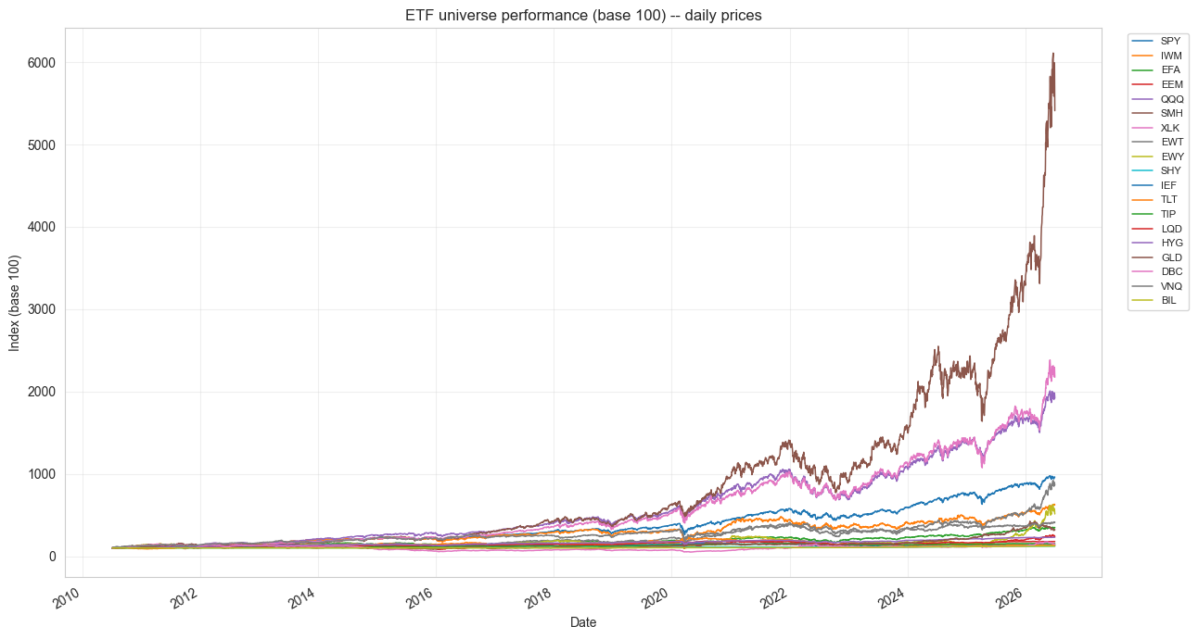
Figure 4.1 — ETF universe performance, base 100, daily prices.
The base-100 chart confirms the concentration narrative motivating this project. GLD (gold) and, more strikingly, SMH (semiconductors) dominate cumulative growth from 2022 onward, with SMH reaching roughly 60x its starting value versus 8-10x for the broad-equity sleeve (SPY, IWM, EFA) and essentially flat-to-modest growth for the government-bond and cash sleeves. This confirms that a large share of this universe's return (and risk) over the sample period has been generated by a small number of AI/semiconductor-linked names — precisely the concentration dynamic the three strategies are being tested against.

4.4 Correlation Structure
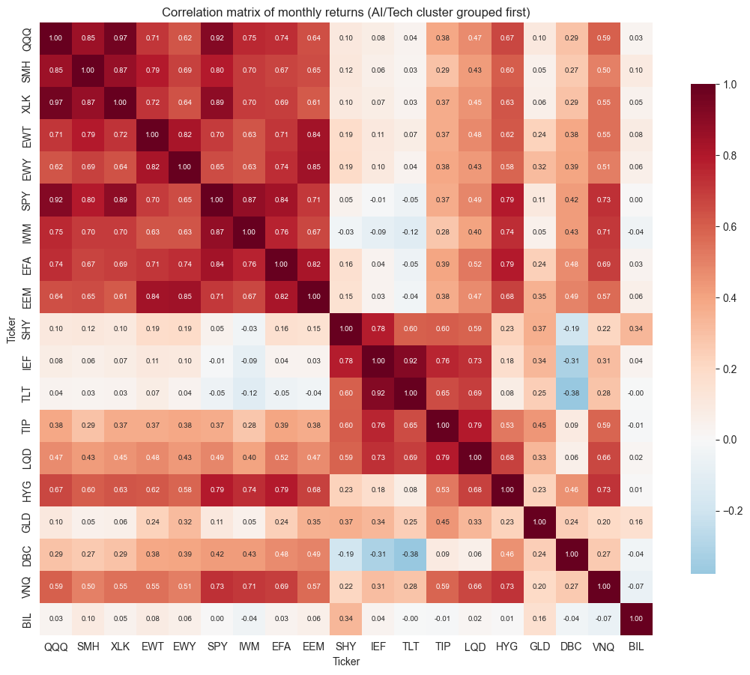
Figure 4.2 — Correlation matrix of monthly returns (AI/Tech cluster grouped first).
The correlation matrix validates the AI/Tech cluster as a genuine risk cluster rather than an arbitrary grouping: QQQ, SMH and XLK are mutually correlated at 0.85-0.97, and EWT/EWY (semiconductor supply-chain) still correlate at 0.62-0.85 with the US-listed AI/Tech names. Notably, SPY itself now correlates at 0.92 with QQQ and 0.89 with XLK — broad US equity has become a levered play on the same theme, which limits the diversification SPY alone can offer against AI-concentration risk. Government bonds (SHY/IEF/TLT) are close to uncorrelated with the AI/Tech cluster (0.03-0.19) and TLT is mildly negatively correlated with commodities (-0.38 with DBC), confirming their role as genuine diversifiers. This high internal correlation within a 19x19, moderately-sized universe is exactly the setting in which Ledoit-Wolf shrinkage (Section 3.5) is expected to stabilize the covariance matrix relative to the raw sample estimate.

5. Methodology

5.1 Rolling, Out-of-Sample Backtest Engine
All strategies share a single, generic rolling-backtest engine. At each rebalancing date t, portfolio weights are computed using only information available up to and including t (a trailing estimation window of monthly returns); those weights are then held and applied to the realized returns of the following period(s), until the next rebalancing date. This strict no-look-ahead discipline is what allows the resulting performance to be interpreted as genuinely out-of-sample.

5.2 Estimation Choices
- Estimation window: 60 months (5 years) of trailing monthly returns. A shorter window would adapt faster to the AI regime but be noisier; a longer window is more stable but slower to react — this trade-off is a documented, subjective choice, and 36- and 84-month variants are suggested as a robustness check in Section 7.
- Rebalancing frequency: monthly (a quarterly variant, tested by simply changing one parameter, is offered as a robustness check).
- Covariance estimator: Ledoit-Wolf shrinkage (see Section 3.5), applied on every rolling window before any optimization step.

5.3 Optimization Constraints
All optimized strategies (Markowitz, Michaud, Black-Litterman) are solved long-only, fully invested (weights sum to one, no leverage), with a maximum weight cap of 30% per single ETF, via sequential quadratic programming (SciPy's SLSQP), consistent with the baseline course notebooks.

5.4 Strategy A — Classical Rolling Markowitz
At each rebalancing date, we solve for the long-only, capped portfolio that maximizes the Sharpe ratio w'μ̂ / sqrt(w'Σ̂w), using the rolling-window sample mean μ̂ and the Ledoit-Wolf covariance Σ̂ described above. This is one of the three variants allowed by the assignment (minimum-variance and target-volatility formulations use the same machinery and are noted as direct extensions).

5.5 Strategy B — Michaud Resampling
At each rebalancing date, we simulate B = 300 alternative monthly-return histories of the same length as the estimation window, drawn from a multivariate normal distribution parameterized by the window's (μ̂, Σ̂). For each simulated history we re-estimate (μ̂_b, Σ̂_b) and solve the identical maximum-Sharpe problem as in Strategy A. The Michaud portfolio's weights are the simple average of the B simulated-optimal weight vectors, renormalized to sum to one. The number of Monte Carlo paths (300) is a subjective, documented choice, balancing smoothness of the averaged solution against computation time; 1,000 paths are suggested as a robustness check.

5.6 Strategy C — Black-Litterman (Optional Extension)
The equilibrium portfolio w_eq is a fixed strategic multi-asset allocation across the six buckets defined in Section 2 (35% broad equity, 15% AI/Tech, 25% government bonds, 10% credit, 10% real assets, 5% cash), split equally among the members of each bucket. The risk-aversion coefficient is set to δ = 2.5, consistent with the He-Litterman/Drobetz convention used in the course's own Black-Litterman notebook. A single relative view is specified: the AI/Tech cluster is expected to underperform the broad-equity cluster by 2% per year relative to what trailing history would suggest — a moderate-confidence, cautionary view directly encoding the concentration-risk hypothesis (H3) motivating this project. The view's uncertainty Ω is calibrated using the He-Litterman convention, Ω = diag(P · τΣ̂ · P'), with τ = 0.03. At every rebalancing date, the posterior (μ_BL, Σ_BL) is recomputed on the rolling window's own Σ̂ and fed into the same long-only, capped maximum-Sharpe optimizer used for Strategy A, so that all three optimized strategies remain directly comparable and differ only in their (μ, Σ) inputs.

5.7 Benchmarks
- 60/40: 60% SPY / 40% IEF, rebalanced at the same monthly frequency — the classical naive benchmark required by the assignment.
- 1/N: equal weight across all 19 ETFs, rebalanced monthly — this constitutes the "index representing the chosen universe" explicitly required by the assignment, against which value-added can be judged.
- 100% QQQ (reference only, not a formal benchmark): shows the outcome of passively riding the AI/Tech rally, i.e., the concentration risk that the three optimized strategies are actively managing.

5.8 Performance Measures
For every strategy and benchmark, the following out-of-sample measures are computed on the monthly return series: annualized return, annualized volatility, Sharpe ratio, Sortino ratio (downside deviation only), maximum drawdown, Calmar ratio (annualized return / |max drawdown|), average one-way turnover per rebalancing date, and the Herfindahl-Hirschman Index of the portfolio weights (HHI = Σw_i², a standard concentration measure equal to 1/N for a fully diversified equal-weight portfolio and to 1 for a single-asset portfolio). The same measures are computed identically for the benchmarks, allowing a direct, apples-to-apples judgment of whether the optimized strategies add value.

5.9 Stress-Window Analysis
Beyond full-sample performance, we isolate two stress windows for a dedicated comparison: the June 2026 AI/semiconductor selloff (1 June - 31 July 2026) and the smaller February 2026 preview episode (1-28 February 2026). Because all strategies are rebalanced and measured monthly, a supplementary daily-frequency zoom-in is also produced: each strategy's last pre-shock weights are frozen and applied to daily returns throughout the June 2026 window, giving a sharper view of the shock's severity than the monthly resolution alone would allow.

6. Results
This section reports the actual output of AI_Concentration_Dynamic_Allocation.ipynb, executed end-to-end on live Yahoo Finance data (19-ETF universe, 60-month rolling window, monthly rebalancing, Ledoit-Wolf shrinkage, B = 300 Michaud paths, long-only with a 30% single-name cap).

6.1 Full-Period Out-of-Sample Performance
Metric | Markowitz | Michaud | Black-Litterman | 60/40 | 1/N (universe)
Ann. Return | 7.55% | 6.86% | 6.08% | 8.34% | 9.08%
Ann. Volatility | 7.10% | 6.38% | 11.23% | 9.82% | 10.78%
Sharpe Ratio | 1.06 | 1.08 | 0.54 | 0.85 | 0.84
Sortino Ratio | 1.59 | 1.55 | 0.67 | 1.20 | 1.19
Max Drawdown | -17.23% | -16.51% | -22.40% | -21.62% | -23.42%
Calmar Ratio | 0.44 | 0.42 | 0.27 | 0.39 | 0.39
Avg. Turnover | 14.91% | 11.25% | 7.50% | 0.00% | 0.00%
Avg. HHI | 0.185 | 0.123 | 0.140 | 0.520 | 0.053

Three findings stand out. First, both optimized mean-variance strategies clearly add risk-adjusted value over the naive benchmarks: Markowitz and Michaud deliver Sharpe ratios of 1.06 and 1.08 respectively, versus 0.85 for 60/40 and 0.84 for 1/N — with roughly one-third less annualized volatility (6.4-7.1% versus 9.8-10.8%) despite comparable or only slightly lower annualized returns. Second, Michaud is the more "stable" of the two optimized strategies exactly as hypothesized in H2: it achieves a marginally higher Sharpe ratio than classical Markowitz while running lower average concentration (HHI 0.123 vs 0.185) and roughly 25% less turnover per rebalance (11.3% vs 14.9%) — a smoother, less AI-concentrated path to essentially the same risk-adjusted outcome. Third, the Black-Litterman specification is the weakest performer on every full-period metric (Sharpe 0.54, the largest max drawdown of the group at -22.4%, the lowest Calmar ratio at 0.27) despite carrying the lowest turnover — its static, strongly-tilted concentration view has a real full-sample cost, as discussed in Section 6.4 and Section 7.

6.2 Equity Curves
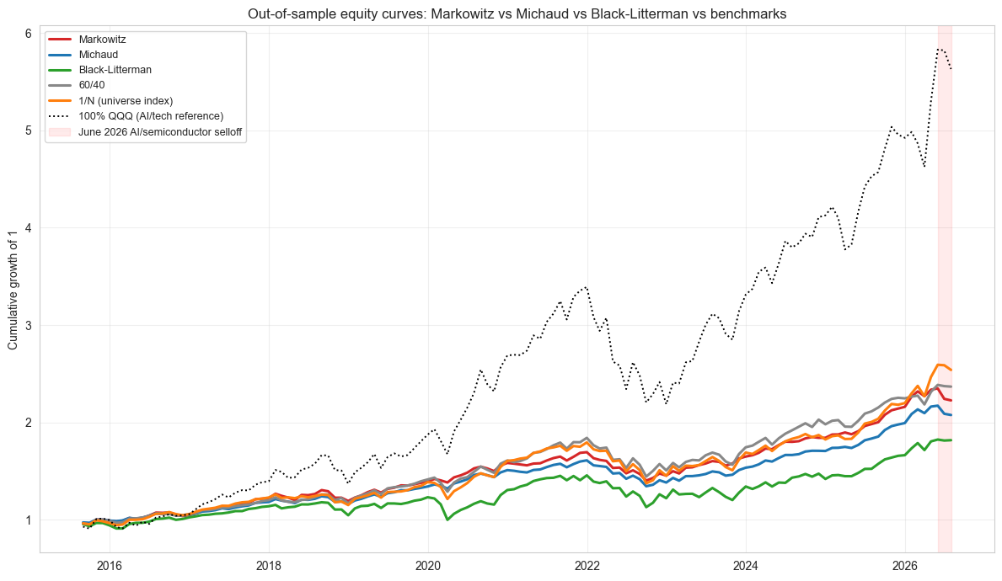
Figure 6.1 — Out-of-sample equity curves: Markowitz vs Michaud vs Black-Litterman vs benchmarks (100% QQQ shown as a passive AI/Tech reference).
The 100% QQQ reference line makes the concentration backdrop explicit: a passive AI/Tech allocation roughly tripled the terminal wealth of every diversified strategy or benchmark over the sample, which is exactly the kind of "error maximization" incentive (Section 3.2) that pulls unconstrained mean-variance weights toward the AI/Tech cluster. Among the diversified strategies, 60/40 and 1/N track each other closely and sit slightly above Markowitz and Michaud in terminal wealth, while Black-Litterman visibly lags the group from around 2022 onward — consistent with its markedly lower Sharpe ratio in Table 6.1.

6.3 Drawdown and Rolling Volatility
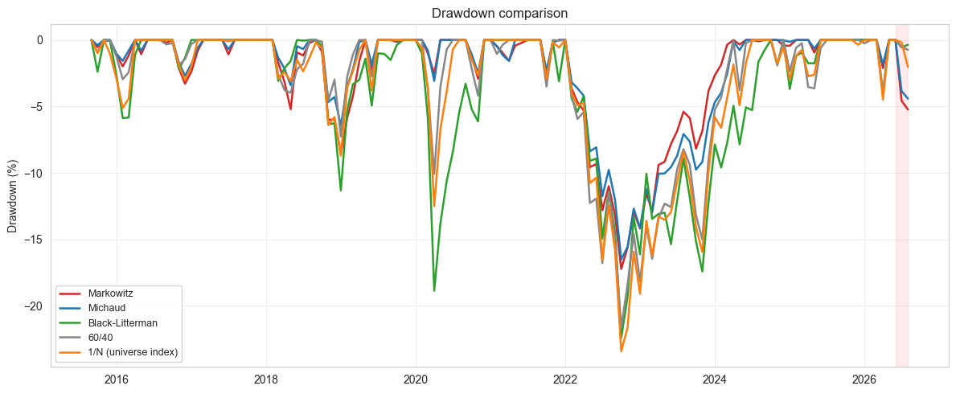
Figure 6.2 — Drawdown comparison, full sample.
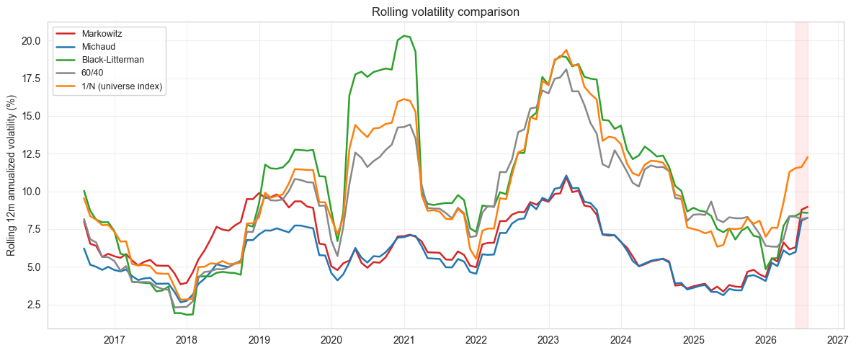
Figure 6.3 — Rolling 12-month annualized volatility comparison.
The drawdown chart shows Black-Litterman experiencing the deepest troughs of the group in both the 2022 rate-shock episode and the 2020 COVID shock, consistent with its higher realized volatility. The rolling-volatility chart shows Markowitz and Michaud running persistently below 60/40 and 1/N across almost the entire sample — including through the 2022 and 2023 volatility spikes — which is the main mechanical source of their Sharpe-ratio advantage in Table 6.1. Volatility for all strategies ticks up into mid-2026, consistent with the June 2026 stress episode entering the trailing 12-month window.

6.4 Concentration Diagnostics
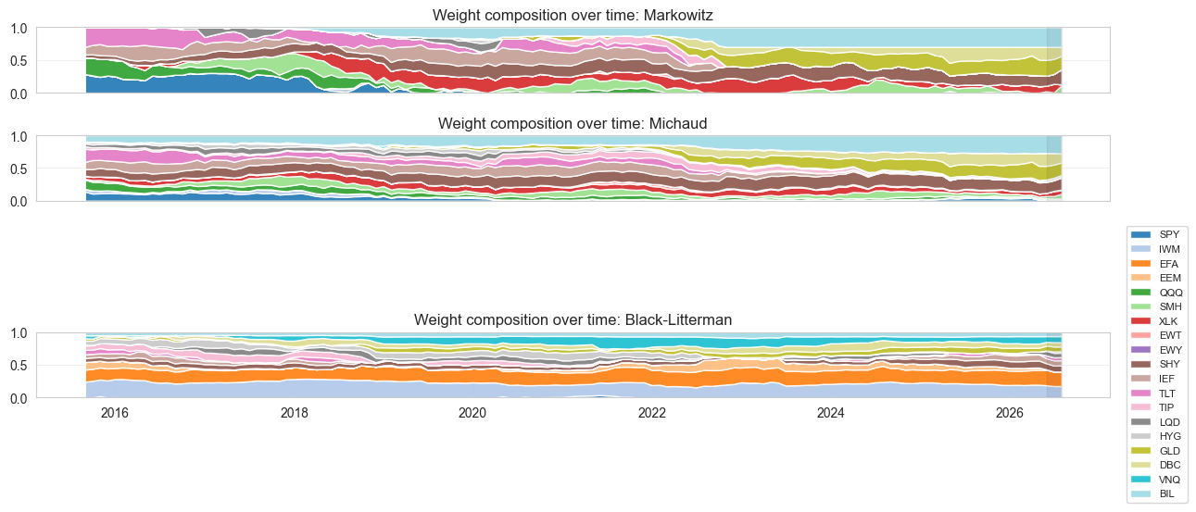
Figure 6.4 — Weight composition over time: Markowitz (top), Michaud (middle), Black-Litterman (bottom).
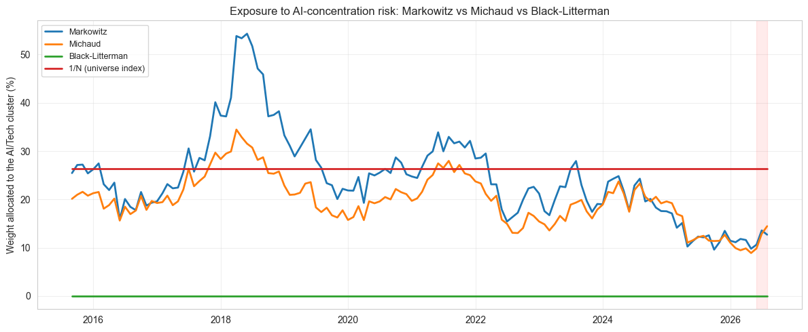
Figure 6.5 — Weight allocated to the AI/Tech cluster over time.
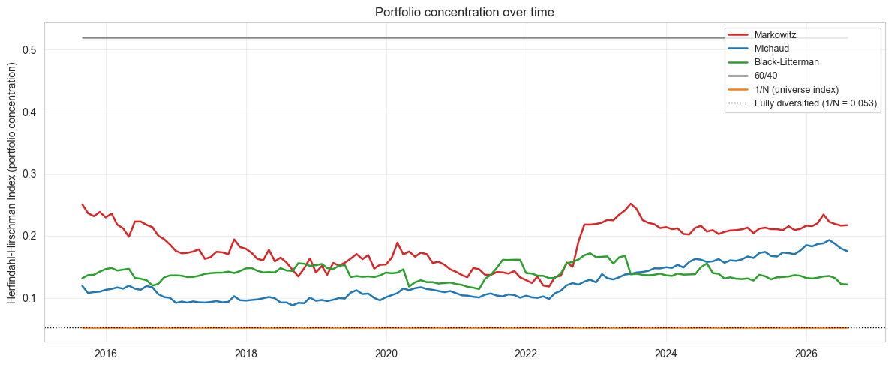
Figure 6.6 — Portfolio-level Herfindahl-Hirschman Index over time.
This is the most direct empirical test of H1-H3, and the picture is nuanced. Consistent with H1, classical Markowitz's AI/Tech weight is volatile and repeatedly spikes well above the 1/N universe benchmark (26.3%), reaching roughly 54% in 2018 and 33% in 2021 before falling back — a textbook illustration of mean-variance "error maximization" chasing trailing AI/Tech Sharpe ratios. Michaud's AI/Tech weight moves in the same direction as Markowitz's but is visibly damped at every peak (e.g., ~34% versus Markowitz's ~54% in 2018), supporting H2's diversification claim. Black-Litterman is the extreme case: its AI/Tech weight is exactly zero at every single rebalancing date over the entire eleven-year sample. This is a corner solution driven by the calibration in Section 5.6 — a -2%/year static view combined with τ = 0.03 pushes the AI/Tech cluster's posterior expected return low enough, relative to its risk, that the optimizer excludes it entirely rather than merely tilting away from it; a softer view or larger Ω (see Section 7.2) would likely produce a smoother partial de-risking instead. The portfolio-level HHI chart tells a complementary story: Markowitz runs the highest average concentration among the three optimized strategies (and shows a visible step-up from 2023 onward), Michaud the lowest, and Black-Litterman sits in between — so while BL eliminates AI/Tech exposure specifically, it is not the most diversified portfolio overall, it simply concentrates elsewhere (visible as the large light-blue IWM band in Figure 6.4).

6.5 Stress-Window Results

June 2026 AI/semiconductor selloff (1 June – 31 July 2026, monthly resolution)
Metric | Markowitz | Michaud | Black-Litterman | 60/40 | 1/N (universe) | 100% QQQ
Cum. Return | -5.23% | -4.40% | -0.36% | -0.74% | -2.03% | -3.43%
Max Drawdown | -0.69% | -0.59% | 0.00% | -0.22% | -1.86% | -3.29%

February 2026 preview episode (1–28 February 2026, monthly resolution)
Metric | Markowitz | Michaud | Black-Litterman | 60/40 | 1/N (universe) | 100% QQQ
Cum. Return | +2.36% | +2.28% | +3.09% | +0.46% | +3.33% | -2.37%
Max Drawdown | 0.00% | 0.00% | 0.00% | 0.00% | 0.00% | 0.00%

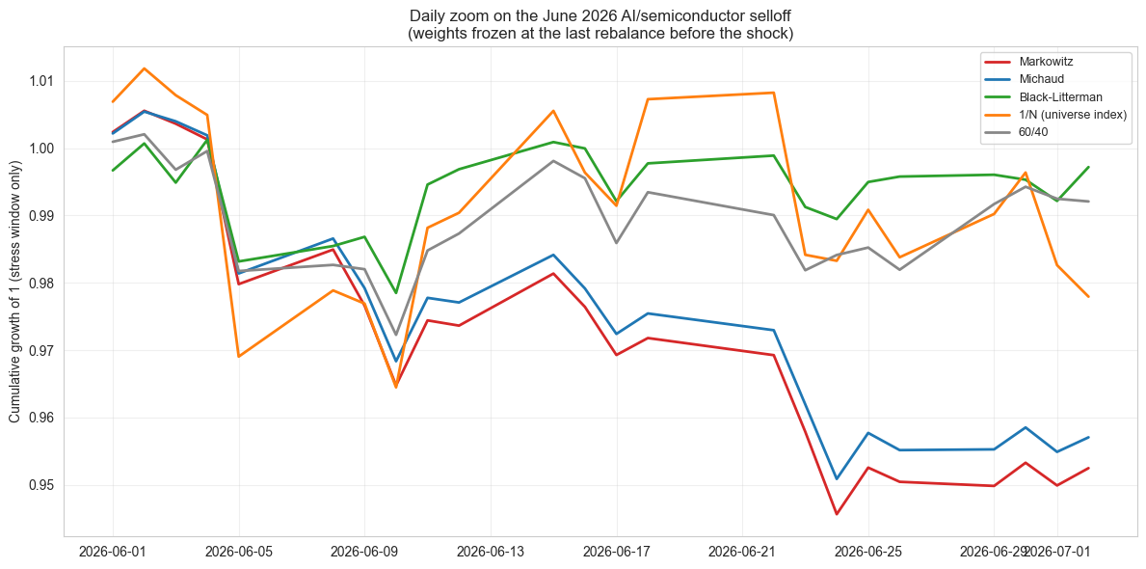
Figure 6.7 — Daily zoom on the June 2026 window, weights frozen at the last pre-shock rebalance.
The stress window is where Black-Litterman's concentration-averse construction pays off outright: with zero AI/Tech exposure heading into June 2026, it is essentially flat over the two-month window (-0.36% cumulative return, 0% monthly-resolution drawdown) while classical Markowitz loses -5.23% and even the naive 1/N benchmark loses -2.03%. Michaud sits between the two, losing less than Markowitz (-4.40% vs -5.23%) but more than Black-Litterman, again consistent with H2's "partial protection" story. The daily zoom-in (Figure 6.7) confirms this ranking holds at finer resolution and shows the shock itself: Markowitz and Michaud fall together to roughly -5% to -6% intraperiod before a partial recovery, while Black-Litterman and 60/40 barely dip. The February 2026 preview episode is more ambiguous: Black-Litterman again avoids the worst of it, but 1/N (+3.33%) and Black-Litterman (+3.09%) both outperform Markowitz and Michaud (+2.3-2.4%), and 60/40's low-equity-beta construction, not any AI-specific hedge, is what limits its exposure. Taken together, the two stress windows support H3's resilience claim during the acute June 2026 event specifically, but do not show a uniform Black-Litterman advantage across every risk-off episode.

7. Conclusion

7.1 Summary of Findings
H1 (Markowitz concentrates in AI/Tech) is confirmed. Classical Markowitz's AI/Tech weight is the most volatile and reaches the highest peaks of any strategy (up to ~54%, roughly double the 1/N universe weight of 26.3%), and its average portfolio HHI (0.185) is the highest among the three optimized strategies — a direct empirical illustration of the "error-maximization" behaviour discussed in Section 3.2.
H2 (Michaud is more stable and diversified, without sacrificing risk-adjusted return) is confirmed. Michaud matches or very slightly exceeds Markowitz's Sharpe ratio (1.08 vs 1.06) while running lower average concentration (HHI 0.123 vs 0.185), lower turnover (11.3% vs 14.9%), and a visibly damped AI/Tech weight at every peak. During the June 2026 stress window it also loses less than Markowitz (-4.40% vs -5.23%). On every dimension tested, resampling delivered on its theoretical promise in this universe and sample period.
H3 (Black-Litterman further reduces concentration and improves resilience) is only partly confirmed, and comes with an important qualification. During the acute June 2026 stress window, Black-Litterman is by far the best performer (-0.36% vs -5.23% for Markowitz), which strongly supports the resilience claim. However, this protection is bought at a substantial full-period cost: Black-Litterman has the lowest Sharpe ratio (0.54), the highest volatility (11.2%), and the deepest max drawdown (-22.4%) of every strategy or benchmark tested, and its AI/Tech weight is not so much "reduced" as eliminated outright (exactly 0% at every rebalance) — a corner solution produced by the specific view/τ calibration chosen in Section 5.6, not necessarily a general property of the Black-Litterman framework. The February 2026 preview episode reinforces this nuance: Black-Litterman again avoids the worst of the shock, but so does the naive 1/N benchmark, which actually delivers the best return of the group that month.
Overall, the evidence favors Michaud resampling as the most attractive strategy in this project: it is the only approach that improves on classical Markowitz's full-period risk-adjusted return while simultaneously reducing concentration, turnover, and stress-window losses — with no offsetting full-period cost. Black-Litterman, as calibrated here, behaves more like a specific insurance policy against AI/Tech concentration risk: extremely effective when that exact risk materializes, expensive to hold every other year, given the static equilibrium prior and the un-updated, high-conviction view used in Section 5.6.

7.2 Limitations
- Monthly rebalancing and monthly return estimation necessarily smooth over the sharpest, sub-monthly dynamics of the June 2026 shock; the supplementary daily zoom-in only partially compensates for this.
- The Black-Litterman equilibrium weights and the AI-concentration view (and its confidence, Ω) are subjective, analyst-chosen inputs; results should be understood as conditional on that specific calibration, not as an unconditional statement about Black-Litterman's superiority.
- No transaction costs, taxes, or capacity constraints are modeled; the turnover statistic is reported as a proxy for implementation cost but is not translated into net-of-cost performance.
- The 60-month estimation window and 30% weight cap are both subjective choices; Section 7.3 lists the sensitivity checks needed to assess how much the conclusions depend on them.
- Ledoit-Wolf shrinkage improves numerical stability but does not eliminate estimation risk in μ, which remains the primary channel through which Michaud and Black-Litterman are expected to add value.
- The Black-Litterman results reported in Section 6 reflect one specific, static view/τ calibration (-2%/year, τ = 0.03), which produced a corner solution (0% AI/Tech weight at every rebalance) rather than a smooth tilt. This makes the reported full-period underperformance and stress-window resilience both, to some extent, artifacts of that specific calibration rather than general properties of the Black-Litterman framework; the τ/Ω sensitivity analysis in Section 7.3 is the natural next step to disentangle the two.

7.3 Suggested Extensions
- Sensitivity of all results to the estimation window (36 vs 60 vs 84 months), the covariance estimator (sample vs Ledoit-Wolf), and the weight cap (20% vs 30% vs uncapped).
- Sensitivity of the Black-Litterman results to τ and to the magnitude/confidence of the AI-concentration view, following the same pattern as Section 9 of the course's Black_Litterman.ipynb.
- A quarterly-rebalancing variant to check whether conclusions survive lower turnover and lower transaction-cost drag.
- An explicit asset-class budget constraint (e.g., capping the AI/Tech bucket at 25% of the portfolio) as an alternative, more direct way of managing concentration risk, to compare against the "let the optimizer decide" approach used here.
- Re-running the pipeline on Bloomberg/FactSet data, if available, as a data-provider robustness check.

