***SEMI-AUTOMATIC STEREOLOGY MACRO STEPS (10.10.2019)***

This macro allows the user to implement a *semi*-automatic stereology of the liver of a stack of T2-dicom images with the software *ImageJ*. In order to make the macro work, the plugin “*Grid*” (it’s a modified version – attached at the end of the description of the procedure) must be installed in the ImageJ’s “*Plugins*” folder.

1. Open ImageJ;
2. Run the plugin: *ImageJ → Plugins → Macro → Run →* Semi-Automatic stereology macro;
3. Follow the instruction of the macro, press “OK” on the “Action Required” window and select the directory that contains the folder of T2 DICOM sequence images.

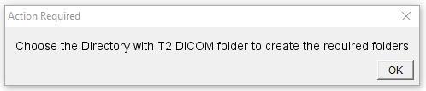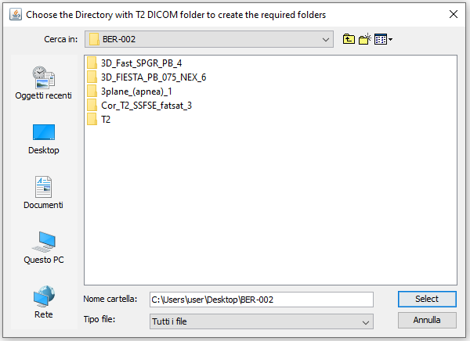

1. The following window will pop up:

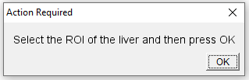

In the “*Stack ROIs*” window, click “*Read ROIs”* and select the ROI of the liver (previously realized):

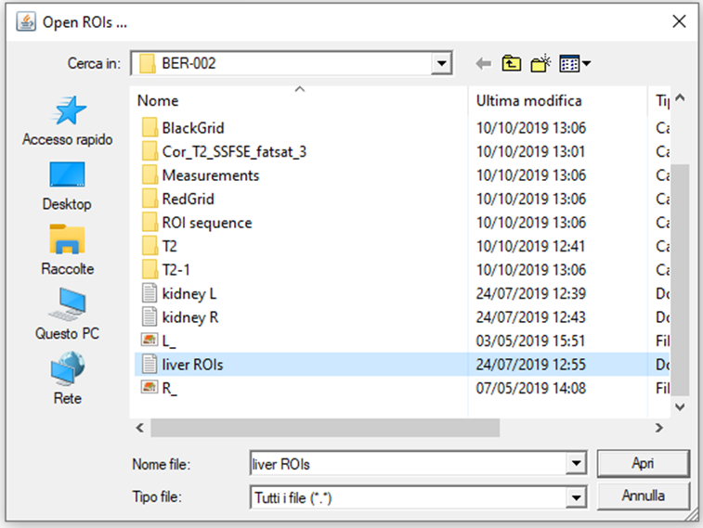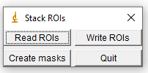

The ROI previously realized will automatically line up the sequence of images. The overlap may not be perfect, since:

* + the number of images of the T2-Stack is different from the stack used for the manual tracking (before launching the macro it is recommended to delete those images of the sequence which are empty);
  + if the ROI is not precise, move it with the cursor in order to improve the overlap;

After that, press “OK” on the previous “Action Required” window.

1. Follow the instruction of the macro, close the ROI Manager and press the button Save as Overlay. After that, press the button “OK” on the “Action Required” window.

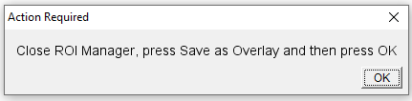

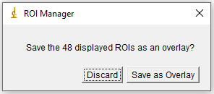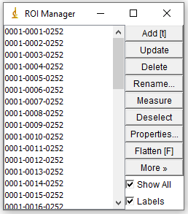

1. The end of the entire process is reported by the following window:

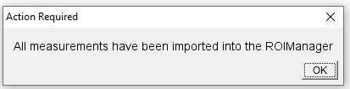

1. At the end of the process the ROI Manager is shown in the following image:
   * Show all: show all points on the corresponding images of the sequence;
   * Labels: assign to every point an increasing number;
   * ROI Manager → More → List; a list of the overlay elements of the sequence is opened. It contains all points detected (the number of all points correspond to the last point “index” value +1, since the numbering starts at 0);

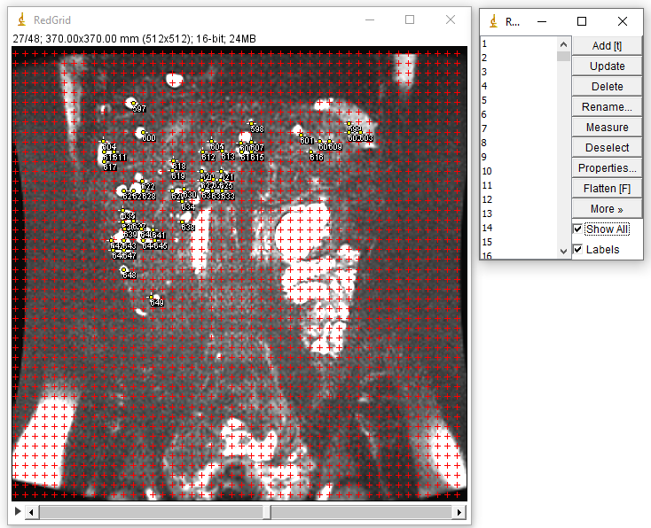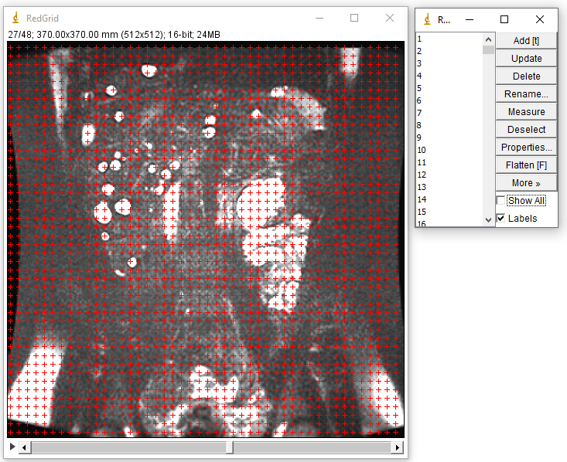

a) in the ROI Manager are loaded all points automatically imported; the points are not shown on the image

b) if “Show all” is checked, points are shown on the image

1. **Manual correction**:
   * to **delete** any wrong point, you can select the point directly on the image; in the ROIManager, select “*Delete*” in order to remove it permanently;
   * to **add** any point, you can select the corresponding cross with the “*Multi-Point*” tool of ImageJ and, by clicking “*t*”, it will be automatically added to the ROIManager list;

To save the points: *ROIManager → Deselect → More → Save → “RoiSet.zip”* → select the directory;

The automatically-detected points are now saved. To visualize them, open the Red-Grid Image sequence and load the RoiSet.zip compressed file as follows: *Analyze → Tools → ROIManager → More → Open* → select the “RoiSet.zip”