# Documentation of the “Yii HEART ”

Version 1.1 (14/Mei/2014)

by Hafid Mukhlasin (milisstudio [at] gmail dot com)

## Create Professional Web Application in minutes, Are You Ready?

### What is the Yii Heart

Yii heart is extension base on wonderfull widget as known as Yiibooster. It for improve result of automatic generation code / gii from yiibooster default be a amazing generation code ☺, so You will get view yiibooster ready. At default gii only generate Model and Create Reate Update n Delete, but in YiiHeart you will get CRUD++++, plus export – import – editable – calendar without type code anymore. With YiiHeart You can create a project by fast, smart, beautiful.. Create Professional Web Application in Minutes, Are You Ready?

### Features of the Yii Heart

* Gii improved for yiibooster
* Gii batch CRUD generator (direct generete crud of all model)
* Export to excel, html, pdf, word
* Import from excel
* Calendar agenda
* Soft delete (not really delete, only update field and hidden from view)

### Changelog

* Version 1.1 (14 Mei 2014)
* New concept, be a extension.
* Focus to improve gii of yiibooster
* Minimimize config in the Yii main config
* Simplification and modification some extension
* Add word doc export feature
* Add batch generate crud feature
* Add theme feature
* Add calendar feature
* Not depend on right extension (optional)
* Version 1.0 (19 April 2014)
* Initial release
* Yiiboilerplate that have feature gii+++ (+editable, export and import : excel-html-)

### Requirement

* Yii 1.1.14 (https://yiiframework.com)
* Yiibooster 2.1.1 (http://sourceforge.net/projects/yiibooster/files/)
* PHPExcel Version 1.8.0 (http://www.codeplex.com/PHPExcel)
* TinyButStrong with opentbs 1.9.0 (http://www.tinybutstrong.com)
* FullCalendar v2.0.0-beta2 (http://arshaw.com/fullcalendar/)
* ~~Right Extension 1.3.0.r147 (little modified so like bootstrap) optional~~

### Why Should Use Yii Heart?

If You use yiibooster, You should use this tool, because it will increase your speed to create a project. YiiHeart help You maximize and explore feature of the YiiBooster, minimize repetition code. With YiiHeart, You needn’t think about view, yes because it will create to You fantastic view.

Many library have wrapped, for example phpexcel, word, pdf. So All of your requirement to create a project have available in this tools.

We hope You get have fun coding ☺

### Installation

1. Download YiiFramework 1.1.14 from http://yiifarmework.com/downloads/ an extract to Your web root (htdocs)  
   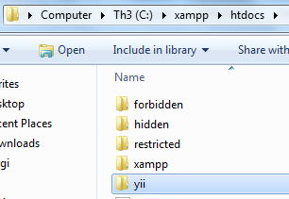
2. Create Web Application base on YiiFramework (Use command prompt)

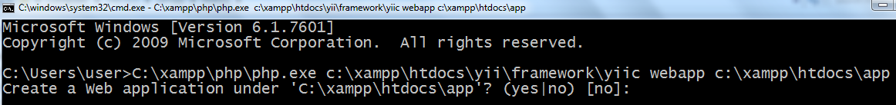

Type yes

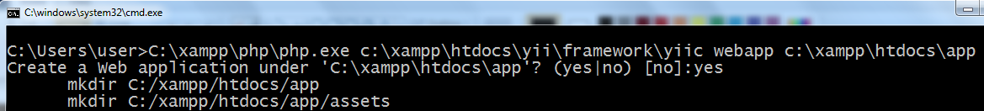

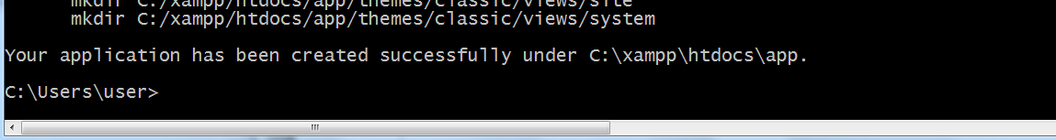

Open browser and check your installation. Type in address bar of browser http://localhost/app (for example we create webapplication in app folder)  
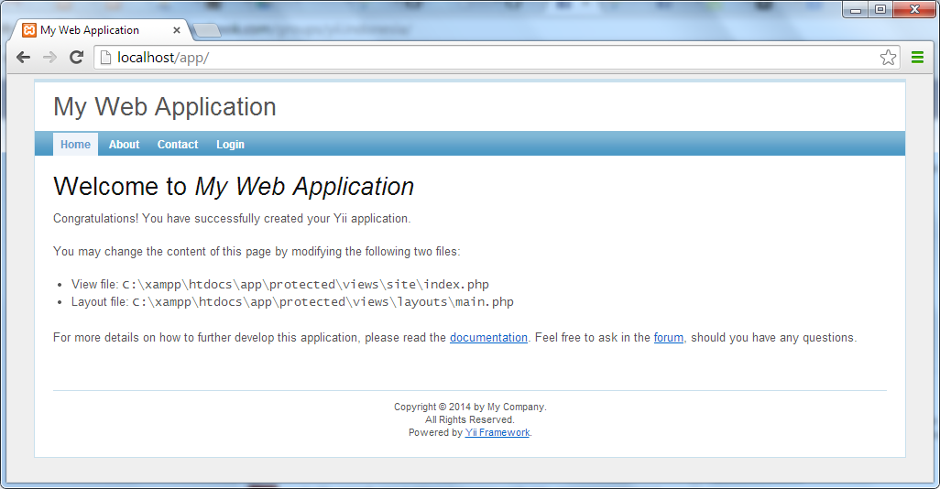

1. Download Yiibooster 2.1.1 from http://sourceforge.net/projects/yiibooster/files and extract to extension directory of Your web aplication

We use this version because this is really stable version at present. Many bug in version 3.xx

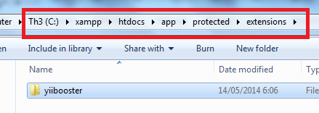

1. Configure on main config (app/protected/main/config.php) of web applications so yiibooster ready  
   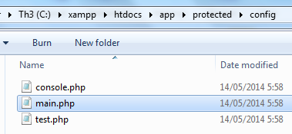

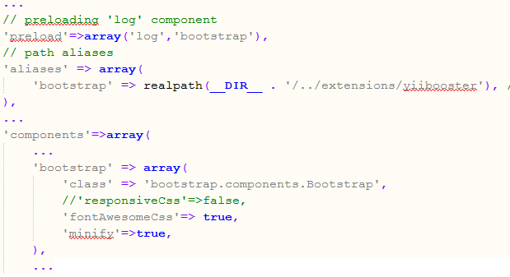

1. Download YiiHeart 1.1 from https://github.com/hscstudio/yiiheart and extract to extension directory of Your web aplication

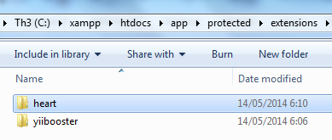

1. Configure on main config of web applications so yiiheart ready

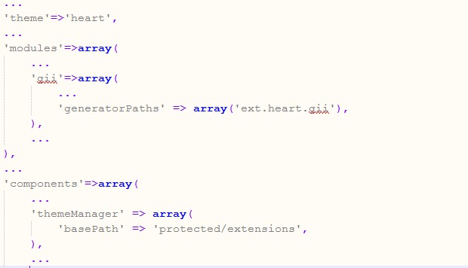

1. Please check Your installation via web browser http://localhost/app

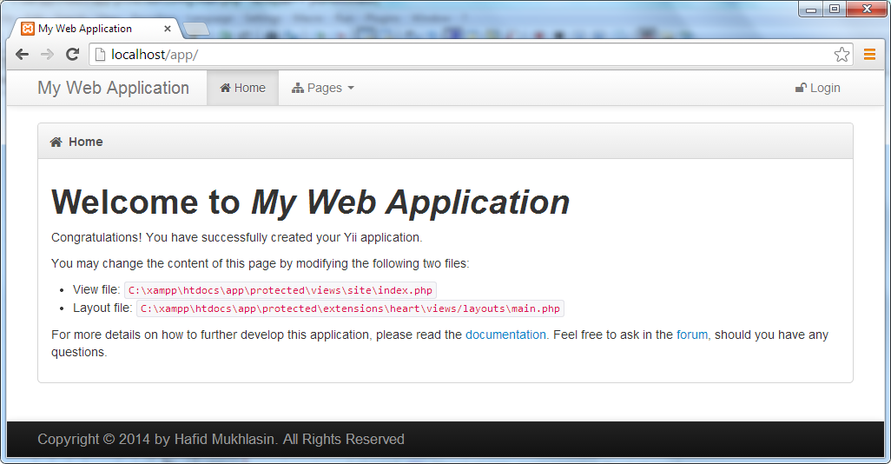

Wow.. yiibooster and yiiheart ready without coding anymore.. Yes You get it only follow this instruction.

1. done

### Folder Management

Yiiheart should located in extension directory of Your web application, same with Yiibooster.

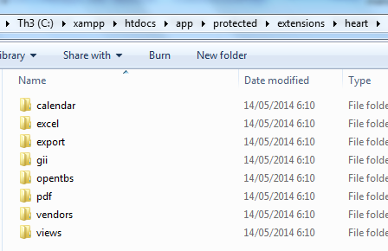

* calendar folder contain extension of fullcalendar (EHeartCalendar – modified of EfullCalendar)
* excel folder contain extension of phpexcel (EHeartExcel – modified of XPHPExcel)
* export folder contain export extension (EHeartExport – modified of EExcelView)
* gii folder contain gii++++ extension (improve yiibooster gii)
* opentbs folder contain opentbs extension (EHeartOpenTBS – inspired of XPHPExcel)
* pdf folder contain pdf extension – wrapper tcpdf library (EHeartPDF – inspired of XPHPExcel)
* vendors folder contain libraries that supported extension (phpexcel, tcpdf, opentbs, dll) not modification yet alias origin
* views folder is theme of the application

### Rule for Maximize usage Yii Heart

To maximize usage this tool You should follow this rule:

#### About Database

* Please use singular english for database, tabel, and field name, and lowercase please. for Example : table of employee, should You type **tb_employee** not tb_employees, tb_karyawan, or tb_wow (very out of the box).
* Table name should have prefix **tb_** or **tbl_** for main table and **ref_** for reference table and lowercase please, for example: tb_training, tbl_employees, ref_religion
* Use lowercase for field name, if consist 2 word or mor You should capitalize it. For example: title (not Title or TITLE), name, birtDay (not BirtDay), etc
* Field name for primary key should **id**
* Field name that should available in table is **name** or **title,**
* If You want use calendar, You should use field type **date** in table (min 1 field).
* Field name for foreign key should use prefix table name of foreign table. For example: ref_religion_id, tb_training_id
* Please add default field at Your table, theay are: created, createdBy, modified, modifiedBy, deleted, deletedBy.
* I suggest You when desain database structure with MySQL Workbench (this professional tools) and this rule appropriate with this tools.

#### About Generator

##### Prepare Data

* Create a database, for example “heartdb.sql” it contains 3 table, they are tb_training, tb_employee, tb_religion. tb_religion and tb_employee have relation one to many..
* Use dummy data in heart/heartdb.sql, and import to database
* Connect your application to database, please edit Your main config with comment sqlite and uncomment mysql, for example  
  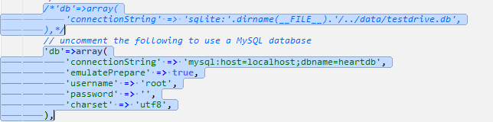
* Activate Gii to generate code automatically, uncomment gii, add generatorPath to ext.heart.gii

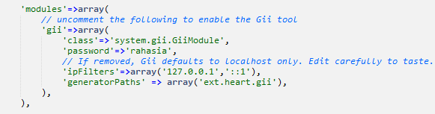

* done

##### Access Gii

* For access generator (Heart Gii) You can type on Your addrees bar browser:   
  http://localhost/yourapplication/index.php?r=gii
* You will redirect to Gii login page, type Your password and login.
* After login, You will redirect to dashboard of the default Gii.  
  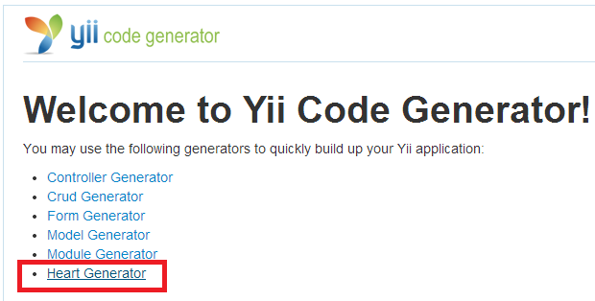
* See list menu generator and choose Heart  
  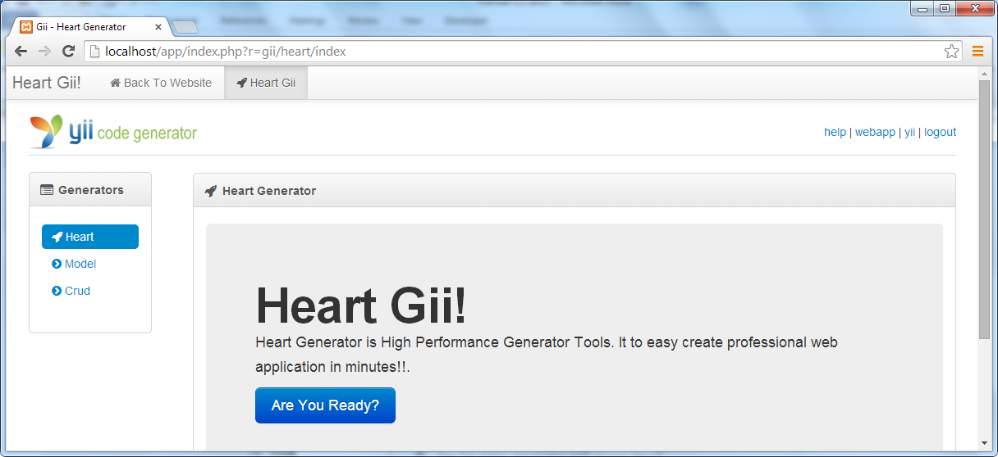
* You can create model+ and crud++++ in here

##### Generate Model

* Choose menu Model, And generate All model one by one

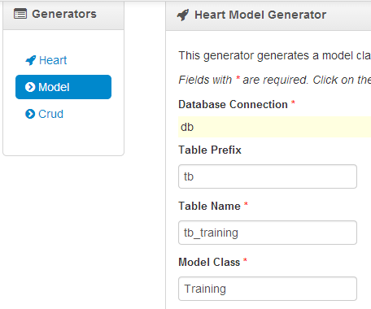

* Or You can generate all model with one click by input * to field table name  
  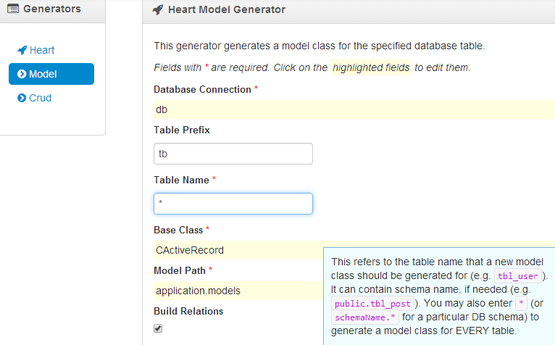
* But in this tutorial, I generate one by one  
  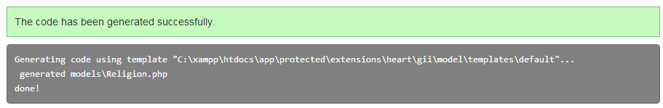
* done

##### Generate Crud

* Choose menu Crud, And generate All crud one by one  
  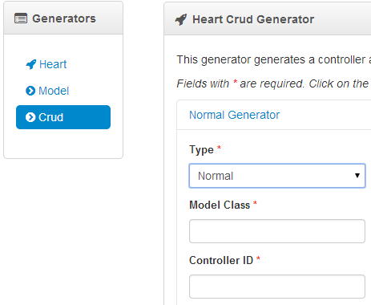
* Choose type of crud, Normal (1) or Parent (2) or Child(3)  
  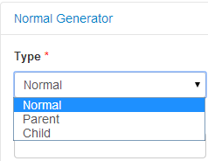

Crud normal is crud normally  
Crud parent is crud that have child  
Crud child is crud that depend on crud parent  
Oke for example, You have 2 tabel, tb_training and tb_training_student. Tb_training is table parent of the tb_student. In crud simulation, You only can access crud TrainingStudent after You choose a Training.

* And then you input Model Class and Controller Id, please use path to Controller Id to easier manage Your application  
  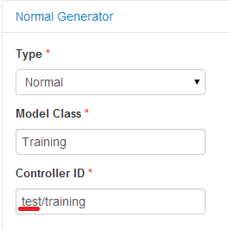

In above example use path test, so Crud will generate code to folder test (protected/views/test/training and protected/controller/test/)

* Then click button Preview

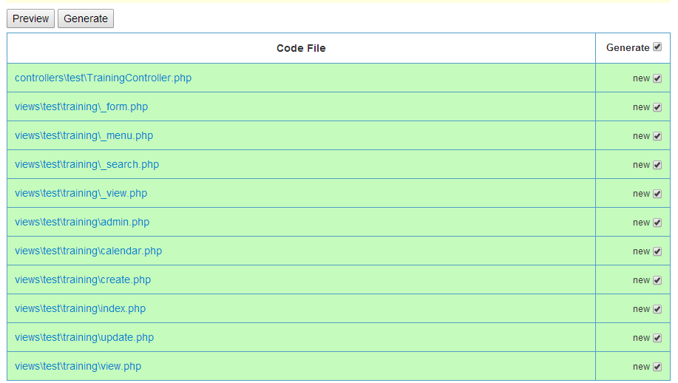

* Then click button Generate

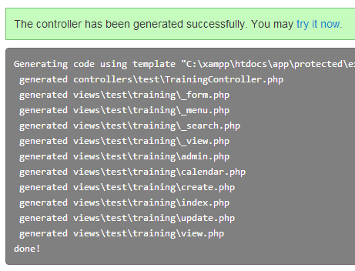

* You can try with access <http://localhost/app/index.php?r=test/training>

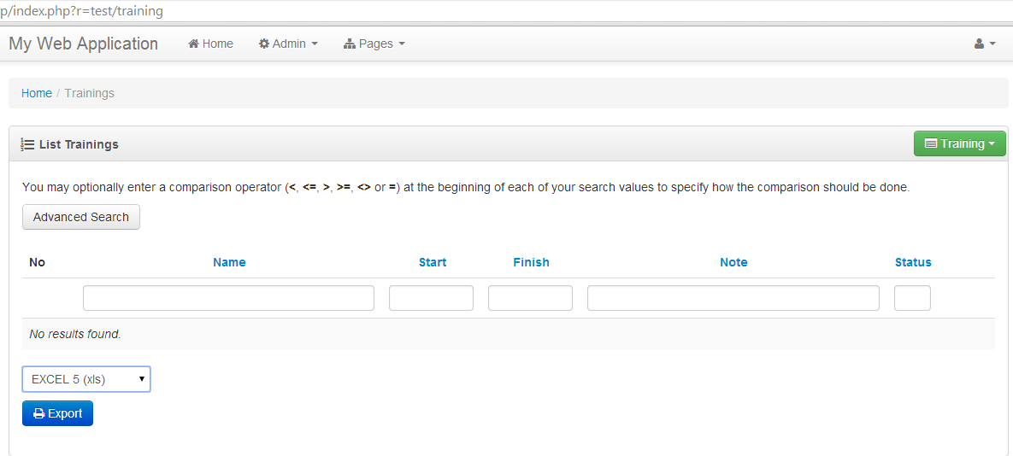

Bootstrap ready kaka.... ☺

Please access menu (button with color green).  
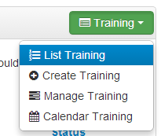

* Choose menu : Create Training

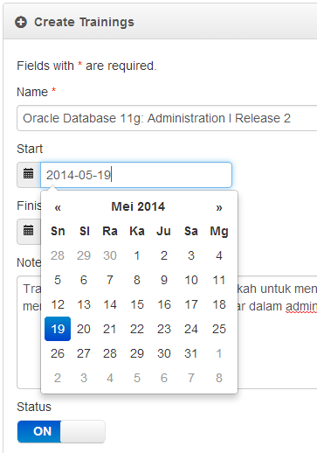

Yes.. auto detect field type without coding anymore  
then Klik button save. So redirect to view

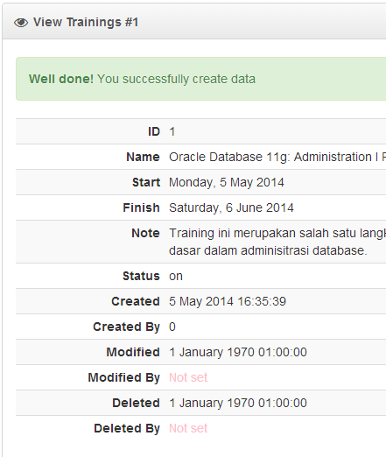

* Choose menu : Manage Training  
  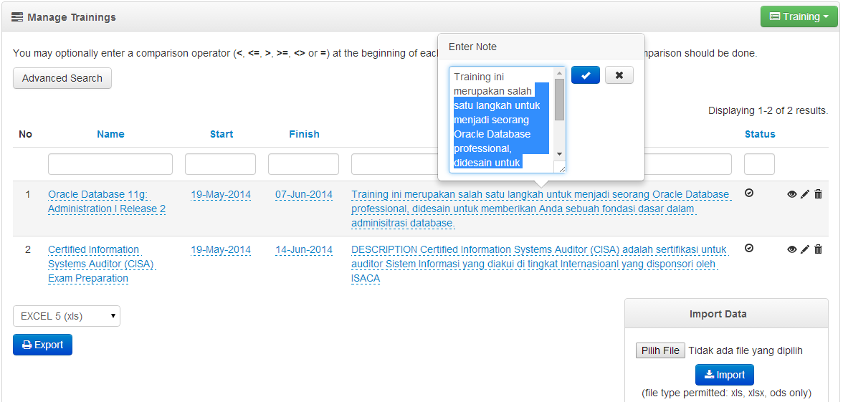

Editable ready, You can edit inplace.. without coding anymore..  
Or You can see detail.. with click icon eye  
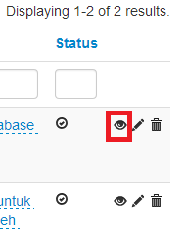

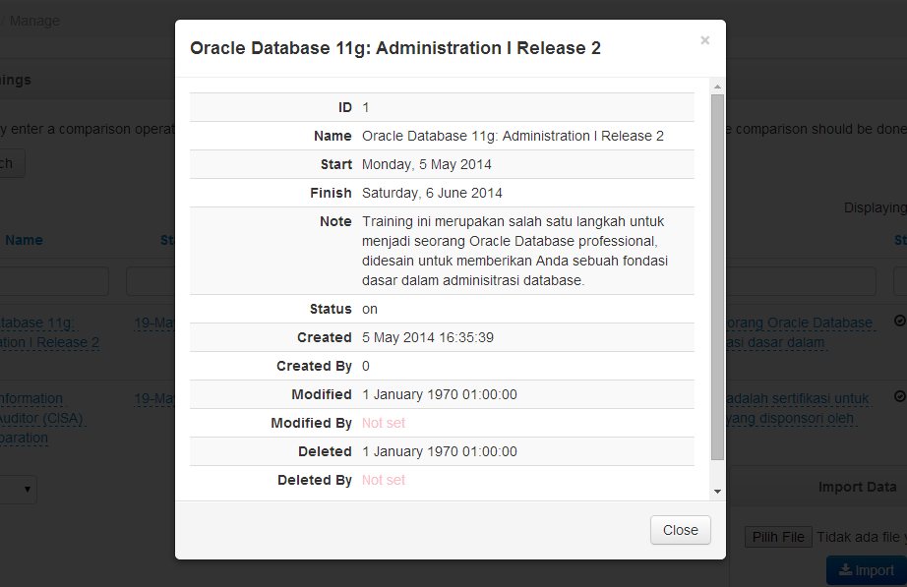

Popup message contains detail of the item... without coding anymore

Feature export ready.. wow ☺ generate data to many format EXCEL, PDF, HTML, WORD  
  
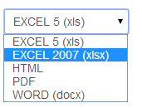  
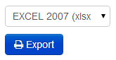  
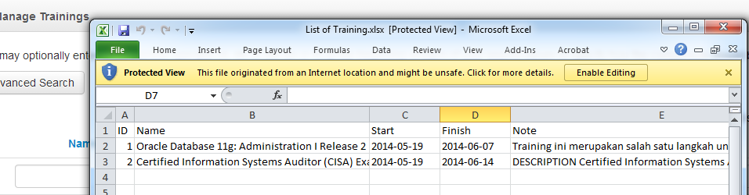

You can import data (not tested)

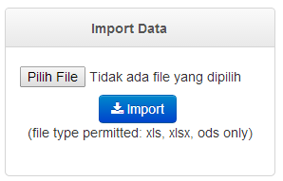

* Choose menu : Calendar Training  
  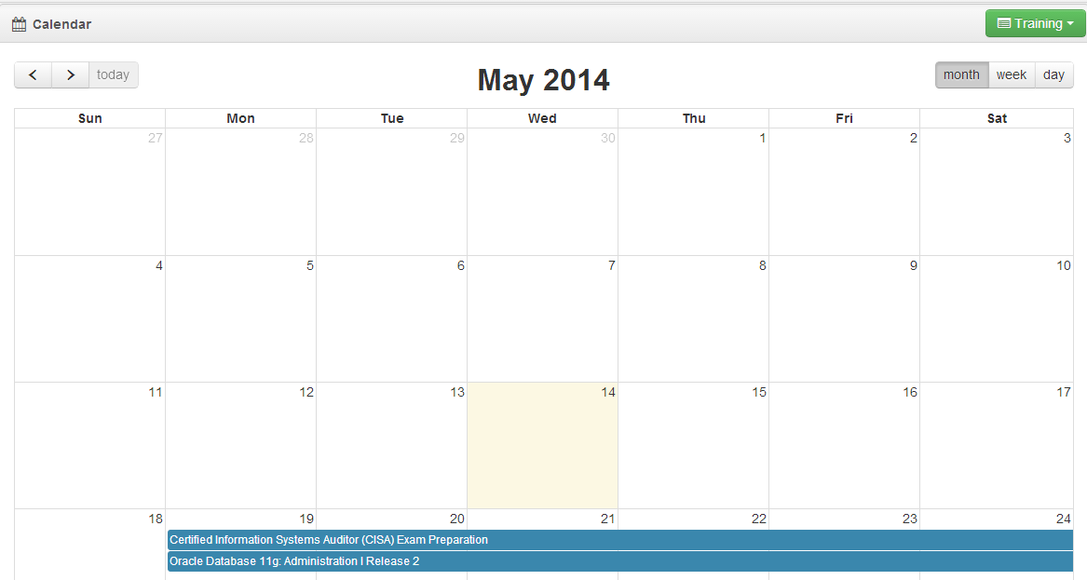

Wow calendar ready and connect with tabel training.. without coding anymore

* Oke done this is fantastic, isnt?
* But I will show You other fantastic feature.. It is Batch Crud Generator, generate all crud with one click
* Back to Gii, choose Crud, Click Batch Generator  
  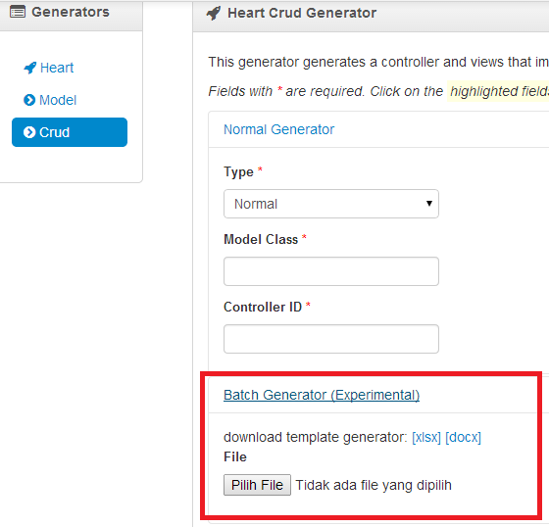
* Download template generator (xlsx)  
  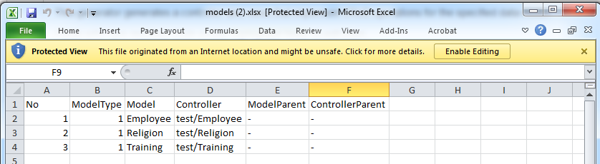

Crud have identify all off Your model in Your application.. so You only few change.. Click enable editing, save

* Browse file that excel..

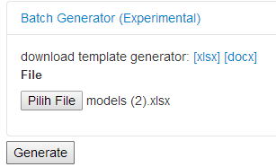

Click Generate  
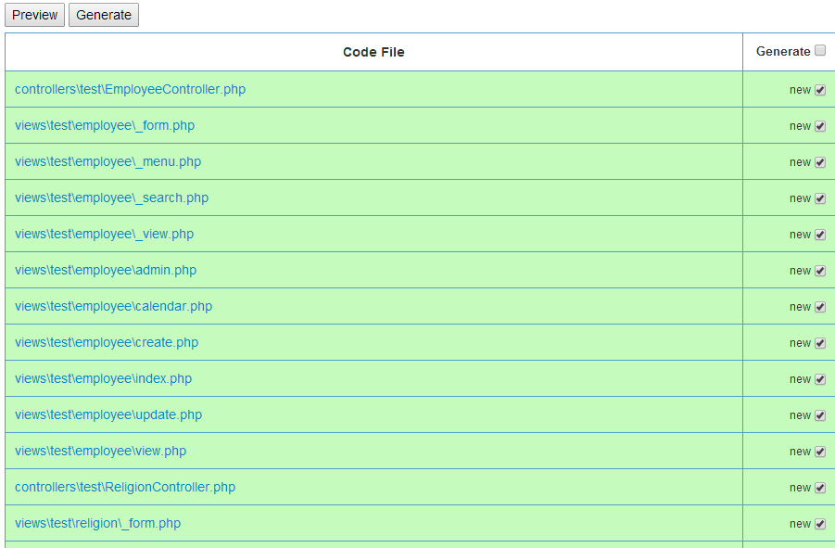

All crud have generate.. wow..

* Done

Jakarta – Indonesia  
14 May 2014 17:02 GMT+7

Hafid Mukhlasin (milisstudio@gmail.com)

Th3Pr0f3550r