THE UNIVERSITY OF ZAMBIA
SCHOOL OF NATURAL AND APPLIED SCIENCES
DEPARTMENT OF COMPUTING AND INFORMATICS

Final Year Project
Implementation Review Report
(comparing the delivered system against the approved project proposal)

Academic Year 2026

Project Title: | TIYENDE [MY YANGO]
Student Name: | Frackson Banda
Student Number: | 2022003578
Supervisor: | Professor Jackson Phiri
Department: | Computing and Informatics
Report Date: | September 2026

Table of Contents
1. Introduction
2. Recap of the Proposed System
3. Method Used for This Review
4. System Overview as Delivered
5. Objective-by-Objective Evaluation
6. Scope Compliance
7. Features Delivered Beyond the Proposal
8. Design Principles Review (GRASP)
9. Issues Identified
10. Recommendations
11. Conclusion
References
Appendix A: Full Feature Matrix

List of Figures
Figure 1 — Tiyende system architecture as implemented
Figure 2 — Role-based navigation as implemented in App.js
Figure 3 — Request status lifecycle (ride, food, delivery, cargo)

1. Introduction
This report checks the Tiyende mobile application against the project proposal that was approved for it. The proposal set out what the system was meant to do; this report looks at what was actually built and says, objective by objective, where the two line up and where they do not. It is based on a direct reading of the delivered source code — 44 JavaScript modules across the screens, navigation, services and configuration layers of the app, plus the Firebase project configuration — rather than on the proposal text alone, because a proposal describes an intention and a final-year project is ultimately judged on what was delivered.
Two versions of the proposal were supplied for this review: an earlier draft that includes an explicit in-scope/out-of-scope list, an ethical-considerations section and a risk register, and a later, more formally formatted draft submitted with the full literature review and reference list. The two agree on the project aim, the four objectives and the core technology choices (React Native, Expo, Firebase, OpenStreetMap), so this report treats them as one proposal baseline and only calls out the source document where a specific claim differs between the two.

2. Recap of the Proposed System
The proposal set out to build “Tiyende [My Yango],” a ride-hailing prototype adapted to Zambian conditions: expensive mobile data, low card/banking penetration, cash and mobile-money habits, and patchy digital map coverage. The stated aim was to design and develop a functional ride-hailing application prototype tailored to the Zambian market by addressing data usage, payment methods and, in the earlier draft, mapping accuracy.

2.1 Objectives
# | Objective (as stated in the proposal)
1 | Analyse the core features of existing ride-hailing apps (Uber, Yango) to understand their user flow and system logic.
2 | Design a simplified system architecture for a ride-hailing app that can function with reduced data usage.
3 | Implement a working prototype covering user registration, ride request, driver acceptance and trip tracking.
4 | Integrate a payment step within the prototype that allows for both cash and mobile money (e.g. Airtel Money) options.

2.2 Scope
In scope: an Android prototype with separate passenger and driver interfaces; a backend for accounts, ride requests, driver availability and trip history; basic GPS to show pickup location and track driver movement; a request/accept ride-matching flow; simulated cash and mobile-money payment selection; a simple, low-data interface; a basic trip-sharing safety feature; and documentation consisting of a user manual and a technical report.
Explicitly out of scope: real payment-gateway integration (actual Airtel Money or MTN MoMo APIs), dedicated hardware, production-grade security or fraud detection, live-traffic routing, collection of real user data, public app-store deployment, and advanced features such as fare splitting or ride scheduling.

3. Method Used for This Review
The review was carried out as a static reading of the repository: every screen, navigation file, service module, hook, context provider and configuration file was opened and read in full — 44 files in total, listed in Appendix A. Each installed package in package.json was checked against actual usage in the code (a call to its API, not just its presence in the dependency list) so that claims about GPS, push notifications and secure storage in this report reflect what the code does rather than what was installed. Findings were then checked against the proposal's stated objectives and scope.
This was a code review, not a live device test. Nothing here reports how the app behaves during an actual demo run on a phone or emulator — only what the source code is written to do. Anything that depends on runtime conditions (network latency, GPS accuracy on a physical device, Firestore security rule behaviour) is outside what this review can confirm and is flagged as such where relevant.

4. System Overview as Delivered
The delivered app is a single Expo/React Native client that behaves as three separate applications depending on the signed-in account's role: a passenger app, a driver app and a restaurant merchant app. The proposal only ever describes a Passenger flow and a Driver flow; the restaurant role, and everything built around it, is additional (see Section 7).
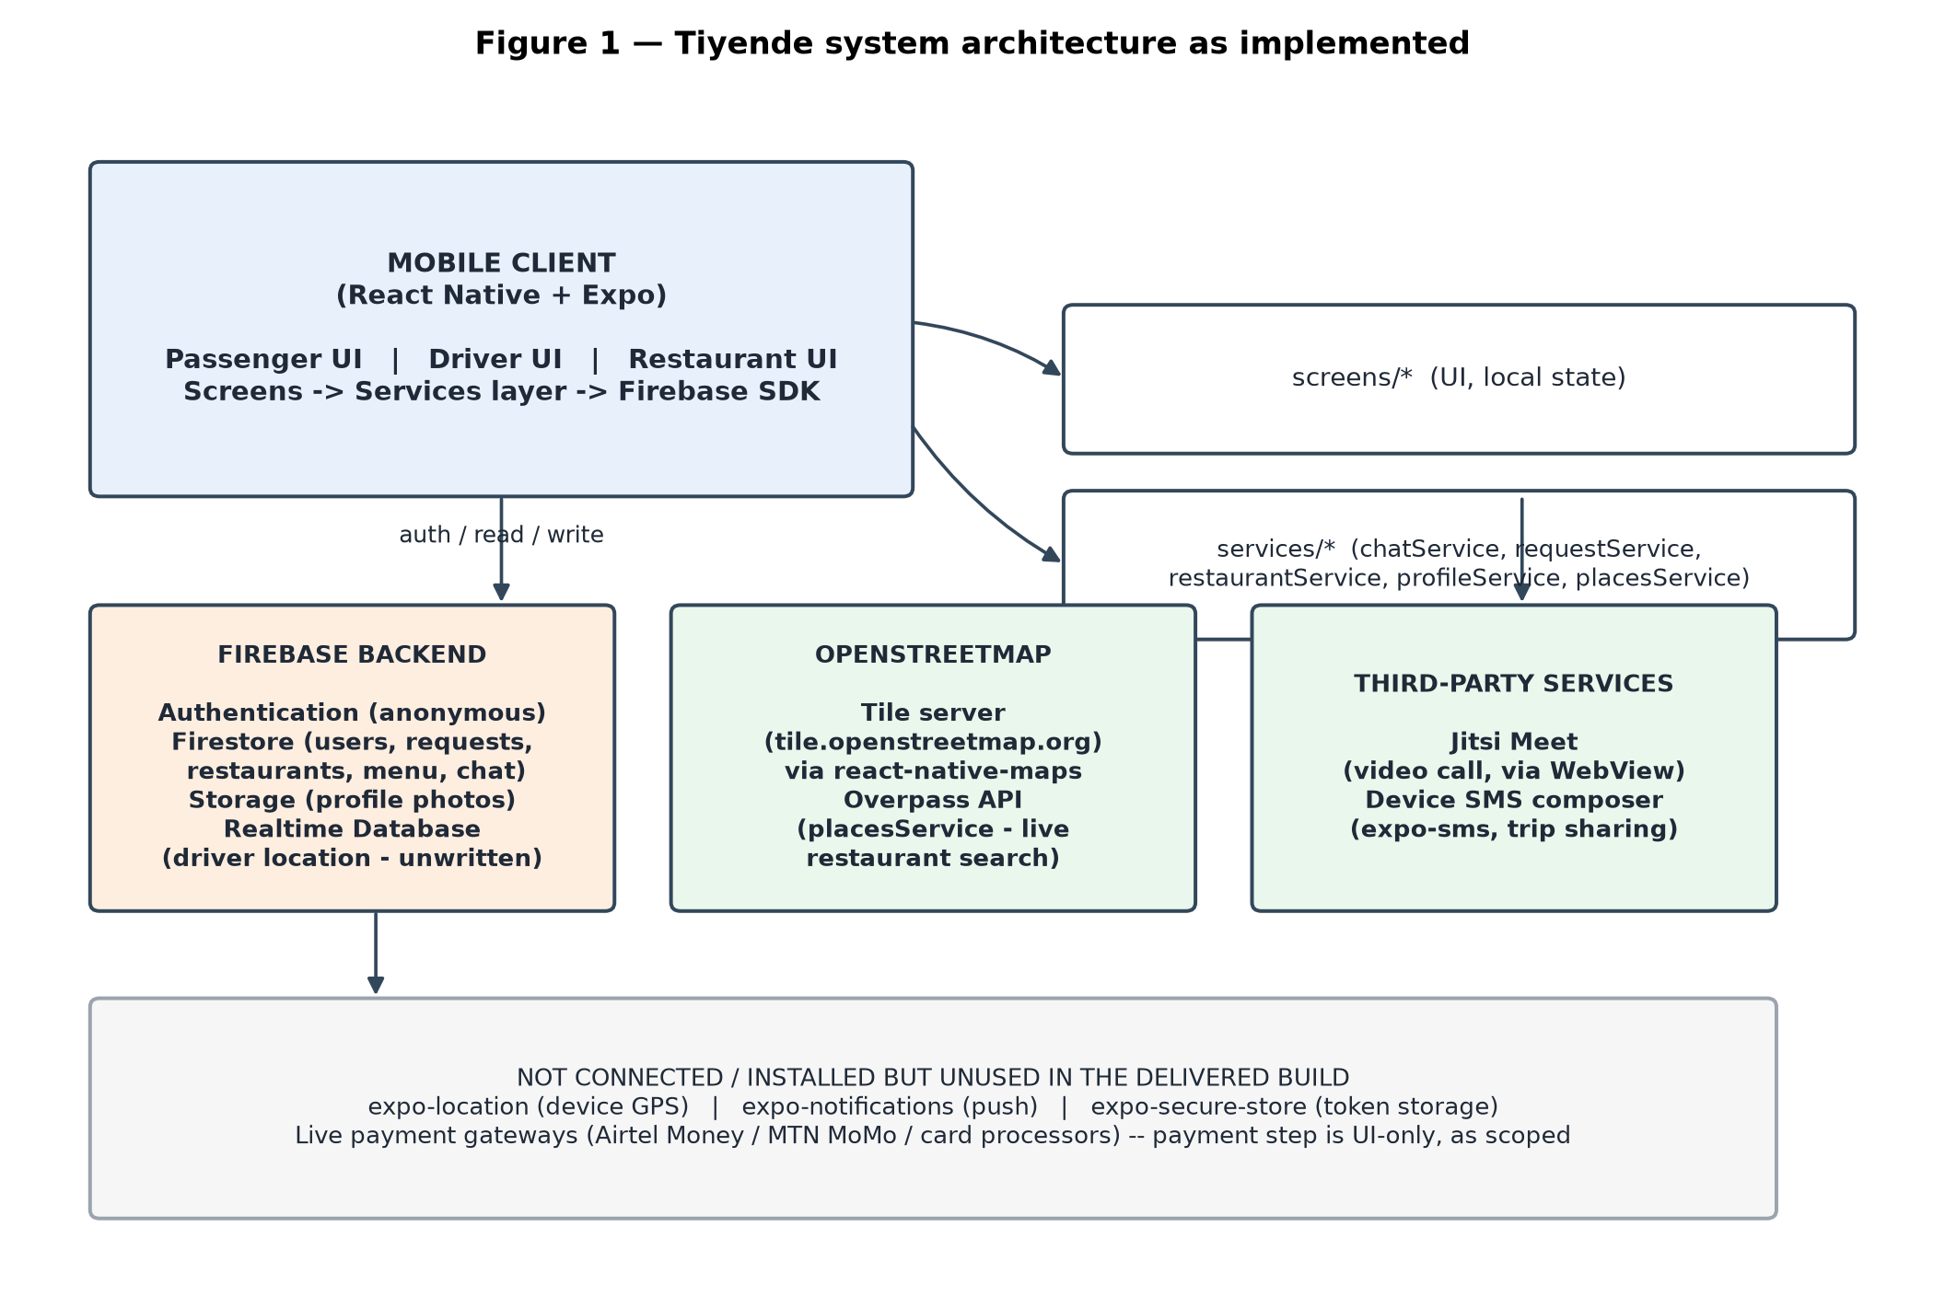
Figure 1 — Tiyende system architecture as implemented.
The client talks to a Firebase project (Authentication, Firestore, Storage and, for one feature, the Realtime Database) for all persistent data, and to two outside services directly from the device: the public OpenStreetMap tile server for map rendering and its Overpass API for looking up nearby restaurants, and a public Jitsi Meet room, opened in a WebView, for the video-call feature. A services/ folder (chatService, requestService, restaurantService, profileService, placesService) wraps most of the Firebase calls so screens generally do not talk to Firestore directly — this pattern is discussed further in Section 8.
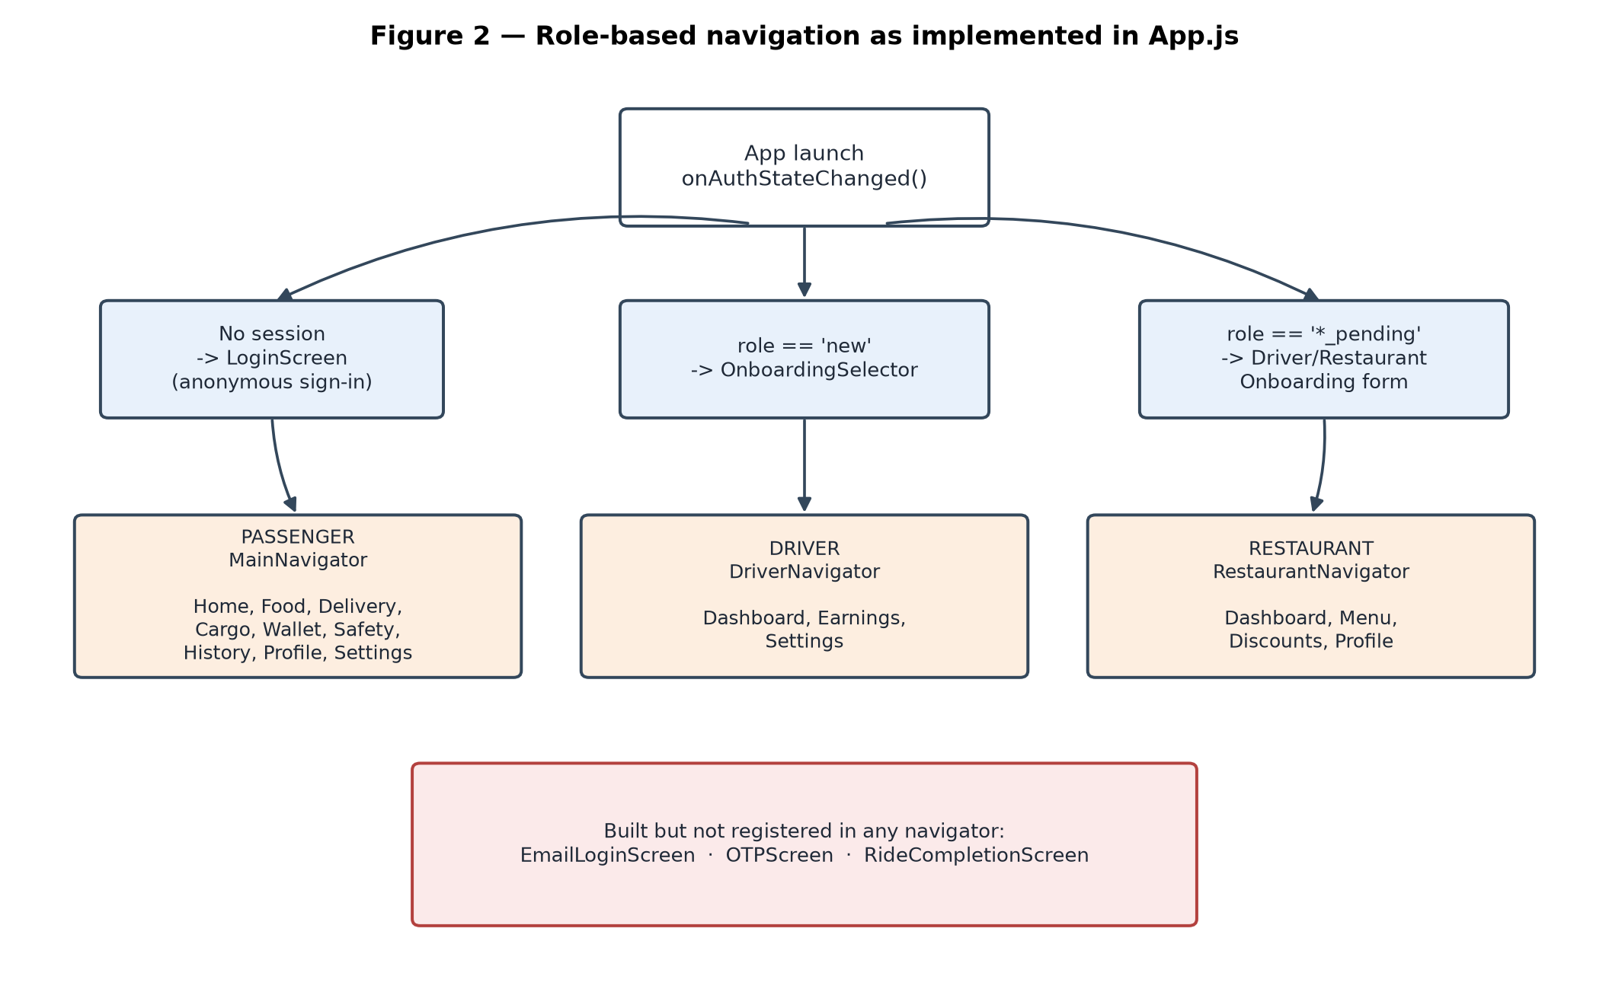
Figure 2 — Role-based navigation as implemented in App.js.
Routing between the three role-based navigators is driven entirely by a role field on the signed-in user's Firestore document, read through onAuthStateChanged and a live onSnapshot listener in App.js. Three screens were built to a finished-looking state but are not reachable from this routing tree at all — EmailLoginScreen, OTPScreen and RideCompletionScreen — shown in red in Figure 2 and discussed in Section 9.

4.1 Technology actually in use vs. installed but unused
Dependency | Purpose in package.json | Actually used in the code?
firebase | Auth, Firestore, Storage, Realtime Database | Yes — used extensively throughout
react-native-maps | Map rendering | Yes — OpenStreetMap tiles via UrlTile in Home, Driver Dashboard and Food screens
expo-image-picker | Photo selection | Yes — profile photos, restaurant logos, menu item photos
expo-sms | SMS composer | Yes, but only in one place — the “Share trip” button on the Home screen
react-native-webview | Embedded web content | Yes — the Jitsi video-call screen
expo-location | Device GPS | No — never called; pickup location is a fixed constant
expo-notifications | Push notifications | No — never imported; the app's notification toggles do nothing
expo-secure-store | Secure token storage | No — configured as a plugin but AsyncStorage is used instead

5. Objective-by-Objective Evaluation
Objective 1 — Analyse existing ride-hailing apps: Achieved
This objective is a research task rather than something the running app demonstrates directly. It is addressed in the proposal's own literature review, and its influence shows up in implementation choices that mirror Uber/Yango conventions — a status-driven trip lifecycle, a driver accept/decline step, and an upfront fare estimate shown before a ride is requested.
Objective 2 — Simplified architecture with reduced data usage: Partially achieved
Choosing OpenStreetMap tiles over a commercial maps SDK is a genuine, deliberate data-and-cost reduction and is consistent with this objective. Against that, there is no other visible data-saving work: there is no tile caching, and restaurant/menu photos are stored as full base64 strings inline in Firestore documents rather than compressed or hosted as files, which works against a low-data design rather than for it. Because device GPS was never wired in (see Objective 3), the location side of “reduced data usage” was never actually put to the test against a live feed.
Objective 3 — Working prototype: registration, ride request, driver acceptance, trip tracking: Partially achieved
Ride request, driver acceptance and trip tracking work end-to-end and are the most solid part of the build: acceptance is wrapped in a Firestore transaction so two drivers cannot double-accept the same request, and status changes are pushed live to both sides through onSnapshot listeners. Registration, however, does not match what either proposal draft describes. Both drafts describe email/password registration, and the second draft's ethics section specifically promises that the app will ask for the user's consent and collect an account. What ships instead is anonymous Firebase sign-in with a typed display name; the fully built email/password screen and the fully built phone/OTP screen both exist in the repository but are never registered in the navigator, so neither is reachable in the delivered app. Trip tracking is real at the status level (pending, accepted, arrived, in progress, completed) but not at the GPS level: the passenger's own location is always a fixed Lusaka coordinate rather than the phone's actual position, and the live courier-location feature built for food orders reads from a Realtime Database path that no driver code ever writes to, so it never shows a moving marker.
Objective 4 — Payment integration (cash and mobile money): Achieved
This is met, and it matches what the proposal actually scoped: the more detailed proposal draft explicitly places real payment-gateway integration out of scope and asks only for a simulated selection between cash and mobile money. The delivered app offers Cash, Mobile Money, Wallet and Card as selectable methods and records the chosen method against the request — exactly the “simulated selection, not real transaction processing” that was asked for, so this objective should be read as fully satisfied rather than judged against a real-money standard the proposal never set.

6. Scope Compliance
In-scope item (proposal) | Delivered? | Note
Android prototype, separate passenger/driver UIs | Yes, and more | A third role (restaurant) was added that the proposal never asked for.
Backend for accounts, requests, availability, history | Yes | Firestore covers all four; driver online/offline toggle works.
Basic GPS: show pickup, track driver movement | Partial | Map is real and interactive, but the pickup point is a fixed constant, not the device's GPS position.
Ride matching: request / accept / decline | Yes | Matching is app-wide rather than filtered to nearby drivers (see Section 9).
Simulated cash / mobile money payment | Yes | Matches the proposal's own scope statement exactly.
Simple, low-data interface | Yes, mostly | Screens are clean and lightweight; undermined somewhat by inline base64 images.
Safety: share trip details with a contact | Partial | Trip-share via SMS works; the separate SOS button on the Safety screen sends nothing real.
User manual + technical report | Not found in repository | Only a short README.md exists; the two documents the proposal promised as deliverables were not located.

On the out-of-scope side, the build stayed disciplined: there is no real payment-gateway code, no hardware dependency, no production-grade security layer, and the Firestore data used throughout is plainly test/demo data rather than real user information. The app has not been submitted to a public app store. These boundaries were respected.

7. Features Delivered Beyond the Proposal
The project grew well past a single-service ride-hailing prototype into a small multi-service marketplace. None of the items below were requested by either proposal draft.
- Food ordering: A full restaurant browsing and ordering flow (FoodScreen) that blends restaurants registered in Firestore with restaurants pulled live from OpenStreetMap's Overpass API, with a cart, checkout and live order-status tracking.
- Restaurant merchant back-office: An entire third app role — dashboard, menu management with per-item discounts, a discount-code system, and an editable business profile — for restaurant owners to run their own listing.
- Parcel delivery: A standalone booking flow (DeliveryScreen) with size-based pricing, separate from the ride-hailing flow.
- Cargo/haulage booking: A separate booking flow (CargoScreen) for larger loads with vehicle-size selection.
- In-app chat: Real-time text chat both between passenger and driver and between passenger and restaurant, backed by Firestore subcollections.
- Video calling: A “data call” screen that opens an embedded Jitsi Meet room for passenger-driver video/audio contact.
- Driver earnings dashboard: A seven-day earnings chart and totals computed from the driver's completed trips.
- Wallet screen: A balance/top-up/transaction-history view (currently not connected to real data — see Section 9).
This expansion is, on balance, a credit to the effort put into the project — building and wiring a second and third role, each with its own Firestore-backed CRUD flows, is substantially more work than the single-service prototype the proposal called for. It does, however, mean the finished system should be judged as a different, larger piece of software than the one that was scoped, and it is worth the report to the supervisor explaining why the delivered scope moved (see Section 10).

8. Design Principles Review (GRASP)
The codebase was read with the GRASP principles in mind, since they are the design vocabulary the Department expects final-year projects to be evaluated against. The findings below are illustrative, not exhaustive, and are anchored to specific files so they can be checked directly.
Information Expert: applied well
utils/geo.js centralises the knowledge needed to answer fare and distance questions (estimateFare, distanceKm, duration formulas) so that the object holding the relevant data is also the one answering questions about it. HomeScreen, CargoScreen, DeliveryScreen and DriverDashboard all call into this one module rather than each recomputing fares independently.
Controller: applied well
Screens act as controllers: they collect user input, call a service function, and re-render from the service's live data. requestService.acceptRequest wraps driver acceptance in a Firestore transaction, which is the correct place to put that coordination logic rather than in the screen itself.
Low Coupling / Indirection: applied inconsistently
A services/ layer (chatService, requestService, restaurantService, profileService, placesService) does shield most screens from talking to Firestore directly, which is good indirection. It is not applied consistently, though: HomeScreen.js, DriverSettings.js, OnboardingSelector.js and DriverOnboarding.js all import Firestore functions (doc, getDoc, setDoc) and write to the same users/{uid} document directly, in parallel with profileService's saveUserProfile doing the same job elsewhere — the abstraction exists but is bypassed in several places for no clear reason.
High Cohesion: weak
HomeScreen.js is over a thousand lines and carries three fairly separate responsibilities — the home dashboard, the ride-booking form, and live trip tracking — as three large conditional branches inside one component with around twenty pieces of local state. The rest of the app already shows the alternative pattern (Food, Delivery and Cargo are each their own screen), so splitting HomeScreen the same way would bring it in line with the rest of the codebase.
Protected Variations: applied well
Ride types, fare constants and known Lusaka locations live in one place (utils/geo.js) and are reused rather than copied, so a change to the fare formula or the base rates only has to happen once.
Pure Fabrication: applied inconsistently
Several small pieces of pure logic that arguably deserve their own module were instead copy-pasted at the point of use: the payment-methods list (Cash/Mobile Money/Wallet/Card) is redefined separately in HomeScreen, DeliveryScreen and FoodScreen; the mapping from a request's status string to a tracking-UI “stage” is implemented twice — once in requestService.foodStatusToStage and again as a separate lookup table inside FoodScreen — and the same service-icon/service-label lookup is repeated verbatim in DriverDashboard.js and EarningsScreen.js. None of these are large problems individually, but they are the kind of duplication that a small shared constants module would remove.
Polymorphism: applied inconsistently
The app leans on configuration-driven rendering (arrays such as RIDE_TYPES and PAYMENT_METHODS mapped into buttons) rather than class hierarchies or interface dispatch, which is a reasonable, lightweight substitute for polymorphism in a component-based UI codebase like this one, though it means the duplication noted above under Pure Fabrication recurs across those same configuration arrays.

9. Issues Identified
These are concrete findings from reading the code, ordered roughly from most to least serious. “Location” gives a file so each item can be verified directly.
Issue | Location | Why it matters
Undefined function called from a Switch handler (fixed during this review) | RestaurantProfileScreen.js | The screen destructured toggleDarkMode from the app context, but AppContext.js never defined it — only darkMode/setDarkMode exist. Toggling that switch would have thrown at runtime. Corrected to use setDarkMode directly, matching the pattern already used in SettingsScreen.js.
Wallet screen is non-persistent mock data | WalletScreen.js | Balance and transactions are hardcoded local state with no Firestore connection; the balance resets to the same figure every time the app restarts, despite reading as a real feature.
Three finished screens are unreachable | EmailLoginScreen.js, OTPScreen.js, RideCompletionScreen.js | Built but never registered in a navigator. In particular, this means there is currently no working rating step anywhere in the app — the screen that would collect a star rating is dead code, and its Done button has no handler even if it were reached.
Hardcoded figures shown as if they were real data | DriverSettings.js (“4.9 · 84 trips”), RidesHistoryScreen.js (“Avg rating: 5.0”), ProfileScreen.js (“Rides: 0”, “Wallet: ZK 0”) | These read as live statistics but are fixed strings, which is misleading during a demo and inconsistent with data that is already available elsewhere in the app (completed-trip counts, wallet transactions).
Driver matching is not location-filtered | requestService.watchDriverPendingRequests | Every online driver sees every pending request nationwide; there is no radius or geohash filtering, so “nearby drivers” is not actually implemented despite being part of both the proposal and the app's own framing.
Live driver-location tracking has no writer | FoodScreen.js reads drivers/{id}/location from the Realtime Database | No code anywhere in the app writes to this path, so the “live courier map” during food-order tracking is wired up to read data that is never produced.
SOS button does not send anything | SafetyScreen.js | Pressing it shows an alert claiming an emergency SMS was sent, but no SMS, notification or network call is actually made. The separate “Share trip” button on the Home screen does use real SMS.
Inconsistent image storage | RestaurantOnboarding.js, RestaurantProfileScreen.js, AddMenuItemScreen.js store images as base64 text inside Firestore documents, while profileService.js uploads profile photos to Firebase Storage and stores a URL | Storing full images inline bloats documents and risks hitting Firestore's per-document size limit as more menu items are added; the app already has a working Storage-based pattern it could reuse instead.
Declared permissions/dependencies with no matching code | expo-location, expo-notifications, expo-secure-store in package.json / app.json | app.json requests location permission and the Settings screens show notification toggles, but neither GPS nor push notifications are ever actually requested or used in code — the toggles do nothing.
Some errors fail silently | e.g. RestaurantDashboard.js, MenuScreen.js, DiscountsScreen.js pass an empty function as the onSnapshot error handler | If a Firestore listener fails, nothing is shown to the user in these specific cases; elsewhere in the app the same kind of failure does correctly show an alert, so the handling is inconsistent rather than uniformly missing.
Firebase configuration committed directly in source | firebase.js | The API key is a client-side identifier and is not a secret the way a server key would be, so this is low risk on its own, but it should still not be committed as plain text and should sit behind Firestore/Storage security rules, which this review did not have access to and could not verify.

10. Recommendations
- Decide the fate of EmailLoginScreen and OTPScreen: either wire one of them into the auth flow so registration matches what the proposal describes, or remove them so the codebase does not present unfinished authentication work as part of the delivered app.
- Rebuild the rating step: register RideCompletionScreen (or add a rating modal to the existing trip-complete view in HomeScreen) and give its Done button a real handler, since no rating currently reaches Firestore anywhere in the app.
- Either connect WalletScreen to real Firestore transaction data or relabel it clearly as a UI concept/mock, so it is not judged as a finished feature by mistake.
- Replace the hardcoded rating and trip-count literals with the real aggregates the app already computes elsewhere (completed-trip counts, wallet totals).
- Wire in expo-location and use the device's actual position for pickup instead of the fixed Lusaka coordinate — this is the most direct way to close the gap on Objective 3.
- Have the driver app write its position to the Realtime Database path the food-tracking screen already reads from, so the live courier map shows something.
- Pull the repeated payment-method list and the duplicated status-to-stage lookups into single shared modules to remove the copy-pasted logic noted in Section 8.
- Write the user manual and technical report the proposal lists as deliverables — neither was found in the repository at the time of this review.
- Add basic radius or geohash filtering to driver matching so “nearby drivers” reflects what the app actually does, rather than broadcasting every request to every online driver.

11. Conclusion
The part of Tiyende that matters most — the ride request, driver acceptance and trip-tracking loop — is solidly built: acceptance is race-safe, status updates are genuinely real-time, and the fare logic is centralised rather than scattered. Payment matches exactly what the proposal scoped, which is easy to miss if the app is judged against a real-money standard it was never asked to meet. Registration is the clearest departure from the proposal: the system anonymous-signs users in rather than using the email/password flow both proposal drafts describe, and two fully built screens for a more complete authentication flow sit unused in the repository. The GPS side of trip tracking was never finished — the app always works from a fixed Lusaka coordinate rather than the device's real position, and one live-tracking feature is wired to a data source nothing ever writes to.
Set against that, the project grew considerably past what was proposed: a third user role, a food-ordering marketplace, parcel and cargo booking, in-app chat, video calling and a merchant back-office were all built and are, for the most part, genuinely wired to Firestore rather than mocked. That growth is a real achievement and should be recognised as such, but it has also left a handful of loose ends — a crash bug in the restaurant profile screen (corrected during this review), a non-persistent wallet, dead screens, and a few hardcoded statistics presented as live data — that are worth clearing up before the project is presented as finished. None of them are large pieces of work; most are the kind of tidying that naturally gets left behind when a project's scope keeps expanding faster than its original plan.

References
[1] J. Cramer and A. B. Krueger, “Disruptive Change in the Taxi Business: The Case of Uber,” American Economic Review, vol. 106, no. 5, pp. 177–182, May 2016.
[2] K. Hüffner, “Digital Transport in African Cities: The Case of Ride-hailing in Nairobi and Dar es Salaam,” Journal of Transport Geography, vol. 76, pp. 235–243, Apr. 2019.
[3] M. Phiri and B. Chanda, “Adoption of Mobile Money Services in Lusaka, Zambia: A User Perspective,” Zambian Journal of Information and Communication Technology, vol. 4, no. 1, pp. 45–58, Jun. 2022.
[4] I. Sommerville, Software Engineering, 10th ed. Boston, MA, USA: Pearson, 2016.
[5] OpenStreetMap Foundation, “OpenStreetMap: The Free Wiki World Map,” 2025. [Online]. Available: https://www.openstreetmap.org.
[6] Google, “Firebase Documentation,” 2026. [Online]. Available: https://firebase.google.com/docs.
[7] Meta Platforms, Inc., “React Native Documentation,” 2026. [Online]. Available: https://reactnative.dev.
[8] C. Larman, Applying UML and Patterns: An Introduction to Object-Oriented Analysis and Design and Iterative Development, 3rd ed. Upper Saddle River, NJ, USA: Prentice Hall, 2004. (source for the GRASP principles used in Section 8)

Appendix A: Full Feature Matrix
Status key: Delivered — fully working and connected to real data; Partial — present but incomplete, mocked, or not reachable in some way; Additional — built beyond what the proposal asked for.
Feature | Origin | Status | Note
User registration & login | Proposal | Partial | Anonymous sign-in + display name; email/password and OTP screens built but not wired in.
Role selection (passenger/driver) | Proposal | Delivered | Restaurant role added beyond the two the proposal described.
Ride request & fare estimate | Proposal | Delivered | Centralised fare formula in utils/geo.js; fare is user-adjustable via an “offer” field.
Driver accept / decline | Proposal | Delivered | Transaction-safe; prevents double-accept.
GPS pickup capture | Proposal | Partial | Map is real (OpenStreetMap); pickup point is a fixed Lusaka coordinate, not live GPS.
Live trip tracking | Proposal | Partial | Status-level tracking is real-time; GPS-level driver position is not populated.
Cash / mobile money payment (simulated) | Proposal | Delivered | Matches proposal's own scope exactly.
Trip history | Proposal | Delivered | Real Firestore data; one hardcoded “avg rating” label.
Safety / trip sharing | Proposal | Partial | SMS share works; SOS button is decorative.
Driver rating | Proposal | Partial | Rating fields exist but are never updated; rating UI is unreachable.
User manual & technical report | Proposal | Not found | Only a short README.md is present in the repository.
Food ordering marketplace | Additional | Delivered | Firestore + live OpenStreetMap restaurant search, cart, checkout, order tracking.
Restaurant merchant back-office | Additional | Delivered | Menu CRUD, discounts, order management, profile.
Parcel delivery booking | Additional | Delivered | Real pricing and Firestore write; post-booking tracking is a manual local simulation, not live.
Cargo booking | Additional | Partial | Booking works; no tracking screen exists after booking.
In-app chat (passenger–driver, passenger–restaurant) | Additional | Delivered | Real-time Firestore chat.
Video call | Additional | Delivered | Embedded Jitsi Meet room via WebView.
Driver earnings dashboard | Additional | Delivered | Real 7-day chart from completed trips.
Wallet | Additional | Partial | UI only; not connected to Firestore or any payment rail.
Discount / promo codes | Additional | Delivered | Full CRUD, validated at checkout.

Files reviewed
App.js, firebase.js, theme.js, index.js, context/AppContext.js, hooks/useUserProfile.js, utils/geo.js, components/FadeScreen.js, components/LoadingScreen.js, components/ProfilePhotoButton.js, navigation/AuthNavigator.js, navigation/MainNavigator.js, navigation/DriverNavigator.js, navigation/RestaurantNavigator.js, services/chatService.js, services/placesService.js, services/profileService.js, services/requestService.js, services/restaurantService.js, screens/auth/DriverOnboarding.js, screens/auth/EmailLoginScreen.js, screens/auth/LoginScreen.js, screens/auth/OTPScreen.js, screens/auth/OnboardingSelector.js, screens/auth/RestaurantOnboarding.js, screens/driver/DriverDashboard.js, screens/driver/DriverSettings.js, screens/driver/EarningsScreen.js, screens/passenger/CargoScreen.js, screens/passenger/DeliveryScreen.js, screens/passenger/FoodScreen.js, screens/passenger/HomeScreen.js, screens/passenger/ProfileScreen.js, screens/passenger/RidesHistoryScreen.js, screens/passenger/SafetyScreen.js, screens/passenger/SettingsScreen.js, screens/passenger/WalletScreen.js, screens/restaurant/AddMenuItemScreen.js, screens/restaurant/DiscountsScreen.js, screens/restaurant/MenuScreen.js, screens/restaurant/RestaurantDashboard.js, screens/restaurant/RestaurantProfileScreen.js, screens/shared/ChatScreen.js, screens/shared/DataCallScreen.js, screens/shared/RestaurantChatScreen.js, screens/shared/RideCompletionScreen.js, package.json, app.json.

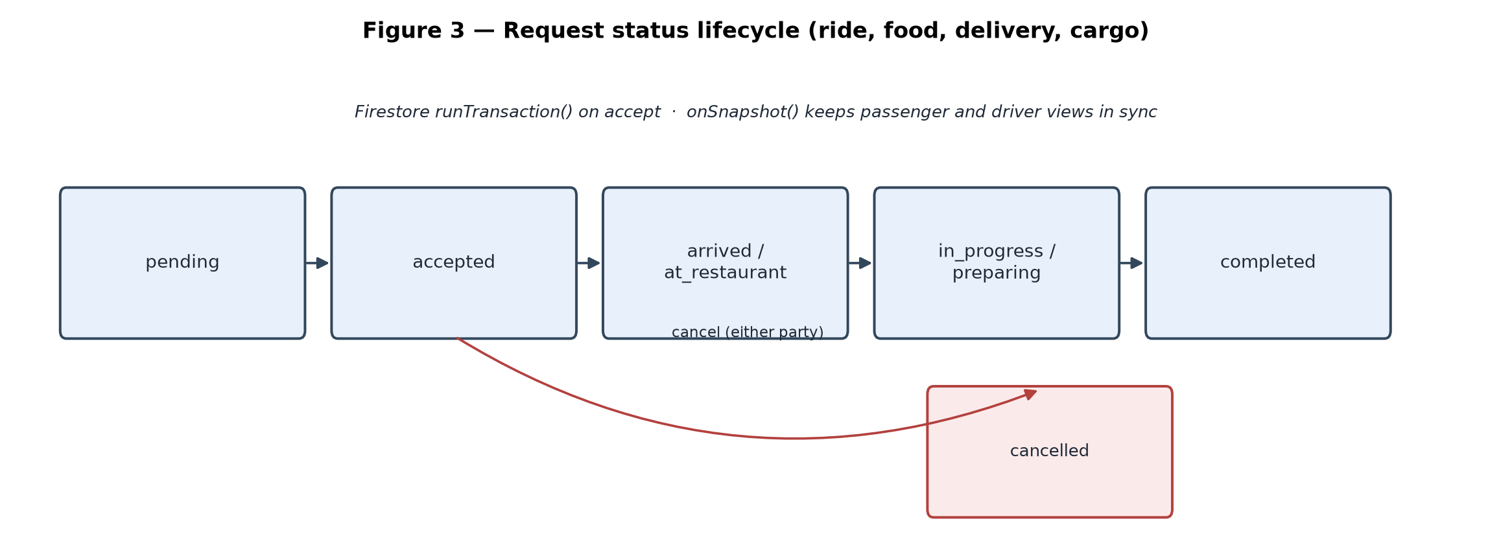
Figure 3 (repeated for reference) — Request status lifecycle used across ride, food, delivery and cargo requests.

