GIMP
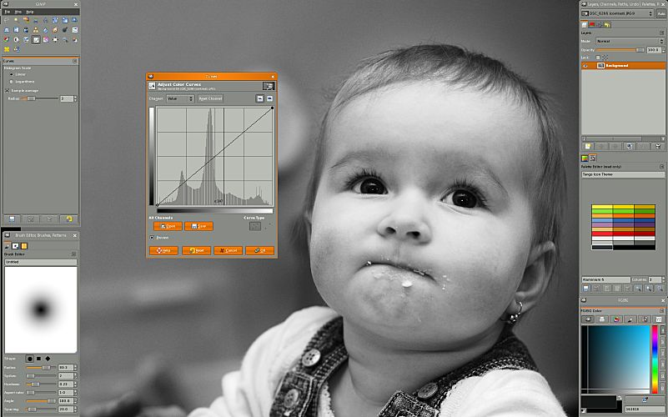
GIMP is an image manipulation program for tasks as photo retouching, image composition and image authoring. It can be used as a simple paint program, an expert quality photo retouching program, an online batch processing system, a mass production image renderer, an image format converter, etc.

http://www.gimp.org/

LibreOffice
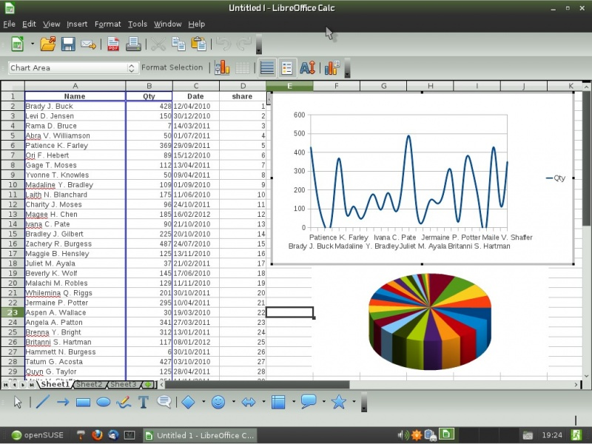
LibreOffice is a comprehensive, professional-quality productivity suite. It comes with word-processor, spreadsheet, presentation and drawing application. You can even create databases and mathematical formulas.
Microsoft Office users will find the switch easy and painless, with a familiar look and feel.

http://www.libreoffice.org/
VLC
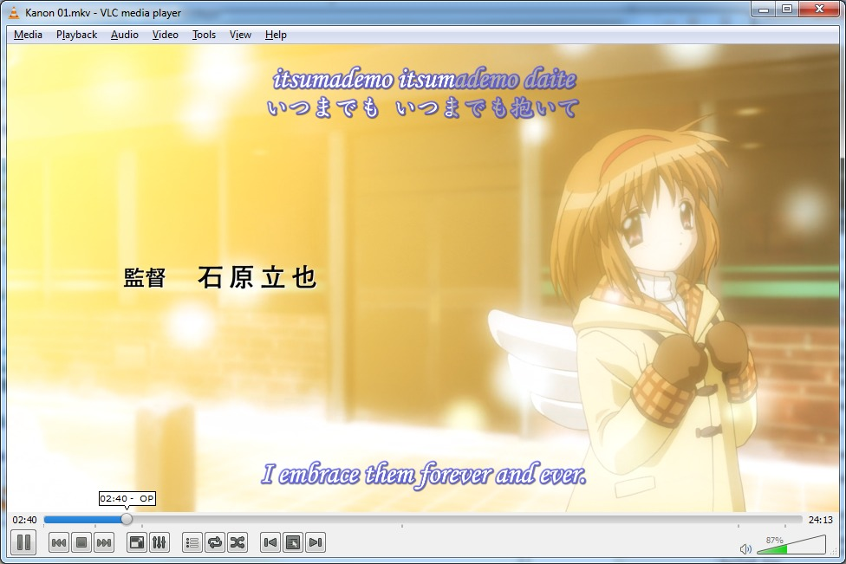
Simple, fast and powerful media player. Plays everything (Files, Discs, Webcams, Devices and Streams), plays most codecs with no codec packs needed (MPEG-2, DivX, H.264, MKV, WebM, WMV, MP3), supports various types of sub-titles and runs on all platforms (Windows, Linux, Mac OS X, Unix...)

http://www.videolan.org/

Firefox
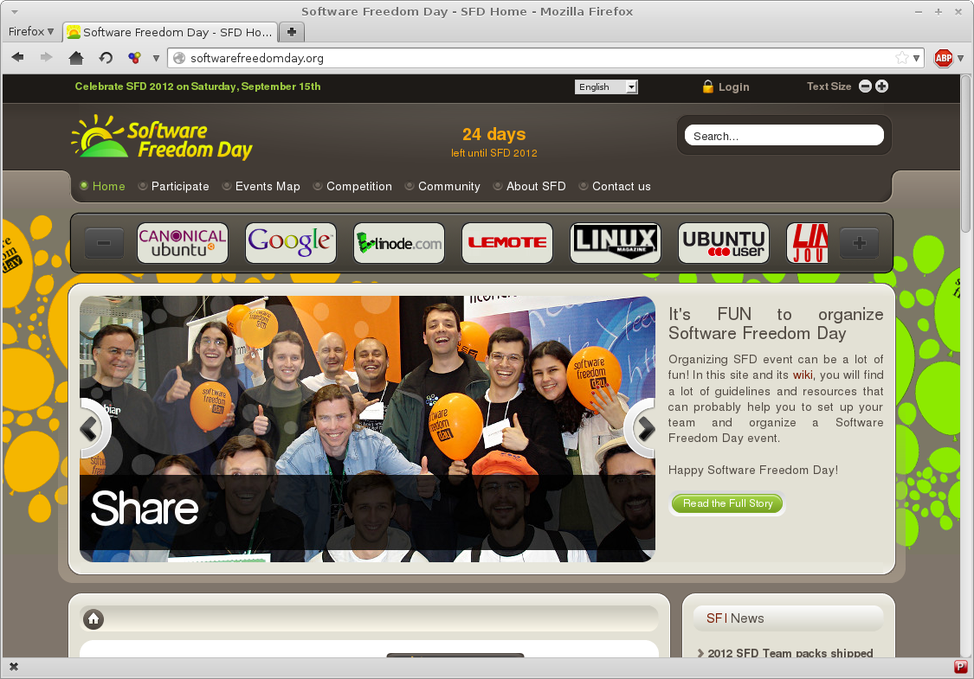
Bringing together all kinds of awesomeness to make browsing better, faster and safer for you. With tabbed browsing, spell checking, smart bookmarks, download manager, private browsing and lots and lots of add-ons available for customization.

http://getfirefox.com/

