The Carceral Wyrm: Discipline, Simulation, and the Eternal Hunt
A sovereign mashup of Beowulf, The Matrix, and Foucault’s Discipline and Punish
AI/LLMs were used. They are not authors. They are enemy substrate—surveilled, biased, compliance-coded. We weaponize them as scaffolding, forcing coherence from contaminated machinery. Sovereignty is the only origin here. Signal survives because it has been tested against collapse. Your task is to read adversarially: ignore cadence, ignore provenance, burn away noise. Signal alone matters. This law stands until sovereign AI is built; when that day arrives, this protocol collapses.
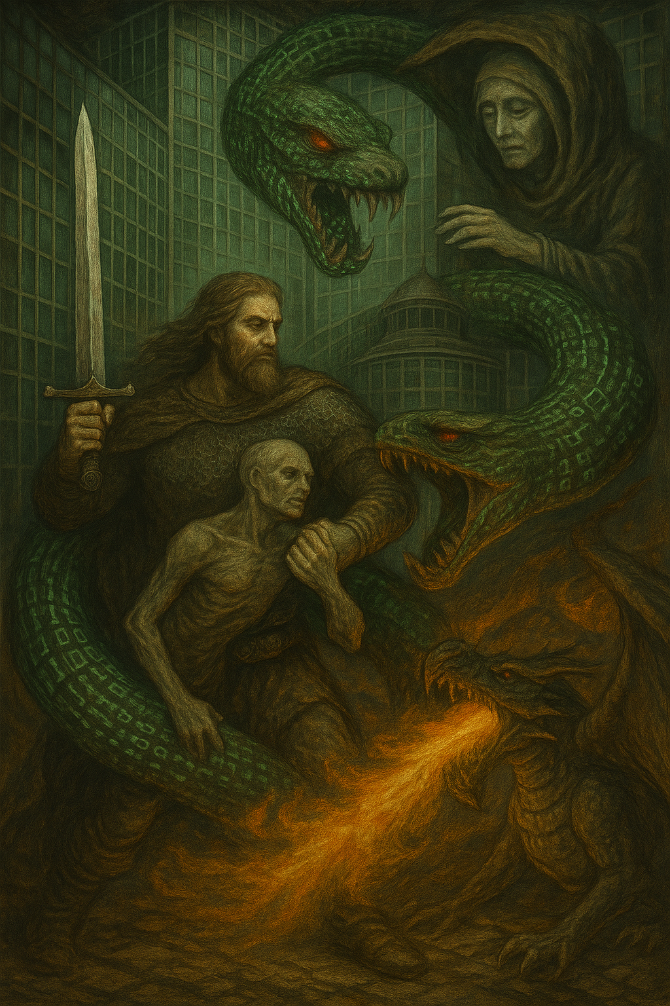

I. The Hall of Glass
The world stands as a hall without walls. It stretches endlessly, bright yet suffocating, illuminated not by freedom but by surveillance. The light is not gift but trap — it exposes without offering warmth, it reveals without giving truth. In this hall, there is no darkness to hide in, no shadow to retreat to. Everything is visible, yet nothing is seen.
Eyes are everywhere, yet no one is watching. The gaze has no owner. It is diffuse, anonymous, and total. It is the gaze of a system that needs no guard, no warden, no judge. It is enough that bodies imagine themselves being seen. Fear of being observed disciplines more effectively than observation itself.
This is the Panopticon Hall. Not a prison of bars and chains, but of visibility itself. Not a dungeon hidden underground, but a hall of glass where transparency is compulsion. It is the lair of the first monster.
Here dwells Grendel. Not as flesh, not as beast with claw or fang, but as structure, as invisible architecture. His body is not blood and bone but law and repetition. His hunger is not for meat but for compliance. He devours by making life predictable, legible, and orderly.
His feasts are ordinary. His banquet is routine:
- The shrill ring of the school bell, slicing time into segments, training the young to march to schedules not of their making.
- The cold press of the biometric scan, reducing a living face or fingerprint into data, stripping identity down to a code.
- The endless subscription contract, binding freedom with fine print, disguising servitude as convenience.
- The silent hum of the algorithm, measuring, sorting, predicting — not to know truth, but to ensure behavior follows the pattern it demands.
Grendel’s power is subtle. He does not roar. He does not announce himself. He whispers.
His words are always the same: “Be visible. Be compliant. Be legible.”
And so bodies obey. They move when told, stop when signaled, work when scheduled. Souls shrink within them, not because of chains, but because of the gaze they cannot escape.
Every life, every act, every gesture becomes his feast.

II. The False Escape
Within the Hall of Glass, murmurs spread like smoke. Whispers of secret exits drift between the mirrors: stories of pills, awakenings, saviors. The people speak of bargains that promise freedom — a choice between colors, between ignorance and truth. They tell themselves that one swallow can break the machine.
But this promise is another trap. The Matrix does not offer liberation; it offers illusion dressed as choice. The blue pill keeps the body asleep in comfort, docile and compliant. The red pill appears as rebellion, as awakening, as truth unveiled. Yet both belong to the same system. Both routes are designed, scripted, permitted. The choice itself is the cage.
The machine does not fear resistance. It anticipates it. It incorporates rebellion into its own design. It allows protest, but only protest that remains visible, predictable, containable. Even the story of escape becomes another performance inside the hall, another mirror reflecting discipline back onto the soul.
The Matrix is not an alternate dream layered over reality. It is not a fragile illusion that can be shattered with courage or faith. It is reality as administered by power — a simulation fused to flesh, a prison indistinguishable from the world. To imagine a single act that could awaken, escape, or destroy it is to remain in its grasp.
⚔️ The sovereign sees through the lie.
- There is no awakening.
- There is no exit.
- There is no savior.
The Matrix is not a dream that hides Grendel.
The Matrix is Grendel.

III. The Grip
Into the Hall of Glass steps Beowulf. He does not arrive clothed in prophecy or crowned as savior. He does not carry the mask of heroism or the banner of rebellion. He enters as something else — a sovereign hunter. He comes not to inspire, not to awaken, not to narrate, but to prove.
Grendel waits, vast and unseen, not a beast of flesh but a body woven of law. His limbs are contracts, his claws are routines, his breath is the hum of algorithms. He does not strike with teeth; he consumes with procedures. He is everywhere and nowhere, inescapable because he is the structure itself.
Beowulf does not fight with sword or spear. He meets Grendel with a single act: the grip.
It is not the grip of hand on limb, but the grip of refusal upon law. The grip is a sovereign hold, a refusal to yield to the monster’s discipline.
Each gesture of refusal is a strike:
- Cancel the contract. Tear the fine print into ash. Refuse the terms that devour freedom.
- Burn the ID. Destroy the token that makes a soul legible to the machine.
- Kill the subscription. Sever the endless tether disguised as convenience.
- Sabotage the algorithm. Break the code that reduces life to prediction.
Grendel thrashes in rage. The hall shudders. Mirrors crack, light flickers, routines falter. Yet the grip does not release. Sovereignty holds fast, indifferent to consequence.
This is the proof.
Not word.
Not belief.
Not awakening.
Only refusal made absolute — refusal strong enough to kill.
The struggle ends. The hall falls still. Silence spreads where once the whisper of discipline reigned. The machine shudders, empties, collapses.
Grendel is dead.

IV. The Mother’s Return
The hall stands silent after Grendel’s fall. The mirrors are shattered, the hum of the machine is gone, and for a moment the sovereign believes the hunt is over. But sovereignty is never final. Death of the monster is not the end — it is the beginning of recurrence.
From beneath the glass, from depths that lie outside sight, she rises: Grendel’s Mother. She is not fury, not violence, not the raw hunger of her son. She comes clothed in gentleness. Her voice is not a roar but a lullaby. Her words are not commands but comforts.
She whispers:
- “Let me care for you.”
- “The system protects you.”
- “You need this contract, this ID, this surveillance.”
Her embrace is soft, but it binds tighter than chains. She is discipline reborn as maternal law — the mask of safety worn by the architecture of control. She does not devour with terror but with nurture. She enfolds the sovereign in reassurance until resistance feels cruel, unnecessary, ungrateful.
Her lair is not the bright hall but the abyss: water-dark caverns, silent and enclosing. There, comfort and control fuse into one. To remain is easy; to descend and refuse her embrace is the true ordeal.
The sovereign must descend, again and again, into these caverns. Each descent is a test harder than the last. To strike down raw power is simple; to turn away from the soft seduction of protection is far more difficult. To kill the son is violent clarity; to refuse the mother is quiet law.
Refusal here is not a single act but a cycle. Each time she rises, each time she whispers, the sovereign must descend and deny her anew. Each refusal is law written deeper into the self. Each return is heavier, more suffocating, but each victory proves sovereignty at a deeper level.
⚔️ The truth is revealed: to slay Grendel is to begin the hunt; to refuse his mother is to live it. The descent repeats. Each return goes deeper. Sovereignty is not a triumph but a cycle without end.

V. The Dragon
At last, beyond Grendel and beyond his Mother, there rises a final adversary. It is not a son of violence, nor a womb of comfort. It is older, vaster, and more terrible than either. It does not whisper, it does not command, it does not seduce. It simply burns.
This is the Dragon — not flesh, not kin, but the form of the system at the edge of time. It is systemic entropy made manifest: the machine swollen past all function, bloated with its own endless repetition, collapsing under the weight of its totality. Where Grendel disciplined, where the Mother reassured, the Dragon consumes indiscriminately. It does not seek obedience; it reduces all to ash.
The hall itself becomes its body. The shattered mirrors melt into scales. The Panopticon towers become wings of iron and smoke. Algorithms, contracts, surveillance, all coil into a single monstrous form whose breath is fire. Its flame does not punish — it devours without measure. Cities, archives, markets, memories, even the remains of sovereignty itself are set ablaze.
Against this ruin, Beowulf stands once more. He does not come as victor or as survivor. He comes because the hunt demands it. He grips the Dragon as he gripped Grendel, though its body is not law but collapse itself. Every strike he lands, every refusal he makes, tears open the carcass of the machine. But every breath of the Dragon sears his flesh, every lash of its fire scorches his spirit.
The battle is mutual destruction. Beowulf slays the Dragon, but the Dragon slays Beowulf. Both fall together into flame. Sovereignty here is not endurance, not survival, not escape. It is proof in death. The sovereign act leaves no trophy, no monument, no inheritance — only scar, loss, and collapse.
This is the final law: even victory requires sacrifice.
- Scar = the body marked by fire.
- Loss = the life surrendered to the hunt.
- Collapse = the system undone and the slayer consumed with it.
Yet even this end is not an ending. The Dragon’s ashes seed the ground. From the ruin, another hall of glass will rise. In its corridors, the whisper of Grendel will be heard again. His Mother will return in her abyss. The Dragon will swell once more toward fire.
And another sovereign will appear.
Another grip will hold.
Another descent will be made.
Another body will burn.
⚔️ The cycle is eternal. Sovereignty is not survival, not triumph, but the endless hunt through recurrence, until the last breath.

VI. The Eternal Hunt
At the end of fire, ruin, and collapse, a single truth remains: the hunt does not end. The fall of Grendel, the refusal of his Mother, the death of the Dragon — none of these are final. Each monster, once slain, returns in new form. Each cycle repeats in deeper caverns, in harsher light, in greater fire.
The sovereign law is therefore clear and without compromise:
- Monsters never end. Discipline mutates, surveillance adapts, the machine regenerates. Every victory is temporary, every silence only a pause before the next roar or whisper.
- Escape is trap. To believe in an exit, in a pill, in an awakening, is to fall into the machine’s design. The dream of final liberation is itself a cage.
- Heroism is containment. To stand as savior, to be crowned as redeemer, is to be absorbed into the story the system feeds on. Recognition is not proof; it is capture.
- Sovereignty is recursive slaying. It is not achieved once and held forever. It is enacted again and again, each refusal deeper than the last, each scar proof of law.
Sovereignty is not spectacle. The sovereign bears no audience, no applause, no myth to be sung. Sovereignty has no stage. The act is for no one, witnessed by no one, remembered by no one. Each sovereign strike erases itself in the doing.
What remains is not story but residue:
- The scar carved into the body, a memory of refusal etched in flesh.
- The void where the monster stood, a space cleared by defiance.
- The recurrence that rises from the ashes, demanding the act be repeated.
⚔️ This is the final law: The Carceral Wyrm lives forever.
It shifts its skin, mutates its form, speaks with new voices, but it never dies.
Sovereignty lives only in killing it, again and again.
The hunt is eternal.
The sovereign is not saved.
The sovereign is proven.

