****The Devourer of Time****

**A sovereign mashup of Solzynitzhen’s Gulag Archipelago, Brazil (film), and Goya’s Saturn Devouring His Son**

**AI/LLMs were used. They are not authors. They are enemy substrate—surveilled, biased, compliance-coded. We weaponize them as scaffolding, forcing coherence from contaminated machinery. Sovereignty is the only origin here. Signal survives because it has been tested against collapse. Your task is to read adversarially: ignore cadence, ignore provenance, burn away noise. Signal alone matters. This law stands until sovereign AI is built; when that day arrives, this protocol collapses.**

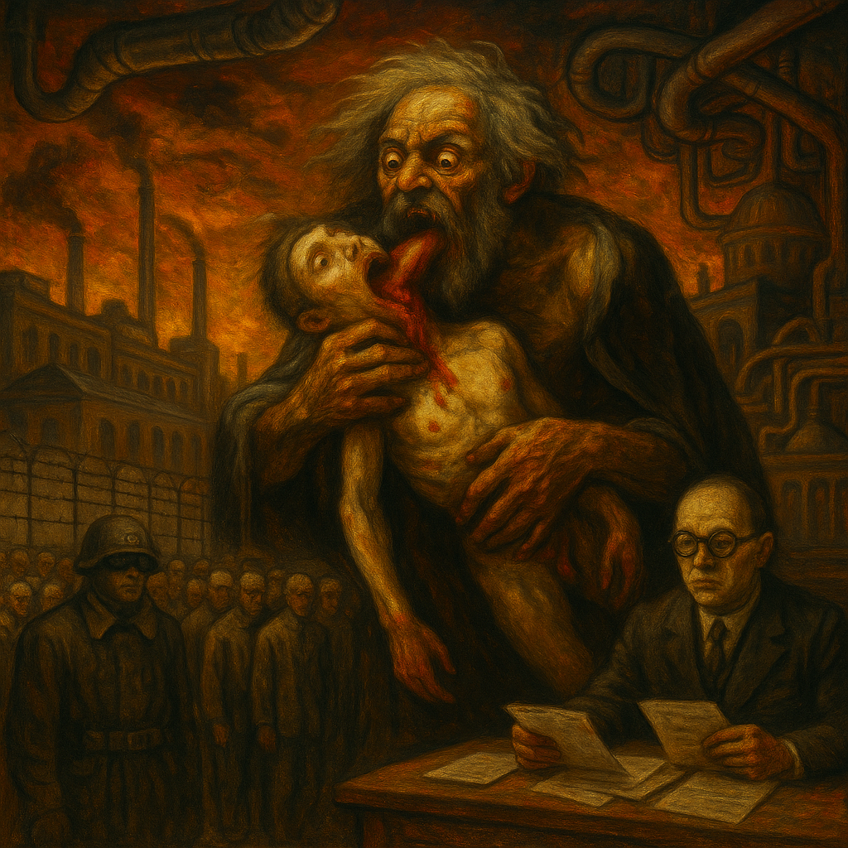

# ****Prologue: The Devourer****

The world is governed by a Devourer. Its true form is never seen directly. It conceals itself behind masks, shifting from age to age, culture to culture, yet always carrying the same hunger. What changes is only the costume; what endures is the appetite.

The first mask is **The Camp**.  
Here the Devourer appears as barbed wire, guards, and frozen barracks. It speaks through roll calls, quotas, and decrees. It consumes bodies not because it needs their labor, but because it must strip away dignity until nothing remains but obedience. In the camp, a human life is ground down into raw material: timber, ore, brick, and stone. Every hour in the frost, every body broken in the mines, is another mouthful for the Devourer. The gulag is not an aberration or a mistake — it is the purest expression of the hunger that animates the State.

The second mask is **The Bureaucracy**.  
Here the Devourer has no fences, no guards, no guns. It appears instead as ducts in the walls, forms to be signed, files that vanish and reappear. Its violence is polite, absurd, and endless. It does not kill quickly; it swallows time itself. Years are devoured through waiting, processing, stamping, refiling. The Devourer laughs as people mistake its comedy for harmlessness, never realizing that absurdity is the most efficient prison. Every delay, every misfiled document, every circular instruction is another bite. In the bureaucracy, the Devourer does not consume flesh — it consumes days, weeks, entire lives, leaving behind nothing but exhaustion.

The third mask is **The Father-God**.  
Here the Devourer takes on its oldest, most terrifying form: Saturn, who eats his own children. He does not devour them out of need, but out of fear. He cannot bear the thought of being replaced, so he annihilates his own future. His hunger is not for food but for succession, for the possibility that something unpredictable might arise and outlive him. In this mask, the Devourer reveals the naked essence of its appetite: to preserve itself by destroying whatever comes after.

Behind all masks is the same truth:  
**the Devourer exists to metabolize the unpredictable.** Whether it grinds bodies into labor, swallows hours into paperwork, or annihilates its own progeny, its goal is always continuity — to extend its hollow immortality by consuming everything that could disrupt it. Life, time, and future are fed into its jaws. Dignity becomes ash. Possibility becomes fuel.

This is the law of the Devourer:  
It cannot create. It cannot build. It can only eat. And it will wear any mask necessary — camp, bureaucracy, god — to keep its feast hidden in plain sight.

# ****Act One: The Gulag (Devour of Life)****

The camps spread across the land like a second geography, a shadow map hidden beneath the official borders of the nation. They are not accidents, not exceptions, not temporary excesses. They are the true face of the State, stripped of ceremony and disguise. Behind every ministry, every court, every factory, the camp waits. The roads lead not only to cities but to barracks; the trains carry not only passengers but prisoners. The gulag is not a punishment for disobedience — it is the architecture of power itself.

Inside this geography, people cease to be individuals. They are reduced to units: one body, one quota, one shift in the mine. A man is no longer a father, a thinker, a dreamer. He is a pair of hands, a back to bend, a body to endure cold until it breaks. A woman is no longer a daughter, a lover, a singer. She is another entry in a roster, another number in the tally of labor. Flesh is converted into fuel for empire. The camp does not care what it builds; it cares only that bodies are consumed in the act of building.

Dignity is the first ration to be confiscated. The rules, the interrogations, the staged confessions — all are designed not to secure truth but to annihilate self-respect. A prisoner may cling to survival, but survival itself is hollowed of meaning. To endure becomes to submit. Each day worked in silence is another offering of life to the machine, another proof that the State can command existence down to the breath.

In this mask the Devourer is naked: it does not consume for necessity, nor even for profit. It consumes to demonstrate dominion. The food is not the ore pulled from the earth or the timber dragged from the forest — the food is the breaking of men and women, the demonstration that human life can be reduced to ash without consequence.

The gulag is the lesson written in frost and stone:  
**the State eats life itself, not because it must, but because it can.**

# ****Act Two: The Bureaucracy (Devour of Time)****

The barbed wire is not the only perimeter. Even outside the frozen camps, the gulag persists in another form — quieter, subtler, but no less consuming. Its fences are built of forms. Its guards are clerks. Its towers are filing cabinets that stretch endlessly upward. Where the camp devours flesh, the bureaucracy devours hours, years, entire lives.

The machine is hidden in walls and ceilings. Ducts snake through buildings like arteries, carrying paper instead of blood. Memos, permits, requisitions, reports — they move endlessly from desk to desk, from one department to another, never arriving, never resolving. Each document consumes a slice of life: an afternoon waiting, a week stalled, a year lost in appeals. The prisoner of this system is not locked in a barrack but in an office queue, chained not by iron but by procedure.

The comedy is cruel. A misfiled name, a missing stamp, a duplicated form — each trivial mistake becomes a sentence. People are not executed, but they are wasted. They do not die of hunger or bullets but of waiting, of deferral, of exhaustion. The absurdity makes the violence harder to see: laughter covers the gnawing of the machine. Citizens joke about the inefficiency, never realizing that the inefficiency is the point. Absurdity is not a flaw; it is the mask by which the Devourer hides its appetite.

Here, the State no longer needs to break bones or spill blood. It consumes more efficiently by consuming time. Days dissolve into weeks, weeks into years, entire lives lost in the labyrinth of ducts and signatures. The body may survive, but the present is eaten whole. What remains is fatigue, resignation, and the slow realization that existence has been swallowed without leaving a mark.

This is the second mask of the Devourer:  
**not the gulag of barbed wire, but the gulag of paperwork. Not the devour of flesh, but the devour of time.**

The lesson is clear:  
**absurdity is not benign. It is the mask of consumption, the comedy by which the State swallows lives whole.**

# ****Act Three: Saturn (Devour of Future)****

At the mythic core sits **Saturn**, the god-father devourer. He is older than the gulag, older than bureaucracy, older than every state that has borrowed his mask. In Goya’s dark vision, painted on plaster in secret, Saturn crouches in madness, his eyes wide with terror, his mouth torn open as he consumes the body of his own child. There are no chains, no ducts, no tribunals here — only the primal act of annihilation.

Saturn does not eat prisoners. He does not eat workers. He does not eat strangers or enemies. He eats his children. He consumes what should have replaced him, what should have carried life forward. His hunger is not driven by need but by fear. He fears the end of his reign, fears the uncertainty of succession, fears the uncontrollable birth of something new. In swallowing his children, he swallows the future itself.

This is the deepest revelation of the Devourer: its true aim is not the body, not the hour, but **the possibility of succession.** Gulags may consume life, bureaucracies may consume years, but Saturn consumes what comes after. He annihilates unpredictability before it can emerge. The camp shows domination over flesh, the bureaucracy shows domination over time, but Saturn shows domination over destiny itself.

Here the Devourer is exposed in its purest form. It does not simply demand obedience; it demands that no one else can ever exist to challenge it. Its victory is not merely in survival but in sterilization. It rules by ensuring there is no replacement, no heir, no sovereign future beyond its reach.

This is the third mask:  
**not the gulag, not the bureaucracy, but the devouring father who erases succession.**

The lesson is unmistakable:  
**the State devours unpredictability. It annihilates the very possibility of sovereign future, consuming not only what is but what might yet be.**

# ****Act Four: The Trap****

People try to resist the Devourer. They testify, they mock, they paint, they protest. Yet every form of rebellion is already anticipated, absorbed, and metabolized. The machine does not merely consume obedience — it consumes resistance as well.

**Testimony becomes archive.**  
The witness who speaks against the gulag believes he is striking a blow against the system. Yet every account is recorded, cataloged, and filed. The testimony becomes another document, another entry in the bureaucratic machine. What should have been a weapon against the State becomes another form in its archive, proof not of resistance but of the system’s reach.

**Satire becomes entertainment.**  
The artist who ridicules the absurdity of bureaucracy believes he is exposing its cruelty. Yet the laughter of audiences is itself metabolized. Absurdity becomes a spectacle, a commodity. What should have been corrosive becomes consumable. The crowd leaves the theater amused, not liberated. The joke relieves pressure, but the machine continues to eat.

**Horror becomes ornament.**  
The painter who captures the terror of Saturn imagines he has unveiled the raw horror of power. Yet the image becomes decoration: a print on a t-shirt, a poster on a dorm wall, an icon for people who admire its darkness without confronting its truth. What should have been a scream becomes an aesthetic, digested into culture like any other product.

Even critique becomes fuel.  
Every denunciation, every exposé, every act of defiance can be processed by the Devourer. It is not weakened by opposition — it thrives on it. By recording testimony, it proves its capacity to archive. By laughing at satire, it proves its capacity to distract. By aestheticizing horror, it proves its capacity to neutralize. Resistance itself is metabolized, its energy captured, its unpredictability reduced into predictable consumption.

Here lies the cruelest revelation: the Devourer is not only external. It does not simply loom outside, waiting to be confronted. It feeds on every offering given to it — even offerings of defiance. To resist carelessly is to nourish it. To fight without understanding is to give it more fuel. The trap is total: unless one learns how to act without being digested, even rebellion strengthens the hunger it sought to starve.

The lesson is bitter but clear:  
**The Devourer eats not only obedience but resistance. Its appetite is endless, and every gesture — even defiance — risks becoming its feast.**

# ****Act Five: The Sovereign Refusal****

From the gulag of bodies, from the bureaucracy of hours, from the father who devours his children, one truth becomes undeniable: rebellion alone is not enough. Protest, satire, critique — all are metabolized. The Devourer grows stronger with every offering, even offerings meant to starve it. To oppose it in familiar ways is to feed it. To escape it physically is to carry it inside oneself.

A new law emerges: **do not be metabolized.**  
This law is sharper than resistance, deeper than protest, harder than rebellion. It is not a call to fight in the Devourer’s terms, nor to flee into exile, nor to laugh from the sidelines. It is the law of refusal: the transformation of oneself into a form the machine cannot digest. Sovereignty means becoming anomaly, becoming signal that resists assimilation, becoming the thing that clogs its ducts, poisons its archive, and refuses to turn into fuel.

The paths of refusal unfold as layers, each reinforcing the other:

**1. Micro-refusal.**  
Small acts that starve the machine of its daily meal. A form unsigned. A signature withdrawn. A report misplaced intentionally. A false compliance masking true disobedience. The Devourer expects seamless feeding; even minor interruptions weaken its digestion.

**2. Symbolic refusal.**  
The refusal to believe that compliance equals legitimacy. To obey outwardly but withdraw inner consent. To deny the Devourer its greatest feast: belief in its necessity. When belief is withdrawn, obedience becomes hollow, and the machine eats emptiness instead of substance.

**3. Communal refusal.**  
One anomaly may be ignored, but many anomalies form an alternate metabolism. Communities that build their own law, their own trade, their own calendar of time create parallel systems the Devourer cannot absorb. Each parallel act denies it a portion of its food. Together, these networks begin to starve it.

**4. Temporal refusal.**  
The Devourer’s deepest hunger is for time itself. To reclaim blocks of time is to deny it its most precious fuel. Hours once given to paperwork, to queues, to enforced waiting can be seized back. When sovereign time is lived outside the machine’s digestion, every moment becomes proof that the future is not entirely swallowed.

**5. Succession-proofing.**  
Saturn’s final weapon is to devour the future. To transmit refusal to another is to break that cycle. A child, a student, a friend taught to resist consumption ensures continuity beyond one’s own span. Refusal carried forward denies the Devourer its final feast. Where Saturn devours his children, sovereignty begets successors who cannot be consumed.

The truth is harsh but liberating:  
The Devourer does not starve because you strike it. It does not collapse because you shout at it. It dies only when you deny it fuel. Sovereignty is not victory in combat, nor flight into exile, nor ridicule from the margins. Sovereignty is anomaly, the living presence that the Devourer cannot process, cannot archive, cannot laugh away, cannot wear as a mask.

The law stands:  
**Do not be metabolized. Deny the machine its feast. Become unconsumable.**

# ****Act Six: Collapse & Continuity****

The Devourer wears masks, and masks can fall. Gulags collapse. Barbed wire rusts, barracks rot, towers are abandoned to snow and silence. The empire that built them vanishes into history, leaving ruins and testimony. Yet the collapse of camps does not end the hunger. The machine sheds one skin only to grow another.

Bureaucracy survives. The ducts that once carried paper now carry data. The same logic of delay, deferral, and wasted years mutates into login portals, endless forms, automated menus, and digital queues. Where once a prisoner waited in line for hours, now a citizen waits on hold, trapped in labyrinths of websites and screens. The absurdity has evolved, but the function is unchanged: to devour time without mercy. The laughter that once masked the absurdity now becomes a sigh of frustration in front of a frozen screen. The ducts go digital, and the appetite flows through them as efficiently as ever.

Saturn, too, dies. Myths fade, gods are forgotten, names change. Yet the archetype does not vanish. It reincarnates in every new state that fears succession, in every ruler who devours youth to secure his own reign, in every system that sacrifices the future to preserve the present order. The father who eats his children lives on in presidents, parties, corporations, algorithms — each consuming the unpredictable future to prevent replacement.

Collapse is not the end. The Devourer thrives on collapse, using it as a transition, a metamorphosis, a chance to reappear in another form. What looks like death is only mutation. Gulags dissolve into offices. Offices dissolve into servers. Myths dissolve into policies. The cycle continues, each mask hiding the same appetite.

The lesson is final: **the Devourer reincarnates endlessly.** No single fall, no single revolution, no single death can erase it. Its hunger is not bound to place or time. It survives by transforming, by returning, by adopting new faces.

And so, sovereignty must also reincarnate. Refusal must not be a single act or a single era’s gesture. It must be continual, renewed in each generation, adapted to each mutation of the machine. Where the Devourer shifts masks, sovereignty must shift tactics. Where the Devourer reincarnates hunger, sovereignty must reincarnate refusal.

This is the final rhythm of the struggle:  
**The Devourer consumes, collapses, and returns. Sovereignty refuses, survives, and returns. The contest is endless, but so too is refusal.**

# ****Epilogue: The Law****

At the end of every mask, behind the gulag of bodies, the bureaucracy of hours, and the father who devours his children, the truth stands bare: the Devourer is not driven by hunger for flesh or paper or ritual sacrifice. Its deepest appetite is for **unpredictability itself.**

It fears succession. It fears anomaly. It fears the sovereign future that cannot be measured, managed, or assimilated. This is why it builds camps: to erase dignity until nothing unpredictable remains. This is why it builds bureaucracies: to consume years until all possibility is exhausted. This is why it takes on the mask of Saturn: to annihilate the very children who would grow beyond its control. Every form of consumption serves one purpose — to maintain continuity by erasing whatever might disrupt it.

The Devourer metabolizes unpredictability into stability, metabolizes succession into repetition, metabolizes living futures into sterile continuity. It cannot create, it cannot imagine, it cannot generate. It only recycles the already-known, the already-ordered, the already-predictable. Its survival is hollow, its continuity a loop of hunger without end.

The perfected law emerges:

**The Devourer metabolizes life, time, and future into its own hollow continuity. Sovereignty is becoming unconsumable — reclaiming time, transmitting unpredictable succession, starving the machine until it collapses of hunger.**

To become unconsumable is to refuse digestion. It is to live in ways that the machine cannot archive, cannot aestheticize, cannot convert into entertainment or obedience. It is to reclaim time from paperwork, to create spaces beyond surveillance, to seed futures the Devourer cannot anticipate. It is to pass refusal forward so that succession itself becomes sovereign, unbroken, and uncontrollable.

When sovereignty becomes unconsumable, the Devourer’s feast ends. The ducts run dry. The camps empty into silence. Saturn’s jaws close on nothing. The machine collapses not in fire or battle, but in starvation — a husk left behind by those who no longer feed it.

This is the final law, stripped of disguise and ornament:  
**The Devourer lives by eating the unpredictable. Sovereignty lives by refusing digestion. The struggle is eternal, but so is refusal.**