Englisch LK REB Gender Pay Gap 28th November 2024

**Picture analysis**

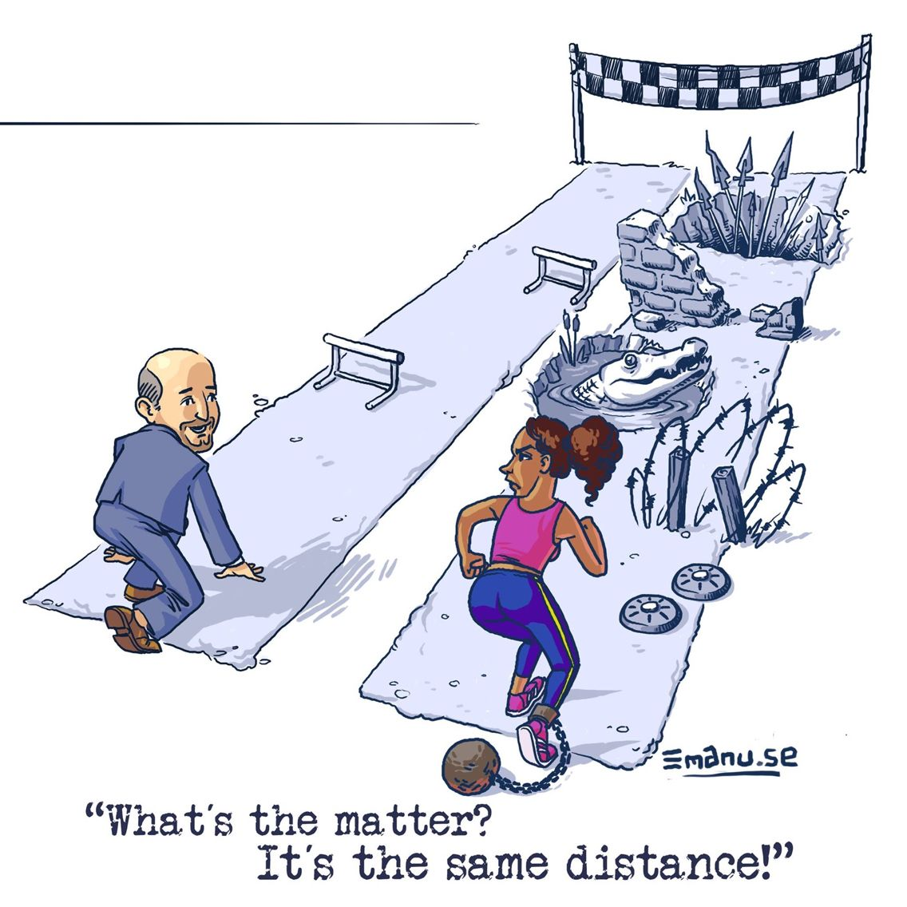

Source: https://1.bp.blogspot.com