%log

%parameters are set as rf = 2, k =8.

weightedBSS_main

BSSTk

rf = 2

k = 8

filename6 =

example_data_rf2_B_k8_kk

filename7 =

example_data_rf2_z0_k8_kk

weighted BSSTk

rf = 2

k = 8

filename6 =

example_data_wavelet_rf2_B_k8_kk

filename7 =

example_data_wavelet_rf2_z0_k8_kk

%example_data.mat is an example data from one subject from our paper, “Weighted Blind Source Separation Can Decompose the Frequency Mismatch Response by Deviant Concatenation: An Meg Study. Front. Neurol. 13:762497. Doi. 10.3389/fneur.2022.762497”

%load example_data.mat　data0, times, info

%Sampling frequency is 1000 Hz.

load example_data

%Trigger selection (512, 1024, 2048, 4096 all represent standard stimuli while 8192 refers to deviant stimuli.)

stim=data0(371,:);c=double(stim);e(2:size(stim,2))=c(1:size(stim,2)-1);ee=c-e;

stim_info_1=find(ee(:)==512); stim_info_2=find(ee(:)==1024);

stim_info_3=find(ee(:)==2048); stim_info_4=find(ee(:)==4096);

stim_info_5=find(ee(:)==8192);

stim_info_stan=[stim_info_1; stim_info_2; stim_info_3; stim_info_4];

stim_info_sort=sort(stim_info_stan);　　 size(stim_info_sort) =818 1

stim_info_dev=stim_info_5;　　 size(stim_info_dev) =207 1

save stim_info_rt stim_info_sort stim_info_dev

%Select gradiometers among 307 channels (EEG, MEG, Stim)

data=data0; data(307:end,:)=[]; data(3:3:306,:)=[]

％ c.f., evoked response of deviant stimuli (gradiometers)

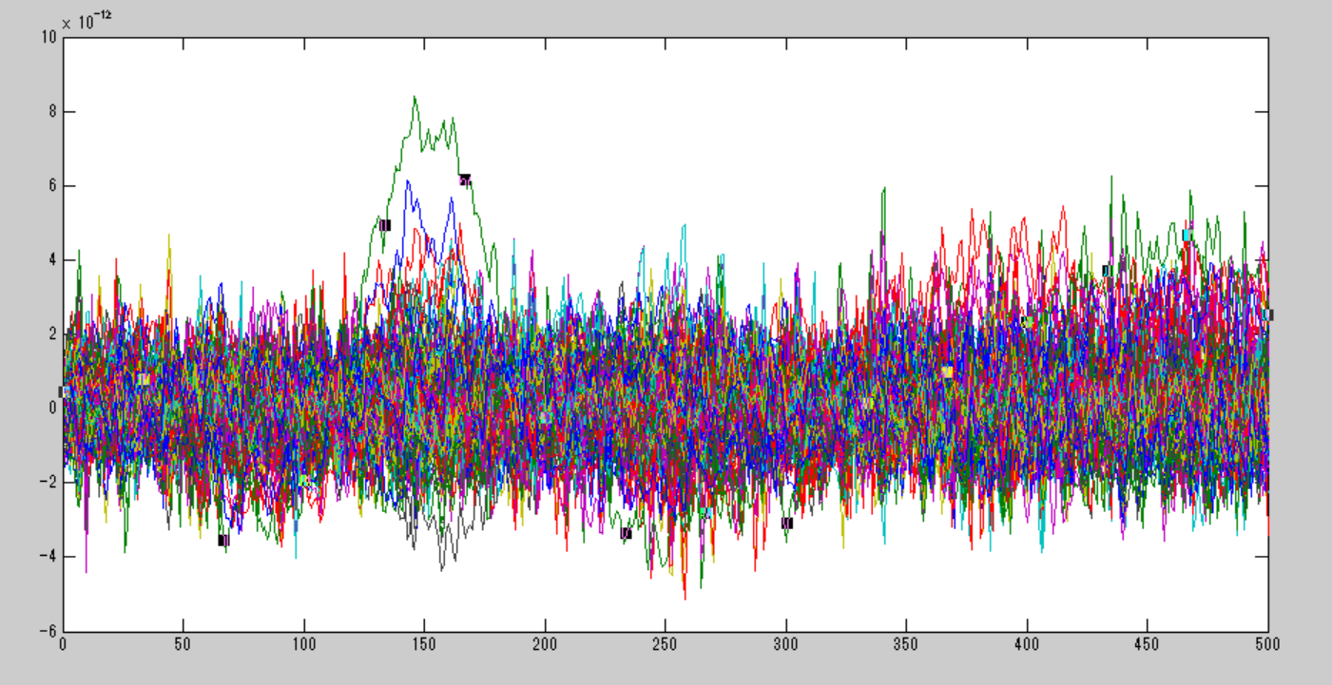

%*BSST/k*

BSS_func_kishida('example_data_rf2',data,1000)

rf = 2　 k = 8

filename6 =example_data_rf2_B_k8_kk

filename7 =example_data_rf2_z0_k8_kk

%c.f., evoked response of deviant stimuli (signal source; light blue BSS53, yellow BSS125)

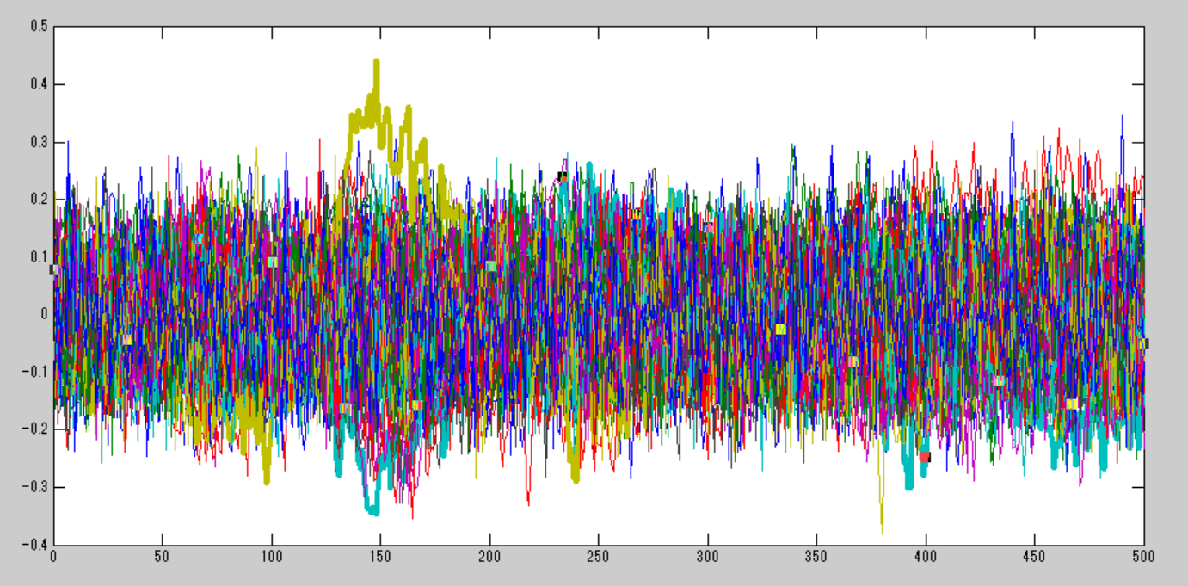

% c.f., topographic maps of BSS53 and BSS125

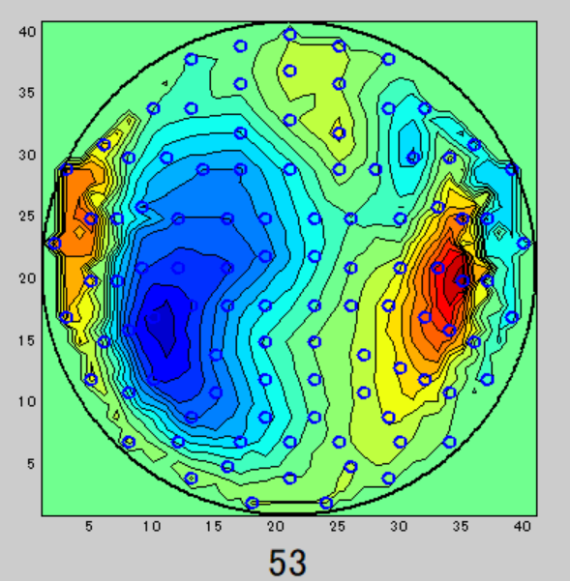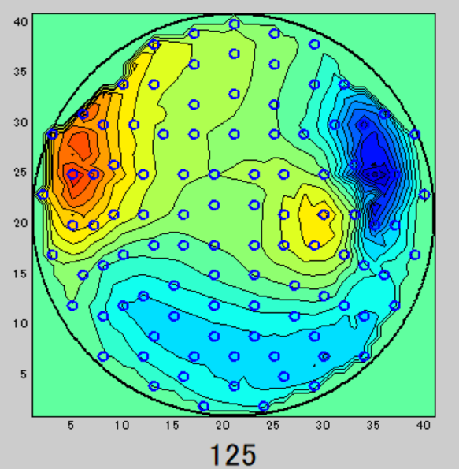

% *Weighted-BSST/k*

% Deviant concatenation and weight assignment at 96-276 ms.

data0=[];for k=1:207 data0=[data0 data(:,stim_info_dev(k):stim_info_dev(k)+95)*0.2 data(:,stim_info_dev(k)+96:stim_info_dev(k)+276) data(:,stim_info_dev(k)+277:stim_info_dev(k)+499)*0.2];end

BSS_func_kishida('example_data_wavelet_rf2',data0,1000)

rf = 2　 k = 8

filename6 =example_data_wavelet_rf2_B_k8_kk

filename7 =example_data_wavelet_rf2_z0_k8_kk

% c.f., evoked response of deviant stimuli (signal source; green BSS107)

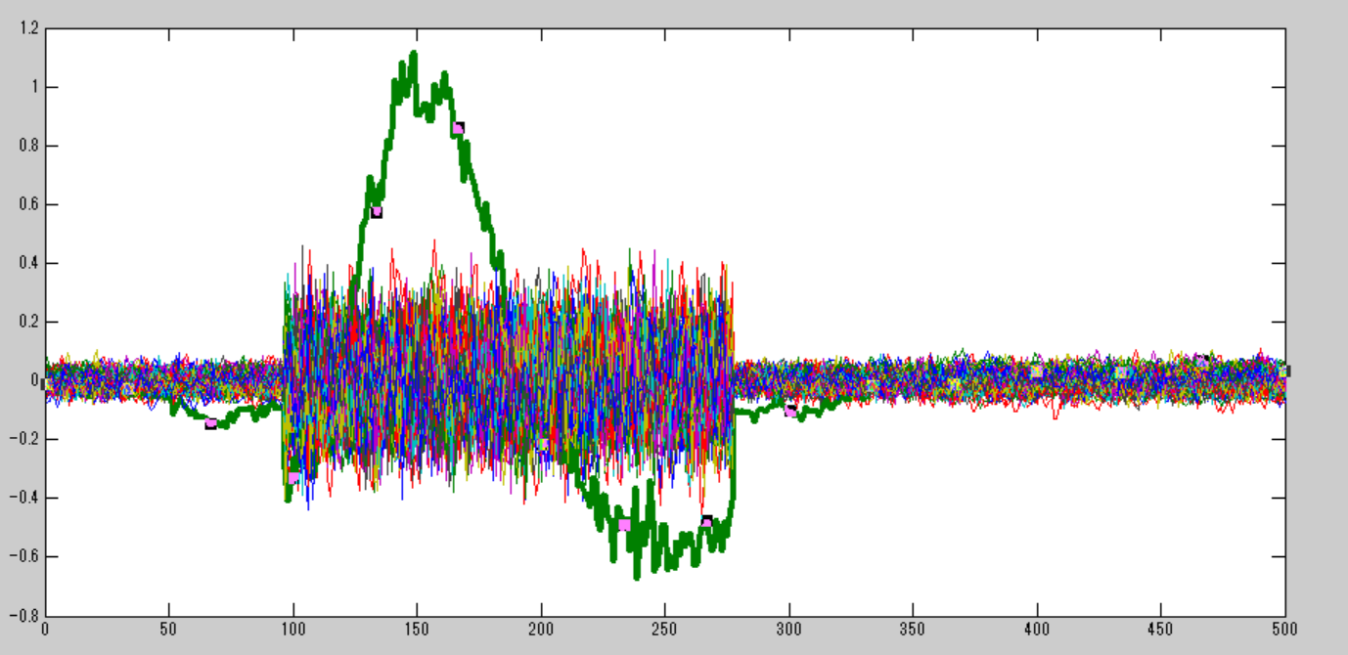

% c.f., topographic map of BSS107

