OpenSonora Alpha
Making Guide
v.0.1 EN

Table of Contents

- Design and features
- PCB Layouts and Bill Of Materials
- Making steps and resources
- PCB Schematics
- License
1. Design and features

OpenSonora Alpha is a high efficiency class-D, low-power bluetooth wireless speaker that follows a non-conventional design.

OpenSonora Alpha sports bottom-facing speakers to produce a distributed sound effect. Moreover, its design allows to use the top plate as a sort of a shelf, which can be usefull f.eg. If it's placed on a on a desktop.

If the sound quality does not meet your taste though, it's possible to rotate OpenSonora and use it as a standard shelf speaker.

In it original implementation, OpenSonora uses reused/regenerated components, such as pallet/reused wood, recovered speakers and discrete electronics components taken from old devices (broken TVs, HiFi, Radios). It pairs these elements with brand new high efficiency modules for amplification and signaling, achieving consumer-grade performance and ease of use while reducing e-waste (RAEE) occurrence.

Moreover, the low-power, low-voltage and high-efficiency components used allow battery-operated tasks, which could be integrated to the actual design for further development, making OpenSonora Alpha portable.

Features

Audio Output: 2x3W Class-D Amplifier on 4Ohm speakers
Audio Input: 2.4GHz Bluetooth 2.0 with A2DP
Wireless range: 2 – 10 meters, according to signal noise, walls and other obstacles
Power: 5V 2A power supply. Can be powered via USB.
2. PCB Layouts / Bill of Materials

There are 2 different PCB Layouts.

- Type A PCB is designed to fit the case OpenSonora Alpha was designed for.
- Tybe B PCB is an alternative to reduce total PCB area, and may fit better on other cases.

If you're trying to integrate OpenSonora Alpha PCB into your own design, use Type A or Type B according to your needs, as they do not have any other difference except size.

Type A PCB

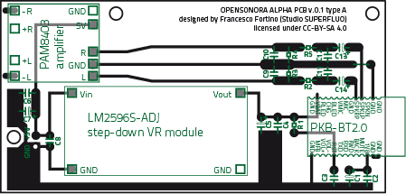
size: 90 x 45 mm
area: 4050 mmq

Type B PCB

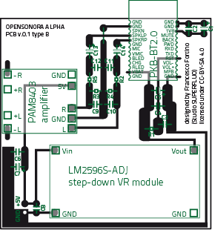
size: 60 x 60 mm
area: 3600 mmq

Bill of Materials (BOM)

Part on PCB | Reference/Notes | Price/unit | Url to shop
Modules
PAM8403 amplifier | Ultra-Miniature Digital Amplifier Board 2*3W D-Type PAM8403 | 1.40 USD | Click Here
PKB-BT2.0 | PKB Bluetooth Stereo Audio Module for Music Speaker | 7.10 USD | Click Here
LM2596S-ADJ step-down VR module | LM2596S-ADJ DC-DC Small-Tiny Adjustable Step-Down Module (3-40Vin, 1.5-35Vout) | 1.70 USD | Click Here
Discrete components
C1, C5, C7 | 47uF 10V electrolytic polarized cap
C6, C4, C2, C12, C11 | 47nF polyester
C3 | 4.7uF ceramic (475) although electrolytic polarized cap can be used with success
C13, C14 | 2.2uF 10V electrolytic polarized cap
R5, R2 | 6.5Kohm
R3, R4 | 47Kohm
C9, C10 | 47pF ceramic (471)
PCB Board | Varies according to the pcb-etching tecnique used. For bromograph etching you'll need pre-sensitized boards. For milling/toner-transfer etching, go for simple copper PCB boards. |  | Presensitized PCB boards  Simple Copper PCB
Others | Some spare break-away pins, straight and 90-Degrees |  | 90-Degrees B-A pins  Straight B-A pins

3. Making steps and resources

In order to make OpenSonora, you'll need to properly manage several practices and tecniques that depends upon the materials being used and the avaiable tools. Basically, we can divide the process into 3 steps:

3.1 Making the board

It's possible to choose at least 3 methods to make the PCB board of OpenSonora.

1) Toner Transfer Method
ref: http://makezine.com/projects/pcb-etching-using-toner-transfer-method/

This tecnique is the most affordable way for making a PCB. It needs only one chemical (Iron Chloride solution), is fast and easy but not that precise. and OpenSonora PCB is optimized for it. This is the reason why the components on the board have relatively huge spacing and the copper lines are wider than needed otherwise. Follow the steps in the guide.

2) PCB Milling
ref: http://www.instructables.com/id/CNC-USB-dual-layer-PCB-milling/

As an alternative, it's possible to mill your own PCB at the local FABLAB or similar laboratories: high precision, no chemicals, just a CNC router is needed.

3) Bromograph Etching
ref: http://www.instructables.com/id/How-to-make-a-printed-circuit-board-PCB-using-th/step1/Build-your-UV-LED-light-box/

It's possible to follow this method if a bromograph is available. UV etching is a way more precise, however, it uses many different chemicals that are not easy to dispose.

Once OpenSonora PCB is ready, just sold all the components on it.

3.2 Making the case

OpenSonora case is made of renewed wood recovered from pallets or other third-level packaging. Bass reflex tubes are standard 25mm PVC pipes found around in the industrial district.

The dimensions of the case have to be considered roughly approximate because of the heterogeneous nature in both quality and sizes for this kind of wood. In other words, the only value to be taken into consideration is the volume of the speaker room.

OpenSonora case has about 2L of air per-speaker. This volume allows to handle almost any kind of woofer from 8 cm to 12 cm in diameter. More precise calculation can be made, even if it could be useless considering the overall system performance and the relatively low output power. Moreover, woofers too are thought to be recovered from not-working electronic devices, and this makes hard to retrieve acoustic values.

Optimizing bass frequency response
Given the volume as fixed, it's possible to optimize bass frequency response by adjusting the lenght of the bass-reflex tubes: the shorter the tube, the higher the resonance frequency.

Optimizing overall volume and frequency response
Another way to optimize overall volume and FR is to add acoustic filling within the speaker room, such as cotton or sponge.

Further reference on reused woodworking tecniques can be found here:

How to make a flat plane: http://en.opencrafts.org/wiki/Make_a_flat_plane#Method_2
How to clean the wood: http://en.opencrafts.org/wiki/Wood_cleaning
How to coat the wood: http://en.opencrafts.org/wiki/Wood_finishing

4. PCB schematics

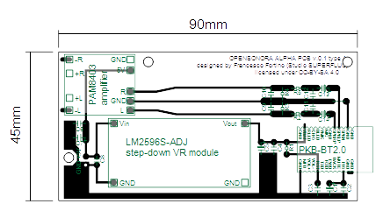

Source file for PCB and 3D drawing of the case can be found on the Github repository at:
https://github.com/frafor1988/opensonora-alpha.git

5. License

The documentation of this project is released under a Creative Commons Attribution Share Alike 4.0 International License. You are free to Share and Adapt this work for any purpose, even commercially, under the following terms:

1) Attribution: you must give appropriate credit to Francesco Fortino (Studio Superfluo), provide a link to the license and indicate if changes were made.

2) ShareAlike: if you mix, transform or build upon the material, you must distribute your contributions under the same license as teh original.

