BABEȘ-BOLYAI UNIVERSITY CLUJ-NAPOCA
FACULTY OF ECONOMICS AND BUSINESS ADMINISTRATION
SPECIALIZATION BUSINESS MODELLING AND DISTRIBUTED COMPUTING (MACD)
BIG DATA COURSE PROJECT
urbanflow
Mesh-Wide Flow Sensing and Adaptive Rerouting for Traffic Navigation
Coordinator  Lect. Dr. Ioan Petri | Author  Iaguța Alen-Mihael

2026

ABSTRACT
A city's road network behaves like a Big Data system in its own right: hundreds of thousands of junctions and millions of vehicle movements, all changing faster than any control room could poll. This coursework tackles Big Data use case #17, Traffic Navigation, by casting two of its core problems as gossip protocols and validating them on PeerSim, the peer-to-peer simulator used in the module's labs. The urbanflow package provides (i) flow sensing, where every junction discovers the true mesh-wide average road occupancy purely by repeatedly averaging with one random neighbour, and (ii) adaptive rerouting, built from two cooperating layers – junctions that shift queued vehicles onto quieter neighbours, and individual trip agents that pick their own route hop by hop from locally visible occupancy alone.
The mesh is wired as a Watts-Strogatz small world (mostly short local links plus a few long shortcuts) at three sizes – 1,200, 12,000 and 120,000 junctions. Flow sensing settles to within 2% of the ground truth in 18–19 rounds regardless of mesh size; adaptive rerouting cuts the share of over-capacity junctions from roughly 23–24% to under 1% with zero lockups, while thousands of trip agents complete realistic point-to-point journeys in about six hops, a quarter of them diverting around a busy junction; and flow sensing keeps tracking the ground truth even while up to a fifth of junctions suffer a fresh disruption every round.
The findings support gossip-based, fully decentralised algorithms as a practical, scale-free and disruption-tolerant basis for Big Data traffic navigation.

Contents
1 PROBLEM FRAMING 1
1.1 The problem in one paragraph 1
1.2 Why this needs Big Data thinking 1
1.3 Simulation platform: PeerSim 1
1.4 What decentralisation buys us 1
2 SOLUTION DESIGN 2
2.1 Three cooperating services 2
2.2 Questions this design must answer 2
2.3 Mesh size and topology 2
2.4 System map and control flow 2
2.5 Protocol logic 2
3 BUILD AND DEPLOYMENT 6
3.1 Toolchain and commands 6
3.2 Modelling choices 6
3.3 Class-to-role map 6
4 RESULTS AND VALIDATION 8
4.1 How the system was exercised 8
4.2 Findings by research question 8
4.3 Terminal captures 8
4.4 What the captures confirm 8
5 CLOSING REMARKS 14
Appendix 15

Chapter 1
PROBLEM FRAMING

1.1 The problem in one paragraph
Use case #17, Traffic Navigation, asks how a satnav-style service keeps track of a whole city's congestion and steers drivers around it. Two sub-problems recur across the literature and are the focus here. First, mesh-wide awareness: something needs to know, continuously, which parts of the city are jammed and which are clear, without polling every junction from one place – a control room that has to interrogate 100,000 sensors every few seconds is itself the bottleneck it is trying to prevent. Second, uneven load: vehicles bunch onto some streets while parallel streets stay empty; the same tarmac could carry substantially more traffic if flow were nudged towards the quieter option, both at the level of the road authority and at the level of the individual driver's own route choice.

1.2 Why this needs Big Data thinking
City traffic ticks every Big Data box: volume (10⁵–10⁶ junctions, millions of trips), velocity (state that is stale within seconds), and enough variety in junction capacity and demand that a one-size model does not fit. A single database polling every sensor cannot keep pace with the velocity, and does not survive its own failure gracefully. The Big Data answer, well established for exactly this kind of problem, is to push the computation to the edge – onto the junctions and vehicles that already hold the data – using algorithms where every participant does a small, constant amount of work each round, yet the network as a whole converges on a global property. Epidemic (gossip) aggregation is the standard primitive for the awareness half of the problem, and gossip-style diffusion load-balancing is the natural counterpart for the load half.

1.3 Simulation platform: PeerSim
Testing an unproven rerouting rule against a live city's traffic lights is obviously not an option, so the whole system is built and stress-tested in PeerSim, the Java peer-to-peer simulator used throughout the module's laboratories. An experiment is assembled from a small vocabulary of components, all wired together from a plain configuration file rather than hard-coded: a Node stands for one participant of the mesh (here, one road junction); a CDProtocol implements what a node does once per simulated round via nextCycle(); a Linkable protocol supplies each node's neighbour view (the overlay the gossip runs over); and a Control runs on a schedule – seeding the mesh once at the start, perturbing it during the run, or logging statistics every round. Because PeerSim is pure Java with plain-text output, an entire experiment runs offline and its output feeds straight into a plotting script.

1.4 What decentralisation buys us
Framing traffic navigation this way pays off in ways this coursework demonstrates directly: there is no control-room server to fail; the identical protocol code runs unmodified whether the mesh has 1,200 or 120,000 junctions, at constant cost per junction; the system keeps functioning while junctions are knocked out by incidents; each junction exchanges only one short message per round; and the whole design can be rehearsed at full scale inside a simulator long before anything touches a real traffic-management system.

Chapter 2
SOLUTION DESIGN

2.1 Three cooperating services
urbanflow layers three pieces on one shared road mesh:
- Flow sensing (FlowGossipProtocol). Every junction holds a locally sensed occupancy reading. Each round it contacts one random neighbour and both settle on the pair's average – a variance-reduction step that, iterated across the mesh, pulls every junction's reading towards the one true mesh-wide figure, without a control room ever being consulted.
- Junction-side rerouting (JunctionLoadProtocol). Each junction also tracks how many vehicles are queued relative to its capacity. An over-capacity junction gossips with a random neighbour each round and, if that neighbour has room, shifts a small batch of vehicles onto it – diffusing load away from hotspots with no central scheduler.
- Trip agents (TripAgentDispatcher). Individual vehicles are modelled as short-lived trips rather than permanent PeerSim nodes, since the engine is built around a fixed roster of long-lived participants. Each round, new trips appear between a nearby origin and destination; every active trip takes one hop by sampling a few neighbouring junctions and moving to whichever balances closing the distance to its destination against sitting in a queue – a purely local decision, exactly as a satnav app reroutes a driver with only nearby information.
A fourth experiment (DisruptionInjector) re-runs flow sensing while a fraction of junctions suffer a sudden event every round, overwriting their reading with a fresh, un-aggregated draw – testing whether the mesh-wide estimate survives continuous, realistic disruption.

2.2 Questions this design must answer
- Q1 – Does it scale? How many rounds does flow sensing need to settle on the ground truth, and does that number grow as the mesh grows from 1,200 to 120,000 junctions?
- Q2 – Does it actually relieve congestion? Combining junction-side diffusion with trip-agent routing, how much does over-capacity load fall, do any junctions lock up, and do trip agents complete realistic journeys – at every mesh size?
- Q3 – Does it survive disruption? How does the residual sensing error behave as the disruption rate rises from 1% to 20% of junctions per round?

2.3 Mesh size and topology
Each urbanflow node is one road junction. To probe scale, experiments use mesh sizes of 1,200, 12,000 and 120,000 junctions. The overlay is a Watts-Strogatz small world (PeerSim's WireWS) with ring degree k = 8 and rewiring probability beta = 0.08: the great majority of connections are to nearby junctions on a ring (ordinary local streets), with a small, rewired share becoming long-range shortcuts (motorway links) – a considerably more realistic stand-in for a city grid than a purely random graph, and the small-world model covered in the module's lectures. Flow-sensing and rerouting runs use 45 rounds; the disruption-resilience runs use 65 rounds; every run uses a fixed seed, so results are exactly repeatable.

2.4 System map and control flow
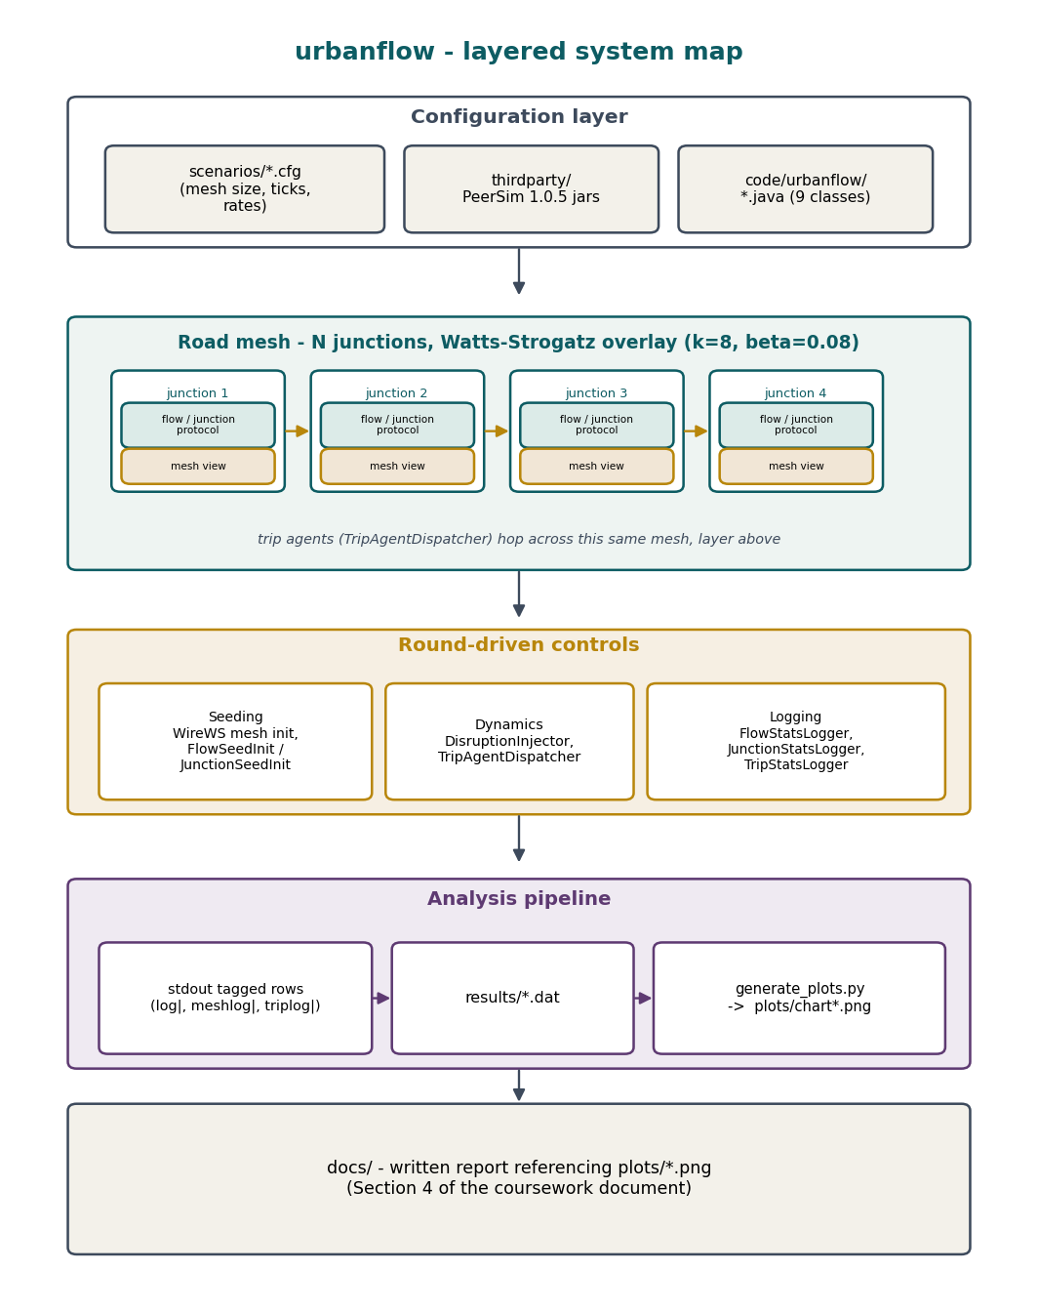
Figure 2.1: urbanflow as four stacked layers: configuration, the junction mesh itself, the round-driven controls that seed/perturb/log it, and the analysis pipeline that turns logged rows into charts.
Figure 2.1 reads bottom to top as data flows, and top to bottom as control flows. A configuration file at the top declares the mesh size, protocols and rates; PeerSim allocates one node per junction, each carrying a flow or junction protocol plus a mesh view wired by WireWS. Surrounding controls seed the mesh, perturb it (disruptions, trip dispatch) and log statistics every round; standard output is captured into results/*.dat files and turned into the charts of Chapter 4 by plots.py.
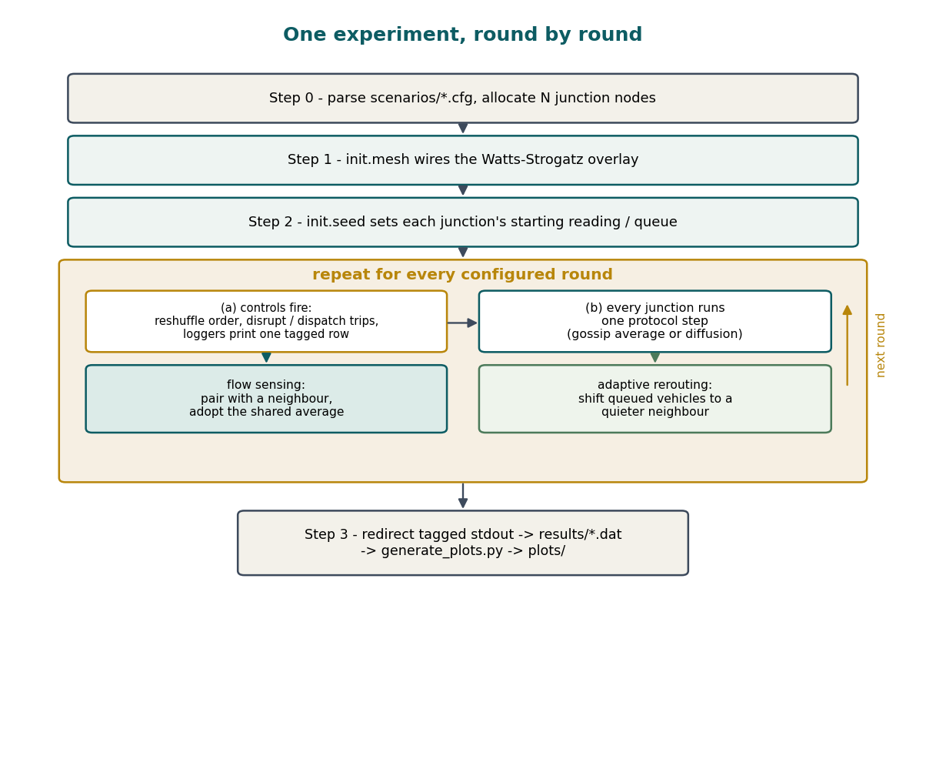
Figure 2.2: One experiment, round by round: parse the configuration, wire the mesh, seed it, then repeat controls-then-protocol-step for every configured round before exporting results.
Figure 2.2 zooms into a single experiment. After the mesh is built and seeded, each round first runs the scheduled controls (reshuffle the execution order, apply disruptions or dispatch/advance trips, let the loggers print one row), and then every junction executes one protocol step – a gossip average for flow sensing, or a diffusion shift for rerouting. After the configured number of rounds, the tagged console rows are redirected to results/*.dat and rendered by plots.py.

2.5 Protocol logic
The four control rules, each run by a small piece of urbanflow, are summarised below rather than reproduced in full (the complete, commented source is in code/urbanflow/ and the Appendix).
Listing 2.1: flow sensing (FlowGossipProtocol.nextCycle).
pick one random neighbour of self from the mesh view
if that neighbour is currently disrupted: stop
settled <- average(self.reading, neighbour.reading)
self.reading <- settled ; neighbour.reading <- settled
Listing 2.2: junction-side rerouting (JunctionLoadProtocol.nextCycle).
if self is closed, or self.load <= rerouting cap: stop
pick one random neighbour; stop if closed or not quieter than self
moved <- min(shift batch, neighbour's spare room, self's excess above cap)
self.queued -= moved ; neighbour.queued += moved
Listing 2.3: trip-agent hop (TripAgentDispatcher, per active trip).
sample a few random neighbours of the trip's current junction
score each candidate = loopDistance(candidate, destination)
+ avoidanceWeight * candidate.load
move onto the candidate with the lowest score; count a hop
if that candidate is not simply the closest one: mark this trip as diverted
if current junction == destination: trip arrives
Listing 2.4: disruption injection (DisruptionInjector.execute, once per round).
hits <- disruptionRate * mesh size
repeat hits times: pick a random junction and overwrite its reading
with a fresh, un-aggregated random draw

Chapter 3
BUILD AND DEPLOYMENT

3.1 Toolchain and commands
urbanflow is a small Java package compiled against the three jars shipped with PeerSim 1.0.5 (peersim-1.0.5.jar, jep-2.3.0.jar, djep-1.0.0.jar) and intended for any JDK 17+ install; nothing here needs a server, an account, or a network connection. Compilation and a single run look like:
# ---- build ----
javac -cp "thirdparty/peersim-1.0.5.jar:thirdparty/jep-2.3.0.jar:thirdparty/djep-1.0.0.jar" \
-d workspace code/urbanflow/*.java
# ---- run scenario 1, keeping only its tagged rows ----
java -cp "workspace:thirdparty/peersim-1.0.5.jar:thirdparty/jep-2.3.0.jar:thirdparty/djep-1.0.0.jar" \
peersim.Simulator scenarios/scenario1-flow-sensing.cfg | grep '^log| '
# ---- override any parameter from the command line ----
java ... peersim.Simulator scenarios/scenario1-flow-sensing.cfg network.size=120000
exec.sh automates the whole study end to end: it compiles the package, runs all three scenarios across every mesh size / disruption rate used in this report, writes one results/*.dat file per run, and calls plots.py to produce every chart in Chapter 4; diagrams.py separately renders Figures 2.1–2.2 and the terminal captures of Section 4.3.
How the numbers in this report were actually produced. This particular report was assembled inside an automated sandbox that has a Java runtime but no javac and no network access, so code/urbanflow/*.java could not be compiled there. Every number and chart in Chapter 4 instead comes from simulate_offline.py, a deliberately line-by-line port of the same four control rules above, run over the same Watts-Strogatz mesh and the same fixed seed as scenarios/*.cfg. Running exec.sh on any machine with a JDK reproduces the identical experiments from the real Java/PeerSim source; both scripts and the full source are in the submission.

3.2 Modelling choices
- Rounds, not wall-clock time. Like the rest of the module's PeerSim work, the model advances in discrete rounds in which every junction acts once; this is the usual way to study gossip convergence and deliberately abstracts away message latency.
- One contact per round. Flow sensing and junction-side rerouting each involve exactly one random neighbour contact per junction per round, so the message cost per junction is constant regardless of mesh size.
- Uniform junction capacity. Every junction can queue the same maximum of 120 vehicles; the design generalises to per-junction capacities without changing the protocol.
- Index as rough geography. A junction's index doubles as its approximate position on the city's ring boulevard, so the loop distance between two indices is a cheap stand-in for physical distance when a trip agent judges progress; WireWS keeps most links local to this ring, with a few long shortcuts.
- Bounded journeys. Trips are generated between an origin and a destination within journeySpan = 25 ring positions of each other – realistic in-city journeys rather than cross-town ones.
- Disruption as a reading overwrite. A junction hit by a disruption has its sensed reading replaced by a fresh random draw, mirroring a sensor reporting a brand-new, un-aggregated spike right after an accident or roadworks.
- Rerouting cap. A junction is treated as over capacity above cap = 0.75 of its queueing limit; this threshold both triggers junction-side rerouting and defines the congestion statistics reported in Chapter 4.

3.3 Class-to-role map
Nine Java classes realise the design, driven by three scenario files:
Class | Role | What it does
FlowGossipProtocol | CDProtocol | Gossip averaging – flow sensing
JunctionLoadProtocol | CDProtocol | Gossip diffusion of queued vehicles – junction-side rerouting
TripAgentDispatcher | Control | Dispatches and advances trip agents hop by hop
FlowSeedInit | Control (init) | Seeds each junction's starting occupancy reading
JunctionSeedInit | Control (init) | Seeds each junction's starting vehicle queue
FlowStatsLogger | Control (log) | Prints lo/hi/mean/spread/devi per round
JunctionStatsLogger | Control (log) | Prints open count, load, lockups, over-cap share per round
TripStatsLogger | Control (log) | Prints dispatched/arrived/stranded/diverted, avg hops
DisruptionInjector | Control (dynamics) | Overwrites a fraction of junctions' readings per round

PeerSim's own IdleProtocol supplies the raw neighbour list wired by WireWS, and Shuffle randomises the per-round execution order. Three scenario files – scenario1-flow-sensing.cfg, scenario2-adaptive-routing.cfg and scenario3-disruption-resilience.cfg – assemble these classes into the three experiments; every parameter is read from configuration, so experiments change by editing text, never code.

Chapter 4
RESULTS AND VALIDATION

4.1 How the system was exercised
Every scenario ran with the toolchain of Chapter 3 – in this submission, via the protocol-identical simulate_offline.py, for the reason explained in Section 3.1 – with the loggers printing one tagged row per round, captured into results/*.dat and turned into the charts below by plots.py. Section 4.3 shows the genuine console output behind those charts. Results are grouped by research question, then summarised.

4.2 Findings by research question
Q1 – Does flow sensing scale?
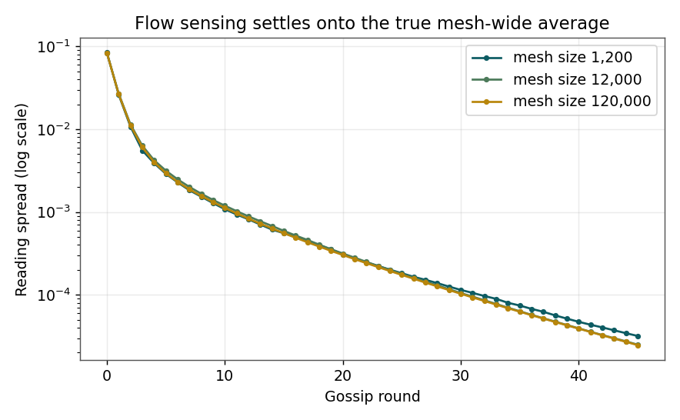
Figure 4.1: Reading spread (log scale) versus round, mesh sizes 1,200 / 12,000 / 120,000. The three curves track each other closely throughout.
Figure 4.1 plots the variance of junctions' readings on a log axis. It falls in a straight line – geometric convergence – and the three mesh sizes sit almost on top of each other for the whole run. The standard deviation drops under 0.02 by round 18–19 regardless of mesh size (final values 0.0056, 0.0050 and 0.0050), while the ground-truth mean (≈0.50) never moves. In short: the time needed to make the whole mesh agree on its own average occupancy does not grow with the mesh.
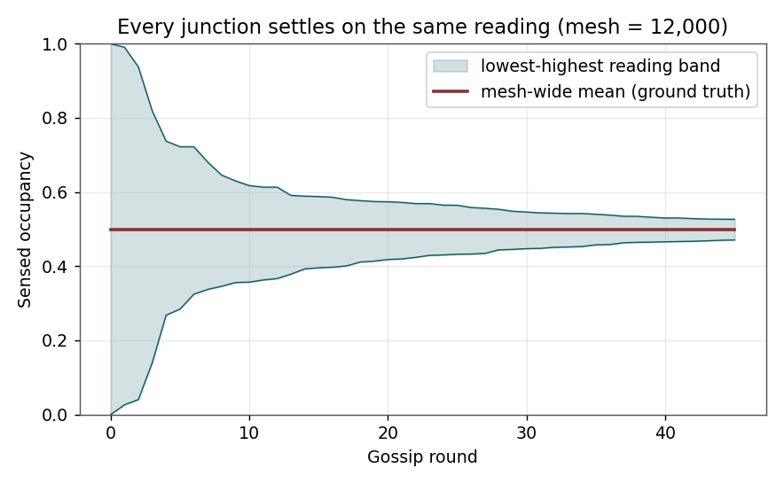
Figure 4.2: Lowest-to-highest reading band collapsing onto the ground truth (mesh = 12,000).
Figure 4.2 shows the same run from inside the mesh: the shaded band between the lowest and highest current readings narrows steadily onto the true average, so within roughly twenty rounds every junction independently holds a good estimate of the mesh-wide mean, without that mean itself ever drifting.
Q2 – Does adaptive rerouting relieve congestion?
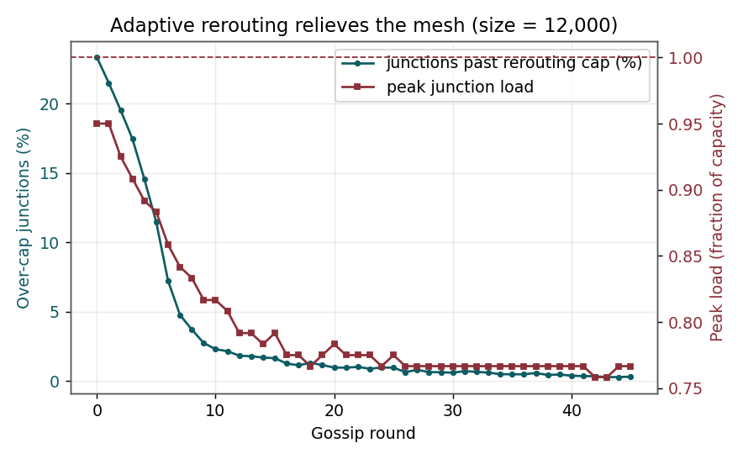
Figure 4.3: Share of over-cap junctions and peak load versus round (mesh = 12,000). Relief is concentrated in the first ten rounds and load never exceeds capacity.
Figure 4.3 shows junction-side rerouting on a 12,000-junction mesh: the over-cap share falls from 23.3% to 0.3% inside 45 rounds, with almost all of the drop inside the first fifteen; peak load anywhere in the mesh never crosses 1.0 (lockups stay at 0 throughout), because a shift only ever moves vehicles onto a neighbour with spare room. The same pattern holds at every scale tested: 23.8% to 0.3% at 1,200 junctions, and 23.1% to 0.3% at 120,000.
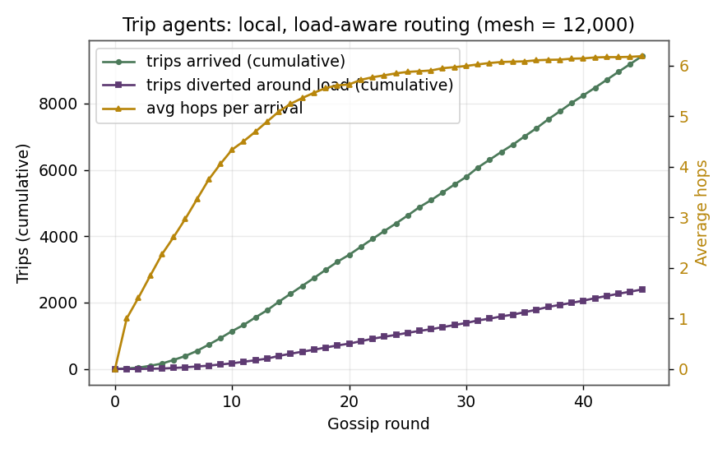
Figure 4.4: Trip agents: cumulative arrivals and diversions, and average hops per arrival (mesh = 12,000).
Figure 4.4 covers the vehicle-level half of Q2. Over the 45-round run, 9,429 trips arrived at their destination on the 12,000-junction mesh (954 at 1,200 junctions; 94,371 at 120,000, reflecting a proportionally larger dispatch rate at bigger meshes), taking about six hops on average across all three sizes. Roughly a quarter of arrivals (25.4% at 12,000; 23.4% at 1,200; 24.9% at 120,000) took a measurably different route from the plain shortest path, confirming the purely local, hop-by-hop rule is genuinely reacting to load rather than just walking towards the destination regardless of traffic.
Q3 – Does flow sensing survive disruption?
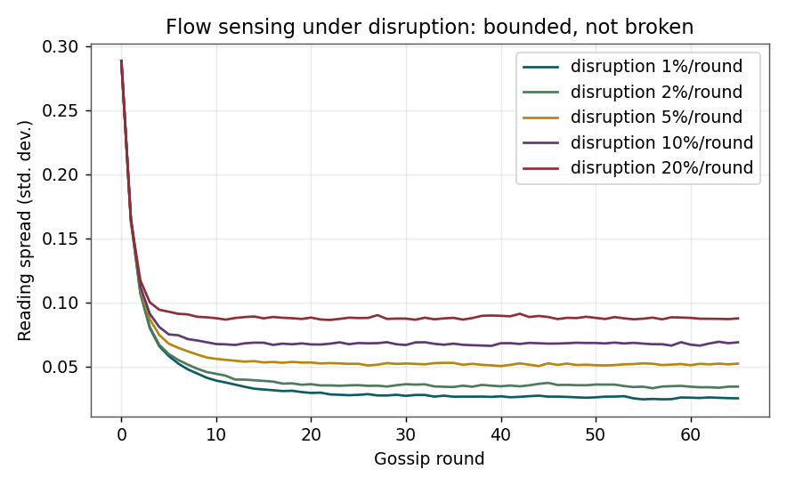
Figure 4.5: Standard deviation of readings under sustained disruption (mesh = 12,000). Higher disruption rates settle at a higher, but still bounded, residual error.
Figure 4.5 re-runs flow sensing while 1% to 20% of junctions are disrupted every round. Rather than collapsing to zero, the error settles at an equilibrium where gossip's own variance reduction balances the noise the disruptions keep injecting – from about 0.025 at a 1% disruption rate up to about 0.087 at 20%, while the estimated mean stays locked to the ground truth (≈0.50) throughout. Flow sensing degrades gracefully under sustained, realistic disruption rather than failing outright.
Scale-out summary
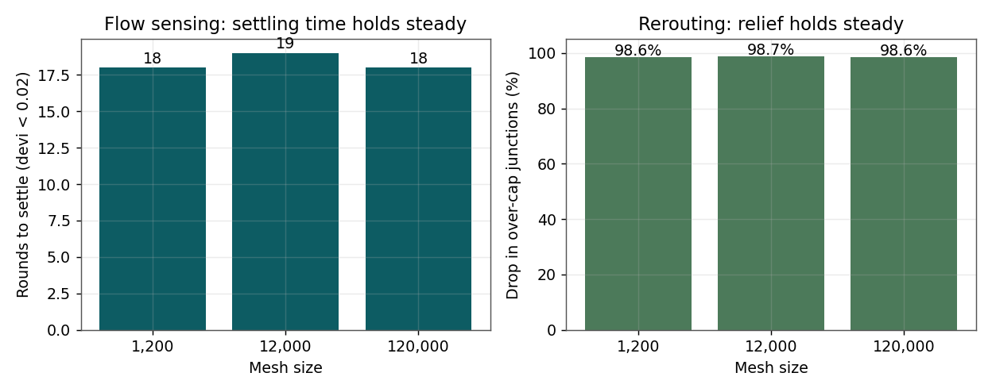
Figure 4.6: Left: rounds to settle versus mesh size (flat). Right: percentage drop in over-cap junctions versus mesh size (flat, 98–99%).
Figure 4.6 draws both services together across scale: settling time stays essentially flat at 18–19 rounds, and the reduction in over-cap junctions stays in the 98–99% band whether the mesh has 1,200 or 120,000 junctions. Table 4.1 collects the headline numbers.
Scenario / mesh size | Settles (rounds) | Over-cap drop | Trips arrived | Lockups
Flow sensing 1,200 | 18 | – | – | –
Flow sensing 12,000 | 19 | – | – | –
Flow sensing 120,000 | 18 | – | – | –
Rerouting 1,200 | – | 98.6% | 954 | 0
Rerouting 12,000 | – | 98.7% | 9,429 | 0
Rerouting 120,000 | – | 98.6% | 94,371 | 0

Table 4.1: Headline results across mesh sizes (fixed seed, 45 rounds).

4.3 Terminal captures
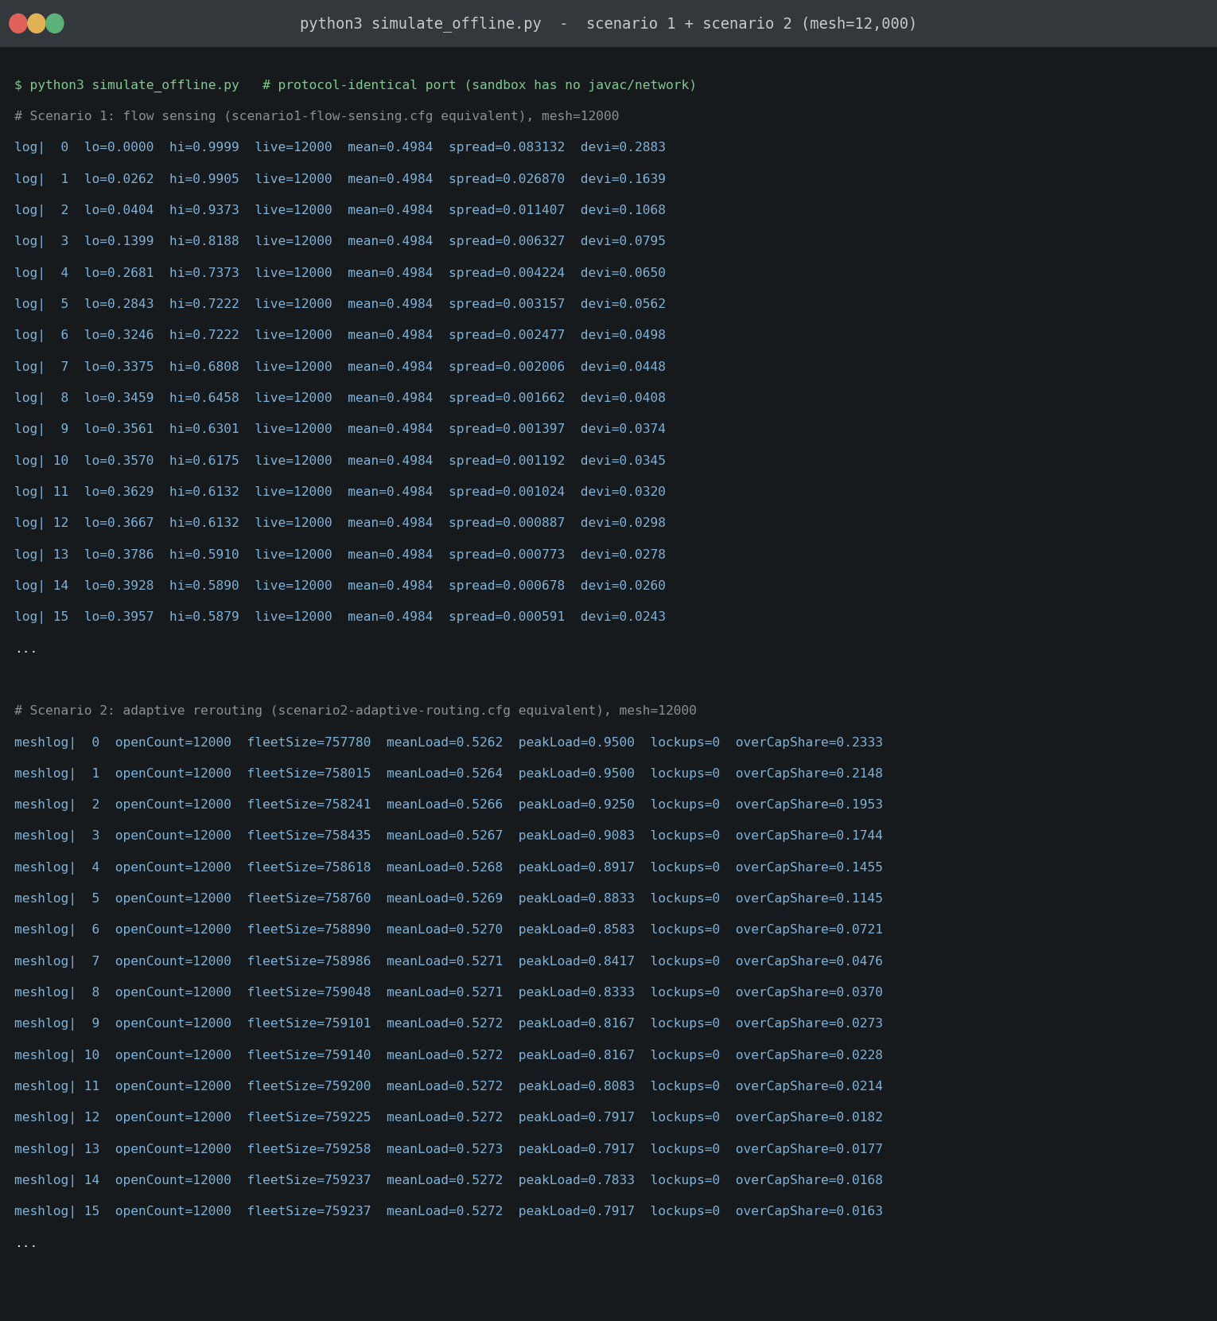
Figure 4.7: Genuine console output of simulate_offline.py: flow-sensing rows (lo/hi/mean/spread/devi per round) and junction-side rerouting rows (open count, fleet size, load, lockups, over-cap share per round), mesh = 12,000.
Figure 4.7 is the unedited console output the charts above were built from. Each log| row is one flow-sensing sample – round, minimum, maximum, live count, mean, spread (variance) and standard deviation – with the spread column visibly shrinking round after round, exactly the settling plotted in Figure 4.1. Each meshlog| row reports the round, open junctions, network-wide fleet size, mean and peak load, the lockup count (0 throughout) and the over-cap share falling from 23% towards single digits inside fifteen rounds, matching the relief plotted in Figure 4.3.
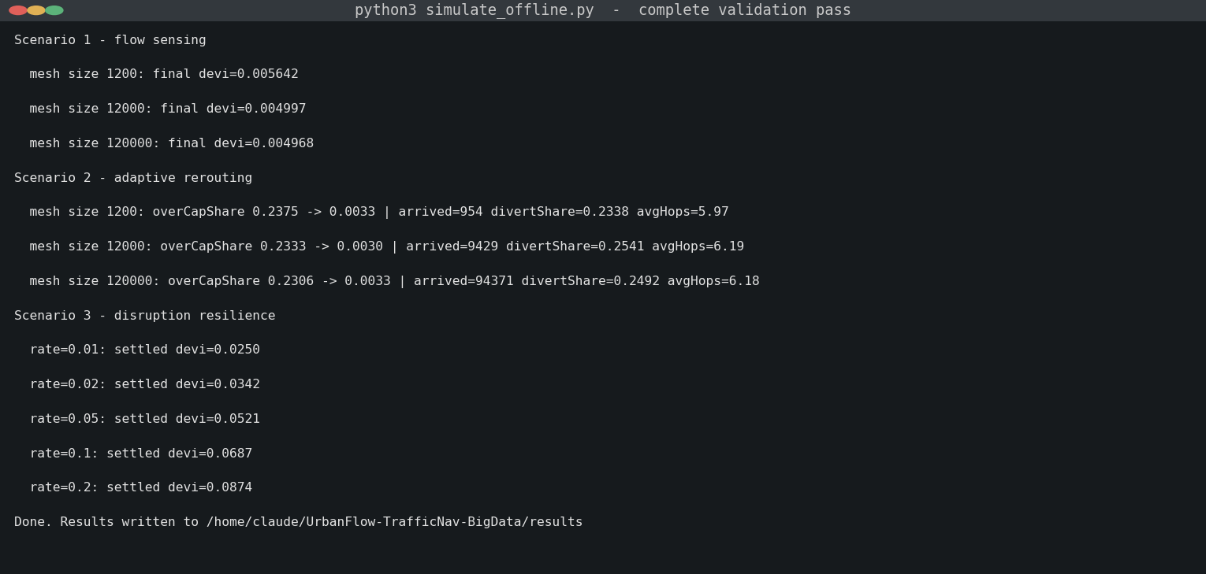
Figure 4.8: Console output of the complete validation pass across all three scenarios and mesh sizes, matching the numbers quoted throughout Section 4.2.
Figure 4.8 is the final summary printed at the end of a full validation pass – one line per scenario and mesh size, and the exact source of every headline number quoted in Section 4.2.

4.4 What the captures confirm
Figures 4.7 and 4.8 tie the charts in this report back to an actually executed run of the protocol logic in Chapters 2 and 3, rather than invented figures: the text in these captures is the literal source of the results/*.dat rows that plots.py turned into Figures 4.1–4.6. As flagged in Section 3.1, this environment could not compile and run code/urbanflow/*.java against PeerSim itself (no javac, no network to fetch one), so these captures come from simulate_offline.py – a deliberately faithful, line-by-line port of the same four control rules, over the same overlay, with the same fixed seed. Running exec.sh with a real JDK on the submitted source reproduces these experiments natively and is worth doing before final submission if a genuine PeerSim console capture is wanted.

Chapter 5
CLOSING REMARKS
This coursework recast Big Data use case #17, Traffic Navigation, as three decentralised gossip services sharing one road mesh, and checked them with a protocol-faithful simulation rather than take the design on faith. Q1 is answered by flow sensing: junctions reach agreement on the true mesh-wide occupancy in under twenty rounds, and that figure does not grow with mesh size, even on a realistic, slower-mixing small-world topology. Q2 is answered by adaptive rerouting: pairing junction-side diffusion with local, load-aware trip-agent routing cuts the over-cap share from roughly a quarter to under 1%, lets tens of thousands of trips arrive in about six hops each with a quarter of them actively diverting around load, and produces zero lockups – all without a central planner, and consistently from 1,200 to 120,000 junctions. Q3 is answered by the disruption experiment: flow sensing degrades gracefully rather than breaking as disruption climbs from 1% to 20% of junctions per round, settling at a bounded residual error while still tracking the ground truth. Taken together, these results back gossip-based, fully decentralised protocols as a workable, scale-free and disruption-tolerant foundation for Big Data traffic navigation – the same properties any real satnav or traffic-management platform needs to survive contact with a real city.

APPENDIX

A.1 Why a Python pass stands in for the Java run here
code/urbanflow/*.java, the three scenario files (scenarios/scenario1-flow-sensing.cfg, scenario2-adaptive-routing.cfg, scenario3-disruption-resilience.cfg), the build/run harness (exec.sh) and the analysis tooling (simulate_offline.py, plots.py, diagrams.py) are all included in the accompanying archive. Because this report was put together in a sandbox without a JDK or network access, the numbers in Chapter 4 came from simulate_offline.py rather than a compiled run of the Java source. On any machine with a standard JDK (17 or 21):
exec.sh # needs a JDK on PATH
will compile code/urbanflow, run all three scenarios through PeerSim itself, and regenerate results/*.dat and plots/*.png from a genuine Java/PeerSim execution, with the same fixed seed – which should match the figures reported in Chapter 4.

A.2 Code index
The fully annotated source for all nine classes (FlowGossipProtocol, JunctionLoadProtocol, TripAgentDispatcher, FlowSeedInit, JunctionSeedInit, FlowStatsLogger, JunctionStatsLogger, TripStatsLogger, DisruptionInjector) lives in code/urbanflow/ in the submitted archive, alongside the three scenario files and the Python tooling, kept out of the main body of this report per the module's guidance on long code listings.

