***Code Panorama – Tool Analysis***

1. ***Prerequisites / Instructions***

CodePanorama is a web application, so therefore there is no need to install anything on your device. You can access it [here](https://codepanorama.io/). Though there are options to locally analyze repositories, in the case that they cannot be cloned online. It can also offer an analysis on non-git repositories, with some exceptions.

We recommend using it online on the web app, but locally you can use docker to have a local web app, for the non-cloneable repositories.

1. ***Usage***

CodePanorama is easy to use as it involved only pasting a github repository and selecting its branch.

Once a github repository is connected, note that there are limitations on the git size, a new screen appears where we set up our preferences, such like:

* Panorama size (dimensions, pages)
* Directories to include (you can disable irrelevant files from the repo)
* Custom settings to include names or unprintable characters, i.e. space

1. 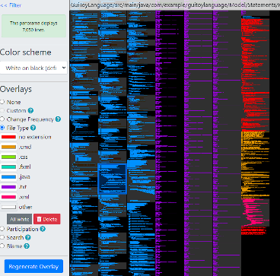***Result***

Once you have configured your preferences, a new screen with a panorama is shown, and at first it may look weird and not understandable, but you can add filters/overlays to see exactly what you want. Filters you can include are:

* Frequency (how often the file is modified)
* File type (colors files of the same type)
* Participation (colors based on authors)
* Search (case-sensitive matches)

We consider CodePanorama a great and easy tool to analyze your code, as the repository cannot reach more than 100k lines, it is very suitable for small-medium projects.

