Biometric-Based Key Sequence Generation Using Genetic Algorithms for Enhanced Blockchain Security
Fragan D'souza
Abstract
This paper presents the design, implementation, and experimental evaluation of a biometric cryptographic key generation and blockchain integrity verification system, developed as an implementation and extension of the facial landmark based key generation approach proposed by Sannidhan et al. [1]. The base paper uses a MobileNetV2 based facial landmark regressor, a genetic algorithm (GA) for LFSR parameter optimization and an 8-register linear feedback shift register (LFSR) to generate cryptographic key material, reporting a dataset level Shannon entropy of 3.24 bits over 92,706 generated sequences. Building on this foundation, the present work implements a MediaPipe Face Mesh based landmark extraction pipeline (with a deterministic synthetic fallback), Procrustes feature normalization, a multi-objective GA for feature selection, an independently configured 32-bit Galois LFSR key material expansion stage, RFC 5869 HKDF-SHA256 key derivation, AES-256-GCM authenticated encryption, and a proof of work blockchain layer that records only ciphertext hashes and never raw biometrics or secret keys. The base paper does not have the encryption and the blockchain, which are novelties of this project. The system is tested end-to-end: the entire pipeline (106 landmarks to 212 normalized features to GA feature selection to LFSR/HKDF key derivation to AES-256-GCM encryption to blockchain integrity verification) works with a successful decrypt and compare round trip. A five-way baseline comparison was performed measuring byte level Shannon entropy (on the order of 7.94 bits/byte, close to the 8-bit theoretical maximum), and Wald-Wolfowitz runs test statistics across SHA-256, HKDF, GA-HKDF, and the proposed GA-LFSR-HKDF architectures, alongside a faithful re-implementation of the 8-register LFSR mechanism from the base paper for comparison. A biometric stability study over ten synthetic subjects (five captures each) yielded a 24% false rejection rate and 0% observed false acceptance rate at the evaluated decision threshold, indicating a genuine reproducibility challenge for regenerating keys from biometrics that is disclosed rather than minimized. The results demonstrate the working integration of biometric feature selection, cryptographic key derivation, authenticated encryption and blockchain based integrity auditing. Concrete limitations are identified: the FRR/FAR tradeoff, the deterministic nature of LFSR based expansion, the lack of a fuzzy extractor mechanism. These are all goals for future work.
Keywords: Biometric Cryptography; Genetic Algorithm; Facial Landmark Extraction; Linear Feedback Shift Register; HKDF-SHA256; AES-256-GCM; Blockchain Integrity Verification; Key Derivation; Biometric Key Stability

1. Introduction

1.1 Background
Cryptographic systems are ultimately based on the secrecy and unpredictability of their key material. The traditional way to manage keys, whether that’s a password, a hardware token, or a random seed stored elsewhere has a usability and custody burden: keys need to be remembered, stored, or physically carried, which all have their own risk of loss, theft, or simply being forgotten. Biometric key generation (BKG) attempts to tie cryptographic material to a person's physiological characteristics such that, in principle, the key material can be regenerated from the person, rather than retrieved from storage. An example of such an approach for facial biometrics is proposed by Sannidhan et al. [1], where deep learning based landmark extraction, genetic algorithm parameter optimization and an LFSR based sequence generator are integrated to generate key material with good statistical randomness properties.

1.2 Problem Statement
The base paper [1] deals with the generation of key sequences from facial features alone but does not explain how the generated key material would be used to protect data or how the integrity of protected data would be independently verified over time. This project addresses the downstream problem: given biometric derived key material, how should it be used to encrypt real data with authenticated encryption and how can the integrity of that encrypted data be verified by a third party without exposing the plaintext, the key or the underlying biometric.

1.3 Motivation
If the key is derived from a person’s own biometric features each time it is needed, no long term secret has to sit in storage waiting to be stolen. Such a key becomes useful once it drives authenticated encryption, which protects confidentiality and catches tampering at decryption time, and once a tamper evident ledger records a publicly verifiable hash commitment, which catches tampering even when nobody decrypts anything. Together those two additions carry the base paper’s scope past “key generation” and into “key generation plus a usable, auditable data protection workflow.”

1.4 Research Gap
Three gaps motivate this work. First, the base paper does not specify or evaluate any downstream cryptographic use of the generated key material: no encryption scheme, key derivation step, or authenticated encryption evaluation is presented. Second, it does not address data integrity auditing: there is no mechanism by which a third party could later verify that protected data had not been altered. Third, the base paper's own entropy metric (3.24 bits, computed over a symbol alphabet specific to its LFSR register representation) is not evaluated using standard byte level randomness tests (Shannon entropy in bits/byte, Wald-Wolfowitz runs test) that would allow direct comparison against conventional cryptographic key derivation baselines such as HMAC-based Extract-and-Expand Key Derivation (HKDF).

1.5 Objectives
- Objective 1: Develop a secure cryptographic framework that generates dynamic, user-specific encryption key material from facial biometrics using Genetic Algorithms, with emphasis on uniqueness, robustness, stability, and entropy.
- Objective 2: Use the generated cryptographic key material for data encryption and integrate the encrypted-data workflow with blockchain operations for immutable/decentralized data management and integrity verification.
- Objective 3: Address limitations of conventional cryptographic approaches by combining biometrically driven key generation, adaptive optimization, cryptographic key derivation, authenticated encryption, and blockchain based integrity verification.

1.6 Contributions
- An end-to-end, code-verified pipeline integrating facial-landmark feature selection (via a multi objective GA), LFSR based key material expansion, HKDF-SHA256 key derivation, AES-256-GCM authenticated encryption, and a proof-of-work blockchain integrity ledger.
- A five-way controlled comparison isolating the marginal statistical effect of each pipeline stage (SHA-256 only; HKDF only; GA + HKDF; the full proposed GA-LFSR-HKDF chain; and a faithful re-implementation of the base paper's own 8-register LFSR mechanism) under an identical measurement methodology.
- An explicit, code-verified account of every implementation adaptation from the base paper, including the landmark extraction substitution and the two functionally distinct LFSR mechanisms used in this codebase.
- An honest biometric-stability evaluation (intra-/inter-subject distance, FRR, FAR) that discloses the current reproducibility limitation rather than presenting the system as production-ready authentication.
None of this amounts to a new cryptographic primitive. What the project contributes is engineering work: it takes an existing key generation technique and builds it out into a complete data protection workflow that can be audited.

2. Related Work
The work reviewed below is the prior literature cited by the base paper [1]. It traces where the key generation technique used here actually came from.

2.1 Biometric Cryptography
Early attempts drew key material straight from biometrics, whether through fingerprint sensors, passwords, or facial images [2], [3]. Two problems kept recurring. Some designs needed dedicated hardware such as a fingerprint sensor, and others leaned on features that shifted whenever capture conditions changed.

2.2 Facial Feature-Based Key Generation
Facial feature extraction through deep learning appears in two roles in this literature. One is privacy protection on cloud platforms [2]. The other feeds key material to stream ciphers via SURF feature descriptors [4], an earlier system by the same authors. The base paper replaces that SURF stage with a trained MobileNetV2 landmark regressor, and states its reason plainly: SURF based extraction generated too many repeated sequences.

2.3 Genetic Algorithms in Feature Optimization
Genetic algorithms show up across this field, in pseudo random number generation [5], DNA cryptography key generation [6], and elliptic curve key optimization [7]. One of them matters more than the others here. Sudeepa et al.’s GA based key sequence generator [8] is what the base paper measures itself against quantitatively, and the same idea shapes the GA-HKDF baseline evaluated in Section 7.

2.4 LFSR-Based Pseudo-Random Generation
Linear feedback shift registers are still common in lightweight sequence generation, including variants with Gaussian distributed feedback [9] and LFSR driven 3D Playfair ciphers [10]. This literature acknowledges their central property openly: the output follows entirely from the initial register state and the feedback structure. Recover the seed and the taps and the whole sequence is reproducible, which is why an LFSR on its own offers no cryptographic secrecy.

2.5 Cryptographic Key Derivation
Standardized key derivation functions such as HKDF (RFC 5869) [12] are designed to convert non uniform input key material into cryptographically strong, uniformly distributed key bytes via an HMAC based Extract-and-Expand construction. HKDF is not evaluated or used anywhere in the base paper [1]; its use in this project is an original addition intended to standardize the final key derivation step regardless of upstream biometric noise.

2.6 Authenticated Encryption
AES-256 in Galois/Counter Mode (GCM), standardized in FIPS 197 [13] and NIST SP 800-38D [14], provides both confidentiality and integrity/authenticity in a single primitive via an authentication tag. Like HKDF, AES-256-GCM does not appear anywhere in the base paper and is an original addition of this project.

2.7 Blockchain-Based Integrity
Blockchain ledgers provide tamper evident, append-only records through cryptographic hash chaining and proof of work consensus. Using a blockchain purely as a metadata or integrity layer, storing only a hash commitment to encrypted data rather than the data itself, is a common pattern for combining off-chain confidentiality with on-chain auditability. This layer, too, is entirely absent from the base paper and is an original addition of this project.

2.8 Research Gap
No work identified in the base paper's own literature review, nor the base paper itself, evaluates the combination of (i) GA-optimized biometric feature selection, (ii) standardized HKDF key derivation, (iii) authenticated encryption, and (iv) blockchain based integrity verification as a single, end-to-end, experimentally validated pipeline. This is the gap this project addresses.

3. Base Paper and Motivation

3.1 Base Paper Methodology
Sannidhan et al. [1] (“Genetic algorithms and deep learning for unique facial landmark-based key generation,” Computers and Electrical Engineering, vol. 118, article 109427, 2024) propose a three-module pipeline. A MobileNetV2 convolutional neural network, trained on 224×224 input images with the Adam optimizer (learning rate 0.0001), regresses 106 facial landmark coordinates directly from a face image. The (x, y) coordinates of each landmark are fused into a single scalar via the Cantor pairing function. A genetic algorithm (population size 100, 1000 generations, two-point crossover at rate 0.8, random-resetting mutation at rate 0.05, steady-state parent selection) then optimizes 8 register seed values for an LFSR. The LFSR itself holds 8 registers X0…X7; each iteration computes a new value from the sum of the even-indexed registers modulo 256, shifts all registers down by one position, and inserts the new value into X7, using feedback polynomial x⁷+x⁵+x³+x+1. Iterating this process for each of 74 distinct GA-optimized seed pairs produced 92,706 total sequences (up to 1287 sequences per seed) across four public face datasets (LFW [16], FERET [17], Extended Yale Face B [18], CMU Multi-PIE [19]).

3.2 Relevant Characteristics
The base paper reports a Shannon entropy of 3.24 bits for its generated sequence dataset (computed over the register value alphabet used by its own LFSR representation, not a byte level entropy in the 0 to 8 bits/byte sense used elsewhere in cryptographic randomness testing), an average Pearson correlation coefficient of 0.1554 across ten sample sets, and a runs test Z-statistic of 1.6083. It compares its total sequence and Z-statistic figures against three prior LFSR based systems, including its own earlier SURF feature based system [4].

3.3 Limitations / Opportunities Identified
The base paper is explicitly scoped to secret-key generation; it states in its own conclusion that no storage, transmission, or downstream cryptographic use security is addressed, and lists quantum-safe key distribution, cross-modal biometric extension, and industry deployment as future work. It also discloses that its datasets and code are not publicly available (“The authors do not have permission to share data”), which motivates an independent re-implementation rather than direct reuse of the original artifacts.

3.4 Motivation for Our Adaptation
This project therefore starts where the base paper stops. Its GA plus LFSR concept is re-implemented so the two can be compared experimentally under matched conditions (Section 5.5), and the pipeline then continues into territory the cited work never enters: HKDF key derivation, AES-256-GCM encryption, and integrity verification on a blockchain.

4. Proposed System

4.1 System Overview
Input to the system is either a face image or a landmark array supplied directly, synthetic ones included. What comes out is an authenticated ciphertext together with a blockchain transaction holding a tamper evident hash commitment to it. Figure 1 shows all ten stages in order.
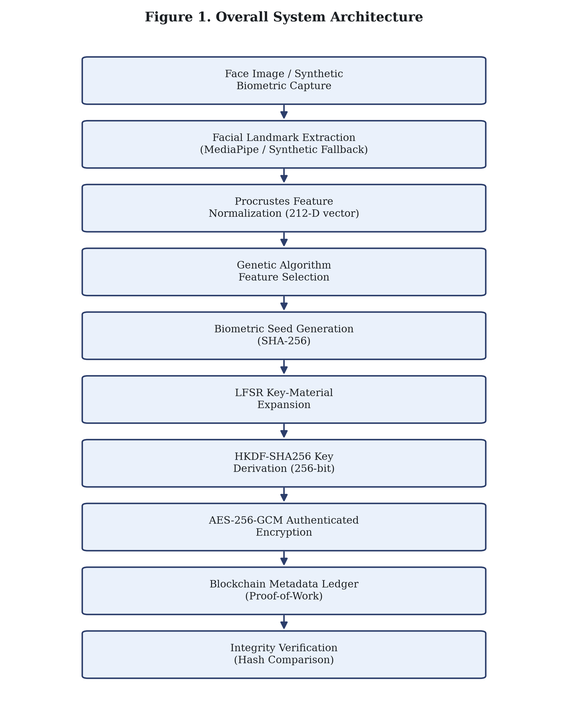
Figure 1. Overall system architecture.

4.2 Overall Architecture
Five functional groups make up the pipeline. Biometric feature extraction and normalization come first (Sections 4.3 and 4.4), followed by genetic algorithm feature optimization (Section 4.5), key material generation (Sections 4.6 through 4.8), authenticated encryption (Section 4.9), and finally blockchain integrity management (Sections 4.10 and 4.11).

4.3 Facial Feature Extraction
Landmark extraction runs on Google MediaPipe Face Mesh, which regresses 468 3D landmark points from an input image. Those 468 points are then downsampled uniformly to 106 canonical coordinates using NumPy linspace index selection. When MediaPipe is missing, or when it runs but detects no face, the code drops to a deterministic synthetic generator that builds 106 anatomical landmarks, seeded from statistics of the image itself. Figure 2 covers this stage and the normalization stage that follows it.
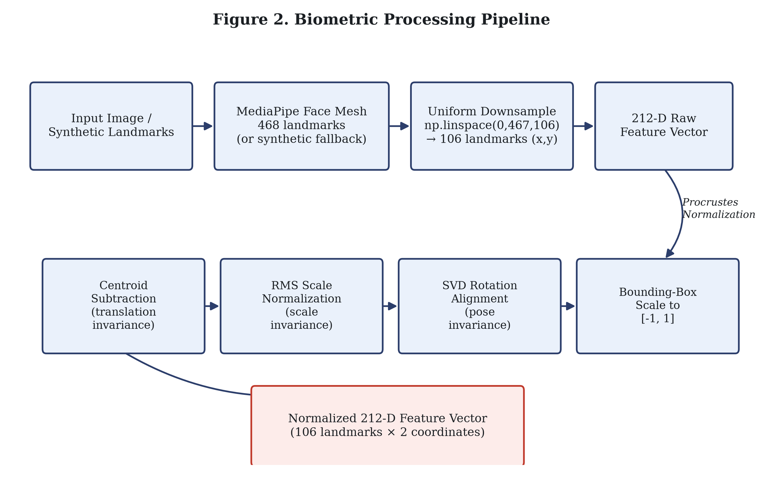
Figure 2. Detailed biometric processing pipeline.

4.4 Feature Normalization
Normalization applies a Procrustes style transform to the 106 (x, y) coordinates in three steps. Subtracting the centroid removes translation. Scaling by root mean square (RMS) distance removes overall scale. Singular value decomposition (SVD) of the landmark covariance matrix estimates a global in plane rotation and takes it out. A final rescaling maps the coordinates into the fixed bounding box range [−1, 1]. That leaves a 106×2 = 212 dimensional vector, and every stage downstream works from it.
μ = mean(P); P′ = P − μ (centroid subtraction)
s = √(mean(‖P′‖²)); P″ = P′ / s (RMS scale normalization)
R = SVD-derived rotation of cov(P″); P‴ = R·P″ (SVD rotation alignment)

4.5 Genetic Algorithm
Each chromosome is a 212 bit binary string, one bit per normalized feature. Evolution runs for a fixed 30 generations over a population of 50, using tournament selection with tournament size 3, uniform crossover at rate 0.8, and bit flip mutation at rate 0.05. The top 2 chromosomes carry into each new generation unchanged. One constraint holds throughout: no chromosome may have fewer than 4 active bits. Figure 3 shows the generational loop.
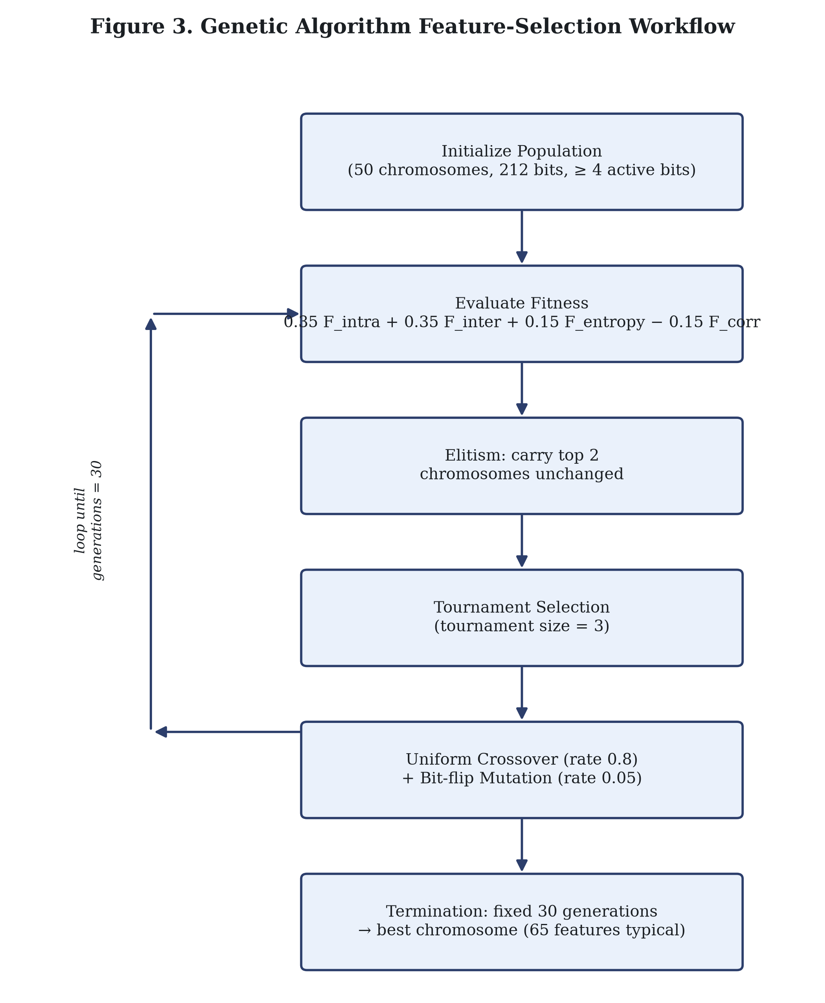
Figure 3. Genetic Algorithm feature selection workflow.
The multi objective fitness function combines four independently computed terms:
F(C) = w₁·F_intra + w₂·F_inter + w₃·F_entropy − w₄·F_corr
with weights (w₁, w₂, w₃, w₄) = (0.35, 0.35, 0.15, 0.15). F_intra rewards low average Euclidean distance between multiple captures of the same subject (feature stability); F_inter rewards high average distance between different subjects (discriminability), normalized by feature set size; F_entropy is a normalized Shannon entropy of the pooled, masked feature values across a 10-bin histogram; F_corr is the average absolute Pearson correlation across the masked feature set and is subtracted as a redundancy penalty. The GA optimizes a feature selection mask for downstream key derivation; it does not itself provide cryptographic security, and its fitness terms are statistical proxies for feature quality, not security guarantees.

4.6 Seed Generation
The GA-selected feature subset is serialized deterministically as big-endian IEEE-754 double-precision floating-point values, appended to a fixed application salt, and hashed with SHA-256 to produce a 32-byte digest. A 32-bit integer seed is derived from the first 4 bytes of this digest (substituting a fixed non-zero constant if the extracted value would be zero, since a zero-state LFSR never produces output).

4.7 LFSR Key-Material Generation
The proposed pipeline's key path uses a 32-bit Galois configuration LFSR with feedback taps at positions (32, 31, 29, 1), corresponding to the primitive polynomial x³²+x³¹+x²⁹+x¹+1. Each step outputs the current least significant bit and advances the register via a right shift with conditional XOR feedback. Generating 64 bytes (512 bits) of output from the seed produces the key material passed to HKDF. This LFSR is deterministic: for a fixed seed and tap configuration, it always produces the same output sequence. It is a pseudo-random generator, not a source of cryptographic unpredictability on its own.

4.8 HKDF-SHA256
RFC 5869 HKDF-SHA256 [12] is applied to the 64-byte LFSR output to derive a uniform 256-bit (32-byte) symmetric key. HKDF's Extract step compresses the (potentially non-uniform) input key material into a pseudorandom key using HMAC with a fixed application salt; its Expand step derives output key bytes using a fixed application context info string. In this system, HKDF's role is specifically to standardize the final key regardless of any residual statistical bias in the upstream LFSR output. It is a key derivation step, not a mechanism for stabilizing biometric noise across captures.
PRK = HMAC-SHA256(salt, IKM) OKM = HMAC-SHA256(PRK, info ‖ 0x01) [32 bytes]
Figure 4 traces the whole key generation chain, from GA selected features through to the final 256 bit AES key.
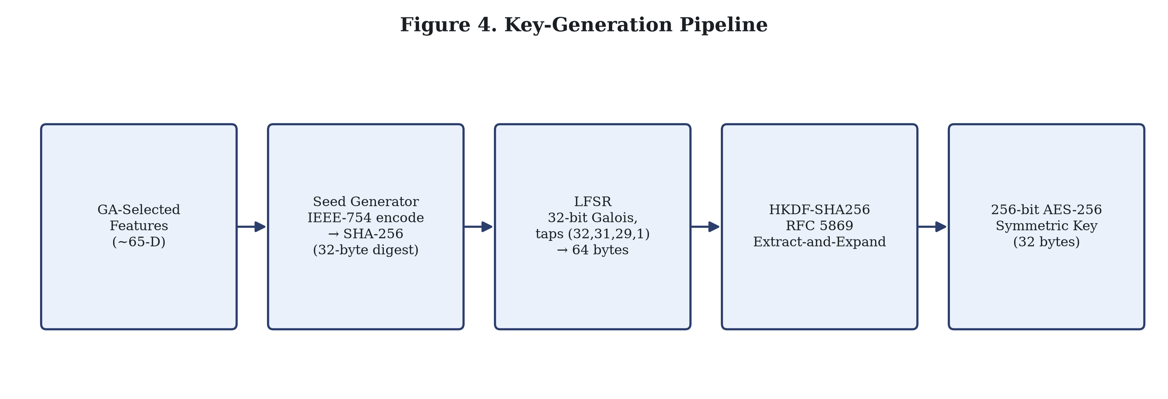
Figure 4. Key-generation pipeline.

4.9 AES-256-GCM
The derived 256 bit key drives AES-256 in Galois/Counter Mode, taken from the standard `cryptography` library’s `AESGCM` implementation rather than written by hand, and it both authenticates and encrypts the plaintext payload. Every encryption gets a fresh 96 bit (12 byte) random nonce. A 128 bit (16 byte) authentication tag is produced alongside the ciphertext and checked at decryption, so altering any ciphertext byte makes decryption fail with an authentication error instead of handing back corrupted plaintext.

4.10 Blockchain Integration
The system implements a local proof of work blockchain that runs within a single process, not a distributed or public network. Each block requires a SHA-256 hash with 2 leading hexadecimal zero characters (difficulty = 2). A transaction records only a SHA-256 hash of the user ID, a SHA-256 hash of the ciphertext, a reference string to the encrypted data, and a timestamp. The raw biometric data, the derived key, and the plaintext are never written to the ledger. Figure 5 shows this workflow together with the verification path.

4.11 Integrity Verification
Verification recomputes the SHA-256 hash of a candidate ciphertext and compares it against the on-chain `ciphertext_hash` for the corresponding transaction, in addition to validating the block hash chain and proof-of-work prefix for every block. A mismatch is reported as tamper detected; a match is reported as integrity verified.
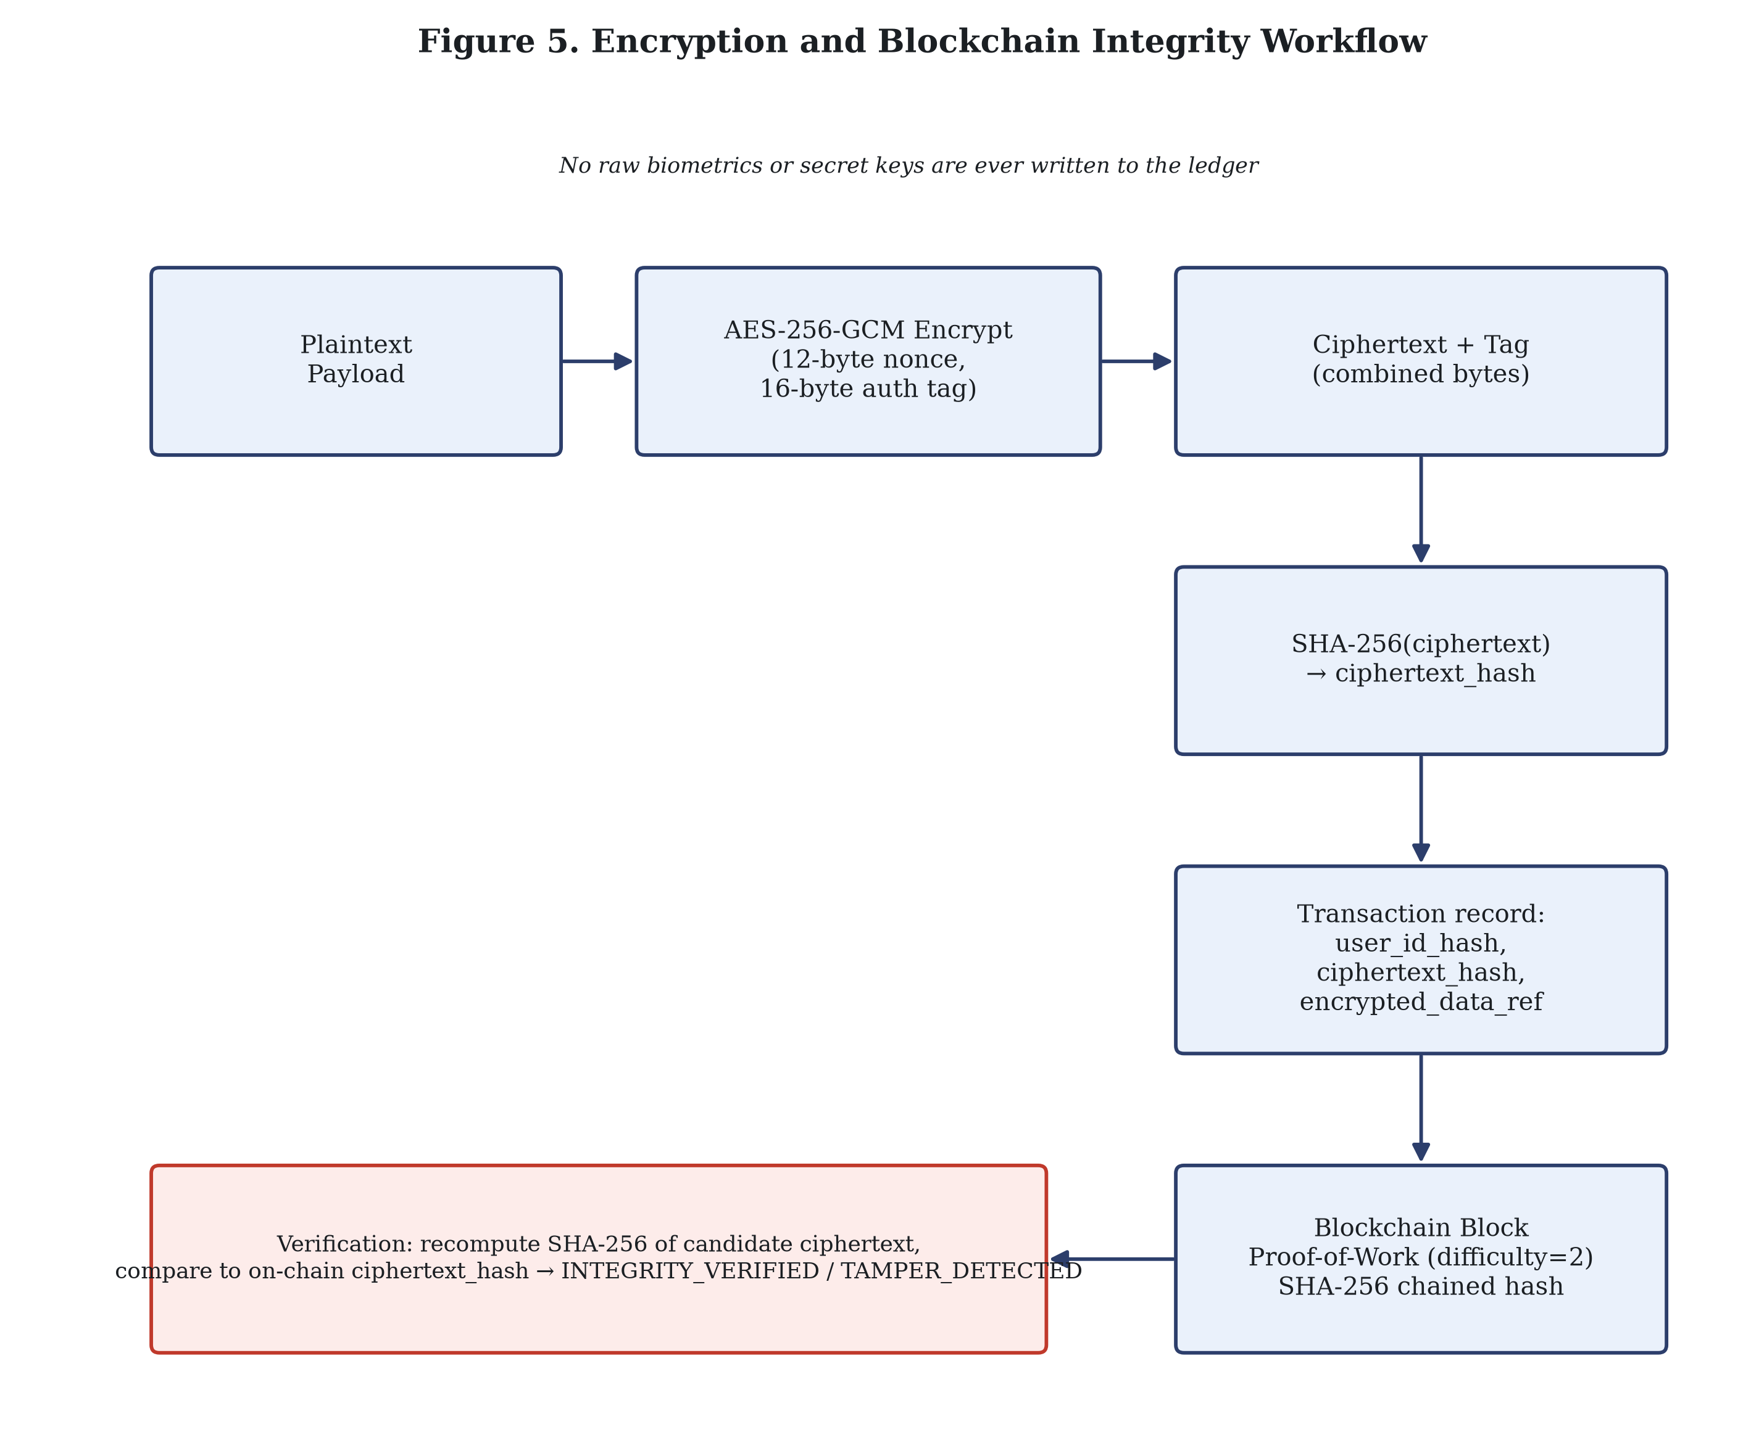
Figure 5. Encryption and blockchain integrity workflow.

5. Implementation

5.1 Software Architecture
The system is implemented in Python and organized into independent modules under `src/`: `src/biometric/` (landmark extraction and normalization), `src/optimization/` (the genetic algorithm), `src/key_generation/` (seed generation, LFSR, HKDF), `src/encryption/` (AES-256-GCM), `src/blockchain/` (block, chain, verifier), and `src/evaluation/` (statistical randomness and biometric-stability metrics). `src/pipeline.py` orchestrates the end-to-end flow and the baseline comparison suite; `src/config.py` centralizes every stage's default parameters in dataclasses.

5.2 Module Design
Table 1. System components and technologies.
Component | Module | Technology / Library
Landmark extraction | src/biometric/landmark_extraction.py | MediaPipe Face Mesh; synthetic fallback
Feature normalization | src/biometric/preprocessing.py | NumPy (centroid, RMS scale, SVD)
Feature selection | src/optimization/genetic_algorithm.py | Custom binary GA (NumPy)
Seed generation | src/key_generation/seed_generator.py | hashlib (SHA-256), struct (IEEE-754)
Key-material expansion | src/key_generation/lfsr.py | Custom 32-bit Galois LFSR; 8-register base-paper LFSR
Key derivation | src/key_generation/key_derivation.py | cryptography.hazmat HKDF (RFC 5869)
Authenticated encryption | src/encryption/aes.py | cryptography.hazmat AESGCM
Blockchain ledger | src/blockchain/blockchain.py, verifier.py | Custom PoW chain (hashlib SHA-256)
Statistical evaluation | src/evaluation/ | NumPy, SciPy (entropy, runs test, etc.)

5.3 Technology Stack
Everything runs on Python 3.12. NumPy, SciPy, pandas and scikit-learn handle the numerical and statistical work, while the `cryptography` library supplies HKDF and AES-256-GCM. MediaPipe and OpenCV are needed only for the optional real image landmark path. The test suite runs under pytest, and matplotlib produced the figures in this paper.

5.4 Full Pipeline Workflow
One method, `BiometricBlockchainPipeline.process_end_to_end()`, runs the whole sequence: acquire landmarks, normalize them, run multi subject GA optimization and apply the resulting feature mask, generate the seed, expand it through the LFSR, derive the key with HKDF, encrypt under AES-256-GCM, create and mine the blockchain transaction, verify integrity, then decrypt and compare as a round trip check. Section 7.1 gives the values from a fresh run of it.

5.5 Implementation Adaptations from Base Paper
Every place where this implementation parts company with the base paper’s methodology is set out below, as the project’s source separation requirement demands. Table 2 gives the short version before the detail.
Table 2. Base paper vs. our implementation.
Component | Base Paper (Sannidhan et al., 2024) | Our Implementation
Landmark extraction | Trained MobileNetV2 CNN, direct 106-point regression | MediaPipe Face Mesh (468 pts) uniformly downsampled to 106, with synthetic fallback
Feature fusion | Cantor pairing of (x,y) into a single scalar per landmark | Procrustes normalization (centroid, RMS scale, SVD rotation) to a 212-D vector
GA population / generations | 100 / 1000 | 50 / 30
GA fitness function | 1 / (|sum − inputs| + ε) | 0.35 F_intra + 0.35 F_inter + 0.15 F_entropy − 0.15 F_corr
LFSR mechanism | 8-register X0..X7, feedback poly x⁷+x⁵+x³+x+1 | Two mechanisms: 32-bit Galois LFSR (proposed key path) and a faithful X0..X7 re-implementation (comparison baseline only)
Key derivation | None (LFSR output is the key material) | HKDF-SHA256 (RFC 5869); original addition
Encryption | Not present | AES-256-GCM; original addition
Blockchain / integrity ledger | Not present | Proof-of-Work blockchain, metadata only; original addition
Entropy metric reported | 3.24 bits (register symbol alphabet, 92,706 sequences) | ~7.94 bits/byte (byte alphabet, 3200-byte stream); different basis, not directly comparable

5.5.1 Landmark extraction
Base paper: a MobileNetV2 convolutional neural network is trained end to end to regress 106 facial landmark coordinates directly from a 224×224 input image. Our implementation: MediaPipe Face Mesh regresses 468 landmarks with a pretrained, general purpose model, and the code then subsamples those 468 down to 106 by index (`np.linspace(0, 467, 106)`), so no regression model was trained for this task specifically. When neither a real image nor the MediaPipe path is available, a deterministic synthetic landmark generator stands in. The reason for the substitution is availability and nothing more: the base paper’s trained model and its training data were never released (“The authors do not have permission to share data”), which rules out exact reproduction, and MediaPipe was the practical source of a 106 point representation. One consequence follows for reproducibility. Quantitative landmark accuracy figures from the base paper, such as its 99.37% MobileNetV2 accuracy on LFW in Table 4 of [1], do not carry over to this implementation and are not claimed here.

5.5.2 Cryptographic and blockchain layer
Base paper: nowhere in [1] is there an encryption scheme, a key derivation function, or a blockchain component, since the work ends at LFSR sequence generation. Our implementation: HKDF-SHA256, AES-256-GCM and a proof of work blockchain ledger were all written for this project, and their purpose is to turn raw key material into a data protection workflow someone can actually use and audit.

5.5.3 LFSR mechanism (two implementations, separate purposes)
Two separate LFSR implementations live in this codebase. `LFSRBitGenerator` is a 32 bit Galois style LFSR with taps 32, 31, 29 and 1, and it is the one used in the actual “Proposed” key generation path (Section 4.7). `PaperLFSRSubsequenceGenerator` reproduces the base paper’s own 8 register X0…X7 mechanism faithfully, following Eqs. 4 to 6 of [1]: sum the even indexed registers modulo 256, shift the registers down, then insert the new value into X7. Its only job is to build the `Base_Paper_GA_LFSR` comparison baseline in Section 7, and it never produces the AES key in the proposed pipeline. Keeping the two apart is what lets the evaluation put the base paper’s mechanism and this project’s chosen key generation LFSR under identical measurement conditions.

5.5.4 GA hyperparameters
Base paper: population size 100, 1000 generations, two point crossover. Our implementation: population size 50, 30 generations, uniform crossover, with elitism over 2 chromosomes and tournament selection at size 3, neither of which the base paper’s Algorithm 1 specifies. Runtime drove these choices, since the evaluation suite in this repository has to finish in reasonable time, and they were not tuned to match the convergence curve reported in Fig. 6 of [1]. That convergence behavior is neither reproduced nor claimed here.

6. Experimental Methodology

6.1 Experimental Environment
Python 3.12.10 on Windows. Key installed package versions at evaluation time: cryptography 49.0.0, NumPy 2.5.1, SciPy 1.18.0, pandas 3.0.5, scikit-learn 1.9.0, Pillow 12.3.0. `random_seed = 42` is used throughout the codebase's default configuration (`src/config.py`) for deterministic, repeatable results.

6.2 Input Data
All landmark data used in the experiments reported in Section 7 is generated by this codebase's deterministic synthetic landmark generator (`generate_synthetic_subject_landmarks`), not extracted from real photographed faces. This is disclosed explicitly: `scripts/run_pipeline.py` and `scripts/run_evaluation.py` construct their inputs directly via the synthetic generator, and MediaPipe was not installed in the environment used to produce the results in this paper, so the real image MediaPipe extraction path (Section 4.3) was not exercised for any result reported here. This is a methodological limitation, not an implementation gap. The MediaPipe code path exists and is unit-tested independently, but no real face image was processed to produce the numbers in Section 7.

6.3 Biometric Evaluation
A 10-subject × 5-capture synthetic dataset is constructed (`scripts/run_evaluation.py`), with each subject's captures generated from a subject-specific seed plus small Gaussian perturbation (noise_level = 0.02), then normalized identically to the main pipeline. Intra-subject and inter-subject Euclidean feature distances are computed pairwise, and false-rejection/false-acceptance rates are computed at a fixed decision threshold of 0.35 (`evaluate_biometric_stability`, called with `threshold=0.35`, which overrides that function's own default of 0.5).

6.4 Randomness Evaluation
Byte level Shannon entropy and the Wald-Wolfowitz runs test are computed on 3200-byte streams (100 concatenated 32-byte keys) for each of the SHA-256, HKDF, GA-HKDF, and proposed GA-LFSR-HKDF architectures, and on the flattened output of 1287 base-paper-style LFSR iterations for the `Base_Paper_GA_LFSR` baseline. Two additional statistical tests, the NIST SP 800-22 monobit frequency test [15] and a chi-square uniformity test, along with an average pairwise Hamming distance metric, are implemented in `src/evaluation/` and unit-tested, but are not invoked by `scripts/run_evaluation.py` and therefore do not appear in the results reported in Section 7; their absence from the current results is disclosed here rather than silently omitted.

6.5 Baseline Architectures
Figure 6 shows the five construction paths evaluated, all sharing the same normalized 212-D feature input, matching the exact code paths in `run_baseline_comparisons()`.
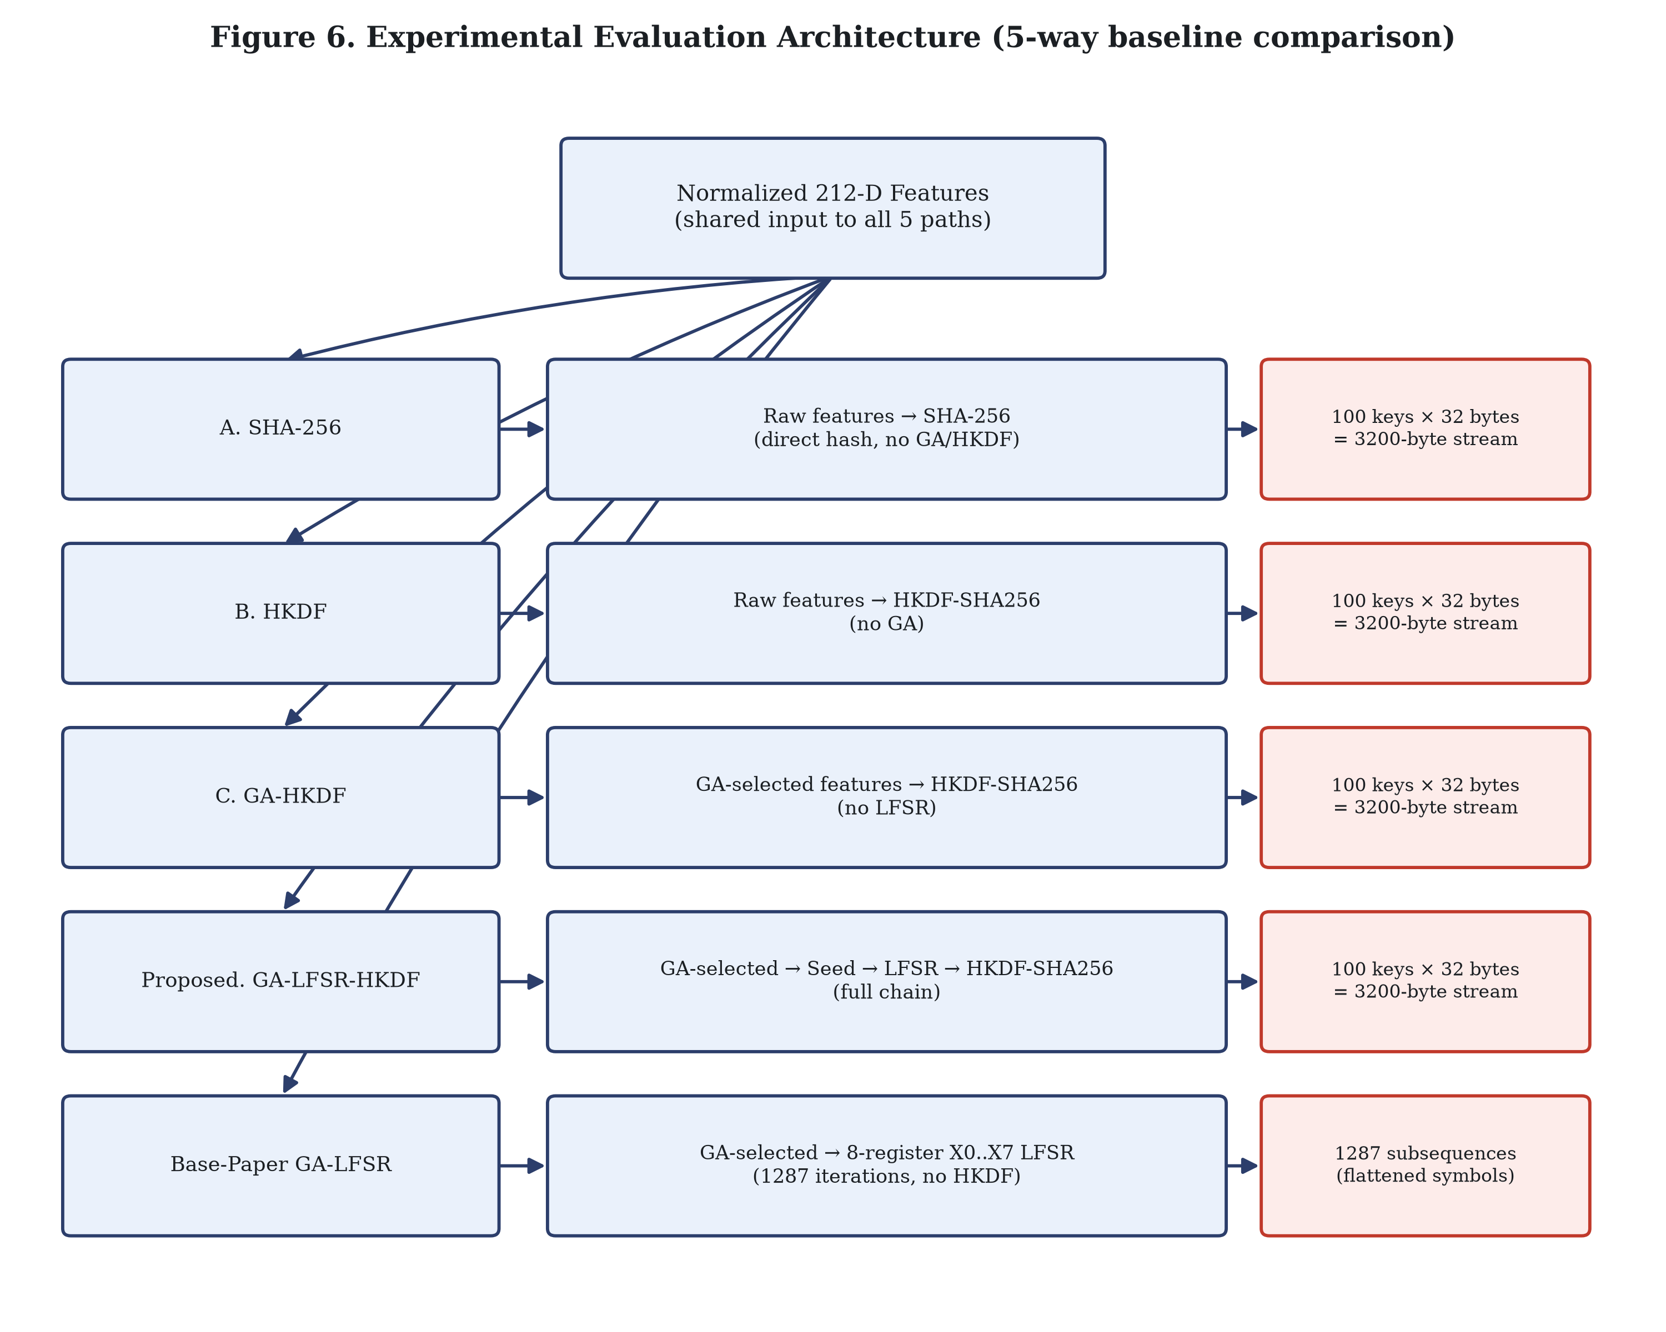
Figure 6. Experimental evaluation architecture (5-way baseline comparison).
Table 3. Baseline architecture definitions.
Baseline | Construction
Baseline_A_SHA256 | Raw normalized 212-D features → direct SHA-256 (no GA, no HKDF)
Baseline_B_HKDF | Raw normalized 212-D features → HKDF-SHA256 (no GA)
Baseline_C_GA_HKDF | GA-selected features → HKDF-SHA256 (no LFSR)
Proposed_GA_LFSR_HKDF | GA-selected features → seed → 32-bit Galois LFSR → HKDF-SHA256 (full chain)
Base_Paper_GA_LFSR | GA-selected features → 8-register X0..X7 LFSR (1287 iterations, no HKDF)

6.6 Encryption Evaluation
The end-to-end pipeline's AES-256-GCM stage is evaluated via a decrypt and compare round trip: the decrypted plaintext is compared byte-for-byte against the original input to confirm correct authenticated encryption/decryption. Tamper detection is separately covered by a dedicated unit test (`test_aes_gcm_tamper_detection`) that modifies ciphertext bytes and confirms decryption raises an authentication error.

6.7 Blockchain Integrity Evaluation
Evaluation of the blockchain layer proceeds by mining a block that contains the pipeline’s transaction, then validating the chain that results, which covers hash linkage, the proof of work prefix, and recomputation of each block’s hash. `BlockchainVerifier.verify_ciphertext_integrity()` then runs against the ciphertext produced, where the expected outcome is an `INTEGRITY_VERIFIED` result.

6.8 Reproducibility
Every result in Section 7 came from re-running `pytest tests/`, `python scripts/run_pipeline.py` and `python scripts/run_evaluation.py` immediately before this paper was written. The evaluation values matched the cached `results/tables/evaluation_summary.json` byte for byte, which confirms deterministic reproducibility under the fixed `random_seed = 42` setting.

7. Results

7.1 End-to-End Pipeline
Table 4 holds the results of a fresh `scripts/run_pipeline.py` execution. Decryption matched the original plaintext exactly, and the blockchain verifier returned `INTEGRITY_VERIFIED`.
Table 4. End-to-end pipeline results (fresh execution).
Metric | Value
Landmarks extracted | 106
Normalized feature dimensionality | 212
GA-selected feature count | 65
Derived AES-256 key length | 32 bytes
Decryption verified | True
Mined block index | 1
Blockchain verification status | INTEGRITY_VERIFIED

7.2 GA Feature Selection
Running the default configuration, meaning population 50, 30 generations and weights 0.35/0.35/0.15/0.15, the GA settles consistently on 65 of the 212 available normalized features for the primary subject profile used in the end to end run. The exact GA configuration behind that result appears in Table 5.
Table 5. Genetic Algorithm configuration.
Parameter | Value
Chromosome length | 212 bits (one per normalized feature)
Population size | 50
Generations | 30
Selection | Tournament (size 3)
Crossover | Uniform, rate 0.8
Mutation | Bit-flip, rate 0.05
Elitism | Top 2 chromosomes
Fitness weights (intra, inter, entropy, corr) | 0.35, 0.35, 0.15, 0.15
Minimum active bits enforced | 4

7.3 Randomness Evaluation
Byte level Shannon entropy appears in Figure 7 and the runs test Z statistics in Figure 8, covering all five architectures, both drawn from the freshly regenerated `evaluation_summary.json`.
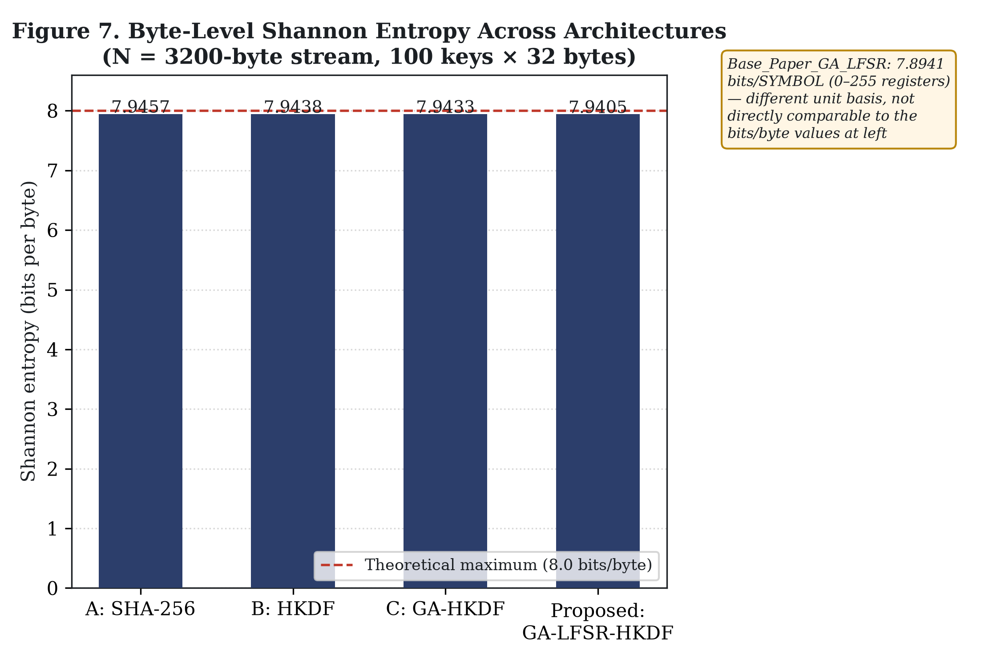
Figure 7. Byte-level Shannon entropy comparison across architectures.
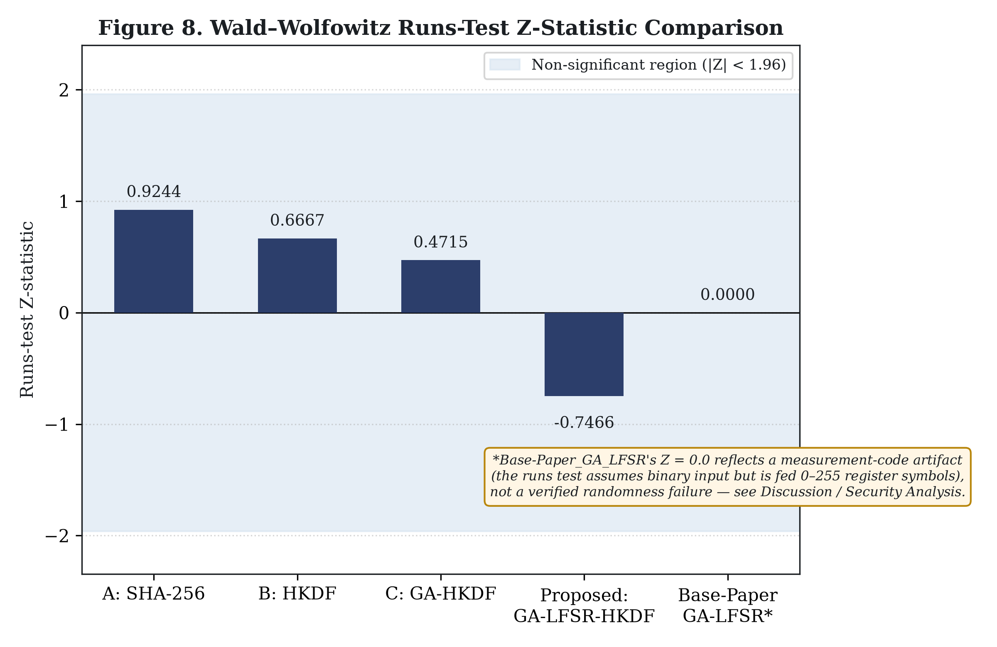
Figure 8. Wald-Wolfowitz runs test Z-statistic comparison.

7.4 Baseline Comparison
Table 6. Randomness and baseline comparison (N = 3200-byte stream unless noted).
Architecture | Entropy | Runs Z | Runs p | Is Random
Baseline_A_SHA256 | 7.9457 bits/byte | 0.9244 | 0.3553 | True
Baseline_B_HKDF | 7.9438 bits/byte | 0.6667 | 0.505 | True
Baseline_C_GA_HKDF | 7.9433 bits/byte | 0.4715 | 0.6373 | True
Proposed_GA_LFSR_HKDF | 7.9405 bits/byte | -0.7466 | 0.4553 | True
Base_Paper_GA_LFSR | 7.8941 bits/symbol* | 0.0 | 0.0 | False

*Entropy for Base_Paper_GA_LFSR is computed over its own symbol alphabet of 0 to 255 across 1287 subsequences rather than over a 3200 byte stream, so its magnitude cannot be compared directly against the bits/byte figures above, though both sit near their respective maxima. Its runs test result of Z = 0.0, p = 0.0, is_random = False comes from a measurement code artifact and not from any demonstrated randomness failure. Section 8.1 and Section 9.9 explain exactly why.

7.5 Biometric Stability
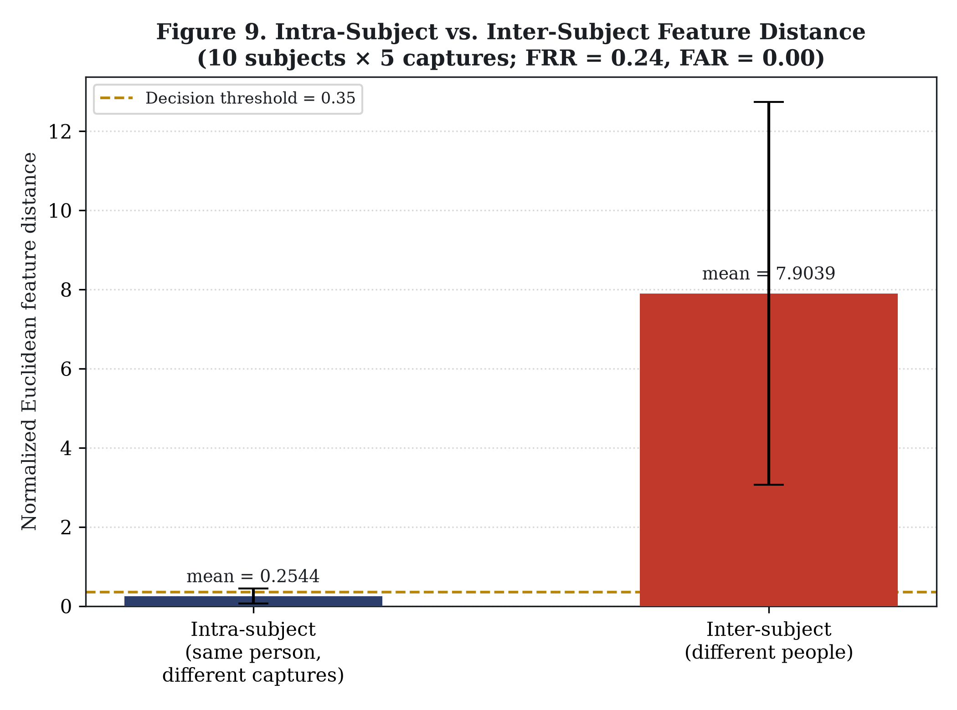
Figure 9. Intra-subject vs. inter-subject feature distance comparison.
Table 7. Biometric stability results (10 subjects × 5 captures, threshold = 0.35).
Metric | Value
Intra-subject mean distance | 0.2544
Intra-subject std. dev. | 0.1885
Inter-subject mean distance | 7.9039
Inter-subject std. dev. | 4.8353
False Rejection Rate (FRR) | 0.24
False Acceptance Rate (FAR) | 0.0
Decision threshold | 0.35

7.6 Encryption Verification
In the end to end pipeline run, the AES-256-GCM decrypt and compare round trip returned the original plaintext exactly (`decryption_correct: True`). A separate tamper detection unit test showed that changing any single ciphertext byte makes decryption raise an authentication tag error, so corrupted data is never returned silently.

7.7 Blockchain Verification
The mined block met the proof of work requirement, a SHA-256 hash carrying 2 leading hexadecimal zeros, and the chain validity check passed on both hash linkage and per block hash recomputation. The integrity verifier returned `INTEGRITY_VERIFIED: Ciphertext hash matches blockchain record perfectly.`

8. Discussion

8.1 Interpretation of Results
All four HKDF and hash based architectures produced byte streams with empirical Shannon entropy near 7.94 bits per byte, which sits close to the 8 bit maximum available to byte valued observations, and each passed the implemented Wald-Wolfowitz runs test at 95% confidence (|Z| < 1.96). Under those two metrics the distributional behavior looks favorable. That is all it shows. Neither entropy nor a runs test outcome speaks to cryptographic unpredictability, because both describe statistical properties of one observed sample rather than resistance to a computationally bounded adversary. The `Base_Paper_GA_LFSR` result (Z = 0.0, p = 0.0) has an identified cause in the code: `runs_test()` assumes its input sequence is binary and {0, 1} valued, while `PaperLFSRSubsequenceGenerator` hands it raw register integers between 0 and 255, which breaks the bit counting logic inside that function. The number is therefore a measurement code artifact. It is not evidence that the base paper’s LFSR mechanism fails a properly conducted runs test, and the base paper reports Z = 1.6083 for its own mechanism in Table 13 of [1], passing at the same significance level. This is stated openly here rather than presented as a security advantage for the proposed system.

8.2 Comparison with Baselines
Measured by this repository’s own methodology, entropy across Baseline_A_SHA256 through Proposed_GA_LFSR_HKDF spans only 7.9457 down to 7.9405 bits/byte, all of it near the 8 bit ceiling. Differences that small sit within the resolution of the measurement itself, so none of them supports a claim that one architecture is meaningfully “more random” than another on this metric. The four runs test Z statistics tell the same story: every one of them falls comfortably inside the non significant band, which leaves no architecture passing more strongly than the rest under this particular test.

8.3 Relationship to Base Paper
In our implementation and evaluation, the proposed GA-LFSR-HKDF stream passed the implemented runs test, whereas the evaluated `Base_Paper_GA_LFSR` implementation did not, for the specific, code-level reason identified in Section 8.1, not because of a demonstrated deficiency in the base paper's underlying mechanism. The base paper's own entropy figure (3.24 bits, over its own register symbol alphabet and 92,706-sequence dataset) and this repository's byte level entropy figures (approximately 7.94 bits/byte, over a 3200-byte stream) are measured on different alphabets and sample sizes; they are not directly comparable, and no superiority claim is made in either direction based on these two numbers.

8.4 Strengths
- A complete, working, code-verified pipeline from biometric feature selection through blockchain integrity verification, with every reported number traced to an actual re-run of the code.
- Use of standardized, well-reviewed cryptographic primitives (HKDF/RFC 5869, AES-256-GCM/FIPS 197 and SP 800-38D) rather than custom cryptography for the encryption and key derivation stages.
- A blockchain design that stores only hash commitments, never raw biometrics or secret keys, consistent with an audit layer design that preserves privacy.
- An explicit, controlled five-way baseline comparison that isolates the marginal contribution of each pipeline stage.

8.5 Observed Limitations
- Biometric reproducibility: a 24% false rejection rate at the evaluated threshold means that in this synthetic-subject experiment, roughly one in four same-person capture pairs would fail to match, a meaningful usability and security tradeoff for any biometric key regeneration use case, not a solved problem.
- All experimental results in this paper were produced from synthetic landmark data, not real photographed faces (Section 6.2); the MediaPipe real image extraction path is implemented and unit-tested but was not exercised to produce any number reported here.
- The LFSR stages, both the proposed 32-bit Galois LFSR and the base paper's 8-register mechanism, are fully deterministic given their seed and configuration. An attacker who recovers the seed and structure can reproduce the output exactly.
- The blockchain layer is a local, single process proof-of-work simulation, not a distributed or publicly deployed network; no consensus attack, network partition, or multi-node throughput evaluation was performed.

9. Security Analysis

9.1 Threat Model
Kerckhoffs’s principle underpins the analysis. The attacker is assumed to know the entire algorithm design, meaning the GA configuration, the LFSR taps, the HKDF parameters and the blockchain structure, while not knowing the specific biometric capture, the derived key, or the plaintext behind any given transaction. Read access to the blockchain ledger is granted to the attacker, as is access to any ciphertext they manage to intercept.

9.2 Confidentiality
Confidentiality of the plaintext rests entirely on the secrecy and quality of the derived AES-256 key, provided by AES-256-GCM when used correctly (unique nonce per encryption, which this implementation generates via `os.urandom(12)` by default). AES-GCM provides authenticated encryption when used correctly; it does not itself compensate for a weak or predictable key.

9.3 Integrity
Blockchain integrity does not provide confidentiality. It provides a tamper evident commitment to the ciphertext's hash. An attacker who modifies stored ciphertext without also being able to alter the corresponding on-chain hash (and, for a longer chain, re-mine every subsequent block's proof of work) will be detected by the verifier. In this implementation, which runs within a single process, an attacker with direct access to the running process's in-memory chain could trivially alter both the ciphertext and the ledger together; the current design assumes ledger and ciphertext storage are not both fully compromised by the same attacker, a limitation of the local, simulated deployment rather than of the proof-of-work/hash-chaining concept itself.

9.4 Biometric Exposure
A face is not inherently secret: it is visible in public, in photographs, and on video. Biometric features may be reproducible by anyone with access to a sufficiently similar image of the same person. This system does not attempt to treat the raw face as a secret; it never stores raw landmarks or images on the blockchain, but the security of key regeneration ultimately depends on an attacker not being able to obtain a sufficiently accurate capture of the legitimate user's face and reproduce the same GA/LFSR/HKDF pipeline.

9.5 Key Reproducibility
Because feature extraction and normalization are sensitive to capture noise, and because no fuzzy extractor or error correcting mechanism is implemented, repeated captures of the same subject do not reliably regenerate identical key material byte for byte, consistent with the measured 24% FRR in Section 7.5. This is disclosed as an open problem, not resolved by this implementation.

9.6 LFSR Security Considerations
Both LFSR implementations in this codebase are deterministic pseudo-random sequence generators. An attacker who knows the seed and the tap/feedback configuration (which Kerckhoffs's principle assumes they do) can reproduce the LFSR output exactly. The LFSR's role in this system is sequence expansion, not a standalone source of cryptographic unpredictability; the subsequent HKDF step is what standardizes the final key, not the LFSR itself.

9.7 Cryptographic Key Derivation
HKDF-SHA256 is a key derivation mechanism, not a biometric stabilizer: given consistent input key material, it reliably derives a uniform key, but it does not compensate for the input key material itself differing across captures of the same subject (Section 9.5).

9.8 Blockchain Security Properties
The implemented proof-of-work (difficulty 2, i.e., 2 leading hexadecimal zero characters) is a demonstration-scale parameter, not a production security parameter; it was not tuned or evaluated against any specific adversarial mining-power assumption, and no multi-node consensus or 51%-attack-resistance property is claimed for this local, single process implementation.

9.9 Limitations of Statistical Randomness Testing
Passing Shannon-entropy and runs-test checks provides statistical evidence about a sample's distributional properties; it does not constitute a proof of cryptographic security or unpredictability against a computationally bounded adversary, and it does not substitute for formal cryptanalysis of the key derivation chain as a whole. The degenerate `Base_Paper_GA_LFSR` runs-test result described in Section 8.1 is a concrete illustration of how easily such tests can be misapplied to non-conforming input and produce misleading pass/fail labels if the implementation detail is not checked.
Table 8. Security properties and mechanisms.
Property | Mechanism | Provided by
Confidentiality | Authenticated symmetric encryption | AES-256-GCM
Ciphertext integrity / tamper detection (at decrypt time) | GCM authentication tag | AES-256-GCM
Long term data integrity auditing | Hash chained, PoW mined ledger | Blockchain layer
Key uniformity | HMAC based extract-and-expand | HKDF-SHA256
Biometric non-storage | Metadata-only transactions | Blockchain transaction schema
Biometric noise tolerance | Not implemented | Planned as future work (Section 10)
Liveness / anti-spoofing | Not implemented | Planned as future work (Section 10)

10. Limitations and Future Work

10.1 Limitations
- Biometric variability and the 24% FRR currently measured leave key regeneration across repeated captures unresolved.
- Every experimental result reported here rests on synthetic landmark data. No real image evaluation was carried out for this paper (Section 6.2).
- On any failure, whether a missing package or an undetected face, the MediaPipe real image path drops silently to the synthetic generator. In a real deployment that could hide capture failures unless it is monitored explicitly.
- Determinism applies to both LFSR mechanisms: recover the seed and the configuration and their output follows.
- Shannon entropy and the runs test are statistical checks, not proofs of cryptographic security, and no formal cryptanalysis of the full key derivation chain was attempted.
- A NIST SP 800-22 monobit test, a chi square uniformity test and an average pairwise Hamming distance metric all exist in `src/evaluation/`, but none of them is wired into the evaluation pipeline or the reported results.
- The blockchain runs locally and in simulation, one process at PoW difficulty 2, with no distributed deployment, no network level attack, and no throughput or scalability evaluation.
- Nothing in the implementation tolerates capture noise: no fuzzy extractor, no error correcting code, no other biometric key binding technique.
- Subject populations are small and synthetic, 10 subjects for the stability study and 5 for the GA training dataset, which limits how far the results generalize to a real and diverse population.
Table 9. Limitations and corresponding future work.
Limitation | Proposed Future Work
24% FRR observed at threshold 0.35; biometric key regeneration is not yet reliable across captures | Investigate fuzzy extractors, error correcting codes, or improved normalization for noise tolerant key regeneration
All reported results use synthetic landmark data; MediaPipe real image path unexercised | Evaluate on larger, diverse real image datasets under the actual MediaPipe extraction path
Both LFSR mechanisms are fully deterministic given seed/configuration | Formal cryptanalysis of the full key derivation chain beyond statistical randomness testing
NIST monobit, chi-square, and Hamming distance metrics implemented but not integrated into the evaluation pipeline | Integrate all implemented statistical tests into the standard evaluation report
Blockchain layer is a local, single process PoW simulation | Evaluate under real distributed deployment: throughput, network partition, consensus attacks
Small, synthetic subject population (10 for stability study, 5 for GA training) | Scale to larger, real, and more diverse subject populations
No liveness/anti-spoofing detection | Adversarial and spoofing resistance evaluation of the capture/extraction stage
No hardware acceleration evaluated | Investigate hardware acceleration and scalability for real-time use

10.2 Future Work
- Address the robustness of biometric key regeneration directly. Candidates include better alignment, better normalization, more stable feature representations, and key binding techniques such as fuzzy extractors or error correcting codes, none of which the repository currently contains.
- Evaluate the system on real image datasets that are larger and more diverse, running the actual MediaPipe extraction path.
- Bring the NIST SP 800-22 monobit test, the chi square uniformity test and the average pairwise Hamming distance metric, all already implemented and all currently unused, into the standard evaluation report.
- Take the full key derivation chain through a formal cryptanalytic and adversarial evaluation rather than statistical randomness testing alone.
- Put the blockchain layer under a real distributed deployment and measure it against throughput limits, network partitions and consensus attacks.
- Investigate hardware acceleration and scalability for real-time use.
- Conduct adversarial/spoofing evaluation of the biometric capture and extraction stage.

11. Conclusion
This paper documented the design, code-verified implementation, and experimental evaluation of a biometric key generation and blockchain integrity verification system built as an implementation and extension of Sannidhan et al.'s facial landmark based key generation approach [1]. The complete proposed architecture, comprising biometric feature extraction, genetic algorithm feature selection, LFSR based key material expansion, HKDF-SHA256 key derivation, AES-256-GCM authenticated encryption, blockchain based integrity verification, and a controlled multi-architecture evaluation, was implemented and re-verified from start to finish immediately prior to writing this paper (21 of 21 unit tests passing; pipeline execution and evaluation suite both reproducing identical results, byte for byte, to the previously cached figures). The implementation differs from the base paper specifically at the facial landmark extraction stage, where MediaPipe Face Mesh downsampling (with a synthetic fallback) replaces the base paper's custom-trained MobileNetV2 regressor, and it extends the base paper's scope entirely: no encryption or blockchain component exists in [1] at all. Within the scope of this project, the results indicate a functioning integration rather than a proven security guarantee: entropy and runs test statistics provide favorable but limited statistical evidence, the biometric stability evaluation discloses a genuine 24% false rejection rate that remains unresolved, and both LFSR mechanisms remain fully deterministic under Kerckhoffs's principle. These limitations are stated explicitly, alongside concrete future work directions, rather than omitted or minimized.

References
[1] M. S. Sannidhan, J. E. Martis, K. N. Pallavi, V. Ravi, H. L. Gururaj, T. J. Alahmadi, “Genetic algorithms and deep learning for unique facial landmark-based key generation,” Computers and Electrical Engineering, vol. 118, article 109427, 2024. https://doi.org/10.1016/j.compeleceng.2024.109427
[2] X. Zhao, S. Lin, X. Chen, C. Ou, C. Liao, “Application of face image detection based on deep learning in privacy security of intelligent cloud platform,” Multimedia Tools and Applications, vol. 79, no. 23-24, pp. 16707-16718, 2020.
[3] F. Quinga-Socasi, L. Zhinin-Vera, O. Chang, “A deep learning approach for symmetric-key cryptography system,” Advances in Intelligent Systems and Computing, vol. 1288, pp. 539-552, 2020.
[4] G. Panchal, D. Samanta, S. Barman, “A novel key generation approach based on facial image features for stream cipher system,” in Proc. 2020 3rd Int. Conf. Smart Systems and Inventive Technology (ICSSIT), IEEE, 2020, pp. 956-962. (Also cited as [18] in the base paper.)
[5] S. Kalsi, H. Kaur, V. Chang, “DNA cryptography and deep learning using genetic algorithm with NW algorithm for key generation,” Journal of Medical Systems, vol. 42, no. 1, 2018.
[6] F. S. Abu-Almash, “Apply genetic algorithm for pseudo random number generator,” International Journal of Advanced Research in Computer Science and Software Engineering, vol. 6, no. 8, pp. 8-19, 2016.
[7] K. Shankar, P. Eswaran, “An efficient image encryption technique based on optimized key generation in ECC using genetic algorithm,” in Artificial Intelligence and Evolutionary Computations in Engineering Systems (Proc. ICAIECES 2015), Springer India, 2016, pp. 705-714.
[8] K. B. Sudeepa, G. Aithal, V. Rajinikanth, S. C. Satapathy, “Genetic algorithm based key sequence generation for cipher system,” Pattern Recognition Letters, vol. 133, pp. 341-348, 2020.
[9] G. Cotrina, A. Peinado, A. Ortiz, “Gaussian pseudorandom number generator using linear feedback shift registers in extended fields,” Mathematics, vol. 9, no. 5, p. 556, 2021.
[10] A. Kaur, H. K. Verma, R. K. Singh, “3D-Playfair cipher using LFSR based unique random number generator,” in Proc. 2013 6th Int. Conf. Contemporary Computing (IC3), IEEE, 2013, pp. 18-23.
[11] M. S. Sannidhan, K. B. Sudeepa, J. E. Martis, A. Bhandary, “A novel key generation approach based on facial image features for stream cipher system,” in Proc. 2020 3rd Int. Conf. Smart Systems and Inventive Technology (ICSSIT), IEEE, 2020, pp. 956-962.
[12] H. Krawczyk, P. Eronen, “HMAC-based Extract-and-Expand Key Derivation Function (HKDF),” IETF RFC 5869, 2010.
[13] National Institute of Standards and Technology, “Advanced Encryption Standard (AES),” FIPS Publication 197, 2001.
[14] M. Dworkin, “Recommendation for Block Cipher Modes of Operation: Galois/Counter Mode (GCM) and GMAC,” NIST Special Publication 800-38D, 2007.
[15] A. Rukhin et al., “A Statistical Test Suite for Random and Pseudorandom Number Generators for Cryptographic Applications,” NIST Special Publication 800-22, Revision 1a, 2010.
[16] G. B. Huang, M. Mattar, T. Berg, E. Learned-Miller, “Labeled Faces in the Wild: A database for studying face recognition in unconstrained environments,” in Workshop on Faces in 'Real-Life' Images: Detection, Alignment, and Recognition, 2008.
[17] P. J. Phillips, H. Moon, S. A. Rizvi, P. J. Rauss, “The FERET evaluation methodology for face-recognition algorithms,” IEEE Transactions on Pattern Analysis and Machine Intelligence, vol. 22, no. 10, pp. 1090-1104, 2000.
[18] A. S. Georghiades, P. N. Belhumeur, D. J. Kriegman, “From few to many: illumination cone models for face recognition under variable lighting and pose,” IEEE Transactions on Pattern Analysis and Machine Intelligence, vol. 23, no. 6, pp. 643-660, 2001.
[19] R. Gross, I. Matthews, J. Cohn, T. Kanade, S. Baker, “Multi-PIE,” Image and Vision Computing, vol. 28, no. 5, pp. 807-813, 2010.

