

**College of Science, Technology & Applied Arts of Trinidad & Tobago**

**DEPARTMENT OF INFORMATION SCIENCE AND TECHNOLOGY**

**GROUP ASSIGNMENT COVER PAGE**

**ASSIGNMENT TITLE: FINAL PROJECT – THE WEAKEST LINK**

**COURSE CODE: ITEC 245**

**COURSE TITLE: INTRODUCTION TO SCRIPTING LANGUAGES**

**CRN:** 22002 **SEMESTER: 2**

**STUDENT NAME STUDENT I.D. PROGRAMME**

**1. SHAQUILLE BABB INTERNET TECHNOLOGY**

**2. NYAME DAVIS 00049367 INTERNET TECHNOLOGY**

**3. TEELON MITCHELL 00048797 CIS**

**DATE OF SUBMISSION: 25/05/2017**

**LECTURER’S NAME: KADEEM BEST**

Contents

Introduction 3

Challenges 3

Storyboard 3

# Introduction

The game given for development was the weakest link. The weakest link is a game which the users or players of the game answers question and can go up to three rounds. In this game, the payers can walk away with up to one million points. The question is manly direction at nationals or anyone who thinks they have the knowledge to take on the game. This is the final documentation for the creation of the program showing from start to finish. The program was created using a number of tool which greatly helped us with merging and syncing of the programing files.

# Challenges

There were many challenges that faced our group, mostly the coding skill level disparity between the members of the group. Shaquille Babb was the head programmer for our team and as you may know his level or style is more advanced than the two of us, so we had to play catchup throughout the coding process. Another challenge that had to be overcome was the time for group meetings. Because the members of the group were working many times the project was placed on hold for us to move forward together so compilation of code would be smooth and painless.

# Storyboard

Upon opening the web application, users are greeted by an interface showing two (2) options.

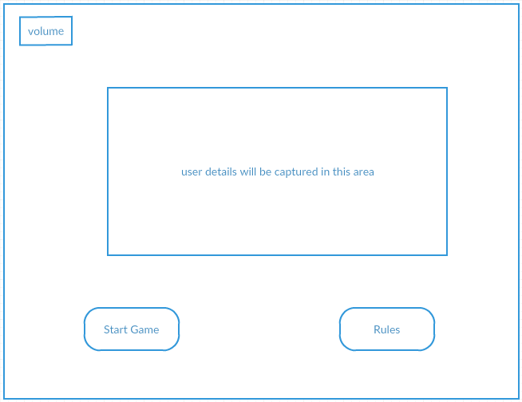

If the user selects the ‘view rules’ option, the how to play guide is generated and the user can review the rules and familiarize himself/herself with the requirements set to successfully play the game.

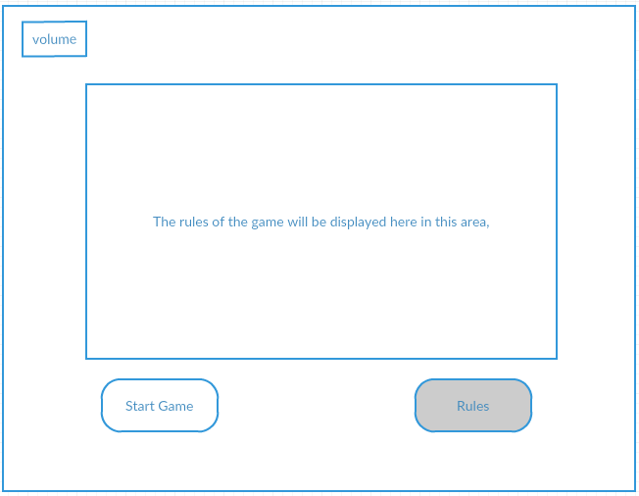

If the user selects the ‘start game’ option, the game page would be generated and the game would begin.

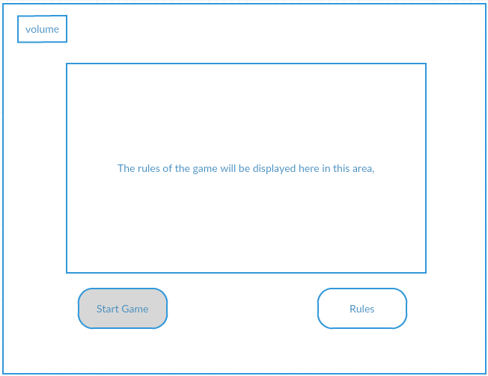

The audio icon in the top corner is clickable, this allows the user to mute the background music he/she is hearing.

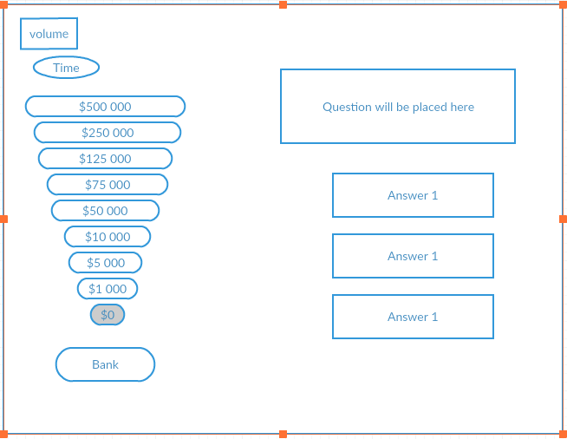

As the game begins, the user must select the answer to the question being displayed. The timer is displayed to the user, showing him/her the amount of time allotted to the selection process. The user is also made aware of his/her bank/earnings by viewing the bank display to the left of the screen.

Once the user has entered an answer correctly he/she is now given the option to bank the money so far earned or go straight ahead to the next question, without banking the earned money.

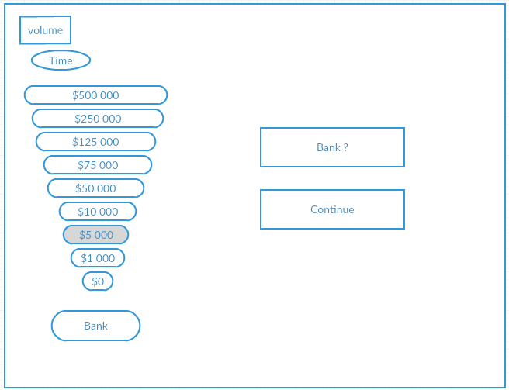

# URL of the Live Working Web Application

# Source Code

## HTML

## JAVASCRIPT

## CSS

# Work Schedule

|  |  |
| --- | --- |
| Task | Person |
|  |  |
|  |  |
|  |  |
|  |  |
|  |  |
|  |  |
|  |  |

# Bibliography