Programming exercises
Crazy Taxi part 2
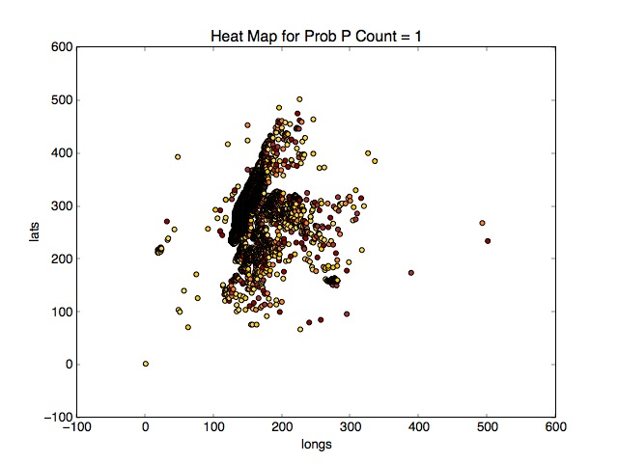
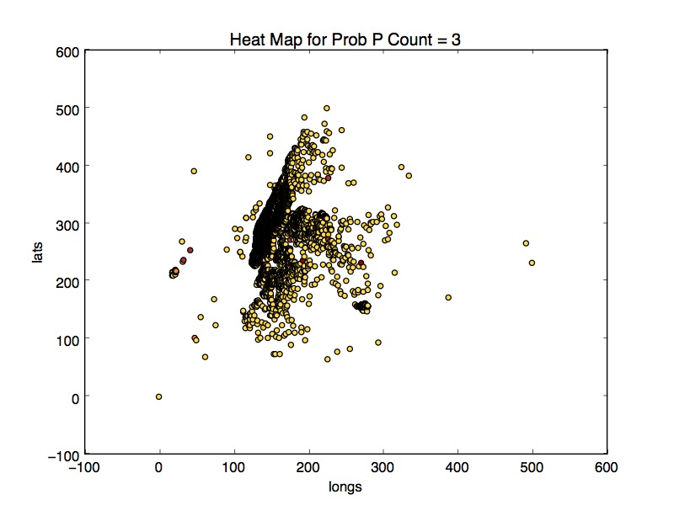
(1.a) We first scaled the lat and long by diving them into buckets for GPS locations. We calculated min and max for each feature, then divided the range into 500 parts. For each lat and long we scale by the min and divide by bucket range to get new arrays for long and lat. These were done in excel and then taken into python to calculate the probabilities and scatter plots.

(1.b) Using 1 nearest neighbors on one hundred thousand trip times we get:
Root Mean Squared Error: 388.9228
Correlation Coefficient: 0.703252
Mean Absolute Error: 247

(1.c) We took pickup time and scaled it to an integer that corresponds to minutes passed since midnight of a day
Root Mean Squared Error: 361.973
Correlation Coefficient: 0.74509628
Mean Absolute Error: 237

(1.d) Our scaling method here was to normalize each feature in test and train set by subtracting mean and dividing by the standard deviation (see lines 39-42 in D.py). The errors are slightly higher than before but our correlation coefficient is the highest from previous methods. All features are now in range -1 to 1. There are probably some small outliers in the set somewhere that are throwing off the distance calculations even by normalizing.

Root Mean Squared Error: 385.200
Correlation Coefficient: 0.7460
Mean Absolute Error: 260

(1.e) For this part, we actually compare the weights on the distances between median, inverse distance and majority voting to see how they compare. It looks like in all cases, k= 5 seems to have the best performance. There is a trend where errors in crease slightly but after K > 14 they start to decrease again indicating maybe there is some overfitting.

(1.f) In order to improve computational efficiency, getting the neighbor with the exact closest difference is not ideal. What we would rather do is compute an approximate distance for the closest point to the query point. We can extend the idea of a bin analogy to nearest neighbors. For every bin size, calculate the distance between query point and bin to be the smallest distance from query to any point on bin boundary. Instead of searching through all the points in the bin to find the closest distance, using a priority queue return the point closest to the query point in the queue and continue from there. This terminates the exhaustive search early without forgoing too much accuracy.

Decision Trees for Food Reviews
(2.a) Example of one review and label pair:
product/productId: B003YXWAF8
review/userId: A1KQXO716WOOD6
review/profileName: Allison Beegle
review/helpfulness: 7/13
review/score: 1.0
review/time: 1309305600
review/summary: Waste of money
review/text: These condiments are overpriced and terrible. The classic is disgustingly sweet. The spiced tastes like a bad spicy marinara sauce from a chain restaurant.

After scanning through multiple reviews, we can infer that positive reviews generally have a rating higher than 3.0 and bad reviews are 2.0 and below. Words associated with negative reviews tend to be: nasty, bad, tasteless, terrible, horrible, overpriced, awful, disgusting etc. Words associated with positive reviews tend to be of type excellent, great, best, fresh, wonderful, flavorful, fantastic, love etc.

(2.b)

Written Exercises
(1.a) Point A is below at (0.5, 0.5)

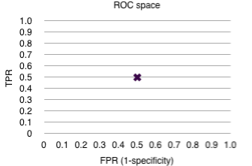

(1.b) Point B in upper left corner.
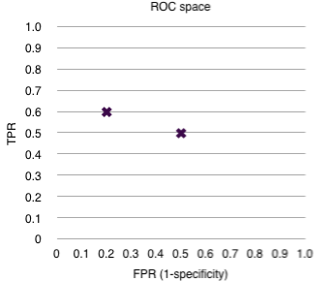
(1.c) Curve C. This is the same line for randomness in classification.
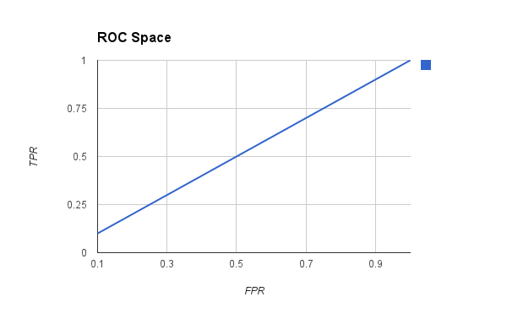

(1.d) Curve D

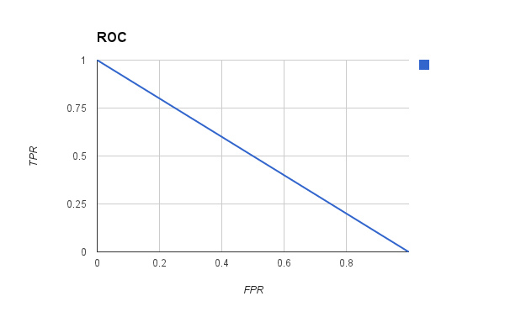

(1.e)
If we were able to influence P, then parameter D would be the best when P = 1 it will always return the correct class implying FPR of 0.

(2.a) If X is a random variable that represents a fair coin flip, then X can take two values H and T (heads and tails), each with probability 0.5.

(2.b) X takes value 1 when lands on H and 0 when lands on T. Expected value of a coin flip is X1p1 + X2p2 = 1(0.5) + 0(0.5) = 0.5.
Similarly, the expected value of a fair 6 sided dice roll is 1/6(1+2+3+4+5+6) = 3.5

(2.c) In this case, Y is the sum of the outcomes of rolling two fair 6-sided dice. For example, if we roll two dice and one comes out 5 and other 11, then Y is 16. Y represents the space of outcomes for rolling two dice, regardless of these events being independent of each other.
E[Y] = E[X1 + X2]= E[X1] + E[X2] = 3.5 + 3.5 = 7.

(2.d) Let Y be a random variable such that Y = X1 + X2. Then:
E[X1 + X2] = E[Y]
= ∑ Y(s) x Pr{s} sum over s∈S
= ∑ (X1(s) + X2(s)) x Pr{s} sum over s∈S
= ∑ (X1(s) x Pr{s} + ∑ X2(s) x Pr{s} sum over s∈S
= E[X1] + E[X2] definition of expectation

(2.e) The variance of a fair 6-sided die would be:
(1/6)x[(-2.5)^2 + (-1.5)^2 + (-0.5)^2 + (0.5)^2 + (1.5)^2 (2.5)^2] = 35/12

(2.f) Var[a + X] = E[(a + X)^2] - (E[a +X])^2
=E[a^2 + 2X

