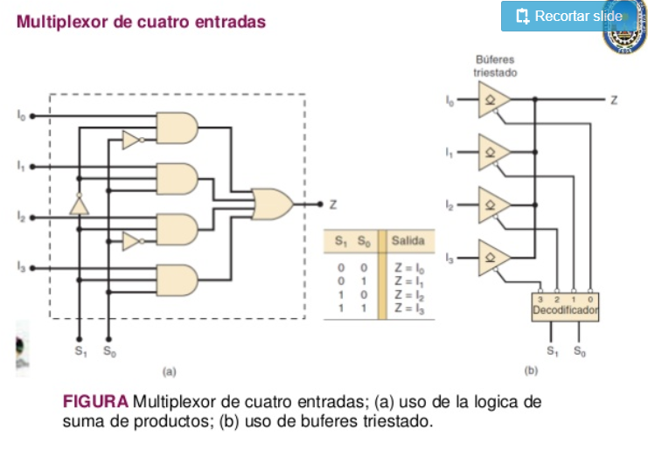

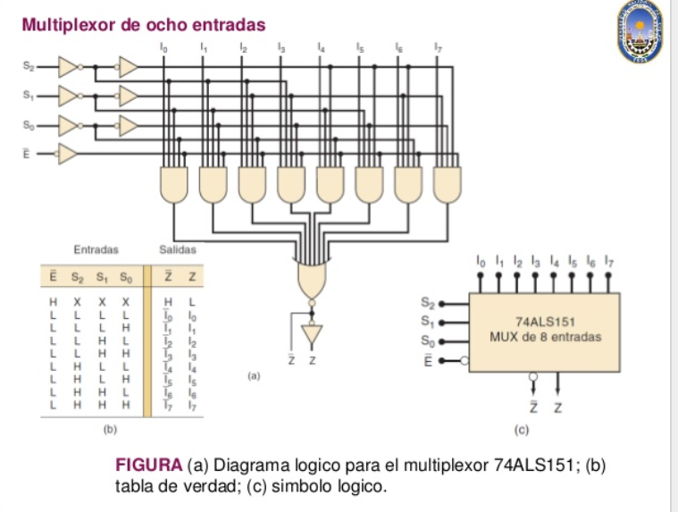

<https://pt.slideshare.net/MarcoAntonio235/sesion-multiplexores-y-demultiplexores-52690969/2>

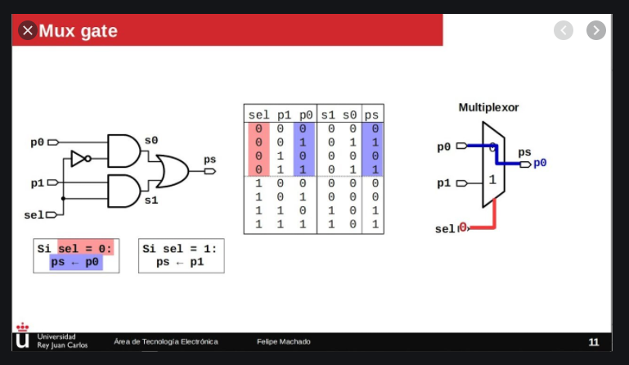

Ilustración : MULTIPLEXOR 2:1