**Coursera Capstone**

**Sushi in Milan**

**Introduction**: If you ask an Italian what the national food is, he/she will 99% respond "Pizza". That 1% belongs to the citizens of Milan, if you by chance pick up one of them, you are likely to be answered "Sushi". I want to understand how the Sushi arena can be accesed in the city I live in: Milan.

**Dataset**: I will be using the Foursquare location data to understand where Sushi makers are located and to specifically discover how many are located close to my house.

**Results:**

* List of Sushi restaurants in Milan and visual representation:

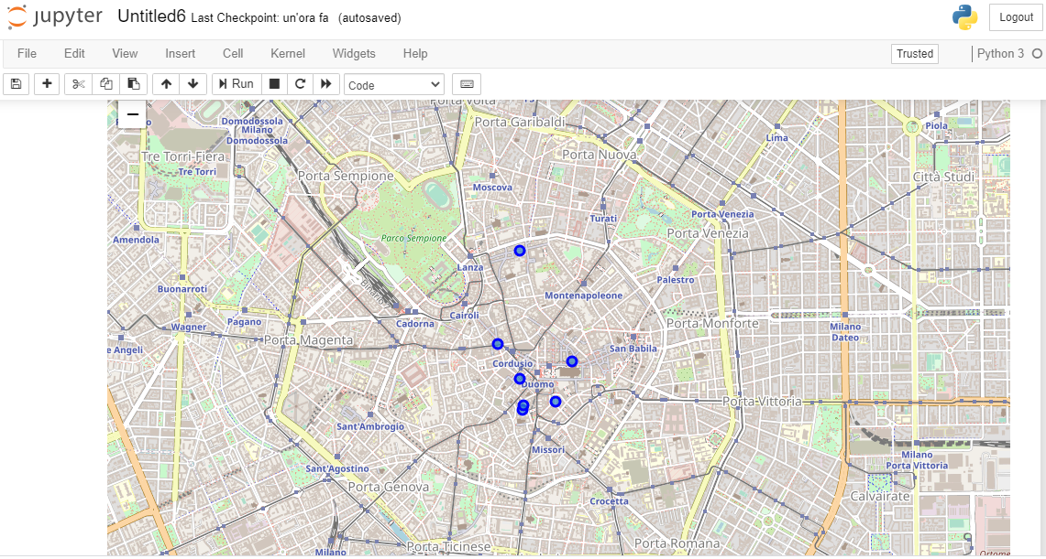

* Focus on the tips from a selected Sushi restaurant:

