Chrome插件:

SwitchyOmega



配置

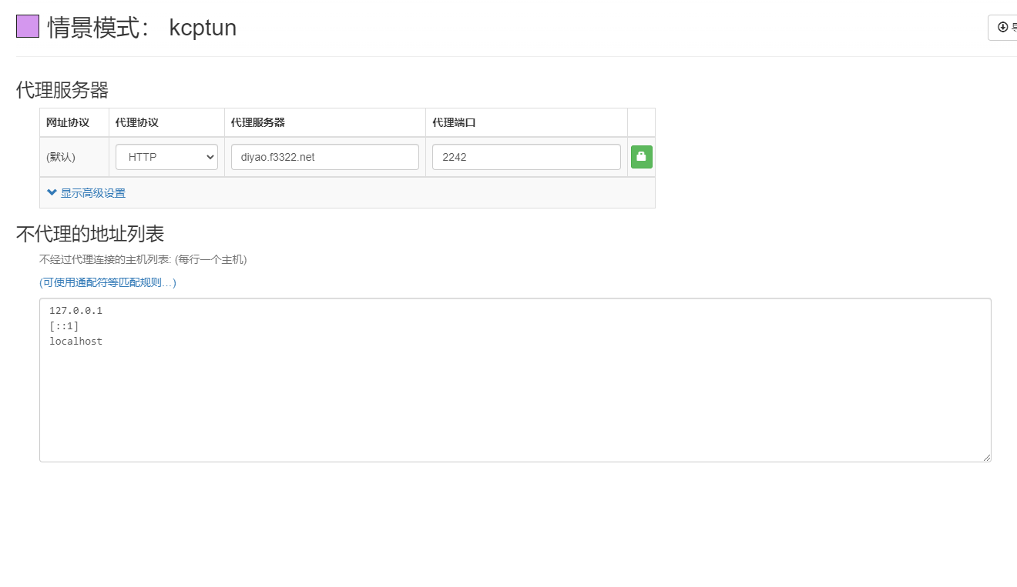

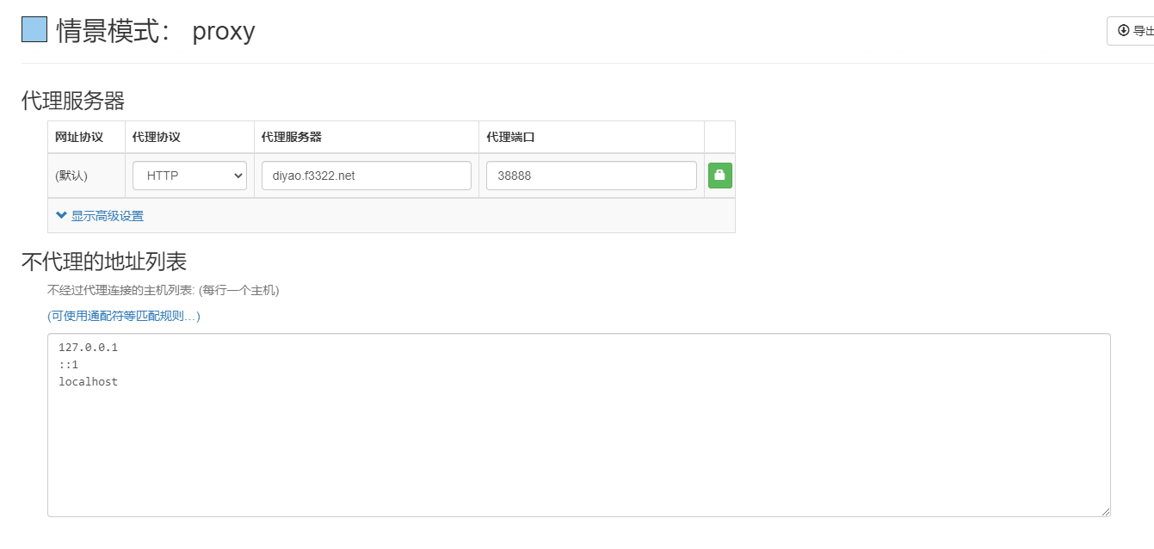

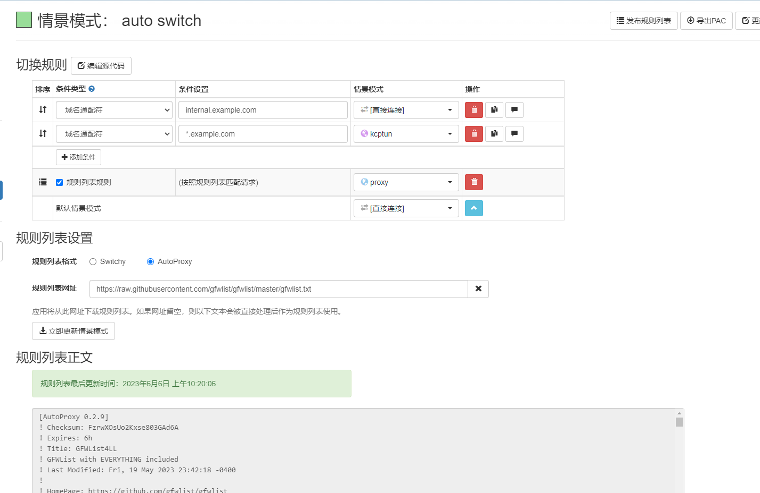

https://raw.githubusercontent.com/gfwlist/gfwlist/master/gfwlist.txt