**Question 1.**

**How would you design the data model for this new service, and how would it relate to the Library? Please provide some sort of schema or diagram and document any concerns/considerations you made that are not directly reflected in your documentation. Documentation can be hand drawn or generated with a tool of your choice.**

*See model diagram below:*

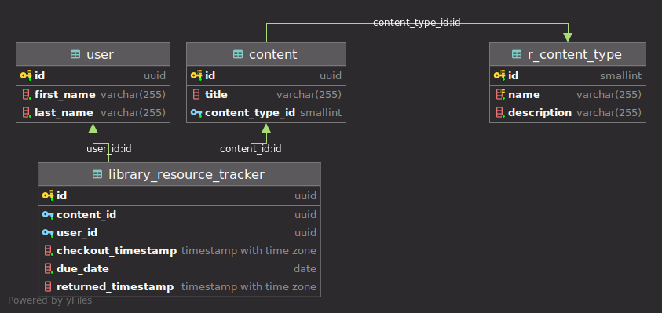

The Library Resource Tracker table (maybe should have just been named Library) is the relationship between Users and the Library’s Content. I went this route of a separate Library table as it will provide a nature Audit and Historic view and will support your typical queries, you would need to perform for seeing who has what checked out. Who and what Content is late, etc.?

**Question 2. How would you control access to Library content? Describe what this mechanism would look like and list any services you would use to accomplish this goal.**

Ideally, I’d use a third party vendor, such as Okta and utilize their OAuth 2.0 and OpenID protocols to handle Authorization and Authentication. Our Library API would integrate with Okta and be configured as a Resource Server and utilize OAuth 2.0 to authorize and grant access to our Library API.

**Question 3. How would you ensure your service would continue functioning if the datacenter it was deployed in had a catastrophic failure and was completely wiped off the map?**

We would want to have 2 or more Regions in different areas on the globe with 2 or more Availability Zones where each A.Z. would have at minimum 2 instances of your app deployed. A load balancer would be in front of each A.Z. in each of your Regions.

Question 4. Describe how you would approach building a dynamically scalable API. Are there any prerequisites for the service code for this to work?

Question 5. Provide a diagram of how you envision the architecture for this to be deployed in a cloud provider. Any provider you choose is acceptable, just be sure to document the services/tools you would be using. Diagrams can be hand drawn or generated by a tool of your choice.

Question 6. After a successful launch of your brand new service (congrats!) it runs flawlessly for a few months. Then suddenly, every Tuesday and Thursday the service falls over and requires manual intervention to get it running again. You don't see any obvious problems. How would you go about troubleshooting this issue? Detail your approach and any tools/services you would use to accomplish this task.

Question 7. Are there any requirements that have not been given as part of this scenario that you would consider essential and push to have included for any service being developed?