Direct repression of evening genes by CIRCADIAN CLOCK-ASSOCIATED 1 in the Arabidopsis Circadian Clock

CCA1 and LHY directly repress expression of TOC1, ELF4 and LUX.

TOC1
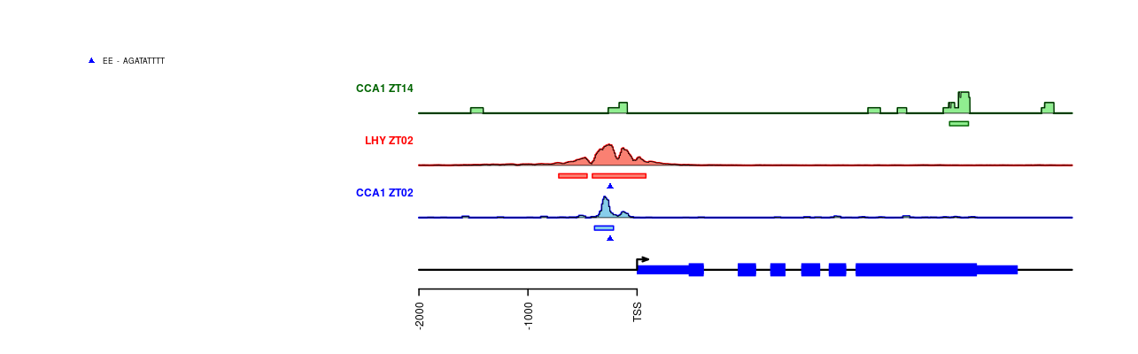
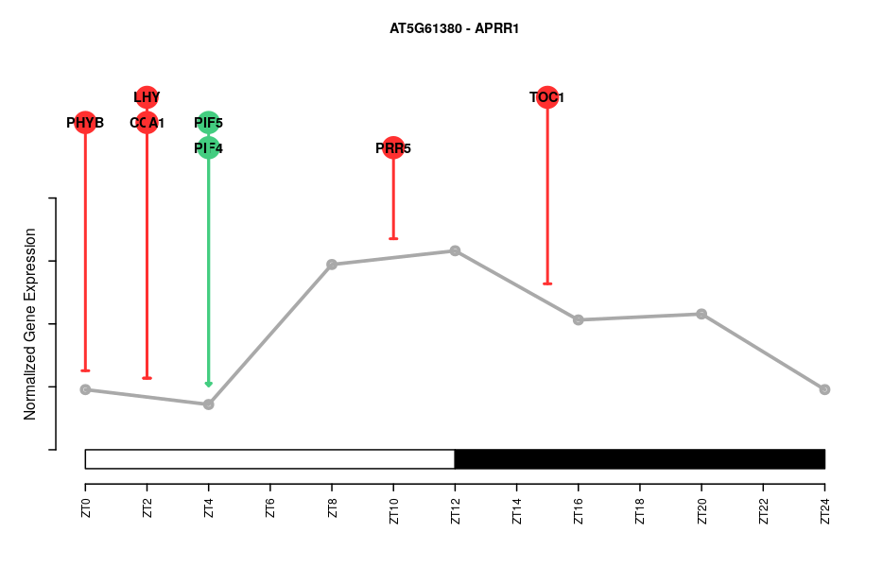

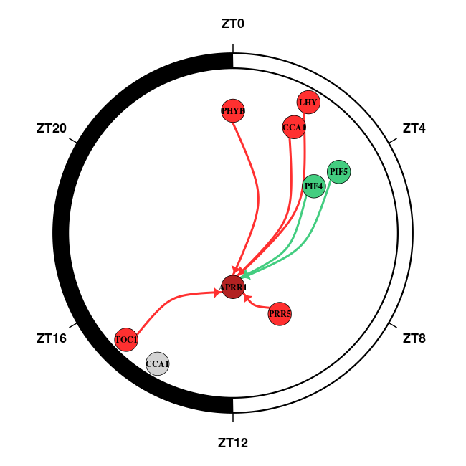

ELF4
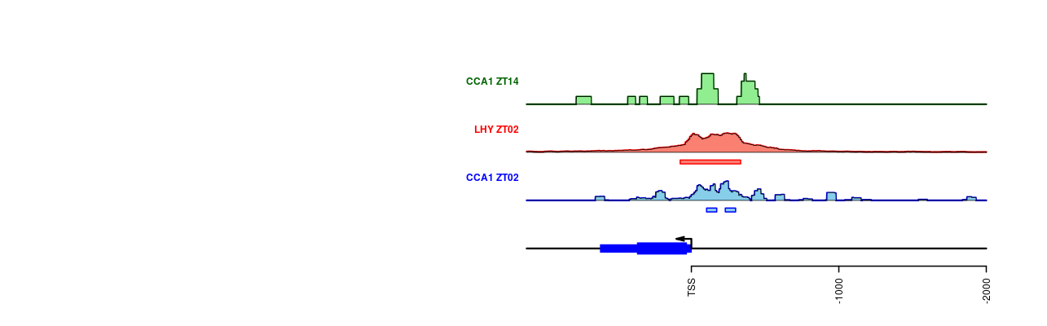
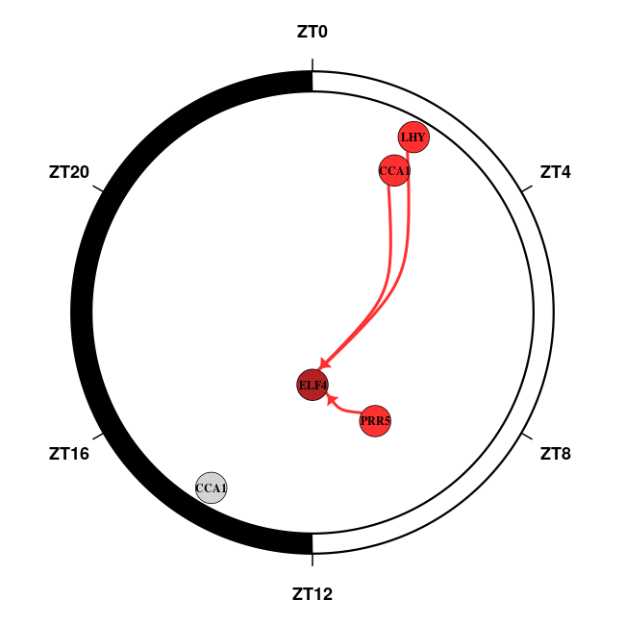

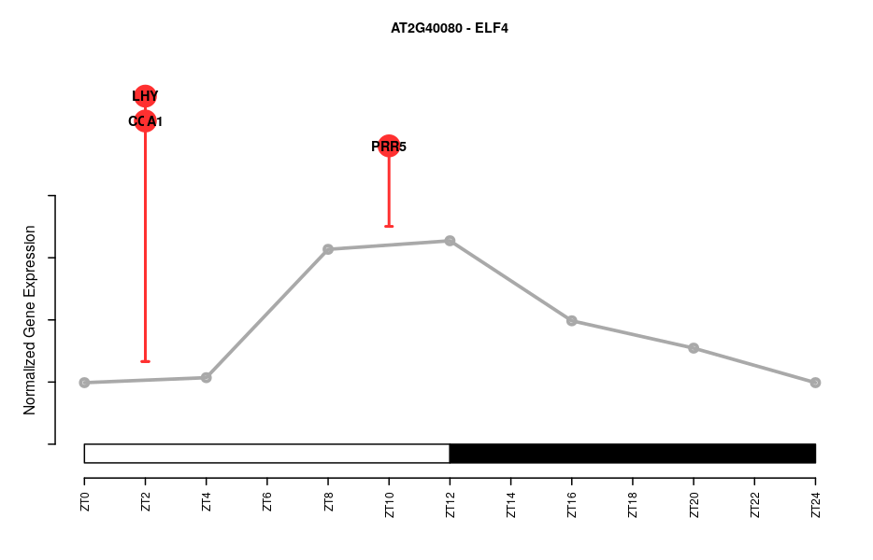

LUX
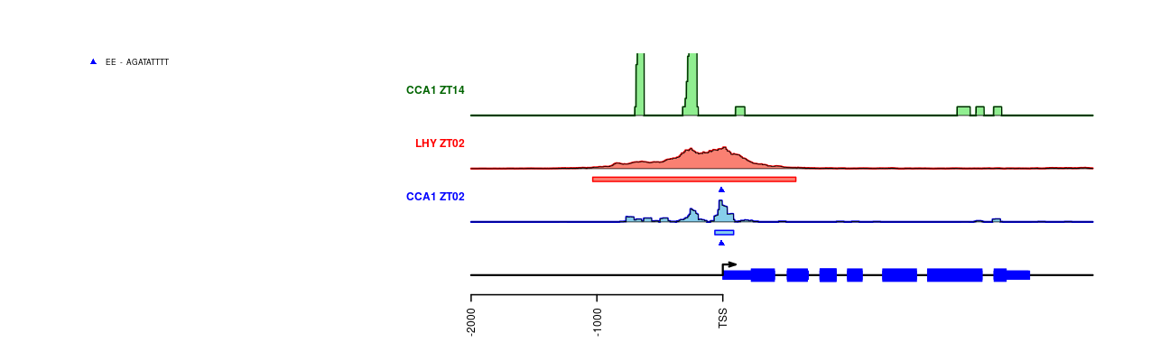

CCA1 and LHY are required for activating expression of PRR9.

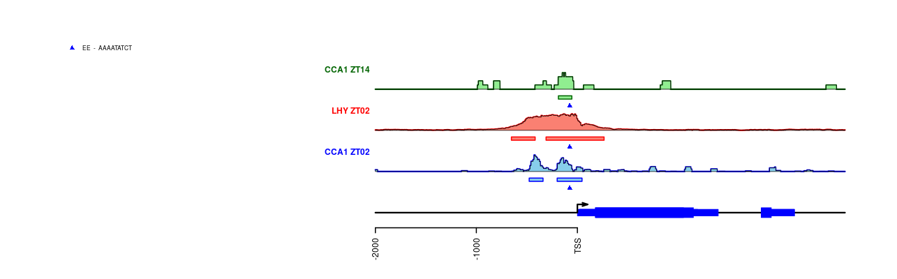
PRR9

CCA1 and LHY are directly repressed by morning-expressed PRR9, midday expressed PRR7, afternoon-expressed PRR5 and evening expressed TOC1.

CCA1
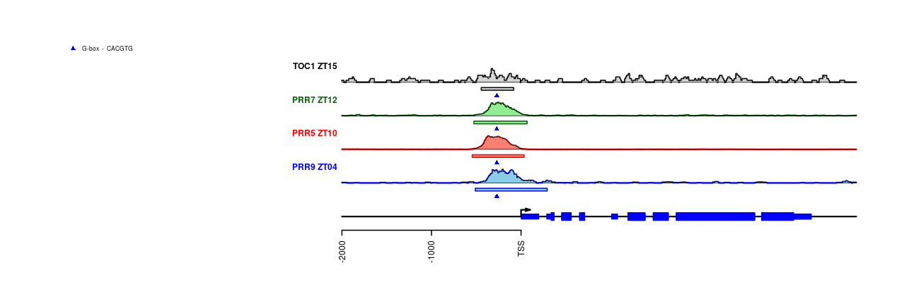

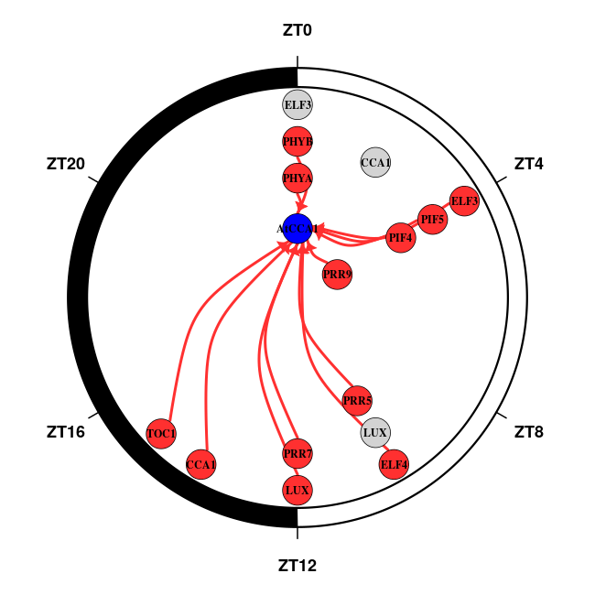

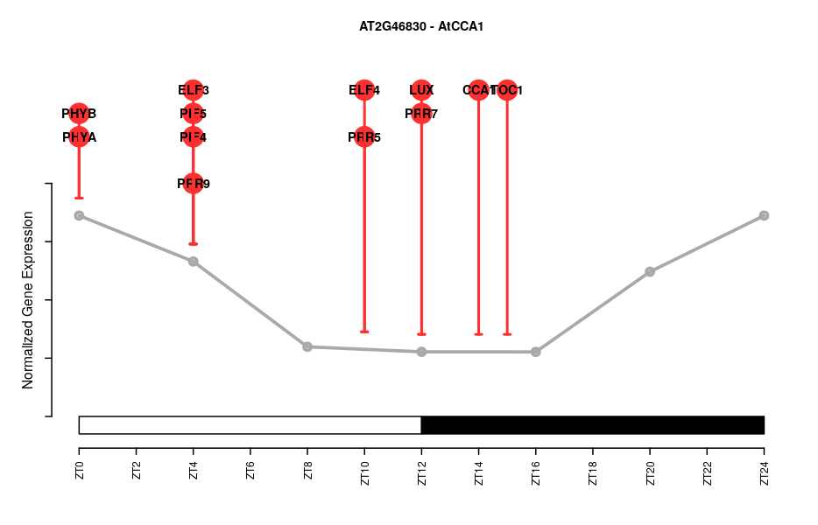

LHY
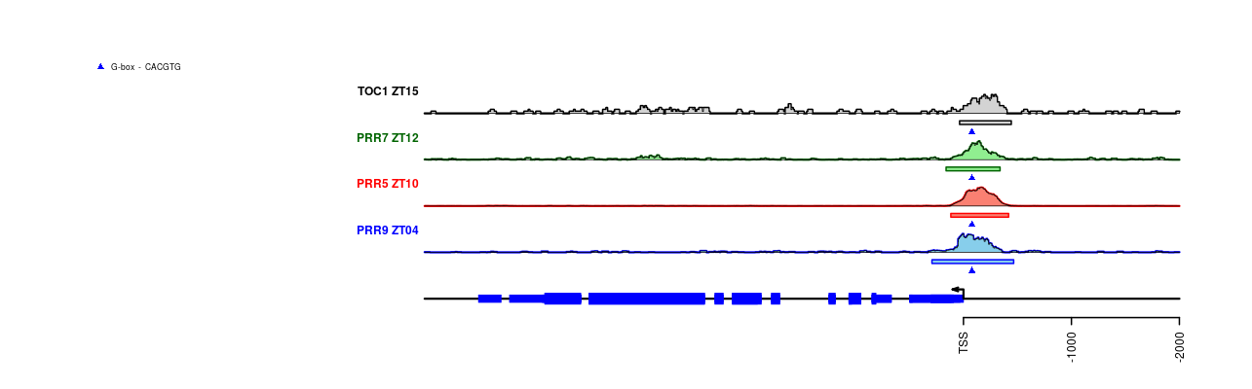

Transcription factors exert their regulation in the circadian clock in groups.

