AlgaeFUN with MARACAS, a microAlgae functional annotation tool for gene sets and genomic loci obtained from RNA-seq and ChIP-seq Analysis
Ana B. Romero-Losada^{1,2}, Mercedes García-González¹ and Francisco J. Romero-Campero^{1,2}
¹ Institute for Plant Biochemistry and Photosynthesis, University of Sevilla – CSIC
² Dpt of Computer Science and Artificial Intelligence, University of Sevilla
Abstract

Background.
Microalgae are photosynthetic single-cells microorganisms that can be found in a huge range of different water-based habitats, from freshwater to salt sea water. Also, they can grow in a broad range of temperatures, salinities, pH values and light intensities, so they are considered a quite diverse group. Along with this, for example we can find more than 5000 species of microalgae in the oceans, and all of them working together produce 50% of the oxygen that other organisms need to breath, like ourselves. (1) Whatsmore, due to their high yield production of biomass they take up the base of marine food chain.
Furthermore, due to the yet increasing number of utilities discovered in them, they have been in the scientific community's spotlight for the last few years. Microalgae have been described as a high yeild source of carbon compounds and as a good candidate to mitigate CO2 emissions. Since then, securing a massive range of interesting products have been coupled with their growth (4). Along with this, their industrial cultivation to produce biofuels (2, 3) and bioproducts (used as health supplements, pharmaceuticals and cosmetics) has been thoroughly studied. They also have been described as efficient producers of polysacharides, lipids, vitamins, antioxidants, etc. (5) Whatsmore, they even have application in wastewater treatment with the opportunity of decreasing CO2 from the atmosphere at the same time (6,7).
Therefore, the interest in these photosynthetic microorganisms is constantly increasing due to the diverse conditions where they can grow and the high yield production of biomass and other interesting products that they can be achieved.
Nowadays, with the newer genome sequencing methods, the research in microalgae is starting to be involved in molecular systems biology studies and, consequently, the use of omics techniques are on the cutting edge in this field. Unfortunately, this kind of studies on microalgae go slower than the ones done with other organisms due to a lack of online tools to interpretate and integrate the results generated. The most of the developed tools that integrate different data bases have focused on the analysis of thoroughly studied organisms (8,9), instead of the newly genome-sequenced and annotated organisms. Processing and interpretating the huge amount of data obtained from molecular systems biology studies requires a big amount of time and effort. In addition, researchers have to explore the different data bases separately, which makes more difficult to integrate the results and generate a cohesive biological meaning of them.
Anyway, it is well-known that researchers need a portal for microalgae that unify different annotation data bases in order to make omics studies easier to achieve, so there have been some attemps to create it. For example, if the microalgae that is being studied is Chlamydomonas reinhardtii, the researcher can find several portals (Table 1) that can interpretate and integrates the results, such as Algal Functional Annotation Tool ( which only supports gene sets from RNAseq studies about the mentioned microalgae) (10), GOrilla (which only supports gene ontology terms enrichment analysis of gene sets from RNAseq studies about different model organisms, but only this single microalgae) (8) and AgriGO (which also exclusively supports gene ontology terms enrichment analysis but from a bigger number of microalgaes, yet not enough) (11,12).
Definitely, with the combination of the apps that we have developed we intend to make microalgae research in molecular systems biology easier to achieve and help the scientific community to generate more interesting results from these promising organisms. Using MARACAS tool, which consists in a parallel automatic computational workflow that can process RNA-seq and ChIP-seq raw data from microalgae studies, the user obtain a set of differentially expressed genes or a list of genomic regions that can both be analyze in the Shiny app AlgaeFUN. This Shiny app works as a portal where metabolic pathway and ontology data are integrated and, consequently, it can carry out analysis of gene ontology terms or metabolic pathway enrichment.

Construction and content
Data collection and processing.
The genomes, functional annotation and genomic structures annotation files were downloaded from different data bases, depending on the microalgae. In the Table. 2 the different data based used are represented: Ensembl (16), which is described as a genome browser that annotate genes, computes multiple alignments, etc.; Orcae (17) which is build on the wiki philosophy and provides the necessary tools and information to validate and correct gene annotations; Joint Genome Institute (JGI), which integrates high-throughput sequenced, metabolomic and annotation data in its database (18,19,20); and a web site released by the Kazusa DNA Research Institute to upload genomic data about Klebsormidium nitens (21).
Genome files were downloaded in fasta format. In some cases each chromosome or scaffold were separated in different files, so they were joined in an unique file manually. In addition, we generated an index for each genome to alleviate the high-cost process of mapping reads to the reference genome. This task was perform using the instruction hisat2-build from the HISAT2 utility (22).
The mentioned functional annotation files were the ones used to generate the annotation packages described above. The gene ontology terms and the KO IDs are the indispensable annotation data needed to carry out our analysis in the app. Gene ontology terms (GO terms) are described as a bioinformatic approach to relate genes with their molecular function, the biological process were it is involved and the cellular component were the product of this gene takes action. Besides that, KO IDs are used to associate genes with the metabolic pathways (collected in Kyoto Encyclopedia of Genes and Genomes, KEGG) were they perform. However, some other annotation indentifiers were recollected in the annotation R packages: Protein Analysis Through Evolutionary Relationships (PANTHER) terms, used to classify gene products by their families and subfamilies, molecular function, biological process and metabolic pathways were they are involved; Enzyme Commission numbers (EC numbers) that consists in a numerical classification identifier for enzymes related to the biochemical reactions they carry out; and Eukaryotic Orthologous Groups (KOG) are used to identify ortholog and paralog proteins.
Genomic estructure annotation files were downloaded in a certain format called GFF3 (General Feature Format), that consists in a data frame that contains 9 columns. In this case, each line correspond to a certain sequence, and the mentioned columns show information about the type of sequence, the start and end position, the strand were it is positioned, and some other attributes. This file is the one used to generate the Txdb R packages. The nineth column is variable, and it can join different information in different ways, but the only valid format for the function hisat2 from HISAT2 utility (22) (that we use to carry out RNA-seq analysis) is the one provided from the GFF3 files from Ensembl. We used a R script to modify the GFF3 files that were took from other data base in order to convert to the Ensembl-like format their nineth column. The R script used are available in git hub (poner url?).
Integration of Multiple annotation databases. (puedo ponerlo asi? esta en la otra herramienta..)
Behind the front-end of our Shiny app, several microalgae R packages have been created manually in order to integrate multiple annotation databases. This kind of R packages already exist in Bioconductor for a lot of model organisms except for microalgae. The ones created for this app will be shared in Bioconductor soon, so researchers will be able to use them for free in their studies.
We generated two kind of R packages for each microalgae supported in this app:
- Annotation package: created using the AnnotationForge R package. It gathers annotation information like GO terms, KEGG IDs, EC numbers, PANTHER terms, etc. of each gene from a specific microalgae.
- ChIP-seq Package?: created using the GenomicFeatures R package. It compiles information about chromosomes length and allows the user to... ?

Description of the web-based applications
The web-based applications that we’ve developed combine two different tools: MARACAS ( MicroAlgae RnA-seq and Chip-seq AnalysiS) and AlgaeFUN (MicroALGAE FUNctional annotation tool). Both of them support several microalgaes: Ostreococcus tauri, Coccomyxa subellipsoidea, Volvox carteri, Chlamydomonas reinhardtii, Phaeodactylum tricornutum, Bathycoccus prasinos, Nannochloropsis gaditana, Klebsormidium nitens and Dunaliella salina.
Arbol filogenetico
Miroalgae RNA-seq and ChIP-seq Analysis (MARACAS) description.
This tool consists in a parallel automatic computational workflow generated using Bash scripting that can process RNA-seq and ChIP-seq raw data from microalgae studies. The main inputs to this workflow are the raw data .fastq files and the principal outputs consist in two lists gathering the differential expressed genes DEGs (activated and repressed genes) in case that the study achieved correspond to a RNA-seq study; or a list of genomic regions that have been significantly occupied by the transcription factors or histone modifications of interest in case of a ChIP-seq study.
The MARACAS’ front-end, which has been created using JavaScript, Fig. Z asks the user to determinate if the raw data either comes from a database or they are uploaded locally, to choose the microalgae used in the study, to describe the experimental design used and some statistical parameters. All this information is collected in a parameters file, which is the main input received by the developed pipeline.
The workflow of the mentioned pipeline is represented in Fig. X, y and w. The first step (Fig. X) consists in loading the parameters file and creating the working directory. It includes one folder where the samples are downloaded or copied, another one where the results are generated and a third one called “logs”. In this last folder are located several text files which contain messages written by the server that are useful to keep track of the important events (called “log files”) and a different type of text file where the processes that takes part in the pipeline are able to write and read messages. This kind of text files are called “blackboards” and are used to communicate between different parallel processes in order to synchronize them. After this two steps, the pipeline divide in two different modes: to execute either a RNA-seq or a ChIP-seq analysis.
The next steps in the pipeline for the RNA-seq analysis are represented in Fig. Y. Depending on the source of the raw data (if it comes from a database or the files have been uploaded), the first step consists in either download and extract the files from a database or copy them to the defined working directory. These fastq-dump files are checked by a quality control and the results correspond to fastqc files. After checking if there is any problem in our raw data, we can carry out the short read mapping against the reference genome using the command hisat2 from HISAT2 utility. Once we have generated the .bam files that contain the mapped reads, we achieve the transcripts assembly and expression quantification using stringtie function. This sample processing steps are carried out in parallel for each sample at the same time and they synchronize in this point of the pipeline using blackboards. When the .ctab (chemical table files? )and .gtf (gene transfer format) files from all the samples are generated, the following sequential steps of the pipeline are executed using the Ballgown (23) (which is a tool for statistical analysis and annotation of assembled transcriptomes) and Limma (24) (used to generate linear models and to define differential expression of RNA-seq and microarray data) R packages.
As a final output, this pipeline generates a differentially expressed genes report that contains a text file with the differentially expressed genes, (DEGs) principal component analysis visualization, and several types of graphs that represent the results (scatter and volcano plots, barplots, etc.). The DEGs are selected using the statistics based on a moderated t-student included in the bioconductor Ballgown and Limma R packages.
Besides that, the pipeline for the ChIP-seq analysis (Fig. W) share some of the first steps with the RNA-seq pipeline described above. The only difference appears in the mapping step, since the mapping is executed by bowtie2 (from bowtie2 utility?) and the synchronization point is reached when the .bam files from all the samples have been generated. After that step, the pipeline uses macs2 (from which utility?) to achieve the peak calling process, which is a computational method used to identify different loci in the genome of reference that have been enriched with the aligned reads as a consequence of a transcription factor bound or a histone modification. The output files of this pipeline consists in a .bed file that collect the genomic regions that have shown some enrichment.
Microalgae Functional Annotation tool (AlgaeFUN) description.
The front-end of Algae-FUN is shown in Figure 1.It has two modes of operation depending on the kind of study achieved to generate the input data:
1. Input data obtained from a RNA-seq study:
In this case, the application carries out a GO terms enrichment and KEGG analysis from a set of target genes. This gene set is the main input to the tool when this mode is being used and consists of a list of gene names in gene ID format (for example: ostta02g12391). Furthermore, the application allows the user to choose whether to use or not his/her own background gene set or the one included in this tool, a determined p-value, and the desiderable kind of analysis to achieve (KEGG analysis, GO enrichment or both).
The application also includes an example set of genes for each microalgae that allows the user to visualize the different outputs that can be generated by this tool. The set of genes included were generated using the datasets from mencionar a cada paper usado.
2. Input data obtained from a ChIP-seq study:
In this situation, the application carries out a GO terms enrichment and KEGG analysis from a list of genomic regions. It also ask the user to choose the distance around the Transcriptional Start Site to determine gene promoters and ...que es eso?.
The outputs generated from both modes are the same and they are available to be downloaded once they are done. Both analysis are carried out using the ClusterProfiler package from R. This R package allows users to achieve statistical analysis and visualize functional profiles (GO and KEGG) for genes and gene clusters. All the outputs are separated in two different tabs: one where the results from the GO enrichment are shown and another one where the results from the KEGG analysis are shown.
The first output in the GO enrichment tab consist in a table that summarizes the results from the GO enrichment analysis carried out over the input gene set or genomic regions. The user can find one row for each GO term and 6 columns that represent some relevant information about the enrichment. The first column shows the GO term identifier, followed by the second column were the user find a human readable description of the GO term. Anyway, if the user wants more information about the GO term represented in a certain row, he/she can click on the GO term identifier and the application will take him/her to a AmiGO link were the term is described in detail. The third and fourth column represents the p-value and q-value, and the fifth one shows the enrichment value: E= (m/n) / (M/N). The value “m” is the number of genes from the target set annotated with the corresponding GO term whereas “M” is the number of genes from the background set of genes annotated with the mentioned GO term. In a similar way, “n” is the number of genes with annotation from the target set whereas “N” is the number of genes with annotation from the gene universe. Finally, the last column shows the genes from the input set of genes annotated with each GO term. The user can click on them to get more more information from the gene entry on Ensembl.
Besides the table, AlgaeFUN also generates several graphs that represent the GO term enrichment. Five visualization methods can help users understand the results.:
- Acyclic graph: Each node stands for a GO term and the color of them indicates the level of significance (from grey, non-significant, to intense red, highly significant). An arrow is drawn from GO term A to GO term B when A is a more general GO term than B or B is more specific than A.
- Barplot: Each bar represents an enriched GO term and the length of it correspond to the number of genes in the target set annotated with the given GO term. Once again, the bar color shows the level of significance (from blue, less significant, to red, more significant).
- Dotplot: Each dot represents an enriched GO term. The x-position of the dot corresponds to the ratio between the number of genes annotated with the corresponding GO term and the total number of annotated genes in the target set. The dot color captures the level of significance (from blue, less significant, to red, more significant).
- GO map: Each node represents an enriched GO term and the size of each node is proportional to the number of genes annotated with the corresponding GO term in the target set. The node colors represent the level of significance (from less signficant in blue to more significant in red) and they are connected by edges when the corresponding GO terms are semantically related.
- Gene-concept network: The beige nodes represents GO terms and the grey nodes genes. An edge is drawn from a gene to a GO term when the gene is annotated with the corresponding GO term. The size of nodes representing GO terms is proportional to the number of genes annotated with the corresponding GO term.
Furthermore, outputs shown in the KEGG analysis tab consist in:
- One table that summarizes the result of the KEGG pathway enrichment analysis. Each row represents a pathway significantly enriched in the target gene set with respect to the selected gene universe. The first column represents the KEGG pathway identifier and the user can click on it to read more information about the pathway. The second column contains a human readable description. The third and fourth column presents the p-value and q-value, and the fifth column displays the corresponding enrichment value E (m/n; M/N) as it were described before. Finally, the last column shows the list of genes from the input gene set annotated to the each enriched pathway.
- Pathway representation. The user can choose a determined enriched pathway using a dropdown menu. In the generated image the user will find the genes from the input gene set highlighted in red.
- A second table that summarizes the result of the KEGG module enrichment analysis. Each row represents a module significantly enriched in the target gene set with respect to the selected gene universe. The columns in this table show the same kind of information as they do in the first table.

Case study 1.
Este caso de studio se basa en la microalga… Debido a que la luz tiene un papel central sobre la fisiologia y desarrollo de los organismos fotosinteticos (ejemplos blooms de algas que se observan en momentos expecificos de ciclo annual de estaciones ej primavera o verano) hemos estudiado la longitud del dia sobre el transcriptoma de clamy. Hasta ahora los diseños exprimentales tiicos que incluyen un periodo de oscuridad en microalgas son los de dia neutral con 12h de luz y 12h de oscuridad, y en este estudio vamos a considerar dos fotoperiodos diferentes dia largo y dia corto. Las muestras se tomaron en cuatriplicado a zt4 (4h despues del amanecer simulado por en encendido de luces en los fitotrones). Con maracas tal y resultados y eso al pasarlo por algae fun tal.
Case study 2.

1. Barsanti L, Coltelli P, Evangelista V, Frassanito AM, Passarelli V, Vesentini N, Gualtieri P. Oddities and curiosities in the algal world. In: Evangelista V, Barsanti L, Frassanito AM, Passarelli V, Gualtieri P, editors. Algal toxins: nature, occurrence, effect and detection. Dordrecht: Springer; 2008. pp. 353–391.
2. Ho SH, Chen WM, Chang G. Scenedesmus obliquus CNW-N as a potential candidate for CO2 mitigation and biodiesel production. Bioresour Technol. 2010;101(22):8725–8730.
3. Paul Abishek M, Patel J, Prem Rajan A. Algae oil: a sustainable renewable fuel of future. Biotechnol Res Int. 2014;2014:272814.
4. Chen, H., Li, T. & Wang, Q. Planta (2019) 249: 195. https://doi.org/10.1007/s00425-018-3066-8
5. Michael A. Borowitzka high-value products from microalgae their development and commercialization.
6. Novoveska L, Zapata AKM, Zabolotney JB, Atwood MC, Sundstrom ER. Optimizing microalgae cultivation and wastewater treatment in large-scale off shore photobioreactors. Algal Res. 2016;18:86–94.
7. https://doi.org/10.1080/07388551.2018.1472066
8. Eran Eden*, Roy Navon*, Israel Steinfeld, Doron Lipson and Zohar Yakhini. "GOrilla: A Tool For Discovery And Visualization of Enriched GO Terms in Ranked Gene Lists", BMC Bioinformatics 2009, 10:48.
9. Carbon S, Ireland A, Mungall CJ, Shu S, Marshall B, Lewis S, AmiGO Hub, Web Presence Working Group. AmiGO: online access to ontology and annotation data. Bioinformatics. Jan 2009;25(2):288-289
10. https://doi.org/10.1186/1471-2105-12-282
11. Zhou Du, Xin Zhou, Yi Ling, Zhenhai Zhang, and Zhen Su agriGO: a GO analysis toolkit for the agricultural community Nucleic Acids Research Advance Access published on July 1, 2010, DOI 10.1093/nar/gkq310. Nucl. Acids Res. 38: W64-W70.
Evaluation to the paper of agriGO from Faculty of 1000 biology
12. agriGO v2.0: Tian Tian, Yue Liu, Hengyu Yan, Qi You, Xin Yi, Zhou Du, Wenying Xu, Zhen Su; agriGO v2.0: a GO analysis toolkit for the agricultural community, 2017 update. Nucleic Acids Res 2017 gkx382. doi: 10.1093/nar/gkx382
Gorilla 13 + 8, GO terms 14 y 15
13. Eran Eden, Doron Lipson, Sivan Yogev, Zohar Yakhini. "Discovering Motifs in Ranked Lists of DNA sequences", PLoS Computational Biology, 3(3):e39, 2007.
14. Ashburner et al. Gene ontology: tool for the unification of biology. Nat Genet. May 2000;25(1):25-9.
15. The Gene Ontology Consortium. The Gene Ontology Resource: 20 years and still GOing strong. Nucleic Acids Res. Jan 2019;47(D1):D330-D338.
16. Daniel R. Zerbino, Premanand Achuthan, Wasiu Akanni, M. Ridwan Amode, Daniel Barrell, Jyothish Bhai, Konstantinos Billis, Carla Cummins, Astrid Gall, Carlos García Giro´n, Laurent Gil, Leo Gordon, et al. Ensembl 2018.
17. Sterck, L., Billiau, K., Abeel, T., Rouzé, P., Van de Peer, Y.
ORCAE: online resource for community annotation of eukaryotes. Nat. Methods (2012) 9, 1041.
18. The genome portal of the Department of Energy Joint Genome Institute: 2014 updates. Nordberg H, Cantor M, Dusheyko S, Hua S, Poliakov A, Shabalov I, Smirnova T, Grigoriev IV, Dubchak I. Nucleic Acids Res. 2014,42(1):D26-31.
19. The Genome Portal of the Department of Energy Joint Genome Institute Grigoriev IV, Nordberg H, Shabalov I, Aerts A, Cantor M, Goodstein D, Kuo A, Minovitsky S, Nikitin R, Ohm RA, Otillar R, Poliakov A, Ratnere I, Riley R, Smirnova T, Rokhsar D, Dubchak I. Nucleic Acids Res. 2012 Jan;40(Database issue):D26-32.
20. Phytozome?
21. CGA?
22. Kim D, Langmead B and Salzberg SL. HISAT: a fast spliced aligner with low memory requirements. Nature Methods 2015
23. Fu J, Frazee AC, Collado-Torres L, Jaffe AE, Leek JT (2019). ballgown: Flexible, isoform-level differential expression analysis. R package version 2.16.
24. Ritchie ME, Phipson B, Wu D, Hu Y, Law CW, Shi W, Smyth GK (2015). “limma powers differential expression analyses for RNA-sequencing and microarray studies.” Nucleic Acids Research, 43(7), e47. doi: 10.1093/nar/gkv007.

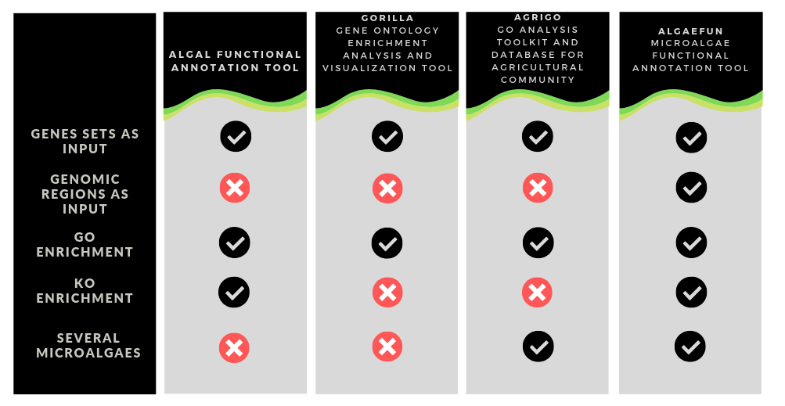
Table 1. Comparison chart of some web based annotation tools, including the one described in this assay.

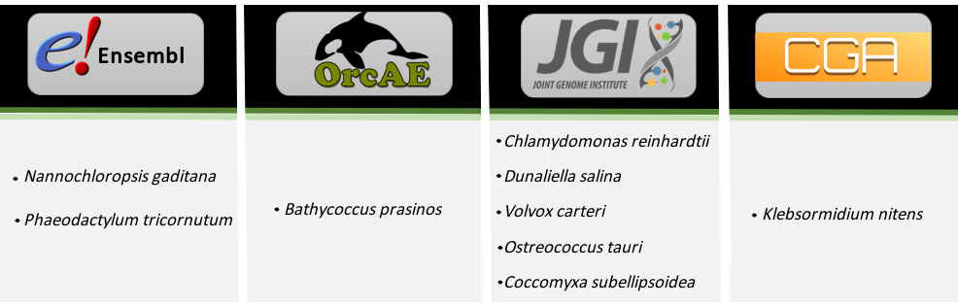
Table 2. Primary databases used to gather the genome, functional and genomic estructure annotation files of each microalgae. In this table is shown from which database was collected the data files from each microalgae. From left to right, the first column correspond to Ensembl (16), which is described as a genome browser that annotate genes, computes multiple alignments, etc.; the second column correspond to Orcae (17) which is build on the wiki philosophy and provides the necessary tools and information to validate and correct gene annotations; the third one shows the Joint Genome Institute (JGI), which integrates high-throughput sequenced, metabolomic and annotation data in its database (18,19,20); and the last one correspond to a web site released by the Kazusa DNA Research Institute to upload genomic data about Klebsormidium nitens (21.

~~~~~~~~~~~~~~~~~~~~~~~~~~~~~~~~~~~~~~~~~~~~~~~~~~~~~~~~~~~~~~~~~~~~~~~~~~
Dudas:
GO terms enrichment and KEGG analysis?
Should I mention the R function used to carry out the GO enrichment and KEGG analysis? Maybe in another section of the assay?
GOrilla removes the duplicated genes found the input set of genes to keep the highest ranking occurence, incluiding duplicates that hide behind different nomenclatures. Should we do the same?

