R for life sciences. Chapter 4: Rmarkdown

2020-09-13

**Rmarkdown tutorial** **2**

What is Rmarkdown? 3

Markdown text 3

Headers 3

Paragraph 4

Emphasis 4

Lists 4

Links 5

Images 5

Horizontal Rule 6

Tables 6

The R chunks 7

The Yaml header 9

Other useful readings 9

**Exercises** **9**

**About this tutorial** **11**

# Rmarkdown tutorial

## What is Rmarkdown?

RMarkdown (.Rmd) is a file format for making dynamic documents with R. An R Markdown document is written in markdown (an easy-to-write plain text format) and contains chunks of embedded R code.

Rmarkdown files have three main parts: - A yamn header, to stablish document formatting. It can be very simple. - The markdown text. As in a text editor, but simpler. - The R (or other languages) chunks.

## Markdown text

Markdown text is one of the simplest ways of writting without spending time in formatting. It is only possible to do some basic formatting and documents can be rendered to any format: html, docx, pdf, epub, …

Some of the things that you can do in markdown are:

Headers  
Paragraph Emphasis  
Lists  
Links  
Images  
YouTube Videos  
Horizontal Rule  
Tables

All the tutorials used in this subject were written in Rmarkdown. You may see and download the original files at the bitbucket repository: <https://bitbucket.org/alfonsogar/tea_daa_tutorials>.

### Headers

Headers for different levels of titles are put using the right number of #.

# H1  
## H2  
### H3  
#### H4  
##### H5  
###### H6

# H1

## H2

### H3

#### H4

##### H5

###### H6

### Paragraph

To start a new paragraph is necesary to separate by two lines.

First sentence of the first paragraph.   
Second sentence of the first paragraph.  
  
First sentence of the second paragraph.

First sentence of the first paragraph. Second sentence of the first paragraph.

First sentence of the second paragraph.

### Emphasis

For enphasizing text there is only options for italics, bold and strikethrough.

Emphasis, aka italics, with *asterisks* or _underscores_.  
  
Strong emphasis, aka bold, with **asterisks** or __underscores__.  
  
Combined emphasis with **asterisks and _underscores_**.  
  
Strikethrough uses two tildes. ~~Scratch this.~~

Emphasis, aka italics, with *asterisks* or *underscores*.

Strong emphasis, aka bold, with **asterisks** or **underscores**.

Combined emphasis with **asterisks and *underscores***.

Strikethrough uses two tildes. ~~Scratch this.~~

### Lists

For sublists are necessary at least 3 spaces.

1. First ordered list item  
2. Another item  
 Unordered sub-list.   
1. Actual numbers don't matter, just that it's a number  
 1. Ordered sub-list  
4. And another item.  
  
* Unordered list can use asterisks  
- Or minuses  
+ Or pluses

1. First ordered list item
2. Another item
   * Unordered sub-list.
3. Actual numbers don’t matter, just that it’s a number
   1. Ordered sub-list
4. And another item.

* Unordered list can use asterisks
* Or minuses
* Or pluses

### Links

Link to a web with angle brackets <https://www.upv.es/>   
or nothing https://www.upv.es/  
  
Link using text: [UPV](https://www.upv.es/)  
  
Link using text and title [UPV](https://www.upv.es/ "Universitat Politècnica de València")  
(put the mouse over the link to see the title.)

Link to a web with angle brackets <https://www.upv.es/> or nothing <https://www.upv.es/>

Link using text: [UPV](https://www.upv.es/)

Link using text and title [UPV](https://www.upv.es/) (put the mouse over the link to see the title.)

### Images

To link an image ![UPV](http://www.upv.es/imagenes/marcaUPVN1.png "Universitat Politècnica de València")

To link an image 

### Horizontal Rule

Three or more Asterisks or Underscores  
  
***  
___

Three or more Asterisks or Underscores

### Tables

Tables aren’t part of the core Markdown but they usually work.

There must be at least 3 dashes separating each header cell. The outer pipes (|) are optional, and you don’t need to make the raw Markdown line up prettily. You can also use inline Markdown.

Colons can be used to align columns.  
  
| Tables | Are | Cool |  
| ------------- |:-------------:| -----:|  
| col 3 is | right-aligned | $1600 |  
| col 2 is | centered | $12 |  
  
You dont need to line up.  
  
Markdown | Less | Pretty  
--- | --- | ---  
*Still* | `renders` | **nicely**  
1 | 2 | 3

Colons can be used to align columns.

|  |  |  |
| --- | --- | --- |
| Tables | Are | Cool |
| col 3 is | right-aligned | $1600 |
| col 2 is | centered | $12 |

You dont need to line up.

|  |  |  |
| --- | --- | --- |
| Markdown | Less | Pretty |
| Still | renders | nicely |
| 1 | 2 | 3 |

More useful are the functions knitr::kable(), xtable::xtable() or stargazer::stargazer() inside a code chunk (see next chapter).

## The R chunks

Rmarkdown is a derivation of markdown that includes R (or other languages) chunks.

A code chunk is included between two lines with three back-ticks each. The first one with r between round brackets (if r language).

**```{r}**

**my.table <- trees[1:5, ]**

**knitr::kable(my.table,** **caption = “Table 1. Five first rows of the trees dataframe from base R.”)**

**```**

Table 1. Five first rows of the trees dataframe from base R.

|  |  |  |
| --- | --- | --- |
| Girth | Height | Volume |
| 8.3 | 70 | 10.3 |
| 8.6 | 65 | 10.3 |
| 8.8 | 63 | 10.2 |
| 10.5 | 72 | 16.4 |
| 10.7 | 81 | 18.8 |

It is also possible to include inline code between back-ticks with and r after the first one.

**The mean of Iris sepal length is ` r mean(iris$Sepal.Length)`.**

The mean of Iris sepal length is 5.8433333.

There are many chunk options, as echo=FALSE for not showing the code or eval=FALSE to not evaluate the code of a chunk. Also to fix the size or caption of figures. This options should be after a comma after the r inside the curve brackets.

**```{r, fig.cap=cap}**

**cap <- “Figure 1: Relationships between Iris variables.”**

**plot(iris)**

**```**

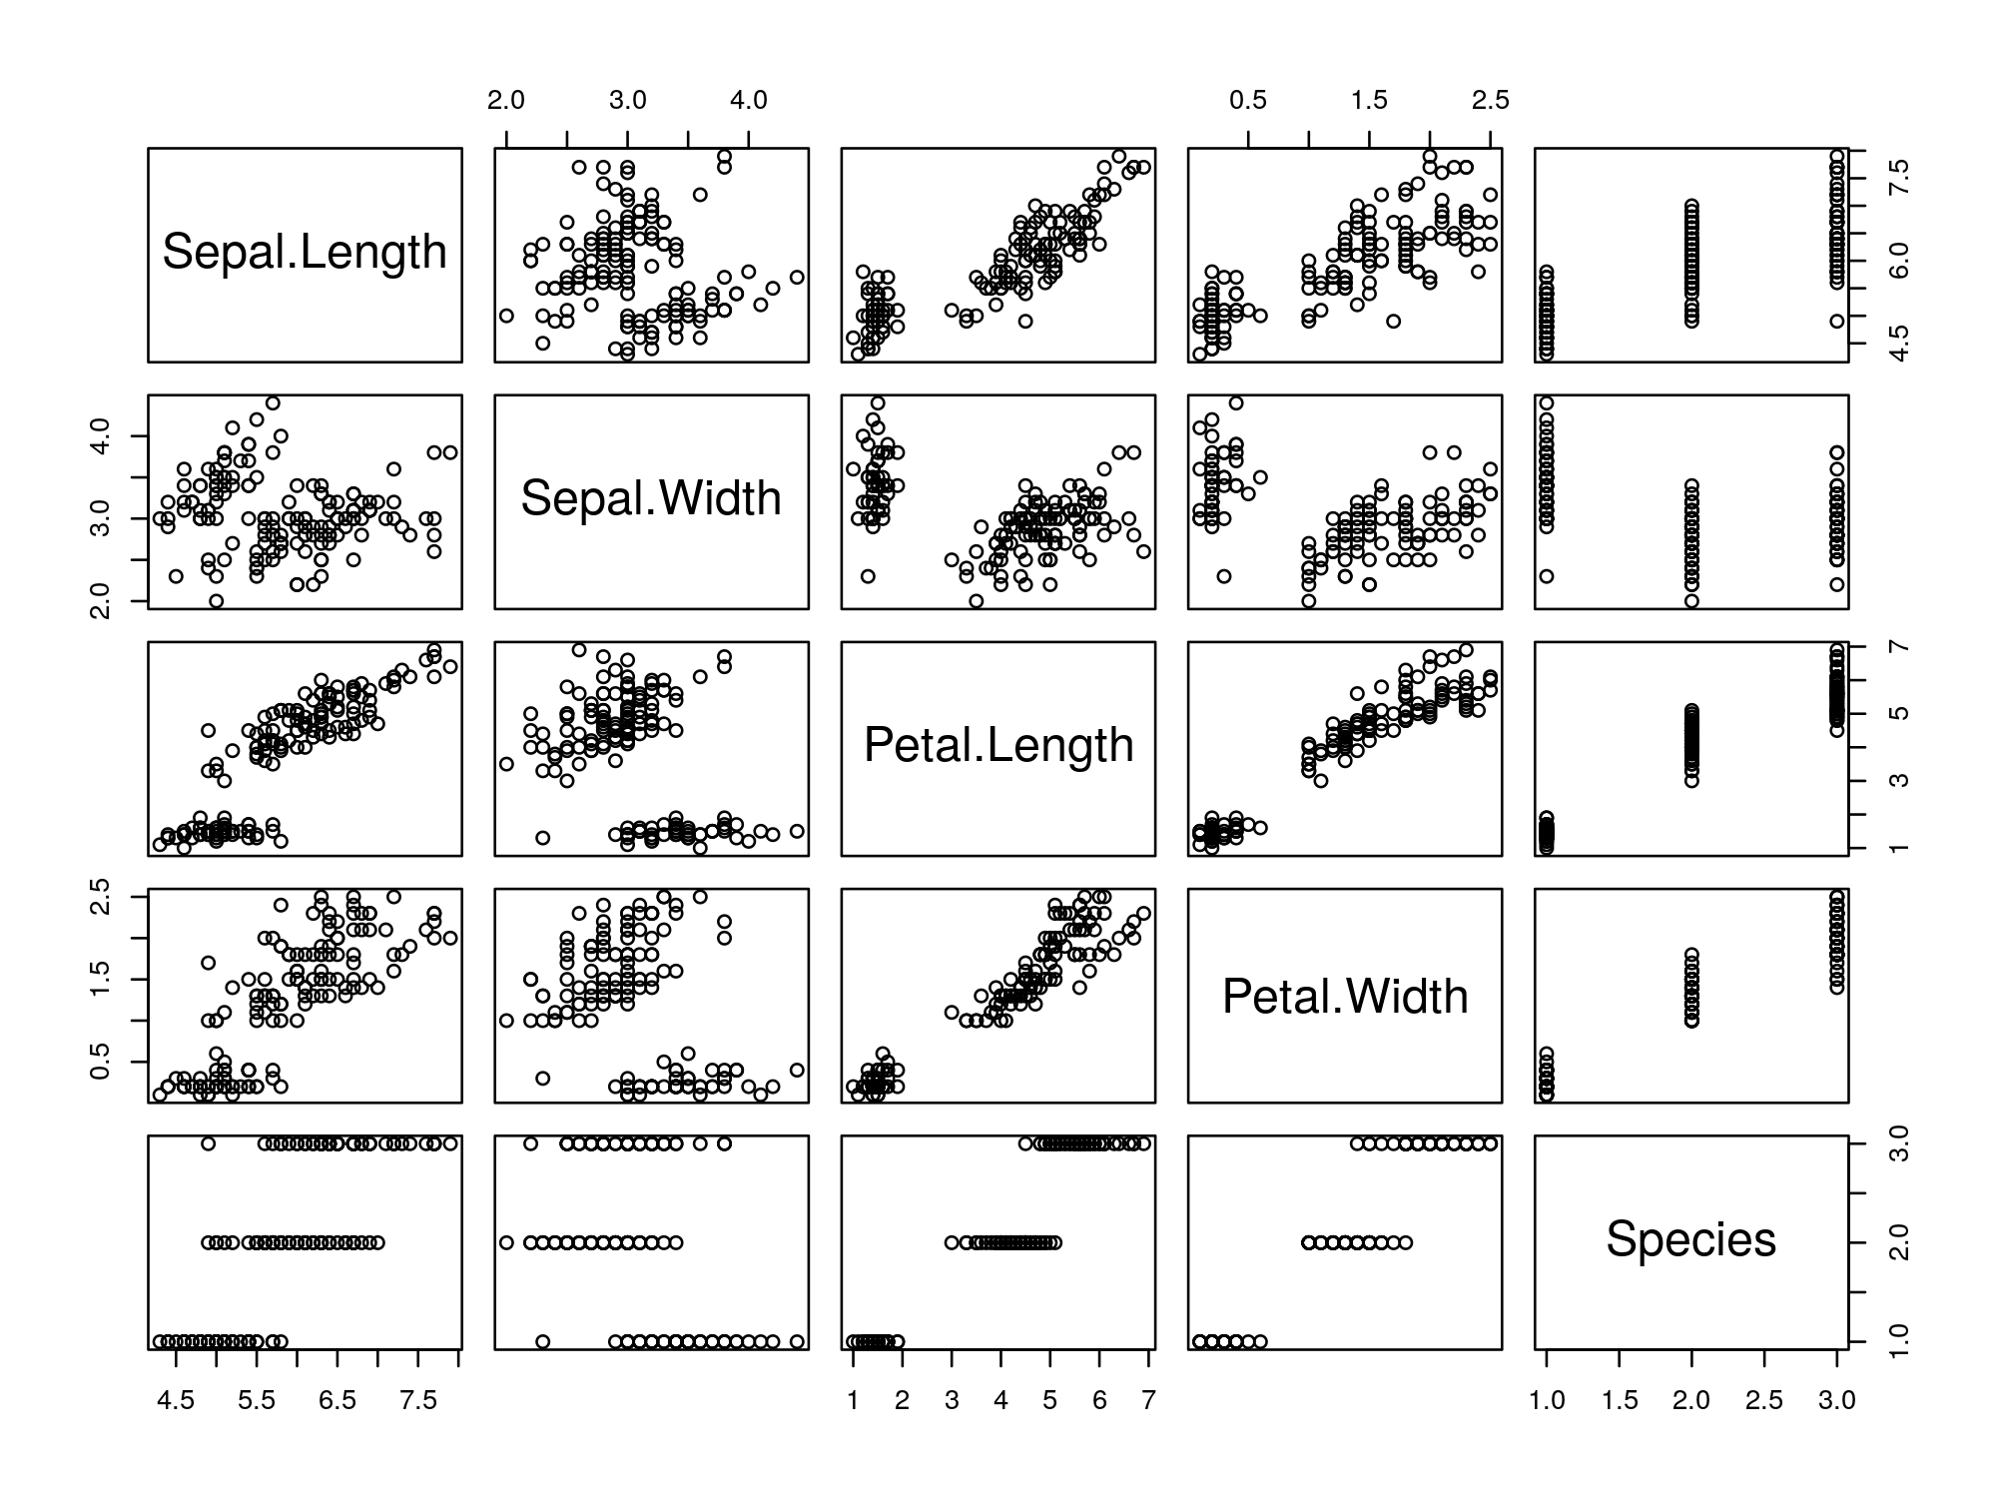

Figure 1: Relationships between Iris variables.

Chunk options by default for all chunks can be set at the begining as in the following example, where by default is stated that code will be not shown, all figures will be saved in the folder “results/figs/”, and the size, format and resolution of figures:

knitr::opts_chunk$set(  
 echo = FALSE, *# Do not show the code*  
 results = 'asis', *# Results at the end*  
 fig.path = "results/figs/", *# Path to save figures*  
 fig.width = 10, *# Figures default width*  
 fig.height = 6.1803, *# Figures default heigth*  
 dev = "png", *# png Figures format*  
 dev.args = list(type = "cairo"), *# png args to improve*  
 dpi = 100 *# 300 for publication*  
)

To read more about the chunk options: <https://yihui.name/knitr/options/>

## The Yaml header

At the begining of a rmarkdown document there is always a yaml header, between two lines with three dashes “—”. This header must have at least the output format when rendered:

output: html_document

There are many possible output formats. click the link to see all possible formats and in any of them to see the possible options for this format.

<https://rmarkdown.rstudio.com/formats.html>

## Other useful readings

You may also find the following resources helpful:

* [The R Markdown Reference Guide](https://rstudio.com/wp-content/uploads/2015/03/rmarkdown-reference.pdf)
* [The R Markdown Cheatsheet](https://rstudio.com/wp-content/uploads/2016/03/rmarkdown-cheatsheet-2.0.pdf)
* [Other R Markdown tutorial](https://monashbioinformaticsplatform.github.io/2017-11-16-open-science-training/topics/rmarkdown.html)
* The official RStudio lessons for RMarkdown, specially the one for [different formats](https://rmarkdown.rstudio.com/lesson-9.html). Check inside the links.

# Exercises

1. In RStudio, open a new Rmarkdown file: file > New file > Rmarkdown (Spanish: Archivo > Nuevo > Rmarkdown).
2. Put a title and your name in Author and choose html format.
3. Look into the document to identify the different parts: yaml header, markdown text and r chunks.
4. Knit the document and see the result.
5. Knit the document in word format and look at the result (in the folder).
6. Change some chunk options and compare the results (best in html to see the result in the viewer).
7. Create a new second level chapter (with ##) to include a table.
8. Create a data frame with the first five rows of the “Iris” data.
9. Plot the data frame using the kable function.
10. Put captions to the figure and to the table.

# About this tutorial

Cite as: Alfonso Garmendia (2020) R for life sciences. Chapter 4: Rmarkdown. <http://personales.upv.es/algarsal/R-tutorials/04_Tutorial-4_R-RMarkdown.html>.

Available also in other formats (pdf, docx, …): <https://drive.google.com/drive/folders/19w914WCg8BVTVBE_zpgShmg2vpjguV1e?usp=sharing>.

Other simmilar tutorials: <https://garmendia.blogs.upv.es/r-lecture-notes/>

Originals are in bitbucket repository: <https://bitbucket.org/alfonsogar/tea_daa_tutorials>.

Document written in [Rmarkdown](http://rmarkdown.rstudio.com/), using [Rstudio](https://www.rstudio.com/).

* System: R version 4.0.2 (2020-06-22) x86_64-pc-linux-gnu (64-bit) Ubuntu 18.04.5 LTS.
* Base packages: stats 4.0.2, graphics 4.0.2, grDevices 4.0.2, utils 4.0.2, datasets 4.0.2, methods 4.0.2, base 4.0.2.
* Other loaded packages: knitr 1.29, rmarkdown 2.3, googledrive 1.0.1.



This work is licensed under a [Creative Commons Attribution-NonCommercial-ShareAlike 4.0 International License](http://creativecommons.org/licenses/by-nc-sa/4.0/).