TABLES

PACO

10/27/2020

library(knitr)

## Warning: package 'knitr' was built under R version 4.0.3

kable(iris, aling = "c")

|  |  |  |  |  |
| --- | --- | --- | --- | --- |
| Sepal.Length | Sepal.Width | Petal.Length | Petal.Width | Species |
| 5.1 | 3.5 | 1.4 | 0.2 | setosa |
| 4.9 | 3.0 | 1.4 | 0.2 | setosa |
| 4.7 | 3.2 | 1.3 | 0.2 | setosa |
| 4.6 | 3.1 | 1.5 | 0.2 | setosa |
| 5.0 | 3.6 | 1.4 | 0.2 | setosa |
| 5.4 | 3.9 | 1.7 | 0.4 | setosa |
| 4.6 | 3.4 | 1.4 | 0.3 | setosa |
| 5.0 | 3.4 | 1.5 | 0.2 | setosa |
| 4.4 | 2.9 | 1.4 | 0.2 | setosa |
| 4.9 | 3.1 | 1.5 | 0.1 | setosa |
| 5.4 | 3.7 | 1.5 | 0.2 | setosa |
| 4.8 | 3.4 | 1.6 | 0.2 | setosa |
| 4.8 | 3.0 | 1.4 | 0.1 | setosa |
| 4.3 | 3.0 | 1.1 | 0.1 | setosa |
| 5.8 | 4.0 | 1.2 | 0.2 | setosa |
| 5.7 | 4.4 | 1.5 | 0.4 | setosa |
| 5.4 | 3.9 | 1.3 | 0.4 | setosa |
| 5.1 | 3.5 | 1.4 | 0.3 | setosa |
| 5.7 | 3.8 | 1.7 | 0.3 | setosa |
| 5.1 | 3.8 | 1.5 | 0.3 | setosa |
| 5.4 | 3.4 | 1.7 | 0.2 | setosa |
| 5.1 | 3.7 | 1.5 | 0.4 | setosa |
| 4.6 | 3.6 | 1.0 | 0.2 | setosa |
| 5.1 | 3.3 | 1.7 | 0.5 | setosa |
| 4.8 | 3.4 | 1.9 | 0.2 | setosa |
| 5.0 | 3.0 | 1.6 | 0.2 | setosa |
| 5.0 | 3.4 | 1.6 | 0.4 | setosa |
| 5.2 | 3.5 | 1.5 | 0.2 | setosa |
| 5.2 | 3.4 | 1.4 | 0.2 | setosa |
| 4.7 | 3.2 | 1.6 | 0.2 | setosa |
| 4.8 | 3.1 | 1.6 | 0.2 | setosa |
| 5.4 | 3.4 | 1.5 | 0.4 | setosa |
| 5.2 | 4.1 | 1.5 | 0.1 | setosa |
| 5.5 | 4.2 | 1.4 | 0.2 | setosa |
| 4.9 | 3.1 | 1.5 | 0.2 | setosa |
| 5.0 | 3.2 | 1.2 | 0.2 | setosa |
| 5.5 | 3.5 | 1.3 | 0.2 | setosa |
| 4.9 | 3.6 | 1.4 | 0.1 | setosa |
| 4.4 | 3.0 | 1.3 | 0.2 | setosa |
| 5.1 | 3.4 | 1.5 | 0.2 | setosa |
| 5.0 | 3.5 | 1.3 | 0.3 | setosa |
| 4.5 | 2.3 | 1.3 | 0.3 | setosa |
| 4.4 | 3.2 | 1.3 | 0.2 | setosa |
| 5.0 | 3.5 | 1.6 | 0.6 | setosa |
| 5.1 | 3.8 | 1.9 | 0.4 | setosa |
| 4.8 | 3.0 | 1.4 | 0.3 | setosa |
| 5.1 | 3.8 | 1.6 | 0.2 | setosa |
| 4.6 | 3.2 | 1.4 | 0.2 | setosa |
| 5.3 | 3.7 | 1.5 | 0.2 | setosa |
| 5.0 | 3.3 | 1.4 | 0.2 | setosa |
| 7.0 | 3.2 | 4.7 | 1.4 | versicolor |
| 6.4 | 3.2 | 4.5 | 1.5 | versicolor |
| 6.9 | 3.1 | 4.9 | 1.5 | versicolor |
| 5.5 | 2.3 | 4.0 | 1.3 | versicolor |
| 6.5 | 2.8 | 4.6 | 1.5 | versicolor |
| 5.7 | 2.8 | 4.5 | 1.3 | versicolor |
| 6.3 | 3.3 | 4.7 | 1.6 | versicolor |
| 4.9 | 2.4 | 3.3 | 1.0 | versicolor |
| 6.6 | 2.9 | 4.6 | 1.3 | versicolor |
| 5.2 | 2.7 | 3.9 | 1.4 | versicolor |
| 5.0 | 2.0 | 3.5 | 1.0 | versicolor |
| 5.9 | 3.0 | 4.2 | 1.5 | versicolor |
| 6.0 | 2.2 | 4.0 | 1.0 | versicolor |
| 6.1 | 2.9 | 4.7 | 1.4 | versicolor |
| 5.6 | 2.9 | 3.6 | 1.3 | versicolor |
| 6.7 | 3.1 | 4.4 | 1.4 | versicolor |
| 5.6 | 3.0 | 4.5 | 1.5 | versicolor |
| 5.8 | 2.7 | 4.1 | 1.0 | versicolor |
| 6.2 | 2.2 | 4.5 | 1.5 | versicolor |
| 5.6 | 2.5 | 3.9 | 1.1 | versicolor |
| 5.9 | 3.2 | 4.8 | 1.8 | versicolor |
| 6.1 | 2.8 | 4.0 | 1.3 | versicolor |
| 6.3 | 2.5 | 4.9 | 1.5 | versicolor |
| 6.1 | 2.8 | 4.7 | 1.2 | versicolor |
| 6.4 | 2.9 | 4.3 | 1.3 | versicolor |
| 6.6 | 3.0 | 4.4 | 1.4 | versicolor |
| 6.8 | 2.8 | 4.8 | 1.4 | versicolor |
| 6.7 | 3.0 | 5.0 | 1.7 | versicolor |
| 6.0 | 2.9 | 4.5 | 1.5 | versicolor |
| 5.7 | 2.6 | 3.5 | 1.0 | versicolor |
| 5.5 | 2.4 | 3.8 | 1.1 | versicolor |
| 5.5 | 2.4 | 3.7 | 1.0 | versicolor |
| 5.8 | 2.7 | 3.9 | 1.2 | versicolor |
| 6.0 | 2.7 | 5.1 | 1.6 | versicolor |
| 5.4 | 3.0 | 4.5 | 1.5 | versicolor |
| 6.0 | 3.4 | 4.5 | 1.6 | versicolor |
| 6.7 | 3.1 | 4.7 | 1.5 | versicolor |
| 6.3 | 2.3 | 4.4 | 1.3 | versicolor |
| 5.6 | 3.0 | 4.1 | 1.3 | versicolor |
| 5.5 | 2.5 | 4.0 | 1.3 | versicolor |
| 5.5 | 2.6 | 4.4 | 1.2 | versicolor |
| 6.1 | 3.0 | 4.6 | 1.4 | versicolor |
| 5.8 | 2.6 | 4.0 | 1.2 | versicolor |
| 5.0 | 2.3 | 3.3 | 1.0 | versicolor |
| 5.6 | 2.7 | 4.2 | 1.3 | versicolor |
| 5.7 | 3.0 | 4.2 | 1.2 | versicolor |
| 5.7 | 2.9 | 4.2 | 1.3 | versicolor |
| 6.2 | 2.9 | 4.3 | 1.3 | versicolor |
| 5.1 | 2.5 | 3.0 | 1.1 | versicolor |
| 5.7 | 2.8 | 4.1 | 1.3 | versicolor |
| 6.3 | 3.3 | 6.0 | 2.5 | virginica |
| 5.8 | 2.7 | 5.1 | 1.9 | virginica |
| 7.1 | 3.0 | 5.9 | 2.1 | virginica |
| 6.3 | 2.9 | 5.6 | 1.8 | virginica |
| 6.5 | 3.0 | 5.8 | 2.2 | virginica |
| 7.6 | 3.0 | 6.6 | 2.1 | virginica |
| 4.9 | 2.5 | 4.5 | 1.7 | virginica |
| 7.3 | 2.9 | 6.3 | 1.8 | virginica |
| 6.7 | 2.5 | 5.8 | 1.8 | virginica |
| 7.2 | 3.6 | 6.1 | 2.5 | virginica |
| 6.5 | 3.2 | 5.1 | 2.0 | virginica |
| 6.4 | 2.7 | 5.3 | 1.9 | virginica |
| 6.8 | 3.0 | 5.5 | 2.1 | virginica |
| 5.7 | 2.5 | 5.0 | 2.0 | virginica |
| 5.8 | 2.8 | 5.1 | 2.4 | virginica |
| 6.4 | 3.2 | 5.3 | 2.3 | virginica |
| 6.5 | 3.0 | 5.5 | 1.8 | virginica |
| 7.7 | 3.8 | 6.7 | 2.2 | virginica |
| 7.7 | 2.6 | 6.9 | 2.3 | virginica |
| 6.0 | 2.2 | 5.0 | 1.5 | virginica |
| 6.9 | 3.2 | 5.7 | 2.3 | virginica |
| 5.6 | 2.8 | 4.9 | 2.0 | virginica |
| 7.7 | 2.8 | 6.7 | 2.0 | virginica |
| 6.3 | 2.7 | 4.9 | 1.8 | virginica |
| 6.7 | 3.3 | 5.7 | 2.1 | virginica |
| 7.2 | 3.2 | 6.0 | 1.8 | virginica |
| 6.2 | 2.8 | 4.8 | 1.8 | virginica |
| 6.1 | 3.0 | 4.9 | 1.8 | virginica |
| 6.4 | 2.8 | 5.6 | 2.1 | virginica |
| 7.2 | 3.0 | 5.8 | 1.6 | virginica |
| 7.4 | 2.8 | 6.1 | 1.9 | virginica |
| 7.9 | 3.8 | 6.4 | 2.0 | virginica |
| 6.4 | 2.8 | 5.6 | 2.2 | virginica |
| 6.3 | 2.8 | 5.1 | 1.5 | virginica |
| 6.1 | 2.6 | 5.6 | 1.4 | virginica |
| 7.7 | 3.0 | 6.1 | 2.3 | virginica |
| 6.3 | 3.4 | 5.6 | 2.4 | virginica |
| 6.4 | 3.1 | 5.5 | 1.8 | virginica |
| 6.0 | 3.0 | 4.8 | 1.8 | virginica |
| 6.9 | 3.1 | 5.4 | 2.1 | virginica |
| 6.7 | 3.1 | 5.6 | 2.4 | virginica |
| 6.9 | 3.1 | 5.1 | 2.3 | virginica |
| 5.8 | 2.7 | 5.1 | 1.9 | virginica |
| 6.8 | 3.2 | 5.9 | 2.3 | virginica |
| 6.7 | 3.3 | 5.7 | 2.5 | virginica |
| 6.7 | 3.0 | 5.2 | 2.3 | virginica |
| 6.3 | 2.5 | 5.0 | 1.9 | virginica |
| 6.5 | 3.0 | 5.2 | 2.0 | virginica |
| 6.2 | 3.4 | 5.4 | 2.3 | virginica |
| 5.9 | 3.0 | 5.1 | 1.8 | virginica |

plot(iris)

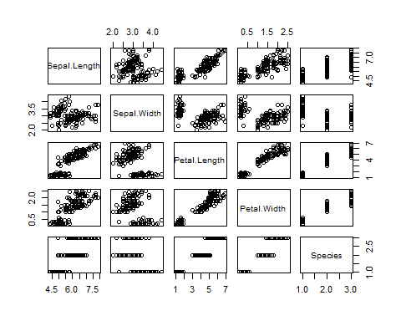

## Lab3

Webcsv <-"https://dfzljdn9uc3pi.cloudfront.net/2014/328/1/Appendix1.csv"  
Data <- read.table(Webcsv, header = T, sep = ",", skip = 2)  
Data[-1]

## crop site treatment mean_yield richness total_visits  
## 1 Field bean UK1 Net 6.825000 2 18  
## 2 Field bean UK1 Open 30.692500 2 18  
## 3 Field bean UK10 Net 35.207500 4 27  
## 4 Field bean UK10 Open 63.382500 4 27  
## 5 Field bean UK2 Net 25.832500 6 8  
## 6 Field bean UK2 Open 29.240000 6 8  
## 7 Field bean UK3 Net 9.722500 1 8  
## 8 Field bean UK3 Open 47.985000 1 8  
## 9 Field bean UK4 Net 26.195000 3 20  
## 10 Field bean UK4 Open 48.402500 3 20  
## 11 Field bean UK5 Net 15.352500 4 18  
## 12 Field bean UK5 Open 26.280000 4 18  
## 13 Field bean UK6 Net 27.677500 4 31  
## 14 Field bean UK6 Open 48.050000 4 31  
## 15 Field bean UK7 Net 20.972500 4 10  
## 16 Field bean UK7 Open 21.742500 4 10  
## 17 Field bean UK8 Net 15.017500 2 8  
## 18 Field bean UK8 Open 35.127500 2 8  
## 19 Field bean UK9 Net 33.210000 1 10  
## 20 Field bean UK9 Open 33.677500 1 10  
## 21 Buckwheat Biala Net 19.500000 6 14  
## 22 Buckwheat Biala Open 33.079167 6 14  
## 23 Buckwheat Branew <NA> NA 17 767  
## 24 Buckwheat Branew2 Net 13.083333 10 763  
## 25 Buckwheat Branew2 Open 44.488889 10 763  
## 26 Buckwheat Daleka <NA> NA 6 447  
## 27 Buckwheat Godziszow <NA> NA 12 759  
## 28 Buckwheat K_branewka <NA> NA 10 334  
## 29 Buckwheat Kapronie Net 21.958333 18 706  
## 30 Buckwheat Kapronie Open 104.316667 18 706  
## 31 Buckwheat Majdan Net 11.250000 11 112  
## 32 Buckwheat Majdan Open 49.937500 11 112  
## 33 Buckwheat Rataj <NA> NA 13 845  
## 34 Buckwheat W_ratajowska <NA> NA NA NA  
## 35 Oilseed rape A Net 2.579593 8 26  
## 36 Oilseed rape A Open 2.940995 8 26  
## 37 Oilseed rape D Net 7.770367 9 578  
## 38 Oilseed rape D Open 8.691746 9 578  
## 39 Oilseed rape F Net 5.698827 8 52  
## 40 Oilseed rape F Open 7.460621 8 52  
## 41 Oilseed rape H Net 2.793999 20 340  
## 42 Oilseed rape H Open 4.841241 20 340  
## 43 Oilseed rape HA Net 1.409587 6 130  
## 44 Oilseed rape HA Open 1.457758 6 130  
## 45 Oilseed rape HI Net 2.831556 26 222  
## 46 Oilseed rape HI Open 3.668414 26 222  
## 47 Oilseed rape HU Net 4.182181 12 390  
## 48 Oilseed rape HU Open 5.493835 12 390  
## 49 Oilseed rape L Net 2.173144 7 22  
## 50 Oilseed rape L Open 2.007574 7 22  
## 51 Oilseed rape R Net 3.083433 3 13  
## 52 Oilseed rape R Open 3.556380 3 13  
## 53 Oilseed rape V Net 6.937560 14 42  
## 54 Oilseed rape V Open 8.012705 14 42  
## 55 Strawberry 1 Net 9.664095 12 157  
## 56 Strawberry 1 Open 11.257907 12 157  
## 57 Strawberry 10 Net 8.825857 15 304  
## 58 Strawberry 10 Open 11.200245 15 304  
## 59 Strawberry 2 Net 4.588175 11 104  
## 60 Strawberry 2 Open 7.816829 11 104  
## 61 Strawberry 3 Net 10.410188 11 215  
## 62 Strawberry 3 Open 13.142985 11 215  
## 63 Strawberry 4 Net 6.162095 17 356  
## 64 Strawberry 4 Open 10.961260 17 356  
## 65 Strawberry 5 Net 5.834598 10 393  
## 66 Strawberry 5 Open 6.535234 10 393  
## 67 Strawberry 6 Net 9.814652 14 479  
## 68 Strawberry 6 Open 10.470343 14 479  
## 69 Strawberry 7 Net 12.464611 15 371  
## 70 Strawberry 7 Open 14.720840 15 371  
## 71 Strawberry 8 Net 10.787149 12 203  
## 72 Strawberry 8 Open 12.821494 12 203  
## 73 Strawberry 9 Net 13.767690 12 634  
## 74 Strawberry 9 Open 14.989863 12 634  
## honeybee_visits bumblebee_vists hoverfly_visits wildbee_visits mean_quality  
## 1 12 3 0 3 4.8050000  
## 2 12 3 0 3 3.9700000  
## 3 7 16 0 4 4.0975000  
## 4 7 16 0 4 3.9100000  
## 5 3 3 0 2 4.2750000  
## 6 3 3 0 2 4.1175000  
## 7 0 6 0 2 4.4900000  
## 8 0 6 0 2 4.2675000  
## 9 8 11 0 1 4.3900000  
## 10 8 11 0 1 4.5900000  
## 11 0 11 0 7 4.2700000  
## 12 0 11 0 7 4.3575000  
## 13 16 14 0 1 4.2975000  
## 14 16 14 0 1 4.2750000  
## 15 1 8 0 1 4.0225000  
## 16 1 8 0 1 4.4650000  
## 17 1 5 0 2 4.2450000  
## 18 1 5 0 2 3.9050000  
## 19 0 9 0 1 3.7450000  
## 20 0 9 0 1 3.5375000  
## 21 9 0 2 3 0.7772674  
## 22 9 0 2 3 0.6755583  
## 23 623 2 131 11 NA  
## 24 730 0 31 2 0.7411859  
## 25 730 0 31 2 0.7510769  
## 26 335 2 106 4 NA  
## 27 664 0 90 5 NA  
## 28 304 0 28 2 NA  
## 29 662 1 35 8 0.7584084  
## 30 662 1 35 8 0.8948058  
## 31 65 0 44 3 0.7384787  
## 32 65 0 44 3 0.7901198  
## 33 794 1 43 6 NA  
## 34 NA NA 0 0 NA  
## 35 12 7 6 0 49.8750000  
## 36 12 7 6 0 51.4250000  
## 37 536 10 19 0 47.7250000  
## 38 536 10 19 0 49.5000000  
## 39 31 3 10 0 49.3500000  
## 40 31 3 10 0 50.3750000  
## 41 267 9 56 0 48.1750000  
## 42 267 9 56 0 48.1000000  
## 43 107 10 5 0 51.7000000  
## 44 107 10 5 0 54.6500000  
## 45 150 23 46 0 46.5750000  
## 46 150 23 46 0 47.9500000  
## 47 353 6 22 0 46.5750000  
## 48 353 6 22 0 47.9750000  
## 49 4 14 3 0 46.5500000  
## 50 4 14 3 0 48.2250000  
## 51 1 10 2 0 47.5500000  
## 52 1 10 2 0 48.3250000  
## 53 10 4 27 0 47.1000000  
## 54 10 4 27 0 47.4000000  
## 55 105 39 1 12 2.2571429  
## 56 105 39 1 12 1.8749811  
## 57 227 19 14 44 2.5603175  
## 58 227 19 14 44 2.1874251  
## 59 74 11 3 16 2.9166667  
## 60 74 11 3 16 2.6237503  
## 61 170 20 11 14 2.2541667  
## 62 170 20 11 14 1.8864114  
## 63 299 25 5 27 2.6485500  
## 64 299 25 5 27 1.9293998  
## 65 274 89 6 24 2.7528045  
## 66 274 89 6 24 2.6567189  
## 67 377 72 4 26 2.1104167  
## 68 377 72 4 26 2.1273810  
## 69 321 24 4 22 1.8277778  
## 70 321 24 4 22 1.5522088  
## 71 163 17 3 20 2.2914117  
## 72 163 17 3 20 1.9175282  
## 73 581 8 20 25 1.9625687  
## 74 581 8 20 25 1.6465349

str(Data)

## 'data.frame': 74 obs. of 12 variables:  
## $ X : int 1 2 3 4 5 6 7 8 9 10 ...  
## $ crop : chr "Field bean" "Field bean" "Field bean" "Field bean" ...  
## $ site : chr "UK1" "UK1" "UK10" "UK10" ...  
## $ treatment : chr "Net" "Open" "Net" "Open" ...  
## $ mean_yield : num 6.83 30.69 35.21 63.38 25.83 ...  
## $ richness : int 2 2 4 4 6 6 1 1 3 3 ...  
## $ total_visits : int 18 18 27 27 8 8 8 8 20 20 ...  
## $ honeybee_visits: int 12 12 7 7 3 3 0 0 8 8 ...  
## $ bumblebee_vists: int 3 3 16 16 3 3 6 6 11 11 ...  
## $ hoverfly_visits: int 0 0 0 0 0 0 0 0 0 0 ...  
## $ wildbee_visits : int 3 3 4 4 2 2 2 2 1 1 ...  
## $ mean_quality : num 4.8 3.97 4.1 3.91 4.28 ...

Data <- Data [-1]  
Data$crop <- as.factor(Data$crop)  
  
for (i in names(Data[5:11])) {  
 plot(Data$mean_yield ~ Data[[i]], ylab = "Mean yields", xlab = as.character(names(Data[i])), col = Data$crop)  
 title(main= paste("Mean yield in function of", as.character(names(Data[i]))))  
   
   
}

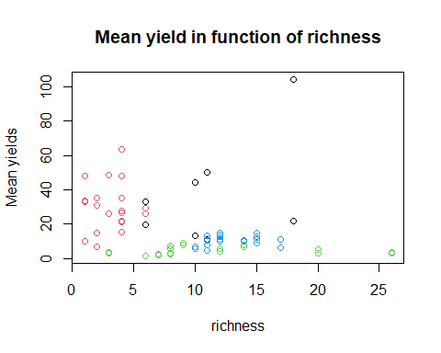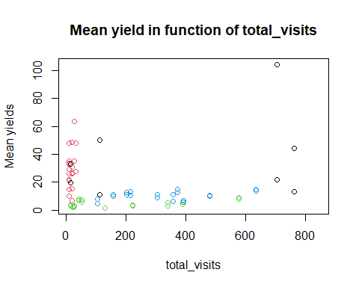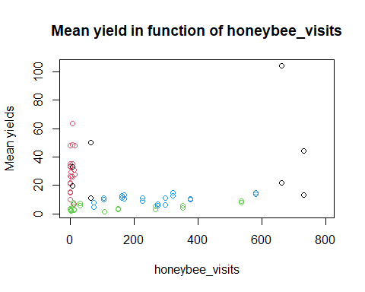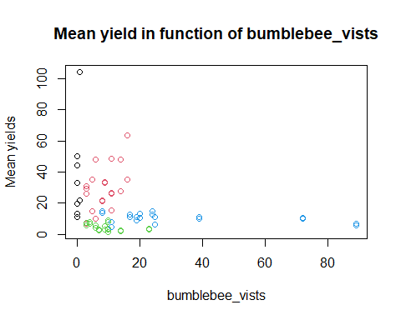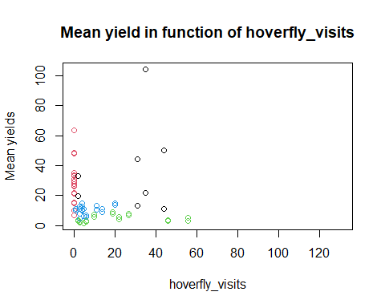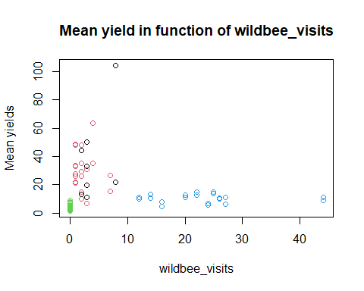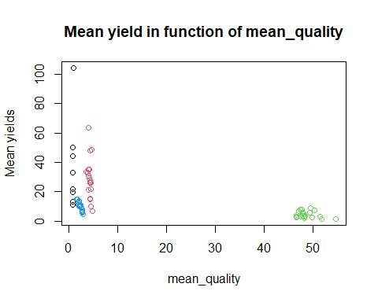

## R Markdown

This is an R Markdown document. Markdown is a simple formatting syntax for authoring HTML, PDF, and MS Word documents. For more details on using R Markdown see <http://rmarkdown.rstudio.com>.

When you click the **Knit** button a document will be generated that includes both content as well as the output of any embedded R code chunks within the document. You can embed an R code chunk like this:

summary(cars)

## speed dist   
## Min. : 4.0 Min. : 2.00   
## 1st Qu.:12.0 1st Qu.: 26.00   
## Median :15.0 Median : 36.00   
## Mean :15.4 Mean : 42.98   
## 3rd Qu.:19.0 3rd Qu.: 56.00   
## Max. :25.0 Max. :120.00

## Including Plots

You can also embed plots, for example:



Note that the echo = FALSE parameter was added to the code chunk to prevent printing of the R code that generated the plot.