|  |  |
| --- | --- |
| 1 | let practicefile=[273.15]; |
|  | console.log(practicefile);//print [273.15] |
|  | let a=42,b="hello"; |
|  | practicefile.push(a,b);// print [273,15,42,"hello"] |
|  | console.log(practicefile); |
|  | let c=[false,-4.6,"87"]; |
|  | practicefile.push(c); //print [273,15,42,"hello",false,-4.5,"87"] |
|  | console.log(practicefile); |

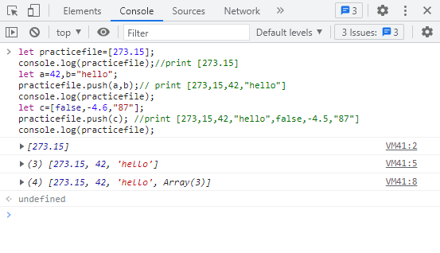

|  |  |
| --- | --- |
| 2 | //PUSH,POP,SHIFT AND UNSHIFT |
|  | let cargoHold=['oxygen tanks','space suits','parrot','instruction manual','meal packs','slinky','security blanket']; |
|  | console.log(cargoHold); |
|  | //print ['oxygen tanks','space suits','parrot','instruction manual','meal packs','slinky','security blanket'] |
|  | cargoHold[cargoHold.indexOf('slinky')]='space tether'; |
|  | cargoHold.pop(); |
|  | //print ['oxygen tanks','space suits','parrot','instruction manual','meal packs','space tether','security blanket'] |
|  | console.log(cargoHold); |
|  | // print ['oxygen tanks','space suits','parrot','instruction manual','meal packs','space tether'] |
|  | cargoHold.shift(); |
|  | console.log(cargoHold); |
|  | // print ['space suits','parrot','instruction manual','meal packs','space tether'] |
|  | cargoHold.push(1138); |
|  | console.log(cargoHold); |
|  | // print [1138,'space suits','parrot','instruction manual','meal packs','space tether'] |
|  | cargoHold.unshift('20 meters'); |
|  | console.log(cargoHold); |
|  | // print ['20 meters','space suits','parrot','instruction manual','meal packs','space tether',1138] |

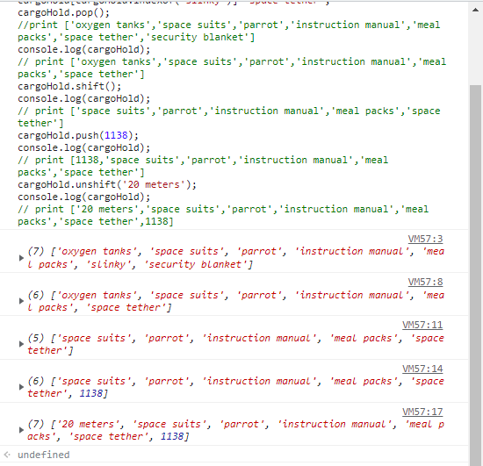

|  |  |
| --- | --- |
| 3 | //SPLICE |
|  | let cargoHold=['20 meters','space suits','parrot','instruction manual','meal packs','space tether',1138] |
|  |  |
|  | cargoHold.splice(3,0,'Keys'); |
|  | console.log(cargoHold); |
|  | //print ['20 meters','space suits','parrot','keys','instruction manual','meal packs','space tether',1138] |
|  | cargoHold.splice(cargoHold.indexOf('instruction manual'),1); |
|  | console.log(cargoHold); |
|  | //print ['20 meters','space suits','parrot','keys','meal packs','space tether',1138] |
|  | cargoHold.splice(2,3,'cat','fob','string cheese'); |
|  | console.log(cargoHold); |
|  | //print ['20 meters','space suits','cat','fob','string cheese','space tether',1138]; |
|  |  |
| 4  //CONCAT |  |
|  | let holdCabinet1=['duck','tape','gum',3.14,false,6.022e23]; |
|  | let holdCabinet2=['orange drink','nerf toys','camera',42,'parsnip']; |
|  | holdCabinet1.concat(holdCabinet2); |
|  | console.log(holdCabinet1); |
|  | //print ['duck','tape','gum',3.14,false,6.022e23] |
|  | console.log(holdCabinet1.slice(1,3)); |
|  | //print['tape','gum'] |
|  | console.log(holdCabinet1); |
|  | //print ['duck','tape','gum',3.14,false,6.022e23] |
|  | console.log(holdCabinet2.slice(2,4)); |
|  | //print ['camera',42] |
|  | console.log(holdCabinet2); |
|  | //print['orange drink','nerf toys','camera',42,'parsnip'] |
|  | console.log(holdCabinet1.reverse()); |
|  | //print [6.022e+23, false, 3.14, 'gum', 'tape', 'duck'] |
|  | console.log(holdCabinet2.sort()); |
|  | //print [42, 'camera', 'nerf toys', 'orange drink', 'parsnip'] |

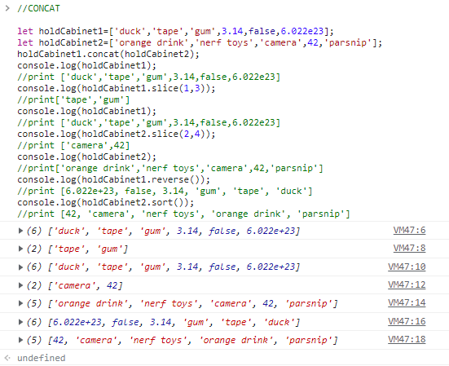

5

|  |
| --- |
| //SPLIT |
|  |  |
|  | let str='In space, no one can hear you code.'; |
|  | console.log(str.split()); |
|  | //print ['In space, no one can hear you code.'] |
|  | console.log(str.split('e')); |
|  | //print ['In spac', ', no on', ' can h', 'ar you cod', '.'] |
|  | console.log(str.split(' ')); |
|  | //print ['In', 'space,', 'no', 'one', 'can', 'hear', 'you', 'code.'] |
|  | console.log(str.split('')); |
|  | //print  ['I', 'n', ' ', 's', 'p', 'a', 'c', 'e', ',', ' ', 'n', 'o', ' ', 'o', 'n', 'e', ' ', 'c', 'a', 'n', ' ', 'h', 'e', 'a', 'r', ' ', 'y', 'o', 'u', ' ', 'c', 'o', 'd', 'e', '.'] |
|  | let arr=['B','n','n',5]; |
|  | console.log(arr.join()); |
|  | //print B,n,n,5 |
|  | console.log(arr.join('a')); |
|  | //print Banana5 |
|  | console.log(arr.join('')); |
|  | //print Bnn5 |
|  | console.log(arr.join(' ')); |
|  | print B n n 5 |
|  | // No, split and join does not change the original array |

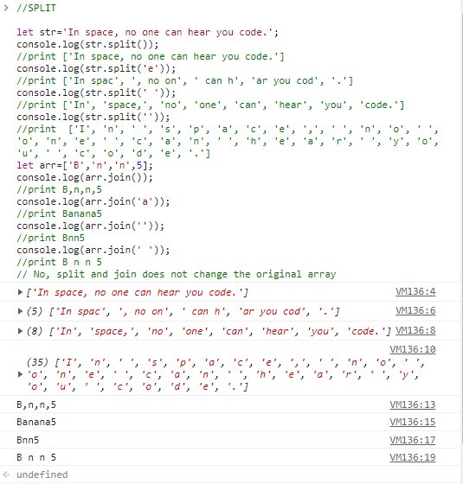

|  |  |
| --- | --- |
| 6 | // MULTI DIMENSIONAL ARRAY |
|  |  |
|  | let element1=['hydrogen','H',1.008]; |
|  | let element2=['helium','He',4.003]; |
|  | let element26=['iron','Fe',55.85]; |
|  | let table=[]; |
|  | table.push(element1,element2,element26); |
|  | console.log(table); |
|  | //print [['hydrogen','H',1.008],['helium','He',4.003],['iron','Fe',55.85]] |
|  | console.log(table[1]); |
|  | //print ['helium', 'He', 4.003] |
|  | console.log(table[1][1]); |
|  | //print He |
|  | console.log("element1 mass="+ table[0][2]); |
|  | //print element1 mass=1.008 |
|  | console.log("element2 name="+ table[1][0]); |
|  | //print element2 name=helium |
|  | console.log("element26 mass="+ table[2][1]); |
|  | //print element26 mass=Fe |

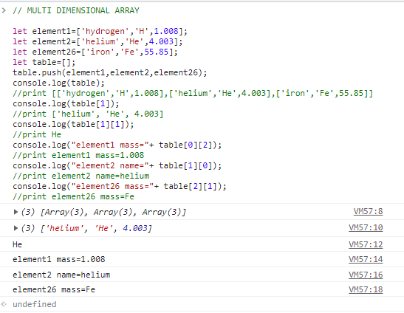

7

|  |
| --- |
|  |
|  | let people=["Greg","Mary","Devon","James"]; |
|  | let index=0; |
|  | //iterate the people using loop |
|  | for(index=0;index<people.length;index++) |
|  | { |
|  | console.log(people[index]); |
|  | } |
|  | //print |
|  | //Grey |
|  | //Mary |
|  | //Devon,James |
|  |  |
|  | //command to remove "Greg" |
|  | people.shift(); |
|  | console.log(people); |
|  | //print ['Mary', 'Devon', 'James'] |
|  |  |
|  | //command to remove "James" |
|  | people.pop(); |
|  | console.log(people); |
|  | //print ['Mary', 'Devon'] |
|  |  |
|  | //command to add "Matt" at front |
|  | people.unshift("Matt"); |
|  | console.log(people); |
|  | //print ['Matt', 'Mary', 'Devon'] |
|  |  |
|  | //command to your name at the end |
|  | people.push("FRANAL"); |
|  | console.log(people); |
|  | //print ['Matt', 'Mary', 'Devon', 'FRANAL'] |
|  |  |
|  |  |
|  | //iterate to "Mary" |
|  | for(index=0;index<people.length;index++) |
|  | { |
|  | console.log(people[index]); |
|  | if(people[index]=="Mary") |
|  | break; |
|  | } |
|  | //print |
|  | // Matt |
|  | //Mary |
|  |  |
|  |  |
|  | // slice and store the value in new array |
|  | let newArray=people.slice(2,people.length); |
|  | console.log(newArray); |
|  | //print ['Devon', 'FRANAL'] |
|  |  |
|  | //commanmd to find the index of "Mary" |
|  | console.log(people.indexOf("Mary")); |
|  | //print 1 |
|  |  |
|  |  |
|  | //commanmd to find the index of "Foo" |
|  | console.log(people.indexOf("Foo")); |
|  | //print -1 |
|  |  |
|  | //Redefine |
|  | people=["Greg","Mary","Devon","James"]; |
|  |  |
|  | //splice |
|  | people.splice(people.indexOf("Devon"),1,"Elizabeth","Artie"); |
|  | console.log(people); |
|  | //print ['Greg', 'Mary', 'Elizabeth', 'Artie', 'James'] |
|  |  |
|  |  |
|  |  |
|  | //create new letible withBob and assign "Bob" |
|  |  |
|  | let withBob=people+",Bob"; |
|  | console.log(withBob); |
|  | //print Greg,Mary,Elizabeth,Artie,James,Bob |

