First, check for artifacts in the dataset:

1. Photo bleaching
2. Motion artifact

Next, set the window size by empirically evaluating the “filtered” movie output.

If there is 1. Artifact in the first and last frame, then decrease the window size.

Now, set tau by looking at the output mask. If your the mask is distorting the size of your detected events (as in they’re bigger than the should be), then decrease tau.

Now, increase the ngm value if your mask includes background (non-signal)

There are 4 major parameters involved in S8 detection:

1. Threshold algorithm
2. Smoothing window size
3. Xy blur amount
4. Noise gate multiplier value

**Threshold Algorithm**

There are 3 choices of adaptive threshold algorithms in order of least to most stringent:

1. Triangle
2. Otsu
3. Yen

The default algorithm is otsu. To tune s8, the user must evaluate a sample output file for false positives (detected erroneous events) or false negatives (missed real events).

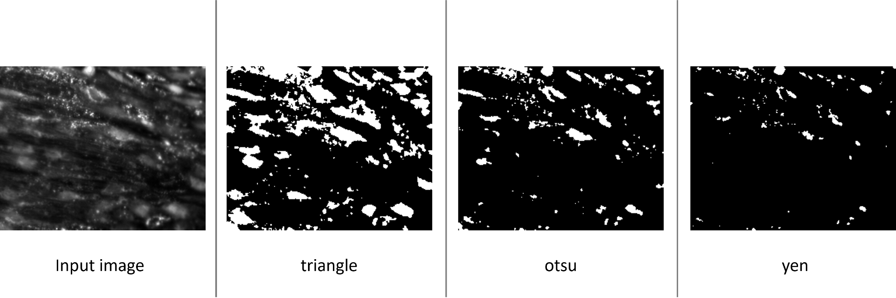

Next, the user may change the threshold algorithm to accommodate the signal-to-noise ratio of the data. To do this, open s8 in a text editor or a python development environment (pycharm). Find line ~121:

Gauss_thresh = threshold_**otsu**(blurred[:])

Change the word **otsu** to either **triangle** or **yen** depending on the desired stringency and save.

**Smoothing Window Size**

The Savitzky Golay filter performs time series smoothing similar to a moving average. For each pixel, time-dependent intensity information is filtered to remove image noise. To do this, Savitzky Golay fits a 3rd order polynomial to successive time windows based on Nyquist sampling.

The default window size is 21 (this number must always be odd) To tune s8, determine if your sampling rate is much greater or lower than 8 fps. For most purposes, this value should be sufficient. However, if you notice over-smoothing or under-smoothing, change line 815 in the code:

Win_size = 21

**XY Blur**

To help with adaptive thresholding, there is an xy blurring function

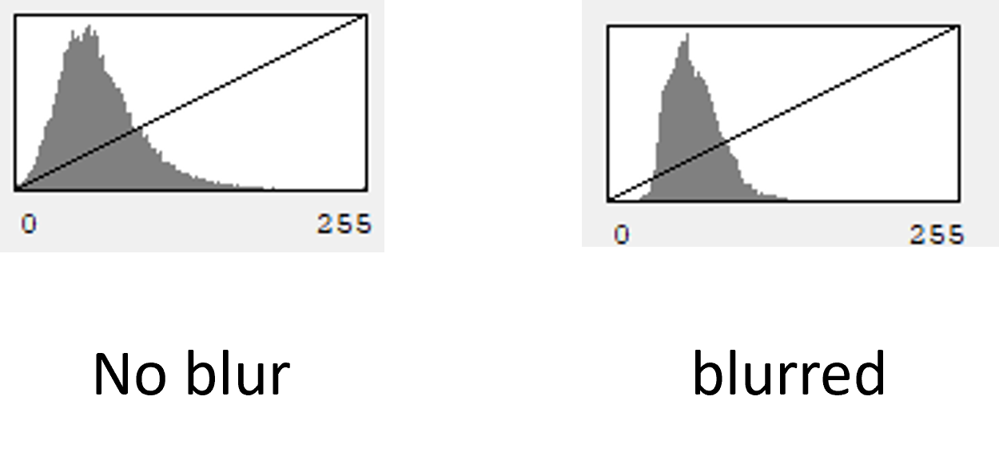

The default value of blur is sigma = 1. More blur helps with thresholding, but may overestimate the size of detected signals.

**Noise Gate Multiplier**

S8 has a built-in noise gate to “mute” background noise. This filter is iterative, first truncating the per–pixel time series data at the mean, then computing a mean “background” value from this baseline approximation. The filter includes a multiplier value, which may be tuned to data with low SNR. The default value is 1 (no multiplier). To engage, change the ngm value on line ~102 to something >1.