DriverPass — System Design Document | CS 255 | Francella Rivera

UML Diagrams

UML Use Case Diagram
The diagram identifies the actors and primary functions supported by the DriverPass platform.
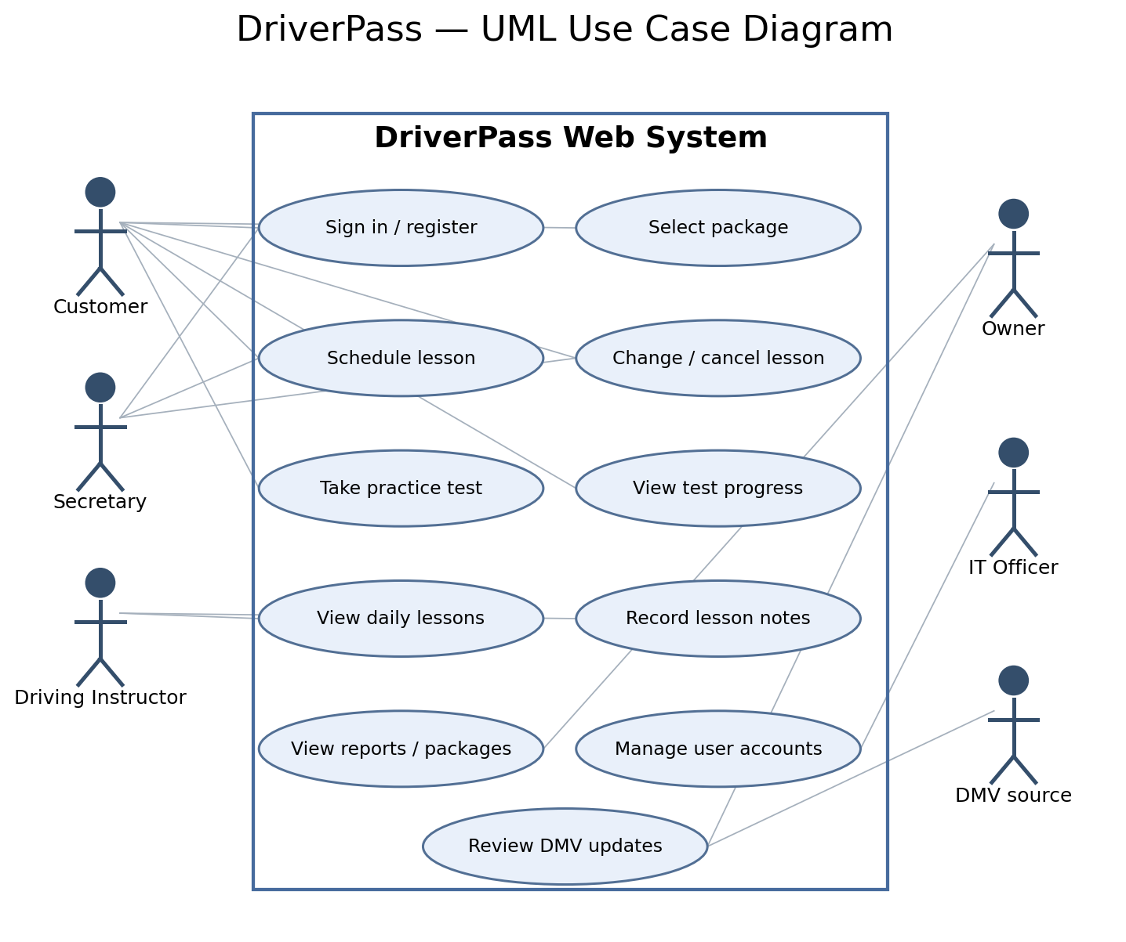

UML Activity Diagrams
Use case 1: Schedule a Driving Lesson. Checks eligibility and availability before booking a two-hour lesson.
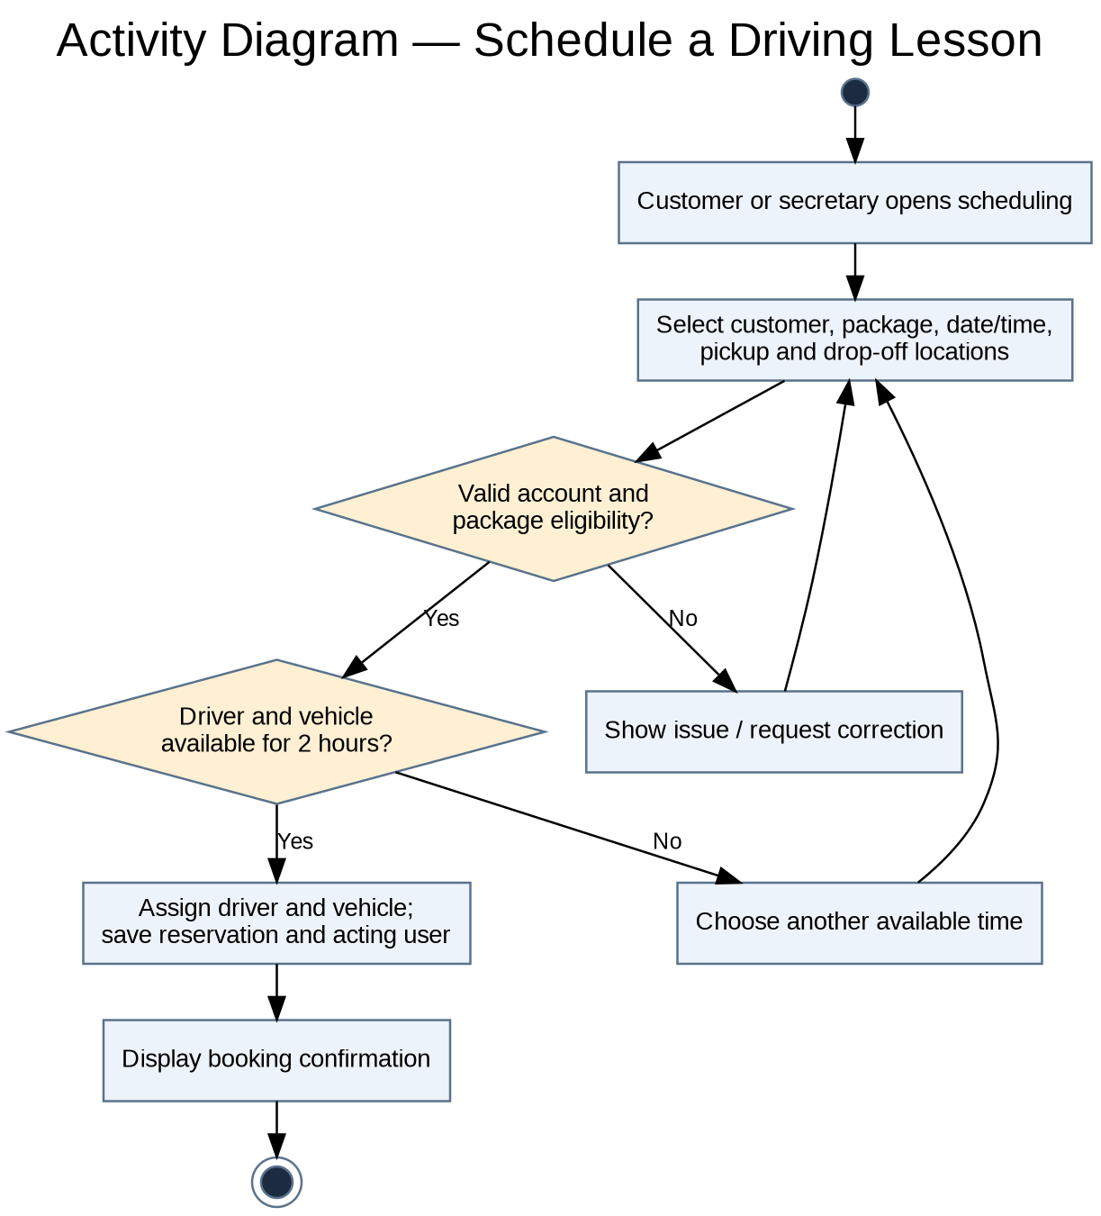
Use case 2: Complete a Practice Test. Restricts access to eligible packages and records assessment progress.
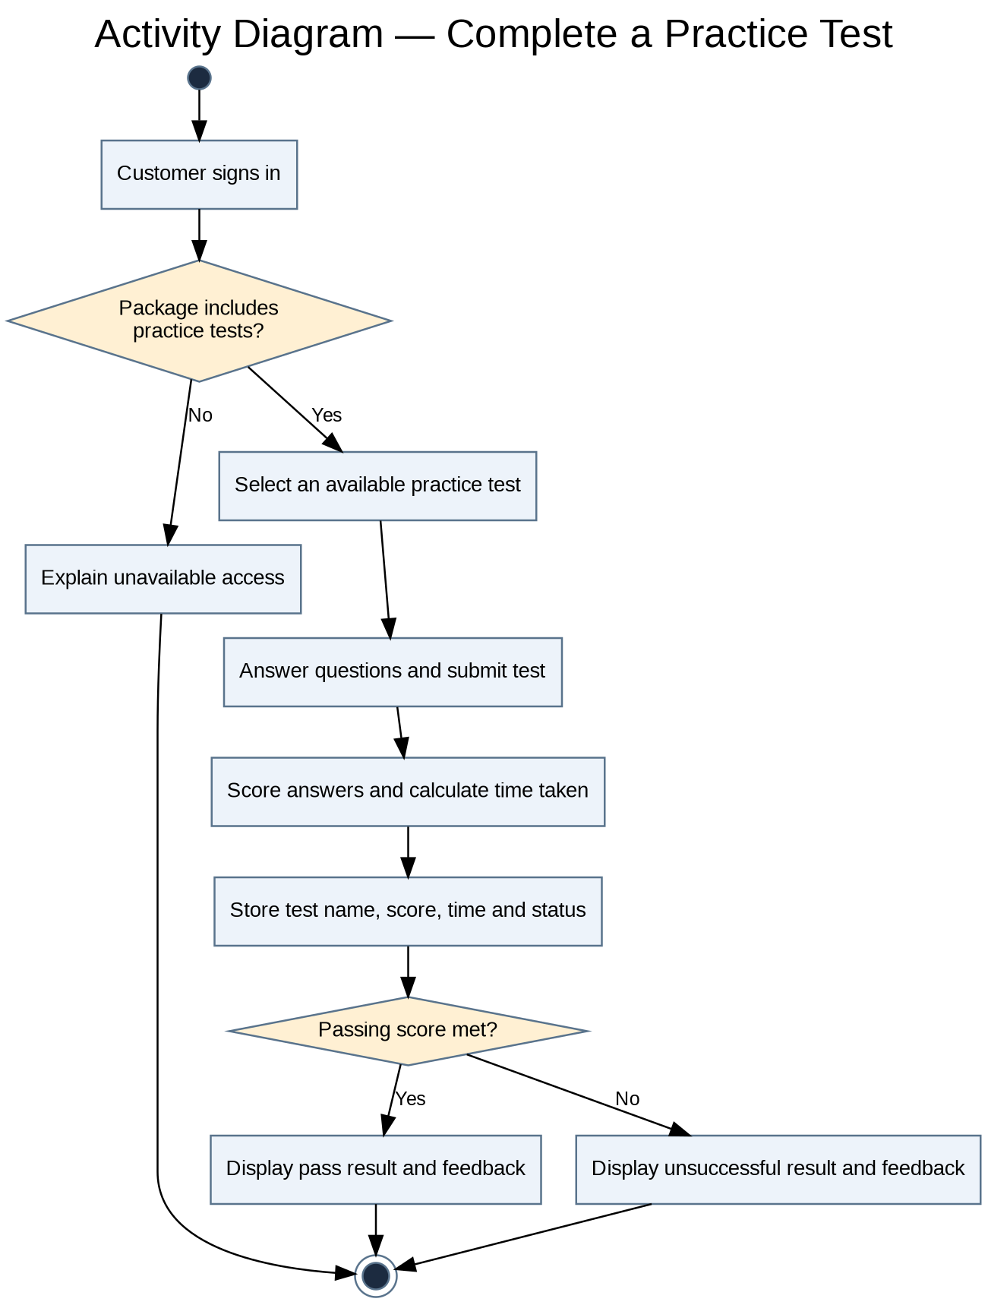

UML Sequence Diagram
The lesson-scheduling sequence shows the interactions required to validate and record a booking.
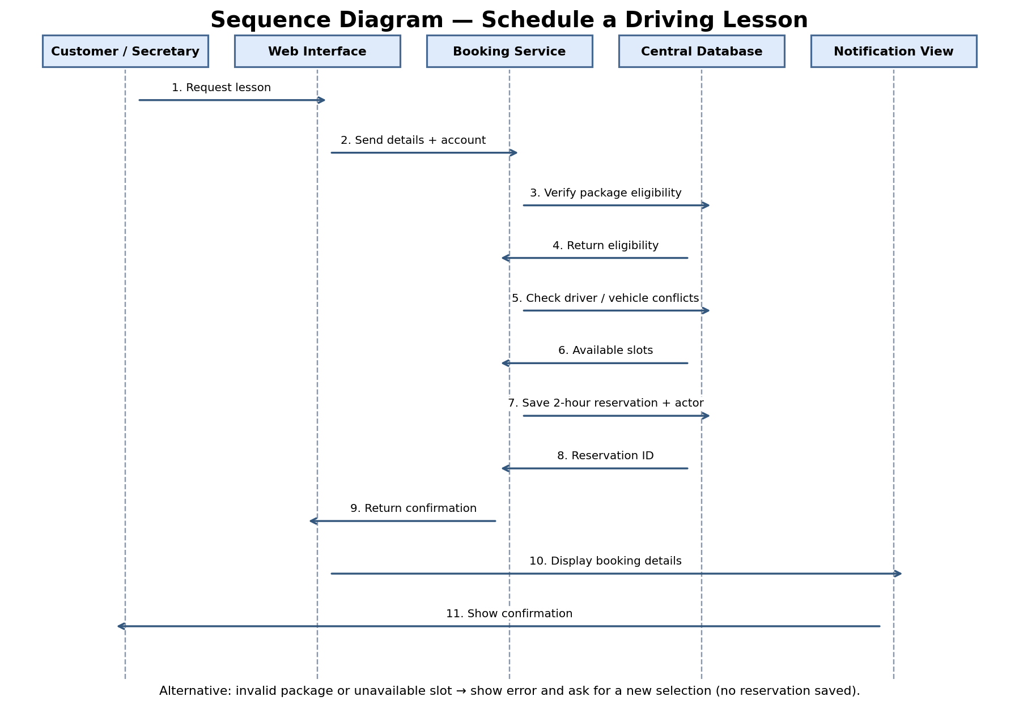

UML Class Diagram
Core domain classes, principal attributes, and associations. Multiplicities indicate one-to-many relationships where relevant.
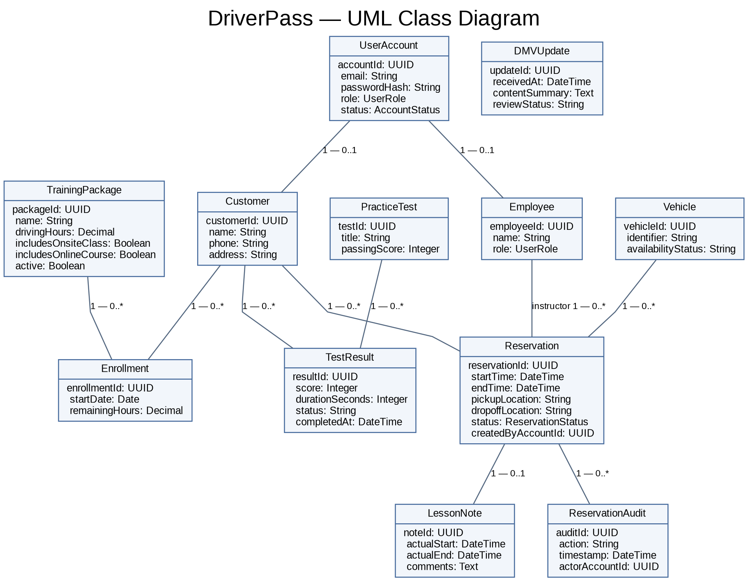

Technical Requirements
Hardware and end-user access: DriverPass users need internet-capable computers, tablets, or phones with a current web browser. Driving instructors need a device suitable for viewing schedules and entering lesson notes. DriverPass does not need to operate an on-premises application server under the proposed cloud-hosted design.
Software architecture: Build a responsive browser-based interface and a server-side application with separate presentation, business-rule, and data-access layers. Enforce package entitlement, two-hour scheduling, driver/vehicle conflict checks, and role permissions on the server rather than trusting browser input.
Database and data management: Use a centralized relational database to persist user accounts, customers, employees, training packages, enrollments, reservations, assigned vehicles and instructors, practice tests and results, lesson notes, reservation audit records, and DMV updates. Use transactions and uniqueness/conflict safeguards to prevent double booking.
Security and payments: Require authenticated logins and role-based authorization for customers, secretary, drivers, owner, and IT officer. Protect traffic with HTTPS/TLS, store only securely hashed passwords, limit repeated failed logins, and provide verified password resets. Use an approved third-party payment processor so full payment card details do not appear in the DriverPass database, reports, or ordinary screens.
Cloud infrastructure and reliability: Host the website, application service, and database in a managed cloud environment with automated encrypted backups, recovery testing, monitoring, secure network rules, and least-privilege administrative access. Save customer and scheduling updates promptly; downloaded reports can be viewed offline, but cannot modify live records.
Integrations, tools, and maintenance: Provide a configurable DMV update intake process that uses an approved API or notifications if available, followed by authorized review before content changes are published. Developers will need source control, separate test and production environments, database migration tools, automated testing, and deployment/monitoring tools. Lucidchart is the CASE tool required to reproduce and maintain UML deliverables.
Design constraints and scope: Package One: six driving hours; Package Two: eight driving hours plus an on-site DMV lesson; Package Three: twelve driving hours, a DMV lesson, and an online course with practice tests. Every road lesson occupies two hours. Owners can disable packages, but editing package structures or building new modules requires future development. Live scheduling depends on internet service, and automated DMV access depends on what the DMV provides.

