

Quality Assurance Office - Administration

CIT-U Liquidation System
System Design Document (SDD)

Project Title: CIT-U Liquidation System — Multi-Office Liquidation Automation Platform
Prepared By: Frances Anne B. Riconalla, QAO-NAS

Revision History Table
Version | Date | Author | Changes Made | Status
1 | 08/27/2026 | Frances Anne B. Riconalla | Initial draft — Executive Summary, FRS, and NFR based on project planning discussions | Draft
2 | 08/27/2026 | Frances Anne B. Riconalla | Added architecture, component, and ERD diagrams; API contract; database design; project plan | Draft

Table of Contents
Revision History Table 1
Table of Contents 1
Executive Summary 1
1.1 Project Overview 1
1.2 Objectives 1
1.3 Scope 1
1.0 Introduction 1
1.1 Purpose 1
2.0 Functional Requirements Specification 1
2.1 Project Overview 1
2.2 Core User Journeys 1
Journey 1: Employee Sign-Up and Admin Approval 1
Journey 2: Employee Builds and Generates a Liquidation 1
Journey 3: Admin Oversees the System 1
2.3 Feature List (MoSCoW) 1
2.4 Detailed Feature Specifications 1
Feature: Authentication & Access Control 1
Feature: Liquidation Management (Employee) 1
Feature: Expense Ledger & Live Calculations 1
Feature: Certification Handling 1
Feature: Acknowledgement Receipt Handling 1
Feature: Document Generation 1
Feature: Repository & Dashboard 1
Feature: Admin Oversight 1
2.5 Acceptance Criteria 1
AC-1: Successful Sign-Up 1
AC-2: Blocked Access Before Approval 1
AC-3: Admin Approves a Pending Account 1
AC-4: Live Calculation Accuracy 1
AC-5: Receipt-Validity Branching 1
AC-6: Returned Amount vs. Excess Budget Exclusivity 1
AC-7: Office-Scoped Access 1
AC-8: Blank Formatting Rule 1
3.0 Non-Functional Requirements 1
3.1 Performance Requirements 1
3.2 Security Requirements 1
3.3 Reliability Requirements 1
3.4 Availability Requirements 1
3.5 Compatibility Requirements 1
3.6 Usability Requirements 1
4.0 System Architecture 1
4.1 Architecture Pattern 1
4.2 Technology Stack 1
4.3 Component Diagram 1
4.4 System Architecture Diagram 1
5.0 API Contract & Communication 1
5.1 Communication Model 1
5.2 Result / Status Codes 1
5.3 Action / Endpoint Specifications 1
Authentication Actions 1
signUp — Employee/Admin Sign-Up Request 1
login — Email/Password Login 1
logout — End Session 1
GET /api/offices — List Offices (Public) 1
forgotPassword — Request Password Reset (Should Have) 1
resetPassword — Set New Password (Should Have) 1
Admin Actions 1
approveUser — Approve a Pending Account 1
rejectUser — Reject a Pending Account 1
deactivateUser — Deactivate an Active Account 1
Liquidation Actions 1
createLiquidation — Start a New Liquidation 1
updateLiquidationHeader — Edit Liquidation Details 1
addExpenseCategory / updateExpenseCategory / removeExpenseCategory 1
addExpenseItem / updateExpenseItem / removeExpenseItem 1
updateLiquidationStatus — Change Status 1
softDeleteLiquidation — Delete (Recoverable) 1
Document Generation Actions 1
generateLiquidationReportPdf 1
generateCertificationPdf 1
generateAcknowledgementReceiptsPdf 1
generateExpenseBreakdownExport 1
Repository & Dashboard Actions 1
getRepository — List Liquidations (Filtered) 1
getDashboardStats — Reporting Summaries 1
exportRepositoryExcel — Excel Export 1
6.0 Database Design 1
6.1 Entity Relationship Diagram 1
Detailed Relationships 1
Key Tables 1
Table Structure Summary 1
8.0 Plan 1
8.1 Project Timeline 1
8.2 Milestones 1
8.3 Risk Mitigation 1
8.4 Repository Structure 1

Executive Summary

1.1 Project Overview
The CIT-U Liquidation System is a centralized, multi-office liquidation reporting platform designed to replace the manual, paper/Word/Excel-based liquidation process currently used across CIT-U offices such as QAO-Admin, RDCO, and HRD. It enables Employees to log expenses against an approved Purchase Request (PR), automatically computes category variance, totals, and Returned Amount / Excess Budget, and generates print-ready PDF documents that are physically signed and submitted to the Finance and Accounting Office (FAO) exactly as before. The system provides Admin users with an approval and oversight layer to control who can access each office's liquidation records, and a cross-office repository and dashboard for reporting.
The system integrates the following components:
- Next.js (App Router) full-stack web application (TypeScript, React)
- PostgreSQL database via Prisma ORM
- Auth.js (NextAuth) Credentials-based authentication with office-scoped, Admin-approved access
- @react-pdf/renderer for direct, code-based PDF generation (Liquidation Report, Certification, Acknowledgement Receipts, Expense Breakdown)
- SheetJS for Excel export of the expense breakdown and the cross-office repository
- Recharts for the reporting dashboard
- Resend (or SMTP) for password-reset email only — not used for account sign-up

1.2 Objectives
- Digitize the liquidation workflow currently performed manually across CIT-U offices
- Eliminate re-typing of the same figures across the Liquidation Report, Certification, and Expense Breakdown by deriving all computed values from a single ledger
- Enforce office-scoped, Admin-approved access so only verified CIT-U staff can create or edit a given office's liquidations
- Automatically compute category variance, totals, and Returned Amount / Excess Budget with zero manual arithmetic
- Generate print-ready PDF documents (and an Excel export) that visually match the university's existing approved templates
- Provide a searchable, cross-office repository and a lightweight dashboard for reporting to office heads
- Deploy the system on a fully free hosting stack, appropriate for an internal university tool with no dedicated budget

1.3 Scope
Included Features:
- Sign-up with email (@cit.edu only), password, and office selection in a single form — no email verification step
- Admin approval queue: an account cannot access any liquidation data until an Admin approves it
- Role-based access: Employee (office-scoped, collaborative) and Admin (cross-office oversight)
- Liquidation creation with an editable, per-liquidation list of expense categories and their approved budgets
- Expense ledger with live-calculated category subtotals, variance, totals, and Returned Amount / Excess Budget
- Three-way receipt-validity handling: valid receipt, Certification (no receipt), or Acknowledgement Receipt (cash paid directly to a person)
- Automatic generation of four documents: Liquidation Report, Certification, Acknowledgement Receipt(s), and Type of Expenses breakdown (PDF + Excel)
- Cross-office Repository with filtering, and a Dashboard with basic spend/status charts
- Soft-delete with confirmation and a 30-day recovery window before permanent purge
- Account deactivation (never hard-delete) that preserves historical liquidation attribution

Excluded Features:
- E-signatures or any in-system digital approval/signing workflow — signing remains on paper, off-system
- Integration with the existing PR portal — PR data entry is permanently manual
- Receipt photo upload or OCR — all ledger entry is manual
- FAO-side digital review or kickback workflow — submission remains manual/paper
- Per-office Admin delegation — a single, flat Admin role oversees all offices
- Mobile application (v1 is web-only)

1.0 Introduction

1.1 Purpose
This document serves as the comprehensive design specification for the CIT-U Liquidation System — a multi-office liquidation reporting platform for Cebu Institute of Technology - University. It provides detailed functional requirements, architectural decisions, the application's communication contract, database schema, and an implementation roadmap to guide development of the web application.

2.0 Functional Requirements Specification

2.1 Project Overview
Project Name | CIT-U Liquidation System — Multi-Office Liquidation Automation Platform
Domain | Higher Education / Internal Finance & Administrative Operations
User Roles | EMPLOYEE (office-scoped, Admin-approved), ADMIN (cross-office oversight)
Application | Next.js (App Router, TypeScript) — Feature-Based / Server Actions Architecture
Database | PostgreSQL via Prisma ORM
Integrations | Resend/SMTP (password reset only)

Problem Statement: Manual liquidation preparation across CIT-U offices requires the same figures to be typed multiple times across a Word report, an Excel breakdown, and (when applicable) a Certification document, with all arithmetic performed by hand. This is slow, error-prone, and leaves no searchable record once a liquidation is printed and filed.
Solution: The CIT-U Liquidation System provides a single web-based ledger per liquidation from which every other computed value and document is derived, with office-scoped, Admin-approved access so multiple offices can safely share one platform.

2.2 Core User Journeys

Journey 1: Employee Sign-Up and Admin Approval
- Employee visits the system and clicks Sign Up.
- Fills in email (validated server-side as @cit.edu), password, and selects their Office from a dropdown — all in one form. There is no separate email-verification step.
- Account is created with approval_status = pending_office_approval.
- If the Employee attempts to log in before being approved, they see a screen stating their account has not yet been approved — no liquidation, repository, or dashboard routes are reachable.
- An Admin reviews the pending-approvals queue (name, email, requested office) and approves or rejects the request.
- On approval, the account becomes active and office-scoped; the Employee can now log in normally and access their office's data.

Journey 2: Employee Builds and Generates a Liquidation
- Employee logs in and navigates to Liquidations.
- Creates a new Liquidation: PR number, payer name, project name, date, amount, and an editable list of expense categories with an approved budget per category, entered manually from the PR.
- As receipts come in, adds expense items to the ledger: payee, amount, category, and doc type.
- An item with no valid receipt is flagged doc_type = certification, with a required reason.
- An item that is cash paid directly to a person (honorarium, raffle prize, etc.) is flagged doc_type = acknowledgement_receipt, with recipient context (event name, dates, venue, reason template).
- The system live-recomputes category subtotals, variance, total actual expense, and Returned Amount / Excess Budget on every ledger change.
- Any other Employee in the same office can also open and edit this liquidation — access is collaborative and office-scoped, not locked to the creator; last_edited_by and updated_at are tracked.
- When ready, the Employee generates all four documents and downloads the PDFs (and Excel export for the breakdown).
- The Employee prints two copies, hands them to the Head/Dean for physical signature, and manually submits to FAO — exactly as in the previous manual process.
- If a correction is needed, the Employee edits the ledger and regenerates — there is no version lock.

Journey 3: Admin Oversees the System
- Admin logs in with access across all offices.
- Reviews pending sign-up requests and approves legitimate CIT-U staff for their requested office, or rejects requests that do not check out.
- Deactivates any account that no longer needs access — the account is never hard-deleted, and its historical liquidation attribution remains fully intact.
- Browses the Repository across all offices, filtering by office, status, or date range.
- Views the Dashboard for spend summaries and liquidation-status counts.
- Exports the repository to Excel on demand, to hand to leadership as an up-to-date report.

2.3 Feature List (MoSCoW)
MUST HAVE
- Sign-up: email (@cit.edu only) + password + office selection, in one form, no email verification
- Admin approval queue — approve/reject pending accounts before any office data is reachable
- Login / logout with role-based route protection (Employee vs. Admin)
- “Account not yet approved” screen shown to any logged-in, not-yet-approved user
- Create Liquidation (PR info + editable, per-liquidation expense categories with approved budget)
- Expense ledger: add / edit / delete expense items per category
- Live calculation engine: category variance, totals, Returned Amount vs. Excess Budget
- Receipt-validity flagging: receipt / certification / acknowledgement_receipt
- Certification capture (reason) and automatic Certification document generation
- Acknowledgement Receipt capture (recipient inherited from payee, amount-in-words, reason template) and generation
- Liquidation Report PDF generation
- Certification PDF generation (skipped, not generated empty, when there are zero certification items)
- Acknowledgement Receipt PDF generation (2-up per page, batched)
- Type of Expenses breakdown — PDF and Excel export
- Office-scoped access control, enforced at the query level (not just hidden UI)
- Soft-delete with confirmation dialog and 30-day recovery window before permanent purge
- Admin “deactivate user” action that never breaks historical liquidation attribution
SHOULD HAVE
- Cross-office Liquidation Repository (searchable, filterable by office/status/date)
- Dashboard: liquidation counts by status, spend by office/category
- Excel export of the (filtered) repository listing
- Liquidation status field (draft / generated / submitted_to_fao / completed), manually updatable
- Password reset via emailed link
- last_edited_by / updated_at collaborative-edit visibility
COULD HAVE
- Reusable expense-category templates within an office
- Additional dashboard breakdowns (e.g. by project/activity type, year-over-year)
- Office-specific PR number format validation
WON'T HAVE
- E-signatures or any digital approval/signing workflow
- Integration with the existing PR portal
- Receipt photo upload or OCR
- FAO-side digital review or kickback workflow
- Per-office Admin delegation
- Mobile application

2.4 Detailed Feature Specifications

Feature: Authentication & Access Control
- Screens: Sign-Up page (email + password + office dropdown, single form), Login page, Account-Not-Yet-Approved screen, Admin Approvals queue
- Fields: CIT-U Email, Password, Office (select)
- Validation: email must end in @cit.edu (server-side), password minimum 8 characters, unique email constraint
- Security: bcrypt password hashing, JWT session (Auth.js) re-validated on every request so a deactivation takes effect immediately, DTOs never expose password_hash
- Note: there is no email-verification step. The Admin-approval step is the sole gate confirming a person actually belongs to their requested office.

Feature: Liquidation Management (Employee)
- Screens: Liquidations list, New Liquidation form, Liquidation detail/ledger view
- Header Fields: PR Number, Payer Name, Date, Project Name, College/Dept, Approved Budget Total, CV/CDV Number & Date (optional), Claimant Name, Dean/Head Name
- Category Fields: Name, Approved Budget Amount, Sort Order — fully editable per liquidation, not a fixed global list
- Access Control: any active Employee in the liquidation's office may view and edit it; access is denied (not merely hidden) to Employees from other offices, even via direct URL

Feature: Expense Ledger & Live Calculations
- Screens: Ledger table within the Liquidation detail view
- Fields per item: Payee, Amount, Category, Doc Type (receipt / certification / acknowledgement_receipt), Doc Reference
- Live Outputs: category actual expense, category variance, total approved, total actual, total variance, Returned Amount OR Excess Budget (mutually exclusive) — all recomputed immediately on any add/edit/delete, no manual refresh
- Formatting Rule: any category or field with zero activity renders as “-”, never “0.00” or “₱0.00”, matching the existing paper templates

Feature: Certification Handling
- Trigger: an expense item marked doc_type = certification
- Required Input: a reason explaining why no receipt exists for that item
- Behavior: payee, amount, and category are inherited from the linked expense item — only the reason is typed separately
- Document: one Certification PDF per liquidation, listing all flagged items and their reasons; not generated at all if there are zero such items

Feature: Acknowledgement Receipt Handling
- Trigger: an expense item marked doc_type = acknowledgement_receipt (cash paid directly to a person — honorarium, raffle prize, etc.)
- Required Input: reason template (honorarium / raffle_prize / custom), event name, event dates, venue, and an editable reason sentence
- Behavior: recipient name is derived live from the linked expense item's payee field — never stored separately, so a later correction to the payee is always reflected
- Amount-in-Words: auto-generated Philippine-peso wording (e.g. ₱400.00 → “Four Hundred Pesos Only”), unit-tested against whole pesos, centavos, ₱0, and six-figure amounts
- Document: one combined PDF per liquidation containing all Acknowledgement Receipts, laid out two per page

Feature: Document Generation
- Screens: a Documents tab/section within the Liquidation detail view
- Outputs: Liquidation Report PDF, Certification PDF (conditional), Acknowledgement Receipt PDF (conditional), Type of Expenses breakdown (PDF + Excel)
- Implementation: generated directly in code with @react-pdf/renderer, laid out to visually match the university's reference .docx/.xlsx templates — the templates are not filled programmatically, since LibreOffice-based conversion is incompatible with free serverless hosting
- Regeneration: always a fresh render from current ledger data; editing and regenerating never leaves stale figures in the new PDF

Feature: Repository & Dashboard
- Screens: Repository (searchable/filterable list), Dashboard (chart summaries)
- Repository Columns: Office, PR No., Project, Date, Approved Budget, Total Actual Expense (computed), Status
- Filters: Office, Status, Date Range — Employees default to their own office, Admins can view and switch across all offices
- Dashboard: liquidation counts by status, approved-vs-actual spend by office/period, spend by category
- Export: one-click Excel export of the current filtered Repository view

Feature: Admin Oversight
- Screens: Pending Approvals queue, User management list
- Admin Functions: approve or reject a pending sign-up request; deactivate an active account
- Restriction: deactivating a user sets account_status = deactivated only — the user row, and every liquidation's created_by / last_edited_by attribution pointing to it, is never deleted or orphaned

2.5 Acceptance Criteria

AC-1: Successful Sign-Up
Given I am a new user with a valid @cit.edu email
When I submit email, password, and select my office, and submit the sign-up form
Then my account is created with approval_status = pending_office_approval
And I cannot access any liquidation, repository, or dashboard route until an Admin approves me

AC-2: Blocked Access Before Approval
Given my account has not yet been approved by an Admin
When I log in
Then I see a screen stating my account has not yet been approved
And I am not redirected to any protected route regardless of the URL I try

AC-3: Admin Approves a Pending Account
Given I am logged in as Admin
When I approve a pending sign-up request
Then that user's approval_status becomes active
And they can now log in and access their requested office's liquidations

AC-4: Live Calculation Accuracy
Given I am building a Liquidation with at least one expense category
When I add, edit, or delete an expense item
Then the category's actual expense, variance, and the Liquidation's total variance recompute immediately, with no manual refresh

AC-5: Receipt-Validity Branching
Given I am logging an expense item with no receipt
When I mark it doc_type = certification and provide a reason
Then it appears on the generated Certification document
And it does not appear on the Acknowledgement Receipt document

AC-6: Returned Amount vs. Excess Budget Exclusivity
Given a Liquidation's total actual expense is less than or equal to its total approved budget
When I view the generated Liquidation Report
Then only “Returned Amount” is shown — never “Excess Budget” — and the reverse holds when actual exceeds approved

AC-7: Office-Scoped Access
Given I am an Employee assigned to Office A
When I attempt to access a Liquidation belonging to Office B, including by direct URL
Then the system denies access, regardless of any UI navigation path

AC-8: Blank Formatting Rule
Given a Liquidation has at least one expense category with zero actual expense
When I generate the Liquidation Report PDF
Then that category's Actual Expense and Variance cells display “-”, never “0.00” or “₱0.00”

3.0 Non-Functional Requirements

3.1 Performance Requirements
- Page load time ≤ 3 seconds on a stable broadband connection
- Live calculation recompute (category variance, totals) completes in under 200ms after a ledger edit — no perceptible lag while entering expense items
- PDF generation completes within 5 seconds for a liquidation with up to 50 expense items
- System supports at least 20 concurrent users, appropriate for a small internal multi-office userbase
- Database queries complete within 500 milliseconds for standard operations

3.2 Security Requirements
- All production traffic served over HTTPS
- Passwords hashed with bcrypt; never stored, logged, or included in any generated document
- Sign-up is restricted server-side to the @cit.edu email domain — not merely a client-side hint
- Session managed via Auth.js JWT, re-validated on every request, so an Admin deactivation takes effect immediately rather than at next login
- Role-based access control (Employee vs. Admin) enforced at the route-guard and server-action level, not only in the UI
- Office-scoping enforced at the query level — every Employee-issued query is filtered by their own office_id server-side, so a direct URL to another office's liquidation is denied, not merely hidden
- Admin approval is the sole membership check for office access — email domain verification alone is treated as identity proof, not authorization

3.3 Reliability Requirements
- Category and total figures (variance, actual expense, Returned Amount / Excess Budget) are always derived server-side from ledger data, never independently re-entered — eliminating an entire class of data-consistency bugs
- Soft-deleted liquidations remain recoverable for 30 days before a scheduled job permanently purges them
- Deactivating a user never cascades to delete or orphan their historical liquidation attribution (created_by / last_edited_by)
- Document generation is always a fresh render from current data — no stale cached PDFs after an edit
- Concurrent edits within the same office use a last-write-wins model, made visible via last_edited_by / updated_at rather than silently lost

3.4 Availability Requirements
- Application hosted on Vercel (free tier) in production
- Database hosted on Supabase (free tier, managed PostgreSQL) in production — may pause after a period of inactivity and require a manual resume
- Target uptime: best-effort, appropriate for an internal university tool at this scale; no formal SLA
- Nightly automated database backup via a scheduled GitHub Action running pg_dump, once deployed

3.5 Compatibility Requirements
- Web application: Chrome, Firefox, Safari, Edge (latest two versions)
- Primary workflow (liquidation building) optimized for desktop use; usable but not primary-optimized on mobile browsers
- Generated PDFs render correctly in standard PDF viewers and print correctly on standard letter/bond-size paper

3.6 Usability Requirements
- Category and ledger forms show live totals so an Employee sees the effect of each entry immediately
- Clear, field-level validation messages throughout
- Consistent CIT-U maroon/gold/Poppins visual identity across all screens
- Error messages provide clear recovery guidance (e.g. explaining that a liquidation belongs to another office, rather than a generic error)

4.0 System Architecture

4.1 Architecture Pattern
The CIT-U Liquidation System follows a Feature-Based (Vertical Slice) architecture within the Next.js App Router, rather than a separate REST API layer behind a decoupled frontend. Request handling and business logic live together in feature-scoped Server Actions, colocated with the pages that call them. This reduces the surface area needed for a project maintained by a small team, while Prisma provides a clean, type-safe data-access layer independent of the feature code.
Layer | Responsibility
Presentation Layer (App Router Pages) | Renders forms and tables; invokes Server Actions directly — no client-side REST/axios boilerplate needed for most operations
Server Actions (Feature Modules) | Validate input (Zod), enforce office-scoping and role checks, contain business logic — the calculation engine and the receipt-validity rules
Data Access Layer (Prisma) | Type-safe queries against PostgreSQL; schema.prisma is the single source of truth for the data model
Security Layer | Auth.js Credentials provider, bcrypt, JWT session, proxy.ts route guard (Next.js middleware equivalent)
Document Generation Layer | @react-pdf/renderer components mirroring the reference templates; SheetJS for Excel export
Scheduled Jobs | 30-day soft-delete purge job; nightly database backup (post-deployment)

4.2 Technology Stack
Component | Technology
Application Framework | Next.js (App Router), TypeScript, React
Database | PostgreSQL, via Prisma ORM
Authentication | Auth.js (NextAuth) — Credentials provider, bcrypt, JWT session
Styling | Tailwind CSS, Poppins (Google Font), CIT-U maroon/gold design tokens
PDF Generation | @react-pdf/renderer — pure JavaScript, no LibreOffice dependency, compatible with free serverless hosting
Spreadsheet Export | SheetJS (xlsx)
Charts | Recharts
Email (password reset only) | Resend, with SMTP as a fallback option
Local Development Database | Docker Compose — PostgreSQL container
Production Database | Supabase — managed PostgreSQL, free tier
Production Hosting | Vercel — free tier
Backups | Scheduled GitHub Action running pg_dump against Supabase

4.3 Component Diagram
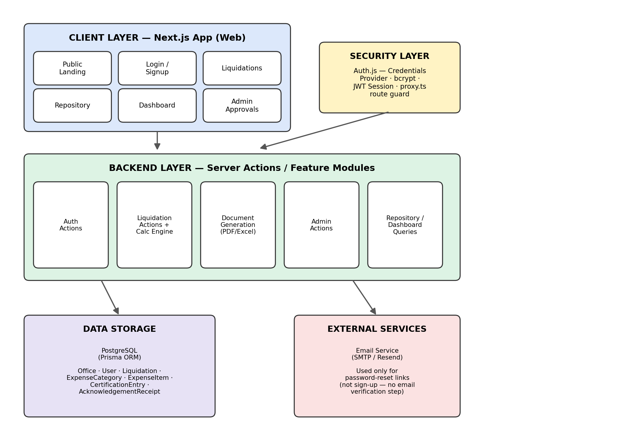
Figure 4.3 — Component Diagram: client, security, backend feature modules, data storage, and external services.

4.4 System Architecture Diagram
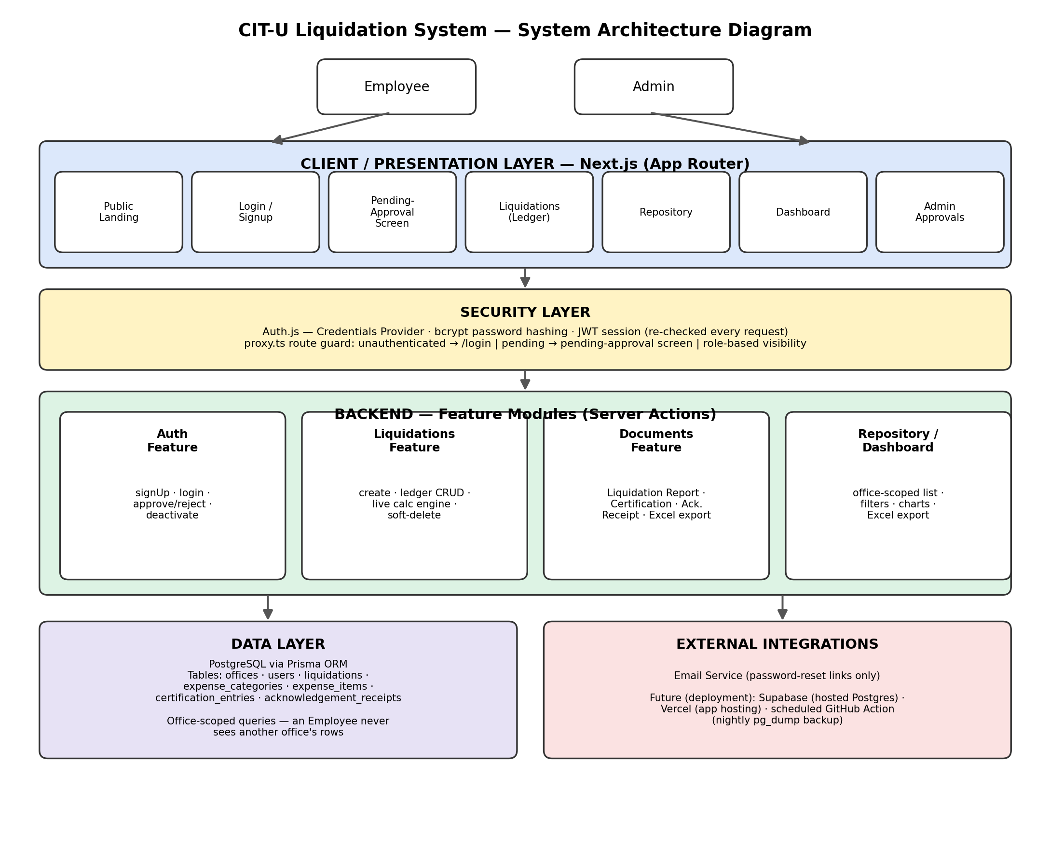
Figure 4.4 — System Architecture Diagram (feature-based / vertical-slice view).

5.0 API Contract & Communication

5.1 Communication Model
Primary Mechanism | Next.js Server Actions — invoked directly from React Server/Client Components; no separate REST client is required for most operations
Supplementary REST Routes | A small number of conventional API routes still exist: /api/auth/[...nextauth] (Auth.js session handling) and /api/offices (public office list for the sign-up dropdown)
Format | JSON for all Server Action inputs/outputs and REST route bodies
Authentication | JWT session cookie managed by Auth.js, re-validated server-side on every Server Action and protected route
Response Structure | { success: boolean, data: object | null, error: { code: string, message: string } | null }

5.2 Result / Status Codes
Code | Meaning
200 OK / success: true | Operation completed successfully
400 Bad Request | Invalid input or business-rule violation (Zod validation failure, e.g. a non-@cit.edu email)
401 Unauthorized | No valid session
403 Forbidden | Authenticated, but insufficient role or wrong office scope
404 Not Found | Requested resource does not exist, or belongs to another office (see §3.2 Security)
500 Internal Server Error | Unhandled server-side error

5.3 Action / Endpoint Specifications

Authentication Actions

signUp — Employee/Admin Sign-Up Request
Description | Register a new user with a requested office. Creates the account directly in a pending state — no verification email is sent.
Type | Server Action: signUp(data)
Auth Required | None (public)
Input | { citEmail, password, officeId }
Success Response | { success: true, data: { userId, approvalStatus: "pending_office_approval" } }
Error / Edge Cases | 400 — invalid email domain or weak password | 409 — email already registered

login — Email/Password Login
Description | Authenticate a user and establish a JWT session via the Auth.js Credentials provider.
Type | Auth.js Credentials Provider (signIn)
Auth Required | None
Input | { citEmail, password }
Success Response | Session established; redirected per approval_status (active → /home, pending → pending-approval screen)
Error / Edge Cases | 401 — invalid credentials | account_status = deactivated is also rejected here

logout — End Session
Description | Clears the JWT session.
Type | Server Action: logout()
Auth Required | Any authenticated session
Input | none
Success Response | Session cleared; redirected to public landing page
Error / Edge Cases | —

GET /api/offices — List Offices (Public)
Description | Returns the list of offices for the sign-up dropdown.
Type | API Route (REST)
Auth Required | None (public)
Input | none
Success Response | { success: true, data: [ { id, name, shortCode } ] }
Error / Edge Cases | —

forgotPassword — Request Password Reset (Should Have)
Description | Sends a password-reset link to the given email, if it belongs to an active account.
Type | Server Action: forgotPassword(email)
Auth Required | None (public)
Input | { citEmail }
Success Response | { success: true, data: "If that account exists, a reset link has been sent." }
Error / Edge Cases | Always returns success to avoid leaking which emails are registered

resetPassword — Set New Password (Should Have)
Description | Consumes a password-reset token and sets a new password.
Type | Server Action: resetPassword(token, newPassword)
Auth Required | Valid, unexpired reset token
Input | { token, newPassword }
Success Response | { success: true, data: "Password updated." }
Error / Edge Cases | 400 — token invalid/expired or weak password

Admin Actions

approveUser — Approve a Pending Account
Description | Approves a pending sign-up, granting office-scoped access.
Type | Server Action: approveUser(userId)
Auth Required | ADMIN role required
Input | { userId }
Success Response | { success: true, data: { userId, approvalStatus: "active", officeId } }
Error / Edge Cases | 403 — not Admin | 404 — user not found or not pending

rejectUser — Reject a Pending Account
Description | Rejects a pending sign-up request.
Type | Server Action: rejectUser(userId)
Auth Required | ADMIN role required
Input | { userId }
Success Response | { success: true, data: { userId, approvalStatus: "rejected" } }
Error / Edge Cases | 403 | 404

deactivateUser — Deactivate an Active Account
Description | Revokes login access without deleting the user row or any historical liquidation attribution.
Type | Server Action: deactivateUser(userId)
Auth Required | ADMIN role required
Input | { userId }
Success Response | { success: true, data: { userId, accountStatus: "deactivated" } } — session invalidated immediately on next request
Error / Edge Cases | 403 | 404

Liquidation Actions

createLiquidation — Start a New Liquidation
Description | Creates a Liquidation header record plus its initial expense categories.
Type | Server Action: createLiquidation(data)
Auth Required | EMPLOYEE (own office) or ADMIN
Input | { prNumber, payerName, date, projectName, collegeDept, approvedBudgetTotal, categories: [{ name, approvedBudgetAmount }] }
Success Response | { success: true, data: { liquidationId } }
Error / Edge Cases | 400 — validation failure | 403 — wrong office

updateLiquidationHeader — Edit Liquidation Details
Description | Updates the header fields of an existing Liquidation.
Type | Server Action: updateLiquidationHeader(id, data)
Auth Required | EMPLOYEE (same office) or ADMIN
Input | { id, ...header fields }
Success Response | { success: true, data: { updated liquidation } }
Error / Edge Cases | 403 — different office | 404

addExpenseCategory / updateExpenseCategory / removeExpenseCategory
Description | Manage the editable, per-liquidation list of expense categories and their approved budgets.
Type | Server Actions (3)
Auth Required | EMPLOYEE (same office) or ADMIN
Input | { liquidationId, name, approvedBudgetAmount, sortOrder }
Success Response | { success: true, data: { category } }
Error / Edge Cases | 400 — duplicate name in same liquidation | 403 | 404

addExpenseItem / updateExpenseItem / removeExpenseItem
Description | Manage ledger entries. Adding/updating an item recomputes category and liquidation totals live.
Type | Server Actions (3)
Auth Required | EMPLOYEE (same office) or ADMIN
Input | { categoryId, payee, amount, docType, docReference? }
Success Response | { success: true, data: { item, recalculatedTotals } }
Error / Edge Cases | 400 — missing reason for certification / missing recipient context for acknowledgement_receipt | 403 | 404

updateLiquidationStatus — Change Status
Description | Manually advances a liquidation's status as the paperwork physically progresses.
Type | Server Action: updateLiquidationStatus(id, status)
Auth Required | EMPLOYEE (same office) or ADMIN
Input | { id, status: draft | generated | submitted_to_fao | completed }
Success Response | { success: true, data: { updated liquidation } }
Error / Edge Cases | 400 — invalid status | 403 | 404

softDeleteLiquidation — Delete (Recoverable)
Description | Soft-deletes a liquidation after a confirmation prompt in the UI. Permanently purged after 30 days by a scheduled job.
Type | Server Action: softDeleteLiquidation(id)
Auth Required | EMPLOYEE (same office) or ADMIN
Input | { id }
Success Response | { success: true, data: { deletedAt } }
Error / Edge Cases | 403 | 404

Document Generation Actions

generateLiquidationReportPdf
Description | Renders the Liquidation Report PDF from current ledger data.
Type | Server Action
Auth Required | EMPLOYEE (same office) or ADMIN
Input | { liquidationId }
Success Response | PDF file stream / download URL
Error / Edge Cases | 403 | 404

generateCertificationPdf
Description | Renders the Certification PDF. Not generated (explicit message shown instead) if there are zero certification-type items.
Type | Server Action
Auth Required | EMPLOYEE (same office) or ADMIN
Input | { liquidationId }
Success Response | PDF file stream / download URL, or a “no certification items” response
Error / Edge Cases | 403 | 404

generateAcknowledgementReceiptsPdf
Description | Renders all Acknowledgement Receipts for the liquidation into one combined PDF, two per page.
Type | Server Action
Auth Required | EMPLOYEE (same office) or ADMIN
Input | { liquidationId }
Success Response | PDF file stream / download URL
Error / Edge Cases | 403 | 404

generateExpenseBreakdownExport
Description | Renders the Type of Expenses breakdown as either PDF or Excel.
Type | Server Action
Auth Required | EMPLOYEE (same office) or ADMIN
Input | { liquidationId, format: "pdf" | "xlsx" }
Success Response | File stream / download URL
Error / Edge Cases | 400 — invalid format | 403 | 404

Repository & Dashboard Actions

getRepository — List Liquidations (Filtered)
Description | Returns liquidations visible to the requesting user — own office only for Employees, all offices for Admins.
Type | Server Action: getRepository(filters)
Auth Required | Any active user
Input | { office?, status?, dateFrom?, dateTo? }
Success Response | { success: true, data: [ { liquidation summary rows } ] }
Error / Edge Cases | —

getDashboardStats — Reporting Summaries
Description | Returns aggregate counts and spend figures for the dashboard charts.
Type | Server Action: getDashboardStats(filters)
Auth Required | Any active user (office-scoped for Employees)
Input | { office?, dateFrom?, dateTo? }
Success Response | { success: true, data: { statusCounts, spendByCategory, approvedVsActualByOffice } }
Error / Edge Cases | —

exportRepositoryExcel — Excel Export
Description | Exports the current filtered Repository view to .xlsx.
Type | Server Action: exportRepositoryExcel(filters)
Auth Required | Any active user
Input | { office?, status?, dateFrom?, dateTo? }
Success Response | File stream / download URL (.xlsx)
Error / Edge Cases | —

6.0 Database Design

6.1 Entity Relationship Diagram
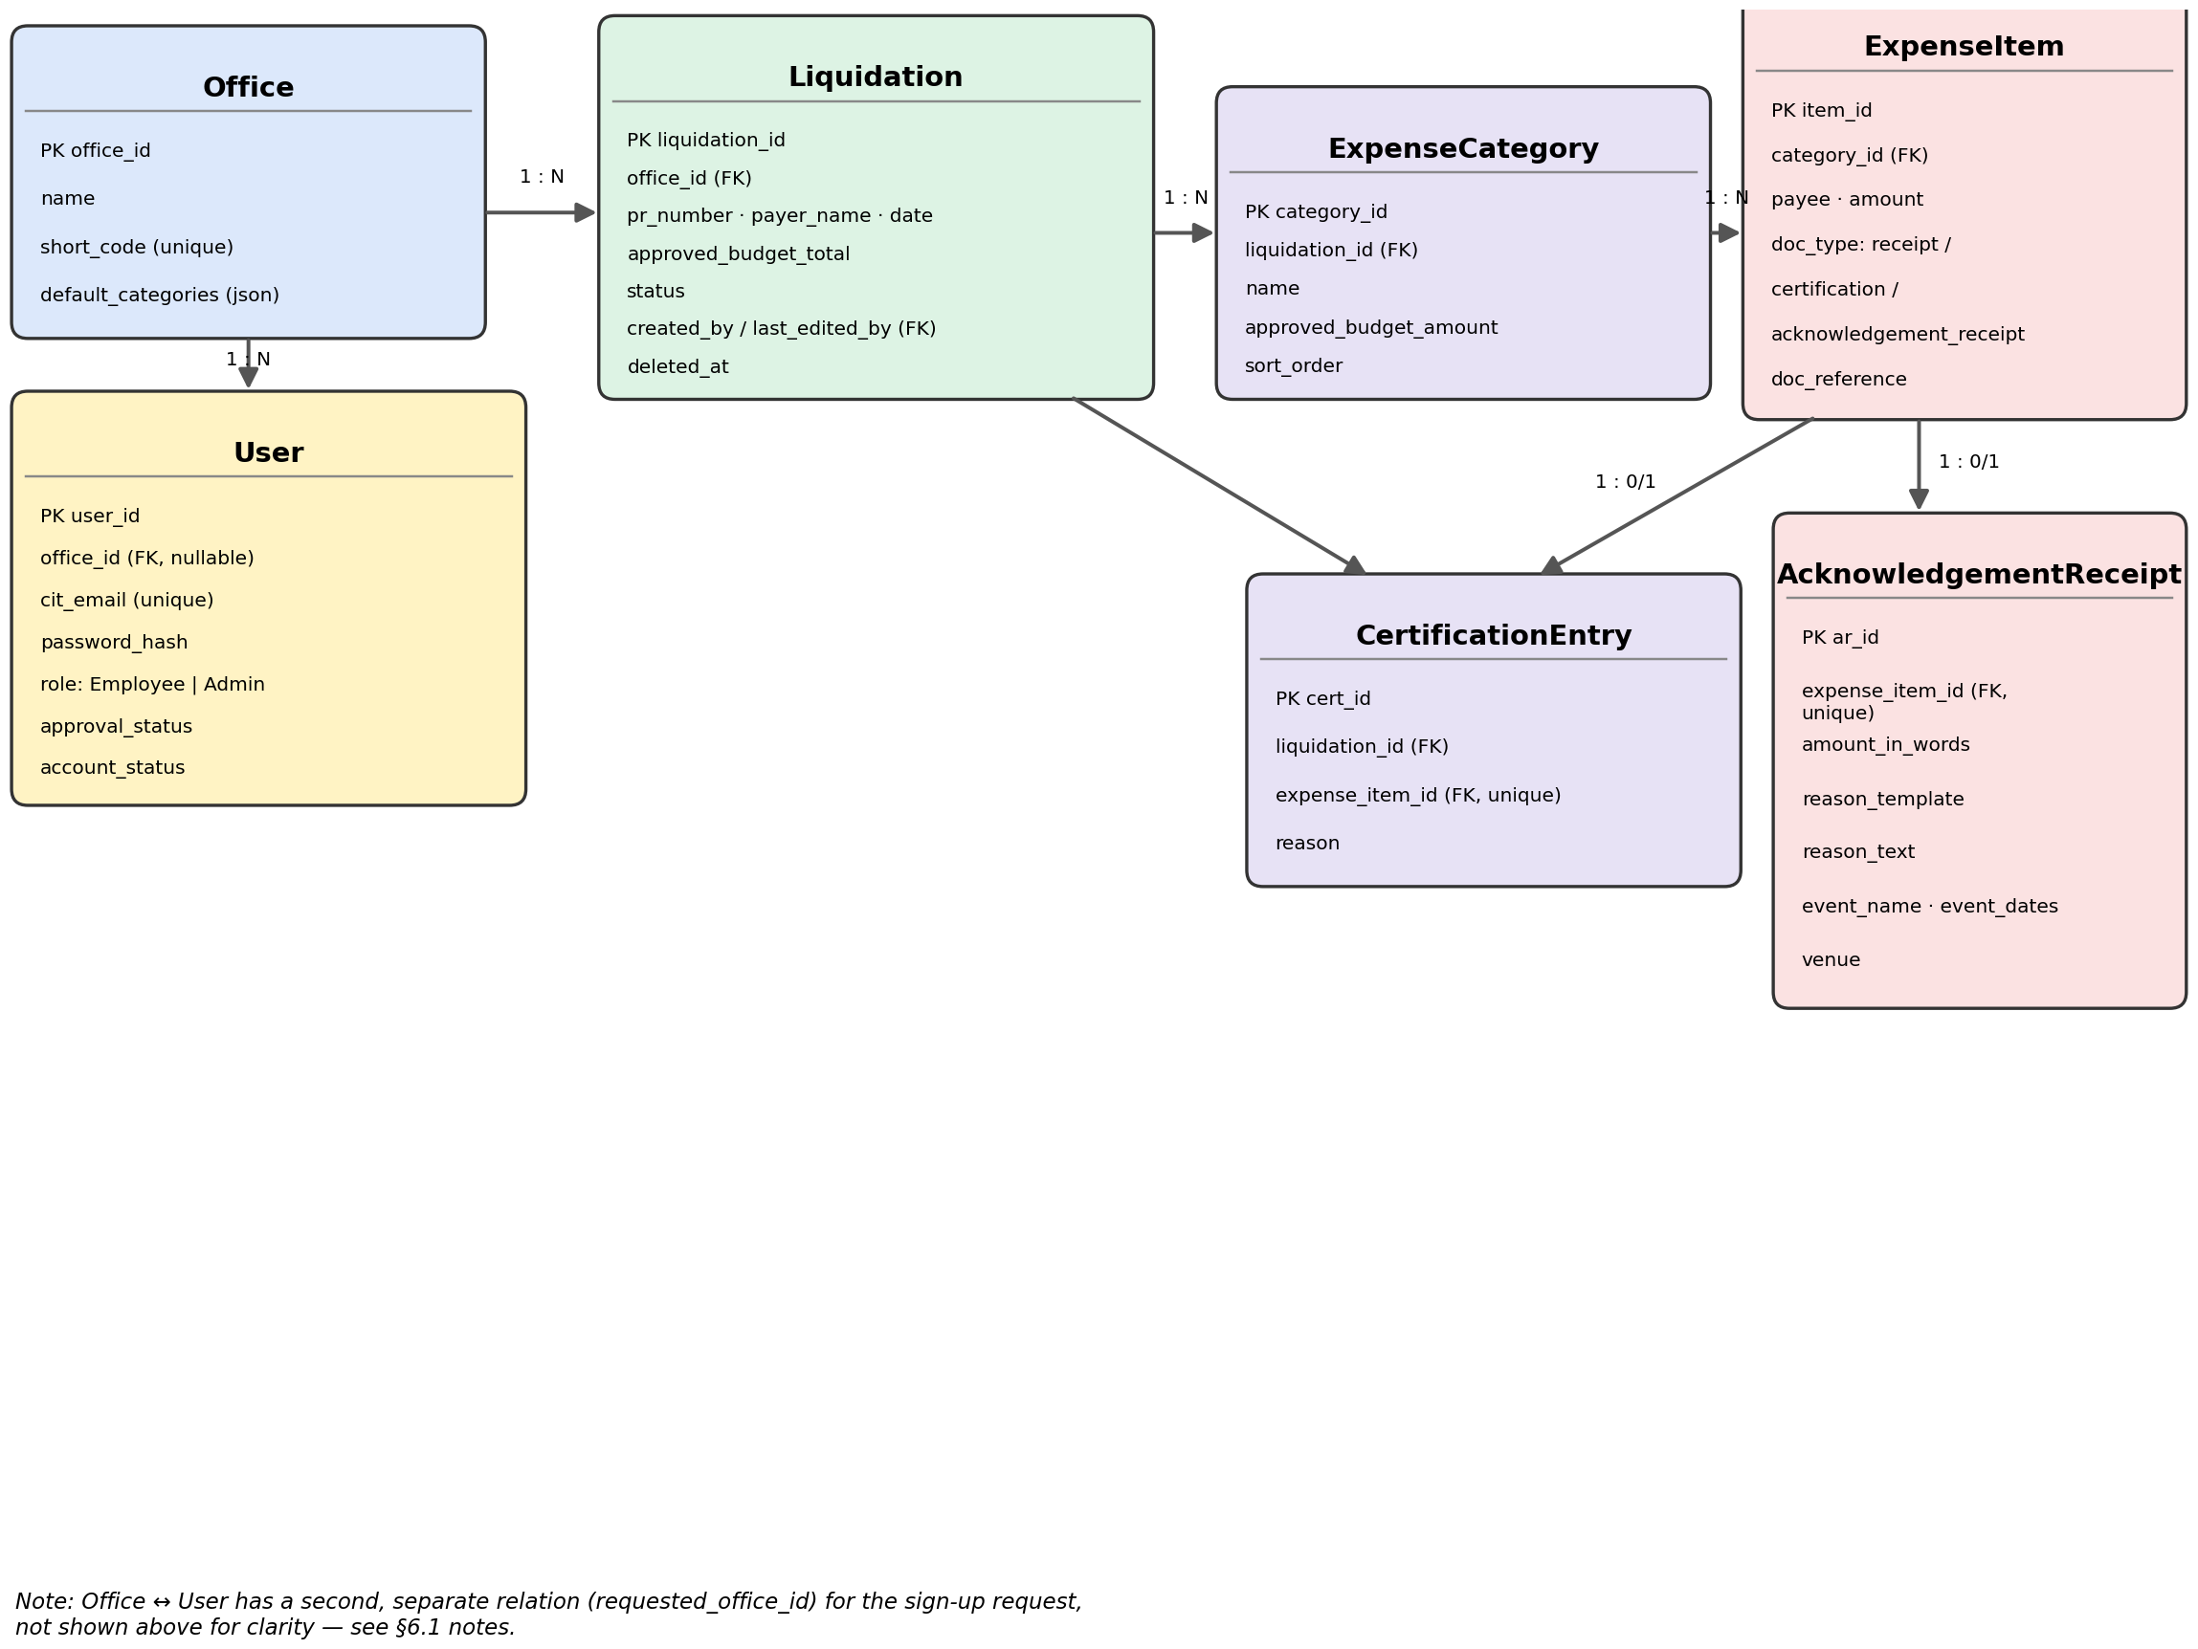
Figure 6.1 — Entity Relationship Diagram.
Note: User has a second, separate foreign key to Office (requested_office_id) used only during the sign-up request, distinct from the granted office_id shown above — omitted from the diagram for clarity.

Detailed Relationships
- Office → User (One-to-Many): a single office can have zero or many active Employees; a User's office_id is nullable until an Admin approves them.
- Office → Liquidation (One-to-Many): a single office can have zero or many liquidations; each liquidation belongs to exactly one office via office_id.
- Liquidation → ExpenseCategory (One-to-Many): each liquidation has its own editable list of expense categories — categories are not a shared global table.
- ExpenseCategory → ExpenseItem (One-to-Many): each category can have zero or many ledger entries.
- ExpenseItem → CertificationEntry (One-to-Zero/One): only present when doc_type = certification; enforced via a unique foreign key on CertificationEntry.expense_item_id.
- ExpenseItem → AcknowledgementReceipt (One-to-Zero/One): only present when doc_type = acknowledgement_receipt; enforced via a unique foreign key on AcknowledgementReceipt.expense_item_id.
- Liquidation → CertificationEntry (One-to-Many, denormalized): also linked directly to the liquidation, so the Certification document can be generated without a multi-hop join.

Key Tables
- Office — Stores each participating office (QAO-Admin, RDCO, HRD, ...), its short code, and its default expense-category seed list.
- User — Stores all accounts: role (Employee/Admin), bcrypt-hashed password, requested vs. granted office, approval_status, and account_status. Never hard-deleted.
- Liquidation — The central transactional record: PR and header info, the manually entered approved_budget_total, status, and soft-delete tracking via deleted_at.
- ExpenseCategory — The editable, per-liquidation list of budget categories, each with its own manually entered approved_budget_amount.
- ExpenseItem — The ledger itself: every receipt or cash payment logged against a category, tagged with a doc_type that drives which document (if any) it also appears on.
- CertificationEntry — The reason text for a no-receipt item; every other field is inherited from the linked ExpenseItem.
- AcknowledgementReceipt — Event/recipient context for a cash-paid-to-a-person item; recipient name is deliberately not stored here, and is instead read live from the linked ExpenseItem.payee.

Table Structure Summary
offices: office_id (PK) · name · short_code (UNIQUE) · default_categories (JSON)
users: user_id (PK) · name · office_id (FK, nullable) · requested_office_id (FK) · role ENUM(Employee, Admin) · cit_email (UNIQUE) · password_hash · approval_status ENUM · approved_by (FK) · approved_at · account_status ENUM
liquidations: liquidation_id (PK) · office_id (FK) · pr_number · payer_name · date · project_name · college_dept · approved_budget_total · cv_cdv_number · cv_cdv_date · claimant_name · dean_head_name · status ENUM · created_by (FK) · last_edited_by (FK) · deleted_at · created_at · updated_at
expense_categories: category_id (PK) · liquidation_id (FK) · name · approved_budget_amount · sort_order
expense_items: item_id (PK) · category_id (FK) · payee · amount · doc_type ENUM(receipt, certification, acknowledgement_receipt) · doc_reference
certification_entries: cert_id (PK) · liquidation_id (FK) · expense_item_id (FK, UNIQUE) · reason
acknowledgement_receipts: ar_id (PK) · expense_item_id (FK, UNIQUE) · amount_in_words · reason_template ENUM · reason_text · event_name · event_dates · venue

8.0 Plan

8.1 Project Timeline
Phase | Activities | Duration
Phase 0: Project Scaffolding | Next.js/TypeScript/Tailwind setup, Docker Compose, ESLint/Prettier, feature-based folder structure | Week 1
Phase 1: Database Schema & Seed | Prisma schema for all 7 models, initial migration, idempotent seed (offices + bootstrap Admin) | Week 1
Phase 2: Authentication & Access Flow | Sign-up (email + password + office, no verification), Admin approval queue, login/logout, route protection, password reset | Week 2
Phase 3: Core Liquidation Ledger & Calculations | New Liquidation form, expense ledger CRUD, live calculation engine, office-scoped collaborative editing, soft-delete | Week 3
Phase 4: Certification & Acknowledgement Receipt Handling | Receipt-validity flagging, Certification reason capture, Acknowledgement Receipt context capture, amount-in-words utility | Week 4
Phase 5: Document Generation | Liquidation Report, Certification, Acknowledgement Receipt, and Expense Breakdown PDFs (@react-pdf/renderer) and Excel export | Week 5
Phase 6: Repository & Dashboard | Cross-office repository with filters, dashboard charts, Excel export, 30-day purge job | Week 6
Phase 7: Polish & Deployment Readiness | Formatting-rule audit, office-scoping audit, Docker Compose finalization, deployment to Vercel + Supabase | Week 7

8.2 Milestones
Milestone | Deliverable | Status
M1 | Project scaffolding complete (Next.js, Docker, database container running) | Complete
M2 | Database schema migrated; offices and bootstrap Admin seeded | Complete
M3 | Authentication and Admin-approval flow fully functional | In Progress
M4 | Core liquidation ledger and live calculation engine functional | Planned
M5 | All four documents generate correctly and match reference templates | Planned
M6 | Repository, dashboard, and deployment to free hosting complete | Planned

8.3 Risk Mitigation
Risk | Impact | Mitigation
Free-tier Supabase database pausing after inactivity | Users briefly locked out until the database resumes | Document the manual resume step; consider a lightweight scheduled ping if it becomes disruptive
@react-pdf/renderer layout drifting from the real templates | Generated PDFs look visibly different from what FAO expects | Verify every generated document against the reference .docx/.xlsx templates before rollout, layout by layout
Office-scoping bugs at the query level | An Employee could access another office's data via a direct URL | Explicit Phase 7 testing pass hitting protected routes directly across offices, not just through the UI
Bootstrap Admin account uses a non-real inbox | No password-reset path for that specific account | Document the direct-database reset path; switch to a real, monitored inbox once the actual institutional Admin is confirmed
Local development environment quirks (Windows/Docker port conflicts, PATH issues) | Lost development time | Fixes already found (port remap to 5433, Docker Desktop PATH refresh) are documented in the project README

8.4 Repository Structure
Folder | Contents
src/app/ | Next.js App Router pages (routes): landing, auth, liquidations, repository, dashboard, admin
src/features/{auth,liquidations,admin,dashboard,documents,repository}/ | Server Actions and feature-specific business logic, colocated by feature
src/components/ | Shared UI components (form fields, auth card shell, etc.)
src/lib/ | Auth configuration, email stub, Zod validators, token utilities, shared constants, Prisma client
prisma/ | schema.prisma, seed.ts, migration history
docs/ | PROJECT_SPEC.md (system source of truth) and this SDD
reference-templates/ | The original CIT-U liquidation Word/Excel templates, used as the visual reference for PDF layout
README.md | Setup and run instructions

