**Guess the Cartoon**

An interactive game where players must first register and login. They must guess the name of a cartoon character shown based on clues and images. The game uses C# (Windows Forms) with a database to store cartoon data.

**How It Works:**

**User Register/Log in**

* Register with a username and password
* Log in to access the game
* Only logged-in users can play

Example:

|  |  |  |
| --- | --- | --- |
| **ID** | **Username** | **Password** |
| 1 | Player 1 | password1 |

**Database Stores Cartoons**

* A table with cartoon names, images, and hints.

Example:

|  |  |  |  |  |  |
| --- | --- | --- | --- | --- | --- |
| **ID** | **Cartoon Name** | **Hint 1** | **Hint 2** | **Hint 3** | **Image Path** |
| 1 | SpongeBob | Lives in the sea | Loves Krabby Patties | Sponge --- | spongebob.png |
| 2 | Tom & Jerry | Cat & Mouse | Always chasing | Tom & ----- | Tomjerry.png |

**Game Interface**

* Picture Box: Displays an image of a cartoon.
* Label: Shows a hint.
* Textbox: Players type their answer.
* Buttons: Submits the guess or skips it.
* Label: Displays feedback.

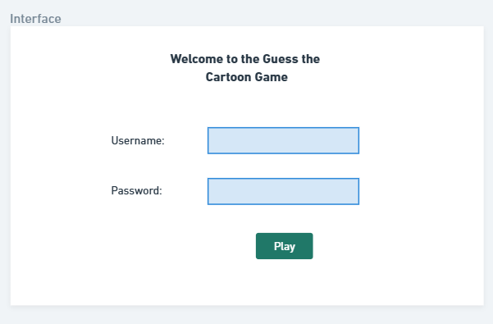

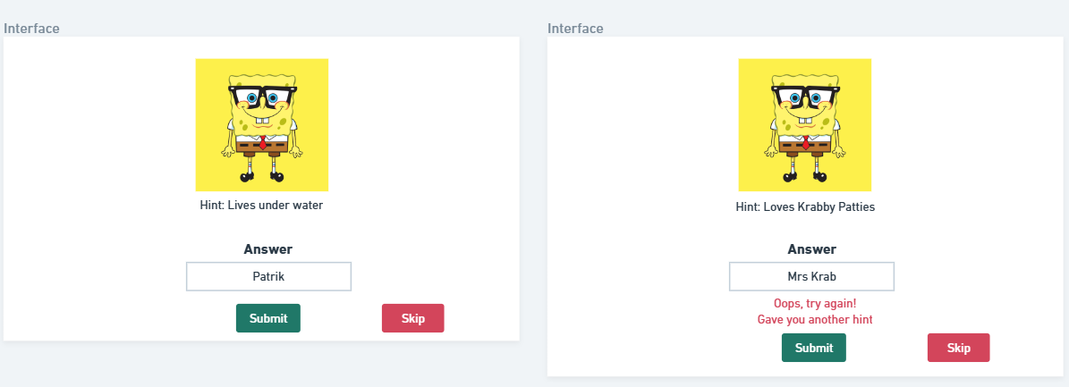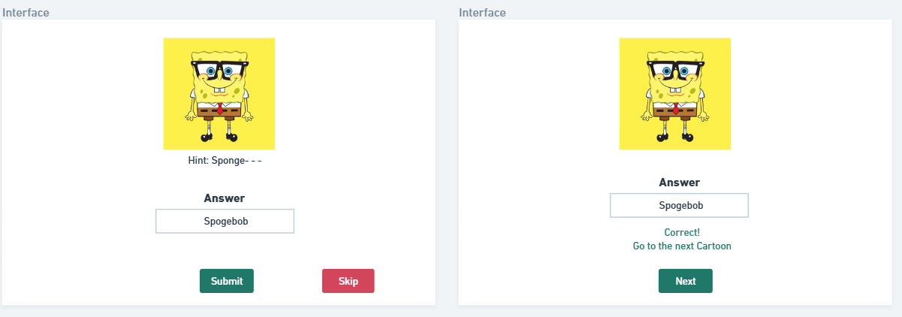

**User Registration Page**:

* New users enter a username & password.
* Data is stored in the Users Table.

**User Login Page**:

* Users enter their username & password.
* They are verified from the database.
* If correct → game starts.

**Game Play**:

* A random cartoon is selected from the database.
* Players get hints & images to guess the cartoon.
* They enter their guess in a Textbox and submit it.
* If correct → Display a "Correct Yay!" message.
  + Move on to the next cartoon.
* If incorrect → Show another hint.
  + Offer a "Skip" option after multiple incorrect attempts.
  + Provide an easier hint.
* If the player doesn't guess the answer at all:
  + Reveal the correct answer.
  + Allow the player to move to the next cartoon.
* End - Show the user answers when there are no more cartoons + Show their score, e.g. Wrong:1, Correct:6.