Podcast Link: https://soundcloud.com/user-160870325/all-talk-billy-no-dates?fbclid=IwAR1uH2MDN31KuLBIhANW8OCWLBUJLEMAyKI1AYZUTVatobN3UoFTzlHYe1U

Evaluative Report

I chose ‘Convergent Media: From Radio to Podcasting’ as my option unit because over the past two years I have found myself listening to more and more podcasts. In addition to this, I find myself holding back from speaking how I really feel and expressing my opinions, so I thought this unit would give me a great opportunity to find my voice. Radio has expanded into a universal medium of communication. (McLeish and Link, 2015) It is the controller for so many things around the world such as air traffic, taxis, fire brigades and the police. Both radio and podcasts have the power to paint pictures, allowing the listener to visualise their own source of the sound and make it more personal to them. For example, when talking about a beach, every single person will envisage a different beach and that’s what makes both these mediums so special. In addition to this, broadcast radio is regulated by Ofcom, however, podcasts are unregulated meaning they do not require a licence. In the past year statistics have risen to find that over 7.1 million people listen to podcasts, which is up to 24% more than in 2018. When looking at statistics, it was clear that the most popular genre of podcast for 15-24-year-olds was entertainment, love and comedy. Knowing this and that it had to be tailored to a UAL audience, I thought it was best to choose one of these genres to base our podcast on. Our group made a mind-map on “How peoples parents met” because this was our original topic. After already having some unbelievable stories we thought it would be fun, interesting and easy to experiment with the sound of our podcast and its characteristics. For example, I thought of bringing in a couple that would record their stories of how they met separately, then merge them together so we could play around with the differences in what they are saying to have a comedic tone. After having feedback from the class, we thought that this topic doesn’t relate to a UAL audience and a lot of people didn’t find the topic engaging enough. It then became agreed that our podcast was going to be about love and dating in UAL. This was chosen because its relatable to every student in the UAL community who all have their own relationship stories and status’. Our brand is a university-based podcast that brings young individuals together by discussing love, sex, fashion, politics and lifestyle. It’s a place to share and listen without judgement or stigma. We are known as “ALL TALK’ with different titles for each episode. Our episode for this project is called “Billy No Dates”. We have tried to capture: what it’s like to date at university, advice from those who have had the experience of dating in university, dating nightmares and an on-scene report of one of our members going on a date. After doing multiple timelines, this was our official schedule and plan of events:

-Introduction: Franki and Em open up with explaining what podcast will include

-On the date: Sara at the date talking through how she’s feeling and what the night will entail

-Interview: Erinna interviewing Olivia Petter (Millennial Love Podcast creator) who can give tips and advice

-Voxpops: Get UAL students themselves to tell their own stories to do with dating at university

-Wrap up: Catching up with Sara and how her date went

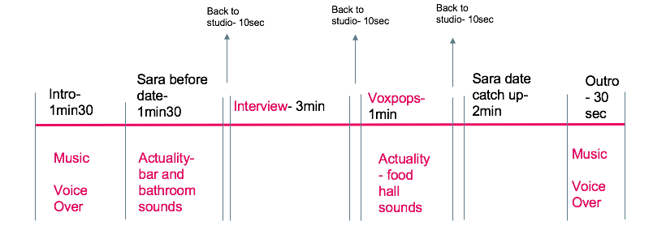

In our podcast we use music, voice overs, actuality, a live interview (phone) and voxpops.

We believe these characteristics bring our podcast to life by making it more technical, professional and interesting to listen to. When recording we were able to book the studio out on a weekly basis so we could go over and re-record what we believe could be improved. It started with free flow chat before we understood that some aspects, such as the introduction, sounded better scripted. This was because we were able to summarise our podcast within five descriptive sentences in order for the listener to feel engaged and special; as if this podcast was just for them. We recorded each section mentioned above separately, so it was easy to keep track of where we were up to and what needed improving/tweaking. Using Adobe Audition was extremely fun and simple to use. With experience in Adobe Premier, I was able to play around with different features that focus more on sound rather than sound and video. The cutting tool was used most, due to slimming down long bits of content in order to fit 10 minutes. Using the tools was very easy however choosing the most important pieces of content was very difficult. The interview was the most difficult to edit because of the constant talk over each other from answering and responding to questions. The questions we asked Olivia we tried to make as relatable to a UAL audience as possible such as “what advice would you give university students in the dating game” and “what do you think of dating apps for our generation? Do you agree or disagree with how they work?” The aim of an interview is to provide opinions and facts in their own words on a particular topic. (McLeish and Link, 2005) We believe these open-ended questions allowed Olivia to express herself and give honest answers instead of questions she could have rehearsed responses to. When coming to the end of editing, we decided to use more actuality in the background of a couple of sections, because it allowed the listener to feel as if they were actually in the room with us.

Overall this experience has been one of the best in my year and a half of university. Learning the ropes of producing a podcast and how far convergence media has come has given me the opportunity to explore a career pathway I never knew I would be interested in. I am happy with the outcome of my first ever podcast and the skills shown within it.

Bibliography:

McLeish, R. and Link, J. (2015) Radio Production, 6th Edition, Oxford: Taylor and Francis

Word Count : 1005 (excluding bibliography)