Principles of Computer Vision for AI Assignment

University of Malta

Faculty of Information & Communication Technology

Bachelor of Science in Information Technology (Honours) (Artificial Intelligence) 2nd Year

ARI2129 – Principles of Computer Vision for AI

Mr Dylan Seychell

|  |  |
| --- | --- |
| Jake Sant | Francesca Maria Mizzi |
| 117699M | 1118201L |

Table of Contents

Part 1 – Object Blending 3

Implementation 3

Stage 1 3

Stage 2 5

Evaluation 6

Part 2 – Image Inpainting 7

Implementation 7

Task A 7

Task B-1 7

Task B-2 7

Evaluation 8

References 10

# Part 1 – Object Blending

The first part of the assignment consisted of creating a variety of functions in order to manipulate images, the overall goal being to implement a successful object blending function. The first stage consisted of 4 functions which were used in order to extract an object from the image using the provided tasks and then blend the extracted object into a new image. The second stage consisted of 2 functions which removed the green screen of an image and replaced it with a new background.

## Implementation

In order to implement the functions described below, the libraries *numpy* and *OpenCV* were used.

### Stage 1

As described earlier, the first stage of part 1 of the assignment involved extracting an object from an image using the provided masks and blending it into a new image. This was done through the use of 4 functions, ExtractObject(), ApplyFilter(), ObjectBlender() and CompareResults().

In order to perform the above functions, the relevant masks and scenes must first be imported. In stage 1, we made use of two different scenes, a photo of a small ornament elephant and a photo of the same elephant but with a small ornament glass, as seen in figures 1 and 2.

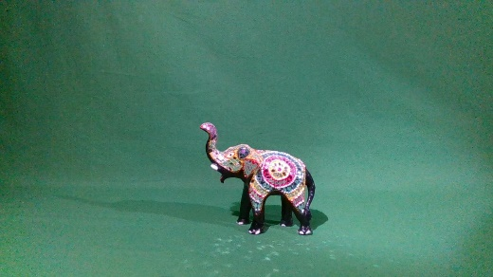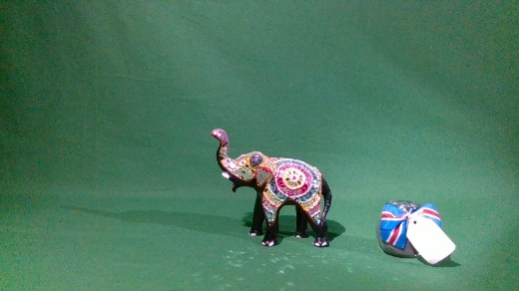

Figure 2 - Small Ornament Elephant with Small Ornament Glass

Figure 1 - Small Ornament Elephant

The first function implemented is the ExtractObject() function. This function multiplied Figure 2 with the given mask and then performed the bitwise_not() function from the OpenCV library in order to extract the ornamental glass from the image as seen in figure 3.

Figure 3 - Extracted Ornamental Glass

The second function implemented is the ApplyFilter() function. This function has the functionality to apply three filters to the newly extracted image, these filters being Gaussian Blur filter, Histogram Equalisation Filter or Median blur. Based on the parameter provided, the function will return the extracted image with the chosen filter.

Figure 5 - Extracted Image with Histogram Equalization Filter

Figure 4 - Extracted Image with Gaussian Blur

Figure 6 - Extracted Image with Median Blur

The third function is the ObjectBlender() function which takes the newly filtered image and blends it into a new image, in our case Figure 1. This is done through the OpenCV function addWeighted() using the parameters alpha = 0.65, beta = 1 – alpha and gamma = -60.

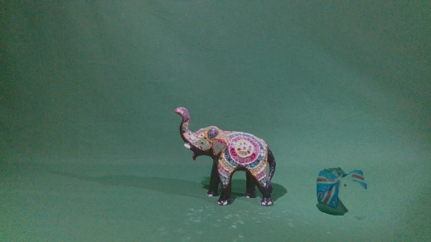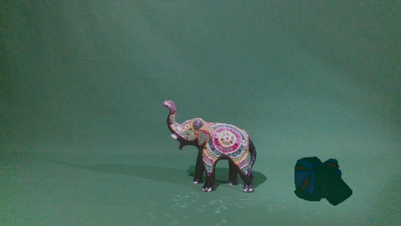

Figure 7 - New photo after Object Blending with Median Blur

Figure 8 - New photo after Object Blending with Histogram Equalization Filter

The final function is the CompareResults() function which compares the newly blended photo with the original and returns either the Sum of Squared Distance Error (SSD) or the Mean Squared Error (MSE) based off of the chosen parameter as seen in figure 18.

### Stage 2

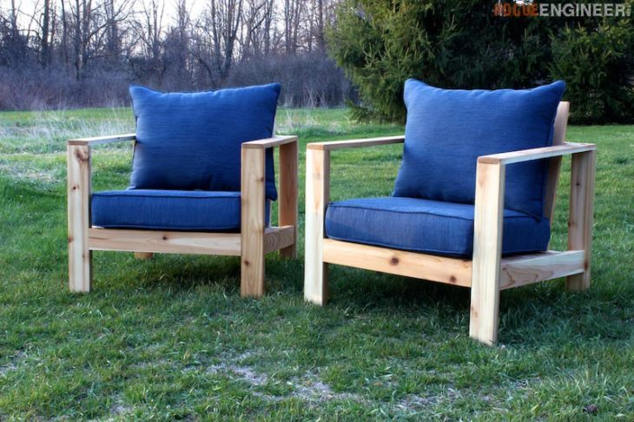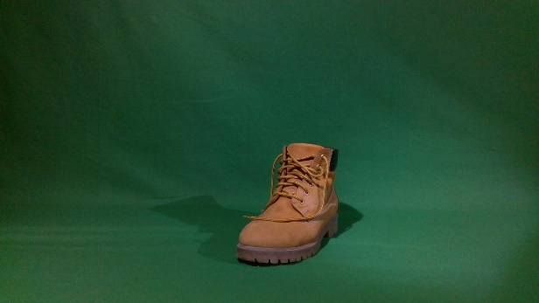The second stage of the first part of the assignment involved removing the green screen of an image and replacing it with a new background. The original image chosen was that of a brown boot and the new backgrounds added were of some chairs outside, stairs in Valletta and a photo of the night sky as seen in figures 9-12.

Figure 9 - Original Image of Brown Boot

Figure 10 - Background image of chairs outside

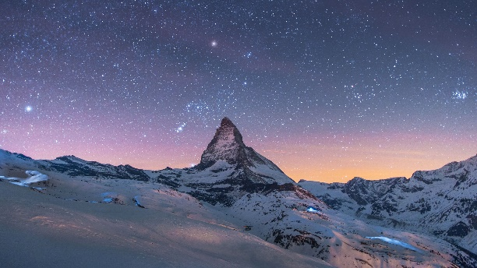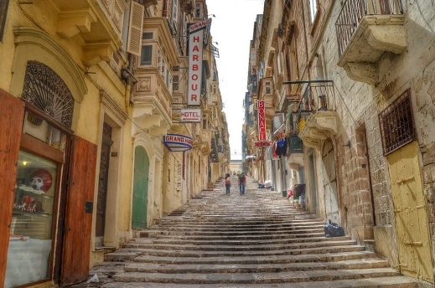

Figure 12 - Background image of the night sky

Figure 11 - Background image of Valletta

The first function implemented was RemoveGreen() which removed the green screen from the original image. This was done by defining the upper and lower bounds for the green in the image and turning all the pixels within that range black as seen in Figure 14.

Figure 13 - The original photo of the shoe without the green screen

The second function is the NewBackground() function which replaces the black pixels with the chosen background image. This is done by first calling the method RemoveGreen() defined earlier to remove the green screen and then layering the new image on top of all the black pixels in the image, resulting in the images seen in figures 15-17.

Figure 14 - Green screen replaced by chairs outside

Figure 15 - Green screen replaced by Valletta street

Figure 16 - Green screen replaced by the night sky

## Evaluation

Comparison of two images in stage 1 is performed using a function that calculates the error score based on a specified metric. The two metrics used are Sum of Squared Distance (SSD) and Mean Squared Error (MSE).

The blended image is compared with the image with two objects (S2) using both error metrics. A lower error value signifies that the blended image resembled the actual image S2 more. The results of the error metrics are shown in figure 17.

|  |  |  |
| --- | --- | --- |
| **Filter** | **SSD** | **MSE** |
| None | 185244013 | 1329 |
| Gaussian | 185525091 | 1333 |
| Histogram Equalisation | 186486483 | 2616 |
| Median Blur | 185400136 | 1325 |

Figure 17 – Blended Image error metrics

The image with the best SSD score used the object without applying any sort of filtering. The image with the best (i.e. lowest) MSE score used the object with median blur filtering. The image which did not use filtering had a very similar MSE score however the median blur image surpassed it slightly.

# Part 2 – Image Inpainting

The second part of the assignment consisted of using off-the-shelf inpainting functions to replicate the results of paper [1] as well as using the same function on new images from the COTS dataset.

## Implementation

In order to implement the second part of the assignment, the libraries *numpy* and *OpenCV* were used.

### Task A

The first part of the image inpainting section involved replicating the results of paper [1] using off-the-shelf functions. The images used were of statues, glasses, books, footwear, mugs and tech. In order to perform inpainting on the images, two algorithms were used, NS and Telea.

After performing inpainting on all the images, the results were compared using the CompareResults() function described in Part 1.

### Task B-1

The second part of the inpainting section involved implementing the same inpainting algorithms but on a new set of images.

After inpainting is performed, the image with a single object and the inpainting image are compared using the aforementioned error metrics.

### Task B-2

In order to find the differences in the background of an image, for each set two images were used. The objects in the image are at the same position, however one image contains some wind which affects and causes movement in the plants and leaves. Using background subtraction, a mask containing areas where the two images differ substantially.

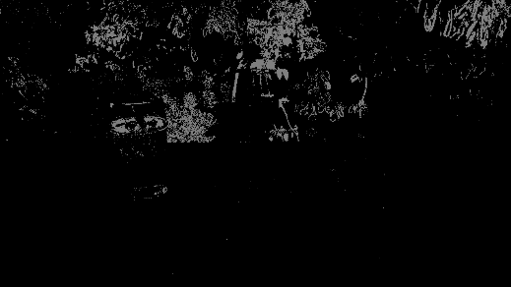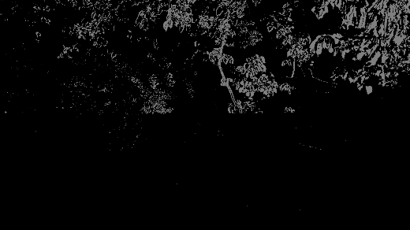For figures 18-21, the regions which contain white pixels are differences in the backgrounds.

Figure 19 – Background differences for cups

Figure 18 – Background difference for statues

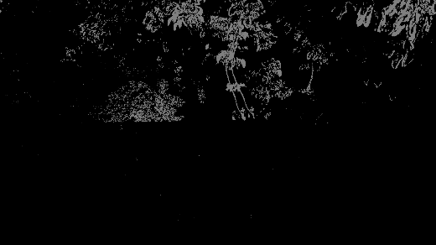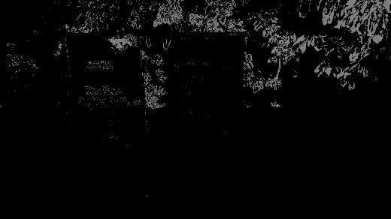

Figure 21 – Background difference for electronics

Figure 20 – Background difference for books

## Evaluation

As with the tasks in Part 1, the SSD and MSE error metrics are used in evaluation.

6 different sets of images are used in task A. Using both the Telea and NS inpainting functions in the OpenCV library, an object is removed from the scene with two objects S2. The inpainted images are then compared with actual image with one object S1. The results are displayed in figure 22.

|  |  |  |  |  |
| --- | --- | --- | --- | --- |
|  | **Telea** | | **NS** | |
| **Set** | **SSD** | **MSE** | **SSD** | **MSE** |
| Statues | 115180351 | 455 | 115914723 | 511 |
| Shot Glasses | 33363637 | 59 | 33704007 | 59 |
| Academic Books | 59162597 | 327 | 61476765 | 383 |
| Footwear | 44000379 | 68 | 46650657 | 90 |
| Mugs | 38383500 | 75 | 40576761 | 84 |
| Technology | 38996685 | 118 | 40382590 | 145 |

Figure 22 - Table holding the error metrics for the original 6 images in task A

The highlighted records are the lowest error score for each image set. A lower score indicates that that algorithm was better at inpainting an object out of an image.

Using the Telea technique provided the best scores for both metrics and hence resembled S1 greater than when using the NS technique.

Task B once again uses inpainting algorithms, this time over 6 sets of images with complex backgrounds obtained from the COTS Dataset. The results are displayed in figure 23.

|  |  |  |  |  |
| --- | --- | --- | --- | --- |
|  | **Telea** | | **NS** | |
| **Set** | **SSD** | **MSE** | **SSD** | **MSE** |
| Food | 214050543 | 3573 | 214916338 | 3664 |
| Statues | 79180499 | 1738 | 79105387 | 1668 |
| Souvenirs | 73850406 | 2996 | 74686615 | 3077 |
| Academic Books | 93337891 | 3547 | 93754563 | 3476 |
| Cups | 125109291 | 902 | 125000973 | 899 |
| Electronics | 58630734 | 511 | 58714712 | 457 |

Figure 23 - Table containing the error metric results for the new 6 images with complex backgrounds

Of these results, the Telea algorithm has a slight advantage, providing the best error results for 4 of the 6 sets of images. However, the NS algorithm still provided results which are quite similar to those obtained using the Telea algorithm.

# References

[1] D. Seychell and C. J. Debono, “An Approach for Objective Quality Assessment of Image Inpainting Results,” in *2020 IEEE 20th Mediterranean Electrotechnical Conference (MELECON)*, Jun. 2020, pp. 226–231.

[2] D. Seychell and C. J. Debono, “Monoscopic Inpainting Approach Using Depth Information,” in *2016 18th Mediterranean Electrotechnical Conference (MELECON)*, Apr. 2016, pp. 1–5.