Market Basket Analysis

# Francesca Prata Blackwell Electronics Data Analytics Department

Table of Contents

Summary 3

Main Findings 4

Data exploration 4

Qualitative observations 5

S.W.O.T. Analysis 6

Strengths 6

Weaknesses 6

Opportunities 6

Threats 6

Conclusion 7

Appendix 8

Data Exploration with Categories 8

Electronidex 8

Blackwell Electronics 9

Association Rule selected for Products 10

Association Rule selected for Categories 11

Pericles’ Question 11

# Summary

In order to aid Blackwell Electronics’ board of directors in their decision to whether or not acquire Electronidex, a start-up electronics online retailer, a market basket analysis has been performed in order to explore the buying patterns of Electronidex’s customers and to gain insight as to what extent the products and the customer type of Electronidex could be beneficial for Blackwell Electronics.

From the analysis, it surfaces that the buying pattern of Electronidex’s clientele differs significantly from the one of Blackwell. Their customers have a preference for desktops, laptops and monitors; and it is not uncommon for multiple laptops or desktops of different brands to be present in the same transaction. Such patterns leads us to believe that Electronidex’s clientele is mostly composed of other businesses rather than private consumers.

This would constitute an interesting opportunity for Blackwell Electronics to diversify its activities and broaden its outreach. Furthermore, Blackwell would increase the range of tablets, printer supplies and monitors that it could offer, particularly if we consider the ViewSonic Monitor which is present in the top-10 list for both companies.

# Main Findings

## Data exploration

The data provided by Electronidex is composed of 9,835 transactions in 30-days’ time . From Figure 1 below we can observe that half of the top-10 products sold by Electronidex are desktops, while 3 of them are laptops, 1 is a monitor and 1 is an accessory.

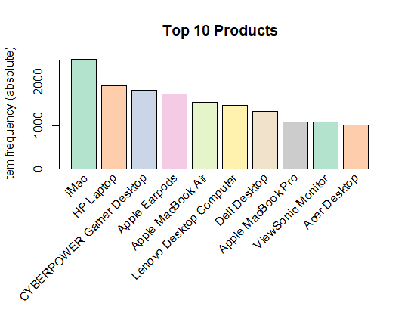

Figure 1: Top-10 most sold products of Electronidex

Similarly, Figure 2 below shows us the top-10 products (by sales volume) of Blackwell Electronics. The two top sellers are game consoles, followed by a smartphone. The ViewSonic monitor is in 4th place (while in Electronidex it takes 9th place), followed by 2 printers and 2 projectors.

Figure : Top-10 most sold products in Blackwell Electronics

Qualitative observations

By observing the product list of both companies, some interesting insights can be gathered. Compared to Blackwell Electronics, Electronidex:

* Does not sell game consoles, netbooks, smartphones and projectors;
* Offers the same variety of monitors as Blackwell Electronics;
* Has less variety of printers, but includes Epson and DYMO Label Manker;
* Has a greater variety of laptops, but does not offer Sony;
* Has a greater variety of tablets, the majority of which are not in Blackwell Electronics’ existing products list;
* Has a wider range of printer supplies;
* Has a larger variety of desktops, but not Sony or iPower.
* Cross-overs in products exist in
  + Laptops (Acer and Asus);
  + Desktops (Dell and HP);
  + Complete cross over in monitors (though Electronidex has more variety);
  + Printers (Brother, Canon, HP);
  + Printer supplies (Brother printer toner, but Electronidex has a wider range);
  + Tablet (Samsung, but Electronidex has a wider range)
* Also sells computer mice, keyboards, headphones (computer and active), computer cords, speakers, computer stands, external hard drives and smart home devices; however it cannot be concluded if Blackwell Electronics also sells them as these categories are not specified in our list.

# S.W.O.T. Analysis

In relation to the question of whether or not Blackwell Electronics would benefit from acquiring Electronidex, a S.W.O.T. Analysis has been performed. This has led to the following considerations about Electronidex.

Strengths

* Electronidex is good at cross-selling, something that is not the case for Blackwell Electronics;
* As previously mentioned, from the rules created we get the impression that Electronidex is focused on B2B transactions. This is an area that Blackwell Electronics lacks.

## Weaknesses

* Electronidex only sells online, which is not the preferred method of purchasing for Blackwell’s customers.

## Opportunities

* Electronidex’s customers appear to be more businesses, as they buy bundles which do not seem in line with single customers’ preferences. Also, it could be speculated that it is in the wholesale business;
* They also mostly sell PC/laptops which are not in the top list for Blackwell

## Threats

* Electronidex sells predominantly desktops, laptops and monitors, which are products that Blackwell rarely sells. Thus, it could be assumed that Blackwell does not have much experience in dealing with these types of products, and thus it could encounter problems in how to do it efficiently
* If Blackwell doesn’t acquire Electronidex, someone else will

# Conclusion

Considering the aforementioned analysis, we would recommend Blackwell to acquire Electronidex. This is mainly driven by the fact that the customers of Electronidex have a distinct buying pattern than the ones from Blackwell. Hence, this would allow Blackwell to diversify its customer base so as to include also businesses.

As far as products are concerned, if we for instance consider laptops, Blackwell sells mostly Sony, while Electronidex sells Acer and Asus. Given that Electronidex does not have Sony in their current product list, introducing the brand through Blackwell would increase its appeal even further.

Lastly, Electronidex has a variety of products (i.e. computer mice, keyboards, headphones (computer and active), computer cords, speakers, computer stands, external hard drives and smart home devices). However, when considering Blackwell, there is the category “Accessories” which components are not specified. It could be possible that by introducing them, customers’ from Blackwell Electronics would react positively.

# Appendix

## Data Exploration with Categories

### **Electronidex**

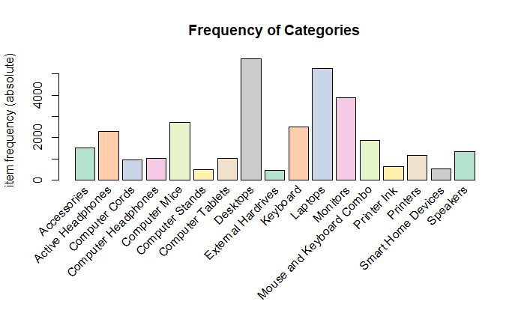Figure : Frequency (absolute) of categories sold by Electronidex

The graph above gives an overview of the frequency of each category at Electronidex. It can be noted that the categories sold more often are desktops, laptops and monitors.

### **Blackwell Electronics**

On the other hand, if we consider the frequency of products at Blackwell, we can see that the product category most frequently sold is Accessories, followed by Extended Warranty and Game Console. Conversely, the least bought categories are PCs, laptops, netbooks and printer supplies.

Figure : Frequency (absolute) of products sold by Blackwell Electronics

## Association Rule selected for Products

*rule3 <- apriori(MarketBasket, parameter = list(supp = 0.01, conf = 0.4))*

|  |  |  |  |  |  |
| --- | --- | --- | --- | --- | --- |
| LHS | RHS | Support[1] | Confidence[2] | Lift[3] | Count |
| {Acer Aspire, ViewSonic Monitor} | {HP Laptop} | 0.01077783 | 0.6022727 | 3.102856 | 106 |
| {Dell Desktop, ViewSonic Monitor} | {HP Laptop} | 0.01525165 | 0.5747126 | 2.960869 | 150 |
| {CYBERPOWER Gamer Desktop, ViewSonic Monitor} | {HP Laptop} | 0.01220132 | 0.5020921 | 2.586734 | 120 |
| {Lenovo Desktop Computer, ViewSonic Monitor} | {HP Laptop} | 0.01403152 | 0.4946237 | 2.548258 | 138 |
| {iMac, ViewSonic Monitor} | {HP Laptop} | 0.02369090 | 0.4794239 | 2.469950 | 233 |
| {Apple Magic Keyboard, Lenovo Desktop Computer} | {HP Laptop} | 0.01057448 | 0.4792627 | 2.469119 | 104 |
| {Acer Aspire, Dell Desktop} | {HP Laptop} | 0.01108287 | 0.4678112 | 2.410122 | 109 |
| {iMac, LG Monitor} | {HP Laptop} | 0.01026945 | 0.4611872 | 2.375996 | 101 |
| {Apple Magic Keyboard, iMac} | {HP Laptop} | 0.01474326 | 0.4559748 | 2.349142 | 145 |
| {Acer Desktop, Dell Desktop} | {HP Laptop} | 0.01240468 | 0.4485294 | 2.310784 | 122 |

## Association Rule selected for Categories

*ruleCat <- apriori(MarketBasketCat, parameter = list(supp = 0.05, conf = 0.7))*

|  |  |  |  |  |  |
| --- | --- | --- | --- | --- | --- |
| LHS | RHS | Support | Confidence | Lift | Count |
| {Keyboard, Laptops, Monitors} | {Desktops} | 0.07484999 | 0.8430699 | 1.453350 | 736 |
| {Accessories, Laptops ,Monitors} | {Desktops} | 0.05542561 | 0.8384615 | 1.445405 | 545 |
| {Computer Mice, Keyboard, Laptops} | {Desktops} | 0.05369674 | 0.8341232 | 1.437927 | 528 |
| {Laptops, Monitors, Mouse and Keyboard Combo} | {Desktops} | 0.05939184 | 0.8213783 | 1.415956 | 584 |
| {Computer Mice, Laptops, Monitors} | {Desktops} | 0.08013831 | 0.8157350 | 1.406228 | 788 |
| {Desktops, Monitors, Mouse and Keyboard Combo} | {Laptops} | 0.05939184 | 0.7448980 | 1.393566 | 584 |
| {Keyboard, Monitors} | {Desktops} | 0.10474931 | 0.8053167 | 1.388268 | 1030 |
| {Active Headphones, Laptops, Monitors} | {Desktops} | 0.06244279 | 0.8036649 | 1.385420 | 614 |
| {Accessories, Desktops, Monitors} | {Laptops} | 0.05542561 | 0.7394844 | 1.383438 | 545 |
| {Computer Mice, Keyboard} | {Desktops} | 0.07312112 | 0.7997775 | 1.378719 | 719 |

## Pericles’ Question

**What happens when you format “single” in the *read.transactions* function?**

If I run this code

MarketBasket <- read.transactions("ElectronidexTransactions2017.csv",  
 format = c("single"),   
 sep = ",",  
 rm.duplicates = "FALSE")

I get this error

Error in read.transactions("ElectronidexTransactions2017.csv", format = c("single"), : 'cols' must be a numeric or character vector of length 2 for 'single'.

That is because when one uses the ‘basket’ format, each line in the transaction data file represents a transaction where the items are separated by the characters specified by the parameter “sep”. Instead, for ‘single’ format, each line corresponds to a single item, meaning that the data consists of only a transaction id and an item id[4]. Thus, obviously in our case we had an error when formatting it to “single” as our data consists of multiple items.

1. How often a rule is applicable to a given data set
2. How frequently items in Y appear in transactions that contain X
3. Measure that summarizes the strength of the association between the products on the left- and right-hand side; thus, the greater the lift the greater the relation between the two products
4. Paraphrased from <https://www.rdocumentation.org/packages/arules/versions/1.6-2/topics/read.transactions>