University Security Control

Case study of Database Systems

a.a 2017/2018

Student: Francesco Giannico

Badge number: 678454

Computer Science

Index

Introduction 3

Specifications 4

Conceptual Design 5

Correct level of abstraction 5

Avoid twisted sentences 5

Synonyms and homonyms 5

Standardization of sentences 5

# Introduction

TODO

# Specifications

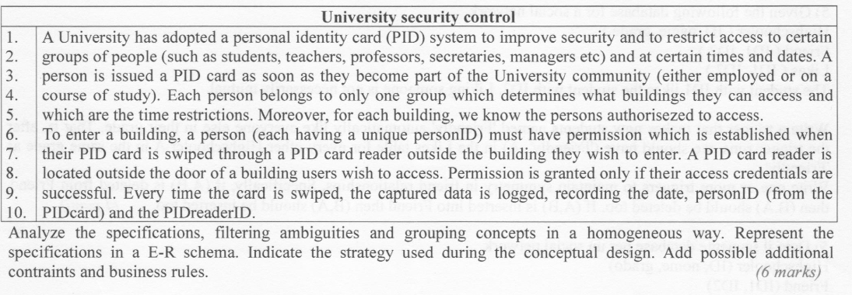

# Conceptual Design

### Correct level of abstraction

### Avoid twisted sentences

### Synonyms and homonyms

### Standardization of sentences

### Terms Glossary

|  |  |  |
| --- | --- | --- |
| Term | Description | Link |
| PIDCard | Card issued for each Person which allows to access to a building. |  |
| PIDReader | Reader of the Cards, located outside the door of a building. |  |
| Person | Persons in the University community: they can be Employees or Students. |  |
| Building | Physical place in which the Persons works or study. |  |
| .. |  |  |
|  |  |  |
|  |  |  |
|  |  |  |
|  |  |  |

### Reorganize sentences by concepts

### Ambiguities analysis

### Skeleton schema

#### Concepts explosion

### Final conceptual schema

# Logical Design

The logical model chosen for this project is object-relational.

The logical design of this database was done by keeping in mind the following operations:

### Operations Table

|  |  |  |  |
| --- | --- | --- | --- |
| **Number** | **Operation** | **Type** | **Frequency** |
| 1 | Insert person | Interactive | 50 times/week |
| 2 | Delete person | Interactive | 50 times/week |
| 3 | Validate entrance | Interactive | 300 times/minute (3 024 000 times/week) |
| 4 | Register entrance | interactive | 50 times/minute (504 000 times/week) |
| 5 | Print the access statistics: per day and per building | batch | 10 times/week |
| 6 | Print the access statistics: per hour and per building | batch | 10 times/ week |

### Volumes Table

|  |  |  |
| --- | --- | --- |
| **Concept** | **Type** | **Volume** |
| Person | Entity | 100 000 |
| Employee | Entity | 100 000*40%= 40 000 |
| Student | Entity | 100 000*60%= 60 000 |
| PIDCard | Entity | 100 000 |
| ExtClosing | Entity | 450/3= 150 |
| Evalidation | Entity | 5*52(weeks per year) * 3 024 000 = 786 240 000 |
| Entrance | Entity | 5*52(weeks per year) * 504 000= 131 040 000 |
| PIDReader | Entity | 60 |
| Dept | Entity | 30 |
| Building | Entity | 30*2= 60 |
| Belongs_to | Relationship | 100 000 |
| Own | Relationship | 100 000 |
| deptExtClosing | Relationship | 15(some dept)*6*5 = 450 |
| buildExtClosing | Relationship | 20 (some builings)*7*5 =700 |
| Pid_EValidation | Relationship | 786 240 000 |
| Allow | Relationship | 131 000 000 |
| Refers_to | Relationship | 131 000 000 |
| DeptBuild | Relationship | 60 |
| Provide | Relationship | 786 240 000 |
| Has | Relationship | 60 |
| Authorization | Entity | 100 000 * 2 = 200 000 |

*Assumptions made:*

* 5 years of activity;
* Persons are for the 40% Employees while the remaining 60% are Students.
* Each department has 2 builings.
* Some departments have 6 extraordinary closing days in an year.
* Each extraordinary closing day refers to 3 departments.
* Some buildings have 7 extraordinary closing days in an year.
* Each extraordinary closing day refers to 4 buildings.
* Each PIDCard allows to access into 2 buildings.
* Each Building has 200 000 entrance.

### Access Table

For each operation it has defined the access table.

The total cost access/week has been computed by considering the frequency of each operation and weighing writing operations as 2 accesses.

|  |  |  |  |
| --- | --- | --- | --- |
| **Operation 1(insert person)** | | | |
| Concept | Concept Type | Number | Access Type |
| Person | E | 1 | W |

Total cost: (1*2) * 50 = 100 access/week

|  |  |  |  |
| --- | --- | --- | --- |
| **Operation 2(delete person)** | | | |
| Concept | Concept Type | Number | Access Type |
| Person | E | 1 | W |

Total cost: (1*2) * 50 = 100 access/week

|  |  |  |  |
| --- | --- | --- | --- |
| **Operation 3(validate entrance)** | | | |
| Concept | Concept Type | Number | Access Type |
| PIDCard | R | 1 | R |
| PidReader | E | 1 | R |
| EValidation | E | 1 | R |
| EValidation | E | 1 | W |
| PIDCard_Building | R | 1 | W |
| Provide | R | 1 | W |
| Building | E | 3(2 times for authorization and 1 for PIDReader) | R |
| buildExtClosing | R | 7 | R |

Total cost: ((3*2)+ 13) * 3024000 = 57 456 000 access/week

|  |  |  |  |
| --- | --- | --- | --- |
| **Operation 4(register entrance)** | | | |
| Concept | Concept Type | Number | Access Type |
| EValidation | E | 1 | R |
| PIDReader | E | 1 | R |
| Building | E | 1 | R |
| Entrance | E | 1 | W |
| Allow | R | 1 | W |
| Refers_to | R | 1 | W |

Total cost: ((3*2) + 3)* 504 000 = 4 536 000 times/week

The Operation 5 and 6 are batch, but i have also decided to check the operations’cost.

|  |  |  |  |
| --- | --- | --- | --- |
| **Operation 5** | | | |
| Concept | Concept Type | Number | Access Type |
| Entrance | E | 131 000 000 | R |
| Building | E | 200 000 | R |

Total cost: (131 000 000 + 200 000)*10= 1 312 000 000 access/week

|  |  |  |  |
| --- | --- | --- | --- |
| **Operation 6** | | | |
| Concept | Concept Type | Number | Access Type |
| Entrance | E | 131 000 000 | R |
| Building | E | 200 000 | R |

Total cost: (131 000 000 + 200 000)*10= 1 312 000 000 access/week

### Redudancy Analysis

### Logical Design