Data Synchronisation
The synchronisation is done by means of a TTL impulse timestamping the GPIO channel and a light bulb in the video camera field. Two separate TTLs channels were employed for safety reasons. The video recording and the miniscope recording start independently and are synchronised with the synchronous TTL timestamp on the GPIO channel/LED switch in the video frame.
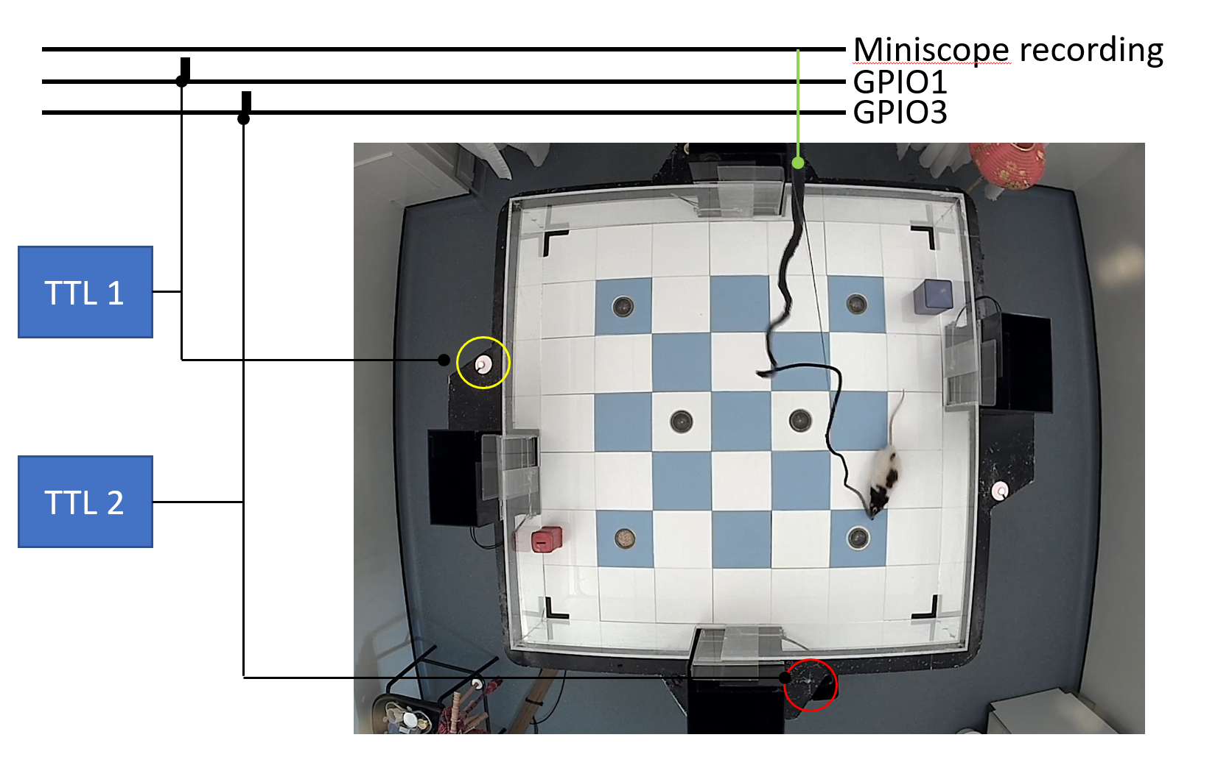
The resulting data is saved as follows:
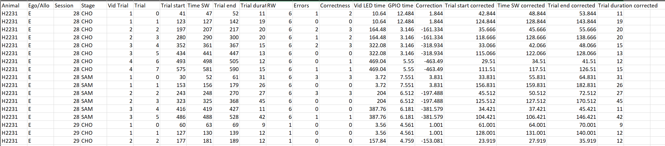
Trial: trial number
Vid Trial: trial number in video (each video recording contains 2 trials)
Trial start: Start of the trial (animal moving out of startbox) as time in video
Time SW: Time where animal reached the sandwell
Trial End: Return to Starbox (video timestamp)
Vid LED time: Time where LED light connected to TTL1 is switched on.
GPIO time: Time when the TTL impulse is timestamped on the GPIO channel
Correction: GPIO/LED correction: the animal positions detected in video will be time shifted and aligned with calcium recording
Trial start corrected, Time SW corrected, Trial End corrected: same as above but aligned to calcium recording timeline

Overview
The following code is provided as Jupyter notebooks in Python.
The code can be run via Anaconda Navigator (https://www.anaconda.com/products/navigator)

Dependencies
Numpy 1.26.4
Matplotlib 3.10.3
Pandas 2.2.2
Opencv (cv2)
Seaborn 0.13.2
Scipy 1.13.1
Sklearn 1.5.1
Math
Time
Collections
Multiprocessing

from place_cells import *
from arena import *

The Code has been tested on a Windows machine. To run on Mac, please change directory format as required. The version of the libraries shows the version on the machine where the code was tested. For the version used in experiments please refer to manuscript methods. Typical installation time for Anaconda varies but is generally <10min. Please save the files in your chosen folder, open Anaconda and launch Jupyter notebook. Navigate to your folder and open selected Jupyter notebooks. Remember to modify the parental folder “codeDir” when launching Jupyter notebooks before running the code.

Example Data
This folder contains example data to run the Jupyter notebook files. Individual files are saved using the same Folder network structure so that the Home directory should be changed to “Example Data”. Animal and Stage, and extra folders, should be modified following code annotation. Expected runtime based on the linked dataset is generally low (<5 min but can be as long as 15min). Example data contains .csv files with neuron activity. Complete files to run all parts of the code such as example videos can be found at Edinburgh DataShare.

Jupyter Notebooks

Place Cells.ipynb
This Jupyter notebook contains the code to calculate place cells map from aligned calcium and extracted video data. Mutual information and maps are calculated here.
Output: Mutual information, criteria satisfaction, rate and density maps
Note that one session is provided in the Example data so n_session=1 should be used
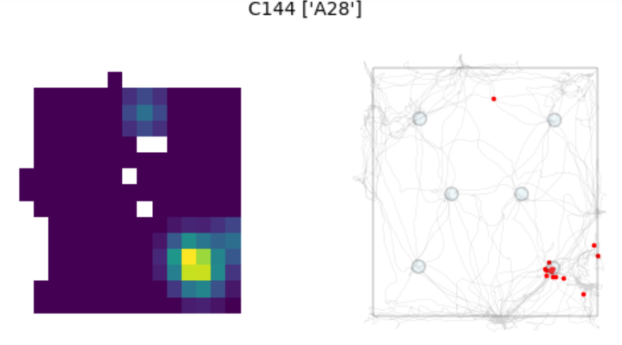

Place Cells Remapping.ipynb
This Jupyter notebook contains code to calculate Place cells properties such as stability (to evaluate remapping) and direction dependency.

Trial_identification_code.ipynb
This Jupyter notebook contains code for the automatic identification of trial starts from animal coordinates.

Startbox activity Export.ipynb
This Jupyter notebook contains code to export the information content of cells active in the startbox in the 10s prior to trial start.
Will read in all the data for the selected animal/Phase (Ego or Allo) and plot the activity detected in the arena for cells active in the 10s before the start trial.
Here is an example output based on the Example data (note the example data only contains an example exploration file and choice trials for the same session)
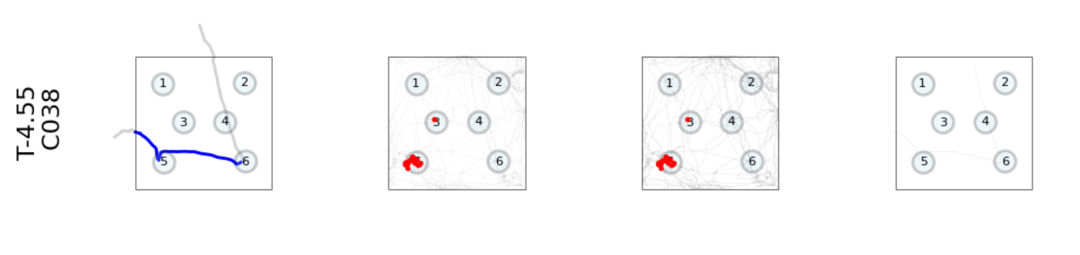

Common SB cells.ipynb
This Jupyter notebook contains code to calculate the fraction of common cells across startboxes before trial start.

arena.py and place_cells.py contain functions used in the Jupyter notebooks.

Our code design saves intermediate steps as data tables in csv format that are then read by separate Jupyter notebooks for later analysis. Data are grouped by animal for convenience.
in ALL_META.csv . Below is an example that describes the format.

ALL_META.csv
This table is generated by concatenation of all trials after automatic trial identification and quality check. Each animal has an individual table
….
Trial Start: Starting startbox
Trial Status: Automatic classification of correct of incorrect trials based on trajectory
Location: Position of animal in that time frame; SB = startbox. Trial start: start of the trial. Outbound: animal traveling to sandwell
LED_frame: synchronising LED status
Combo: use of startboxes in trial (start/end)
Cap_x, …. Tailbase_y: x and y coordinates of animal body parts (head, ears, tail) after correction and translation.
Speed: movement speed
Movement: classification as moving or stationary
Time (s) : time
Session: Session type and number
Stage: SAM or CHO trial
C000…. Event vector of cells; 0: no events, non-zero value: event amplitude (note: events are binarized in analysis

all_trials.csv
Similarly, Events and traces data in Sample and Choice trials are grouped by animal for convenience.
in XXXXX_all_trials.csv where XXXXX is the animal’s ID. Below is an example that describes the format.
In the column Location the trial start is marked as ‘Trial start’ and startbox activity was considered in the 10s before that.

Decoder graphs.ipynb
This Jupyter notebook contains code to display the results of the Decoder analysis applied to the startbox activity (10s interval before trial start).

Frequency calculation.ipynb
This Jupyter notebook contains code to calculate the event rate in the startbox and during exploration for the subset of cells active in the startbox (10s interval before trial start).

Startbox events clustering v2.ipynb
This Jupyter notebook contains code to calculate the temporal clustering of events in the startbox (10s interval before trial start).

