Office Queue Management System

Conceptual design
In this phase, the entity-relationship model of the system was developed, where it was necessary to represent all the entities involved and the relationships required between them. Specifically, in this sprint, the system required the presence of two particular types of users, namely, Customer and Officer, each of whom interacts with the system differently. Furthermore, customer registration was deemed redundant as it was considered "anonymous," as it is closely tied to the ticket entity, and thus, only the ticket would be sufficient to represent the action associated with a user. We can tell the same for the officer, because each counter is managed by an officer so it would be implicit that counter has an officer (it’s not required, in this moment, to access as an officer).
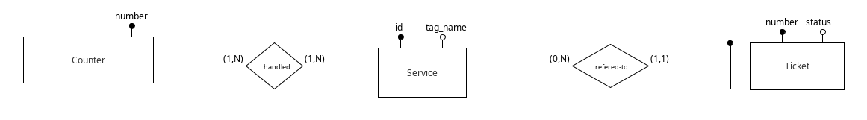

Logical design

Translation of entities and associations
- Counter(number)
- Handled(counter_number, service_id)
- Service(id, tag_name)
- Ticket(number, status, service_id)
attribute: in grassetto => chiave primaria
attribute: in corsivo => foreign key

Referential constraints
- Handled(counter_number) ⊆ Counter(number)
- Handled(service_id) ⊆ Service(id)
- Ticket(service_id) ⊆ Service(id)

Counter
Attribute | Tipology | Description
number | Integer | The number attribute describes the number that is assigned to that particular counter, and being a primary key is unique to each counter.

Handled
This particular table traces all the correspondences between service and counter, that is identifies for every counter all the services that can manage.
Attribute | Tipology | Description
counter_number | Integer | Reference to the counter number
service_id | Integer | Reference to the service id

Service
Attribute | Tipology | Description
id | Integer | Unique indentifier for a service
tag_name | String | Descriptive name for that service

Ticket
Contains all tickets generated by the system. There is a particular field called "status" that has the responsibility to track the current status of the ticket that can take one of the following values:
- 0: waiting
- 1: being served
- 2: served
This field is very important for the implementation of the queue, because it would be enough to update this state in order to update the queue for that service.
Attribute | Tipology | Description
number | Integer | Number assigned to that ticket
status | Integer | Status of the ticket
service_id | Integer | Service id reference

